COMPARISON OF THE EFFECTIVENESS OF THE ROLE PLAYING MODEL WITH THE DEBATE MODEL TO IMPROVE DIALOGUE SKILLS IN DRAMA STAGING

(Quasi-Experimental Study on Grade V Students of SDN Mekartani 3, Singajaya District, Garut Regency for the 2023/2024 Academic Year)

THESIS
Submitted to meet one of the requirements
obtained a Master's Degree in Education
in the Field of Indonesia Language and Literature Education

By
AAL ALAWI
NIM 22882002

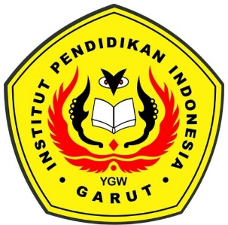

INDONESIAN LANGUAGE AND LITERATURE EDUCATION
GRADUATE PROGRAMS
COLLEGE OF TEACHER TRAINING AND EDUCATION
GET OFF
2024

