THE DIFFERENCES IN ENGLISH TEACHING METHODS AND STUDENTS’ PERCEPTIONS BETWEEN FORMAL AND NON-FORMAL EDUCATION

A PAPER
Submitted to the English Education Program of IPI Garut as Partial Fulfilment of the Requirements for the Bachelor of Education degree

Written by:
NOVI NUR FITRIYANI
21221008

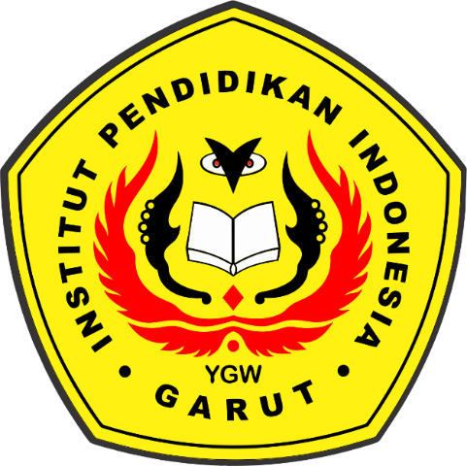

ENGLISH EDUCATION PROGRAM
FACULTY OF SOCIAL SCIENCE LANGUAGE AND LITERATURE EDUCATION
INSTITUT PENDIDIKAN INDONESIA GARUT
2025

