STUDENTS’ PERCEPTION ON USING ARTIFICIAL INTELLIGENCE APPLICATION (CHATGPT) IN WRITING ACADEMIC PAPER

A PAPER
Submitted to the English Education Program of IPI Garut in Partial Fulfillment of the Requirements for the Bachelor of Education Degree

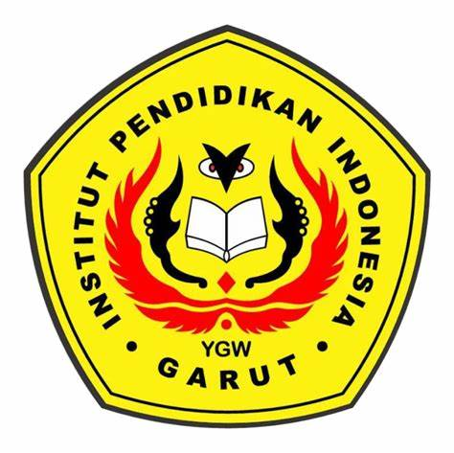
Written By:
Adinda Wahidah Gantina
21226009

ENGLISH EDUCATION PROGRAM
FACULTY OF SOCIAL SCIENCE LANGUAGE AND LITERATURE EDUCATION
INSTITUT PENDIDIKAN INDONESIA GARUT
2025

