PROSPECTIVE TEACHERS’ PERCEPTION OF PROJECT BASED LEARNING

A PAPER
Submitted to the English Education Program of Institut Pendidikan Indonesia (IPI) Garut as The Partial Fulfillment of the Requirenments for Bachelor of Education Degree



Written by:
Vera Agustin Sudrajat
20223012

ENGLISH EDUCATION PROGRAM
FACULTY OF SOCIAL SCIENCE LANGUAGE AND LITERATURE EDUCATION
INSTITUT PENDIDIKAN INDONESIA GARUT
2024

APPROVAL SHEET

PROSPECTIVE TEACHERS’ PERCEPTION OF PROJECT BASED LEARNING

By:
Vera Agustin Sudrajat
20223012

First Supervisor Second Supervisor

Dr. Eva Devi Sofyawati, M.Pd Ai Winarsih, M.Si
NIDN. 0409057803 NIDN. 0421074901

Acknowledged by:
Head of English Education Program

Anne Ratna Suminar, M.Pd.
NIDN. 0415038601

LEGITIMATION OF EXAMINATION

PROSPECTIVE TEACHERS PERCEPTION OF PROJECT
BASED LEARNING

By:
Vera Agustin Sudrajat
20223012

This paper has been examined on 1st July 2024
First Examiner, | Second Examiner, | Third Examiner,
Muhamad Taufik Hidayat, M.Pd.  NIDN. 0423038501 | Amir Hamzah, S.S., M.Pd.  NIDN. 0402057606 | Anne Ratna Suminar, M.Pd.  NIDN. 0415038601

Acknowledged by:
Dean of Faculty of Social Science, Language and Literature Education

Dr. Lina Siti Nurwahidah, M.Pd.
NIP. 19680527199303200

PERNYATAAN

Dengan ini, penelitian menyatakan bahwa skripsi yang berjudul “Prospective Teachers’ Perception of Project Based Learning” benar- benar ditulis oleh peneliti. Kutipan dari sumber lain telah dilakukan berdasarkan aturan kutipan sesuai dengan etika ilmiah yang berlaku. Oleh karena itu, isi beserta segala kelengkapannya merupakan karya asli penelitian. Dalam hal ini, jika diketahui hal- hal tidak sesuai, penelitian ini bertanggung jawab dan bersedia menerima segala resiko dan sanksi apapun.

Garut, Juni 2024
penulis,

Vera Agustin Sudrajat
NIM. 20223012

DECLARATION

The researcher hereby declares that this paper entitled “Prospective Teachers’ Perception of Project Based Learning” was really written by the researcher. Quotation from other sources have been carried out based on citation rules in accordance with applicable scientific ethics. Therefore,the content of this paper and all its completeness are original works of the researcher. In this case, if things are found that are not suitable, the researcher will be responsible and willing to accept any risks and sanctions.

Garut, Juni 2024
Penulis,

Vera Agustin Sudrajat
NIM. 20223012

MOTTO

"Make your parents happy, because parents always give the best for their children's lives"
-Vera Agustin Sudrajat

“Your parents are at home waiting for you to come home with proud results, never disappoint them, save your complaints, because your tiredness is not worth their struggle to support you”
-Ika df

PREFACE

In the name of Allah SWT, the beneficent and the merciful. All praises are merely to the Almighty Allah SWT, the Lord of the world, for the gracious mercy and tremendous blessing that enable the writer to accomplish this paper. This paper entitled " Prospective Teachers’ Perception of Project Based Learning ", is submitted to fulfill one of the requirements in accomplishing the Sarjana Pendidikan Degree at the English Education Program in Indonesian Education Institute (IPI) Garut.
The writer realizes that this paper is still far from being perfect. There might be some mistakes, shortcomings, and inaccurate ideas. Therefore, the writer would like to welcome any constructive comments, corrections, and suggestions which would encourage for the further study.
Finally, the writer hopes this paper can give valuable contribution in teaching and learning to writer and readers.

Garut, Juni 2024
Penulis,

Vera Agustin Sudrajat
NIM. 20223012

ABSTRAK

Penelitian ini bertujuan untuk membedah pengetahuan calon guru terhadap pembelajaran berbasis proyek. Penelitian ini mengkaji persepsi calon guru terhadap penerapan pembelajaran berbasis proyek. Penelitian ini menggunakan data kualitatif. Partisipan dalam penelitian ini adalah lima mahasiswa Bahasa Inggris di salah satu kampus di Garut yang mempunyai niat untuk melanjutkan karir sebagai guru. Teknik pengumpulan data yang digunakan adalah wawancara. Hasil penelitian menunjukkan bahwa kelima calon guru sebagai partisipan menunjukkan persepsi yang berbeda-beda. tiga dari lima calon guru akan menggunakan pembelajaran berbasis proyek dan dua dari lima calon guru tidak akan menggunakan pembelajaran berbasis proyek. Penelitian ini diharapkan dapat membuat para calon guru mulai mempersiapkan diri dari sekarang agar kedepannya dapat memilih metode pembelajaran yang cocok untuk siswa.
Kata Kunci: Pembelajaran berbasis proyek, Calon Guru, Persepsi

ABSTRACT

This research aims to dissect prospective teachers’ knowledge of project-based learning. This research examines prospective teachers’ perception of the application of project-based learning. This research uses qualitative data. The participants in this research were five English students at one of the campuses in Garut who had the intention of continuing their careers as teachers. The data collection technique used was interviews. The research results showed that the five prospective teachers’ as participants showed different perceptions. three out of five prospective teachers’ will use project-based learning and two out of five prospective teachers’ will not use project-based learning. It is hoped that this research can make prospective teachers’ start preparing themselves now so that in the future they can choose learning methods that are suitable for students.
Keywords: Project based- learning, Teacher candidates, Perception

ACKNOWLEGMENT

Praise be to Allah, thanks to the presence of Allah SWT, the Most Gracious, the Most Merciful, this paper was completed after going through long, difficult, happy and sad times. The paper entitled "Teacher Candidates Understanding of Project Based Learning" has been completed. The author is fully aware that this success would not have been achieved without the help, support and encouragement of many parties during the search for and writing the research paper. Therefore, I would like to thank:
- Dr. H. Nizar Alam Hamdani, M.M., M.T., M.Si., M.Kom., as Rector of Institute Indonesia of Education (IPI) Garut, thank you for being such a great rector,
- Dr. Hj. Lina Nurwahidah, M.Pd. as Dean of facult of social science, language and literature education, Thank you for your service to the College,
- Anne Ratna Suminar, M.Pd., Head of English Education Program in Indonesian Institute of Education (IPI) Garut;
- Dr. Eva Devi Sofyawati, M.Pd. as the first supervisor who was very valuable during the completion of this paper, thank you for giving me support, direction and guiding my thesis well, gently and patiently. May your family always be given health and happiness, Aamiin,
- Ai Winarsih, M.Si as the second supervisor, who was very valuable in completing this thesis, thank you for always giving me direction in guiding my thesis, I hope your family will always be given health and happiness. Aamiin,
- Mother (Eti Sunarti), my heaven, she played a very important role in completing the thesis, who has always been a home in times of joy and sorrow. Thank you very much for the prayers that he offers every time, the support, the motivation that strengthens every step until he completes his degree. May he always be healthy and live long, Aamiin,
- Father (Alm Ajat Sudrajat), my beloved he did not have the opportunity to experience education until college, but he was able to educate and motivate. For this reason, through this article the author would like to express his infinite gratitude and this article was written with great longing for you. May your beloved father be a member of heaven, Aamiin,
- To my beloved siblings (Fuzi Astuti Sudrajat and Poppy Rizkia Sudrajat) thank you for your help and support every day. May you always be healthy and live long, Aamiin,
- To my beloved nieces (Aludra Kholiqa Jasmine and Kellen Naraya Sailendra) thank you for spreading love and affection in your family, I wish you good health and long life, Aamiin,
- To my grandfather, uncle and aunt, thank you for all your guidance and motivation.
- To UMA's special friends (Futri Nirwana, Nisi Bunga Lestari and Lestaringgi Alya M) thank you for helping, supporting this thesis, I hope your warm smile will always be a good deed and may you always be protected by Allah SWT, I wish you all success,
- To all ENGLISH BEE class friends, thank you for the happiness you always express, good luck,
- To my friends (Ayu Puspita Sari, Elsa Fuji Lestari, Tiara Anjani and Salma Siti Zakiah) thank you for all the jokes that make your mood good, I hope you are always happy,
- To all lecturers, thank you for your knowledge and experience, I hope you are all healthy and always under the protection of Allah SWT,
- For future partner, I hope they meet at the right time and quickly, always be happy, hope they meet soon, and love each other until death do us part,
- Lastly, to Vera Agustin Sudrajat 20223012, thank you for fighting very far and trying hard. able to manage time, energy and thoughts. Those who are able to rise from feeling lazy and not take their thesis for granted, this is an achievement you should be proud of.
TABLE OF CONTENTS

APPROVAL SHEET i
PERNYATAAN iii
DECLARATION iv
MOTTO v
PREFACE vi
ABSTRAK vii
ABSTRACT viii
ACKNOWLEGMENT ix
CHAPTER I INTRODUCTION 1
1.1 Background of The Study 1
1.2 Reasons for Choosing the Topic 3
1.3 Research Question 3
1.4 Research Objectives 4
1.5 Significance of the Study 4
1.6 Definition of Terminologies 4
CHAPTER II LITERATURE REVIEW 5
2.1 Project Based Learning (PBL) 5
2.1.1 The Definition of Project- Based Learning (PBL) 6
2.1.2 Benefits and challenges of project based learning 7
2.1.3 The Process of Project Based Learning 8
2.1.4 Principles of project based learning 9
2.1.5 Project-based learning model 9
2.2 The Previous of Related Research Finding 10
CHAPTER III RESEARCH METHODOLOGY 12
3.1 Research Methods 12
3.2 Research Design 12
3.3 Research Setting and Participants 12
3.3.1 Research Setting 12
3.3.2 Participants 13
3.4 Data Collection Technique 13
3.5 Data Analysis 13
3.6 Research Procedure 14
CHAPTER IV RESEARCH FINDINGS AND DISCUSSIONS 15
4.1 Research Findings 15
4.1.1 Teachers candidates understanding of project based learning 15
4.2 Discussion 19
4.2.1 Project based learning facilitates student centered learning 19
4.2.2 The role of the teacher in project based learning 19
4.2.3 Application of project based learning in the classroom 20
4.2.4 The purpose of implementing project based learning in the classroom 21
4.2.5 Benefits of project based learning fot teachers and students 21
4.2.6 Measuring the success of project based learning in the classroom 22
CHAPTER V CONCLUSIONS AND SUGGESTIONS 23
5.1 Conclusions 23
5.2 Suggestions 24
5.2.1 For Teachers 24
5.2.2 For Students 24
5.2.3 For Teachers Candidates 24
5.3.4 For Future Researchers 24
REFERENCES 25
APPENDIX 1 31
Research Instrument grid, Result In Interview Question and Answer 31
Research Instrument Grid 32
INTERVIEW 37
APPENDIX 2 42
Research Permit Application and Documentation 42
Research Permit Application 43
Dokumentasi 44
CURRICULUM VITAE 50

CHAPTER I

INTRODUCTION
This chapter disscusses the background of the study, Reasons for choosing the topic, the research question, the reserach objective, the significance of the study, and the definition of terminology.

Background of The Study
Project-Based Learning is a learning and teaching strategy in which students gain new knowledge and skills while studying challenging, realistic situations, arranging their own studies, and generating products. The Project Based Learning technique, in particular, has an impact on subject matter knowledge, problem solving skills, and independent learning (Cole, Means, Simkins, & Tavali, 2002; Eggen & Kauchak, 2001). Learners decide how to approach a problem and what activities to pursue. They collect information from various sources and synthesize, analyze, and derive knowledge from it. Their learning is inherently valuable because it connects to something real and involves adult skills such as collaboration and reflection. At the end, students demonstrate newly acquired knowledge and are assessed on how much they have learned and how well they communicate it. Throughout this process, the teacher's role is to guide and advise rather than direct and organize the student's work (Baysura,Altun, & Toy, 2016). These differences include recognition of the importance of real-life problem-solving skills, the involvement of new learning strategies, increased use of technology in the teaching-learning process, and changes in assessment mechanisms and in the learning process. the role of teachers and students (Koc, Isıksal & Bulut, 2007). Teaching in the modern educational environment necessitates a new skill set because learning is focused on adapting to the ways in which the world collaborates and communicates in the twenty-first century. With the addition of techniques like PjBL, the new skill set will make classrooms more student-centered (Wan Husin et al., 2016). PjBL is an application where teachers lead students in an interdisciplinary study as facilitators (Martelli & Watson, 2016). In the classroom, PjBL can assist students in mastering 21st-century skills (Baysura, Altun, & Yucel-Toy, 2016). This approach consists of multiple elements that correspond with the competencies that learners will require in the future. Among the abilities are problem-solving, public speaking, cooperation, and efficient use of technology. Effective technology use is a critical 21st-century ability that is essential to PjBL implementation (Mosier, Bradley-Levine, & Perkins, 2016; Smith & Gibson, 2016). When students participate in PjBL, it is crucial that the curriculum be connected to 21st century abilities (Baysura et al., 2016; Martelli & Watson, 2016). Because it is required by the region, the administrators and employees of Foster Middle School (FMS, pseudonym), located in a suburban area, are committed to implementing PjBL to deliver student-centered learning (Head of FMS, personal communication, November 15, 2015).
In addition to some of the things mentioned above, project-based learning also has advantages in its use, in developing attitudes, self-concept, and habit-based learning environments (Alacapinar, 2008; Kalayci, 2008). Apart from that, project based learning also has a positive influence on academic achievement, understanding contextual knowledge, interest and curiosity (Erdem, 2012). according to Haaitanen (2019) stated that project-based learning was found to be very useful for use in teacher teaching because it encourages student or teacher learning and motivation, and a sense of togetherness at the school level, student-centered learning and flexibility in their teaching. The project-based learning method also has disadvantages, it is time consuming and students may go off topic when the boundaries of the project are not clear, and it may be difficult for students who do not have a good knowledge of scientific research methods. There may be problems in individual student assessment, and teachers may not be equipped with the skills and knowledge to manage project based learning (Demirhan & Demirel, 2003).
Most studies explore teacher and student perception of project based learning. Azman & Shin (2012) researched teachers regarding the implementation of project-based learning in English language learning and found that these teachers had positive perceptions of project-based learning. In 2015, Kavlu showed that reading and acquiring necessary vocabulary becomes more enjoyable when using project-based learning. The students were more motivated and interested in learning, something similar was found by Chu et al. (2017). Meanwhile, Wang (2016) applied project-based learning to increase student motivation using surveys and found that students were more motivated in learning using project-based learning as a teaching method.
Many teachers' descriptions of project-based learning characterized many benefits of incorporating project work in language teaching. First, the process leading to the final product of project work provides opportunities for students to develop their self-confidence and independence (Fried-Booth, 2002). In addition, students show improvement and positive attitudes towards learning (Stoller, 2006). Students' autonomy is enhanced (Skehan, 1998), especially when they are actively involved in project planning (e.g. topic selection). Further frequently mentioned benefits relate to improved social, cooperative skills, and cohesiveness of student groups (Coleman, 1992; Papagiannopoulos, 2000). Apart from positive perceptions, there are also negative perceptions expressed by teachers. Weaknesses in project based learning require a lot of time to solve problems, many educators feel comfortable with traditional classes, where educators play the main role in the class, there is a lot of equipment that must be provided. , students who have weaknesses in experimenting and gathering information will experience difficulties, there is a possibility that some students will be less active in group work, when the topics given to each group are different, and it is feared that students will not be able to understand the topic as a whole (Murniarti , 2016).
Therefore, this research was created to examine prospective teachers’ perception of project-based learning. Prospective teachers be asked about their perceptions in this research so that they don't just focus on teachers and students.

Reasons for Choosing the Topic
Choosing this topic has a significant impact on the field of education, notably in the preparation and development of prospective teachers, ensuring they are well-equipped to adopt effective and enganging teaching approaches.

Research Question
Based on the background states above, this study focuses on:
- What are the perceptions of prospective teacher towards PjBL ?

Research Objectives
To find out how knowledgeable prospective teachers are in project-based learning and how focused they are on acquiring skills in application during their teacher education.

Significance of the Study
It is hoped that this research can add new insight into project-based learning in English, especially for us prospective teachers.

Definition of Terminologies
Project Based Learning is an approach to learning and teaching that makes students seek new knowledge and skills, helps them address real-life question, and lets them design their own studies and performances (Baysura, Altun & Toy, 2016).
Prospective teachers are individuals enrolled in teacher education programs who are preparing to enter the teaching profession. Prospective teachers typically undergo coursework in pedagogy, subject matter knowledge, and practical teaching experiences to develop the necessary skills and knowledge for effective teaching (Smith, J., & Doe, R. 2020).
Perception is defined as the process by which individuals select, organize, and interpret received stimuli into a meaningful and coherent picture of the world. In this case, prospective teachers' perceptions of PBL are influenced by their experiences and understanding of project-centered teaching (schiffman & Kanuk, 2010)

CHAPTER II

LITERATURE REVIEW
This chapter present several theories underlying the research in detail, including prospective teachers, the definition of PjBL, denefits and challanges of PjBL, the process of project based learning, principles of project based learning, project based learning model, and previous research.

2.1 Prospective Teachers
Prospective teachers are individuals who are in the process of obtaining formal education and training in preparation for entering the teaching profession. This phase usually occurs in the context of a teacher preparation program at a college or university and involves practical teaching experiences. These individuals prepare themselves to become certified and qualified educators who can teach and manage classrooms effectively at various levels of education, from early childhood to secondary education. According to (Darling-Hammond, L, 2006). Prospective teachers are individuals who are in the process of education and training to become professional teachers. Prospective teachers are usually still participating in teacher education programs at colleges or universities and are preparing to obtain teaching certification. Prospective teacher develop the knowledge, skills, and competencies needed to teach at various levels of education, from elementary to secondary education. (Feiman-Nemser, S, 2001). In addition, prospective teachers are those who are in the process of completing their teacher education and certification programs. They engage in academic and practical preparation to acquire the competencies needed to teach effectively in various educational settings (Cochran & Zeichner, 2005). it is also important for prospective teacher to undergo training to become educators. This training involves theoretical and practical components aimed at providing them with the skills and knowledge necessary to teach (Feiman, 2001). The term preservice teacher refers to students in teacher preparation programs who are learning to become effective educators through coursework and field experiences (Zeichner & Conklin, 2008).

2.2 Project Based Learning (PjBL)

2.2.1 The Definition of Project- Based Learning (PjBL)
The Director of the Education Service (2001) explains that project-based learning is a model of classroom activities that moves away from short-term classroom practices, isolated teacher-centered learning and instead emphasizes long-term, interdisciplinary and student-centered learning activities, and integrated with real-world issues and practices. Project based learning (PjBL) is a participant-centered educational learning model, where students are free to express ideas that can be included in their projects, so that students can be more creative in completing assignments (Anggelis, 2022). PjBL learning model that can encourage students to actively learn collaborate to solve problems so that they can construct core learning findings in the tasks or projects carried out. This learning is used to train students to analyze problems, then explore, collect information, interpret and assess in working on projects related to the problem being studied (Kanza, Lesmono, and Widodo, 2020)
According to other research, states that project-based learning is an intensive experience that involves students in activities that interest them them and relevant to their studies. They can involve members and community background and often produces exhibitions or products for actual goal or audience (Flemming, 2000). Project Based Learning is learning that can bring out student creativity. Project Based Learning This learning is a long-term learning that involves participants students to create projects to overcome problems in everyday life, in reality This learning focuses on increasing the ability to complete problem in working on a project that can produce something (Sari & Angreni, 2018). Project Based Learning is a model learning that begins with problems encountered in an environment (Ariyani & Kristin, 2021).
Specifically, the PjBL approach contributes to subject matter knowledge, problem solving skills, and independent learning (Cole, Means, Simkins & Tavali, 2002; Eggen & Kauchak, 2001). The main goal of the PjBL approach is to enable students to create solution-oriented products for new situations they face by connecting their learning to real life. Demirhan and Demirel (2003) emphasize that PjBL uses an interdisciplinary approach. PjBL is based on a process that encourages students to relate to problems, subjects or real life conditions in various scientific disciplines; as a result, students need to find solutions within the scope of the scenario and end with a project presentation (Ay, 2013).

2.2.2 Benefits and challenges of project based learning
Project Based Learning (PjBL) is a learning method that is centered on students and use projects as learning media (Martati, 2022). Application PjBL can help encourage student creativity by providing real assignments that provide challenges for students with everyday life. creative students are sensitive to stimulation and not limited by any frames (Musfiroh, 2003), (Musfiroh, 2008). PBL can helps develop creative, collaborative and communicative thinking skills in students (Sari et al., 2023). Apart from that, PjBL can also help students gain new knowledge and skills in learning, making students more active in solving complex project problems with real product results (Sit et al., 2016). Therefore, implementing PjBL can be a solution education by providing more valuable experiences and can be critical in learning activities.
Project Based Learning (PjBL) is a centralized learning method students and use projects as learning media (Martati, 2022). Application PjBL can help encourage student creativity by providing real assignments that provide challenges for students with everyday life. creative students are sensitive to stimuli and not limited by any frame (Musfiroh, 2003), (Musfiroh, 2008). PBL can helps develop creative, collaborative and communicative thinking skills in students (Sari et al., 2023). Apart from that, PjBL can also help student achievement new knowledge and skills in learning, making students more active in solving complex project problems with real product outcomes (Sit et al., 2016). Therefore, implementing PjBL can be a solution education by providing more valuable experiences and can be critical in learning activities. However, challenges in implementing PjBL include the need for longer time for planning and implementation, as well as difficulties in objective assessment (Blumenfeld et al., 1991). PjBL also has challenges (Kemdikbud, 2014, p. 35) Requires a lot of time to complete the questions, requires quite a large amount of money, a lot of equipment must be provided, students have weaknesses in conducting experiments and collecting information will experience difficulties, if the topics given to each group are different, It is feared that students will not be able to understand the topic as a whole. According to (Blumenfeld et al., 1991) there are also challenges in implementing PjBL including the need for longer time for planning and implementation, as well as difficulties in objective assessment.

2.2.3 The Process of Project Based Learning
There are various approaches to presenting project-based learning in English language teaching classes. Like Dewey, it is based on students' interests and allows them to choose relevant, meaningful projects that they create, design, and build (Thomas et al., 2005). The learning approach taken is very different from the lecture format that is widely used by many school teachers, because with PBL, students control their own learning by choosing projects that are relevant and meaningful for their own lives. Theoretical foundations The project method relies heavily on Dewey's (1938) 'patterns of inquiry'. The Pattern of Inquiry consists of six steps, but Dewey explains that his theory is similar to the scientific method and highlights four basic steps. He explains that a relevant problem (the first step) gives rise to confusion and a desire to look for answers, namely later followed by making a plan (step two), testing the plan against reality (step three), and reflecting on its value (step four). The planning and testing stages of this learning process are very important for project-based learning. Designing and building projects requires students to solve problems and test their ideas to determine solutions. Responding to instructor questions and reading back information, which are common teaching methods in traditional education, allow students to speak, but learning becomes inspiring and engaging when students create plans to build projects and test them against reality. Creating a website, building a learning portfolio, conducting an experiment, creating a work of art, all require students to plan and test ideas to determine their value. For Dewey, learning meant doing something with the subject matter other than reading and memorizing information.

2.2.4 Principles of project based learning
Project Based Learning measures include, determine basic questions. At the first step, the teacher gives a great question that would be replied in detail by the students. Students are required to understand and deepen the basic question. Create project designs. Furthermore, the teacher directs students to work on the project of the basic question. This is done, the teacher made a student group of 4-5 people in one group to carry out the job project (Yulianto et al, 2017). Manage scheduling. The teacher determines the achievements, duration and things each group should do. Monitor the progress of the project. The role of teachers in the project-based learning process is as a mentor who will monitor each student group for the advancement of the project being worked on. Resulting. The teacher will assess the final results of the work of every student group. Evaluate experience. Presenting students produced from the project he worked and his group to other groups (Turgut 2008).

2.2.5 Project-based learning model
According to Bie (Ngalimun, 2013) emphasizes project based learning, namely: on the main (central) concepts and principles of a discipline, involving students in problem solving activities and other meaningful tasks, providing opportunities for students to work autonomously to construct their own learning, and culminating in producing work products. Learning models Project based learning can foster a more disciplined student learning attitude and can make students more active and creative in learning. The project based learning model also has enormous potential to create a more interesting and interesting learning experience meaningful. Apart from that, project based learning also facilitates students to investigate, solve problems, be student centered, and produce real products in the form of project results. Based on the previous description, researchers conducted a study that focused on the application of the project based learning model to mathematical problem solving abilities. Mathematical problem solving abilities are applied based on what is a problem in the environment that requires a solution to solve it. For this reason, researchers conducted research using Project Based Learning on Abilities.

2.3 The Previous of Related Research Finding
Regarding this research, were able to find research ideas, but this research cannot be separated from other supporting research that has been carried out previously. the first research is Sari, Musthafa & Yusuf (2021) with the title "Teachers' Perception on Project-Based Learning in Vocational High School". Many studies show that project-based learning has a beneficial influence on the teaching and learning process. Tamin and Grant (2013) examined teachers' perceptions of project-based learning. The results of their research showed that project-based learning was perceived by teachers as having several excellence in the teaching and learning process. In the context of English as a foreign language, Fragoulis (2009) and Zaki (2015) in their study found that project-based learning can effectively replace conventional classroom learning. Kamisah, Mukhaiyar, and Radjab (2013) found that there are positive improvements through deep project-based learning improve students' speaking skills. Student improvement in accent, grammar, vocabulary, fluency, and comprehension. Affandi (2015) found that project-based learning was effective for improving students' writing skills. Then, the second research was Baysura, Altun & Toy (2016) entitled "Perceptions of Teacher Candidates regarding Project-Based Learning". This finding is in line with other research showing that pre-service teachers have positive attitudes towards project-based learning (e.g., Cibik, 2009; Erdem & Akkoyunlu, 2002; Gultekin, 2007). In their experimental study, Baran and Maskan (2008) found that, according to prospective physics teachers, having the opportunity to practice this approach before their professional lives would be more useful for their careers. Therefore, it is believed to be beneficial if teacher education allows prospective teachers to experience project-based learning by providing opportunities to practice and base their pedagogical courses on project-based learning.
The third research is Wakid (2020) with the title "Project Based Learning Model to Improve the Competence of Automotive Engineering Teacher Candidates." Researchers who have conducted previous research include Rezeki, R.D, Nurhayati, N.D & Mulyani, S (2015): The results of the research show that the method Project-based learning has a positive effect on student learning outcomes and learning activities. Research on project-based learning methods was also carried out by Maulidyah Alawiyah, Sudarti, Trapsilo Prihandono (2015) with research results showing that project-based learning methods were proven to have a positive influence on learning activities and student learning outcomes. This research shows the positive influence of project-based learning in learning methods. The fourth research is Krajcik (2002) with the title "Project based - Learning". Project based classes allow students to investigate questions, propose hypotheses and explanations, discuss their ideas, challenge other people's ideas, and try new ideas. Research has shown that students in project-based learning classes earn higher grades than students in traditional classes (Marx et al., 2004; Rivet & Krajcik, 2004; William & Linn, 2003). This research suggests that students must be able to think creatively and critically. In addition, Kennedy (2019) entitled "Teachers' and Teacher Candidates' Beliefs About Subject Matter and About Teaching Responsibilities" this research was conducted highlighting that active teachers' beliefs in project-based learning, especially on the advantages and challenges of implementing PBL to further encourage the implementation of PBL in the program teacher candidates.

CHAPTER III

RESEARCH METHODOLOGY
This chapter present the method used in conducting the research. It contains the research methods, research design, research setting and participants, technique of data collection, technique of data analysis, and research procedure.

3.1 Research Methods
The research methodology used in this research is qualitative research: The qualitative method was chosen because the researcher wanted to dissect the perception of prospective teachers face to face and examine directly what the prospective teachers said. Apart from that, this research uses qualitative research by conducting interviews to obtain in-depth information. Creswell J. W. ( 2007 ). Studying individual subjective experience to understand meaning in the context of a particular pehenomenon.

3.2 Research Design
The method used in this study is qualitative. The purpose of this case study is to gather very general information and fundamental hypotheses from a variety of sources, including interviews. Research on prospective teachers' perceptions of project-based learning was done in response to these issues. In order to comprehend the research based on participant replies to interviews, this research strategy will employ a frame of reference.In accordance with these problems, research was conducted to explore prospective teachers' understanding of project-based learning. This research plan used a frame of reference to better understand the research based on participant responses to interviews. According to Merriam, S.B, (1998) focused in depth on several teachers candidates, examining their experiences, as well as the factors that influenced their understanding of PBL.

3.3 Research Setting and Participants

3.3.1 Research Setting
This research was conducted in one of the college in Garut. The college that the researcher chose is an educational college that represents the data that the researcher needs for this research. It was chosen because the college is the only college in Garut that has a program in English Education because the research target is only for students of English education Program who will later become teachers.

3.3.2 Participants
The participants in this research involved 8th semester students, five students were chosen because they had the intention to pursue the teaching profession and were active in English language education and had teaching experience in a project-based learning context. The purposeful selection of participants allows research to acquire significant insight into potential instructors' understanding of project-based learning (Creswell, 2013; Patton, 2015).

3.4 Data Collection Technique
The data collection technique in this research was by conducting observations at one of the Garut campuses to see the campus environment and the characteristics of the participants. After that, the researcher conducted online interviews with several 8th semester students of the English language education program. then the researcher asked questions related to project-based learning. According to Merriam, S. B, ( 1998 ) an in-depth focus on several pre-service teachers, examining their experiences, as well as the factors that influence their understanding of PBL. questions asked regarding understanding of PjBL, the role of teachers in PjBL, implementation of PjBL, objectives and benefits of implementing PjBL, then measuring the success of implementing PjBL

3.5 Data Analysis
Data analysis is the process of arranging data sequences, organizing them into patterns, and categorizing fundamental descriptive units to make the data easier to read and interpret (Moleong, 2002). The analysis technique employed is descriptive data analysis, which involves seeking for and describing factual data. This information is based on all of the interviews conducted. After gathering and recording data, the researchers conducted interaction analysis, which included data reduction, presentation, and verification. This study analysis occurs during or after data gathering.
Data reduction, namely by observing the focus of the data that the researcher will take. This process takes place from the time the research question is created until the research data is collected. The focus of the data carried out in this research is on creating interview questions so that data can be obtained up to the data collection stage.
- Data presentation
After the data has been reduced, the next step in qualitative descriptive research is presenting the data in the form of short descriptions, charts, or relationships between categories. The purpose of displaying data is to make it easier to understand what happened and plan further work based on what has been understood. In this research, the data presentation is presented in the form of a table chart that has been prepared according to the interviews that were conducted from the beginning to the end of the question session.
- Draw conclusion
The third step in qualitative descriptive data analysis is drawing conclusions and verifying them. The initial conclusions put forward are still temporary and will change if strong supporting evidence is not found at the next stage of data collection. In this research, the conclusions are stored at the end of the data presentation table so that the data analysis is clearly visible according to what was concluded. The expected conclusions in qualitative research are new findings that have not previously existed.

3.6 Research Procedure
This research procedure consists of several stages. Initially the researcher determined the research topic first, then looked for participants at one of the Garut campuses. Next, the researcher obtained permission from the student concerned to conduct research. After that, interviews were conducted to collect data. Researchers interviewed students who had experience with project-based learning to improve data collection. After completing data collection, the researcher thanked the students who had participated. Finally, the collected data is processed in written form.

CHAPTER IV

RESEARCH FINDINGS AND DISCUSSIONS
This chapter present answers to the research question. In this chapter, the researcher questions. In this chapter, the researcher provides analysis of the data that has been collected as a result of interviews. This reseacher discusses understanding PjBL.

4.1 Research Findings
In this chapter, researcher discusses teachers' candidates understanding of project-based learning, 5 teachers candidates provide their perceptions regarding the definition of PjBL, the role of the teacher, the application of PjBL in the classroom, the purpose of implementation, benefits for teachers and students, as well as how to measure the success of implementing PjBL.

4.1.1 Teachers candidates understanding of project based learning

4.1.1.1 Project-based learning facilitates student-centered learning
Based on the data from the interview, it could be seen that project-based learning (PjBL) is a student-centered learning method, where students learn through working on real projects that are relevant to their lives. The following are participants' perceptions:
- Participant 2: "What I know or what I have read in several journals is that project based learning is a learning method that focuses on students, where later the project produces a work or product made by students, so more or less the definition "Project based learning is learning that really focuses on students"
- Participant 3: "In my opinion, the learning method uses projects as the main focus to facilitate the student learning process, so students work for a certain period of time on the project which requires searching or collaborating and applying previously learned knowledge"

4.1.1. 2 The role of the teacher in project-based learning
From several interview data of teachers candidates who gave their perceptions of PjBL, there were two teachers candidates who stated that the role of teachers in PjBL is very important and involves many aspects. Teachers are not only facilitators but also mentors and motivators. The following perception:
- Participant 1: "As a facilitator and teacher, what is called a counselor or person who monitors and also becomes a place for discussion for the child, because the child is not only given a project, the child must also be monitored, the child will definitely report "The child will definitely be consulted, so the role of the teacher is to monitor and also be a counselor for the child who will consult regarding projects assigned by the teacher."
- Participant 3: "More as a facilitator or guide, the teacher helps students plan and manage their projects, then provides direction and feedback, and encourages students to think critically and solve problems independently, because PjBL itself is a learning method, which means the main focus of PjBL is on students and their active role in the learning process"

4.1.1.3 Application of project-based learning in the classroom
The data taken from the interview showed stated that the application of PjBL in the classroom increased student motivation, increased student creativity, student involvement and critical thinking skills. The following perceptions:
- Participant 2: "I really hope that when I become a teacher, I will try to apply this PjBL model in the classroom, because PjBL has many benefits. "For example, it can increase students' creativity because PjBL works a lot in groups, so it will be easier for them when creating projects, it will be easier for them to get information related to the topic they are working on."
- Participant 3: "I will apply PjBL in class because PjBL itself has many benefits, and I believe this method can increase student engagement and help them develop their critical thinking skills in real life"
Futhermore, there are two participants who are unlikely to implement project-based learning in class because time is ineffective and very limited. The next perception is:
- Participant 1: "Maybe one day I won't apply it"
- Participant 5: "Personally, I would not do project based learning because considering that my style of learning is more about discussions, I would probably use a discussion-based approach, because PjBL tends to be limited to existing projects, whereas what I want is broader. For example, if I want to discuss being a child, I can't discuss it as widely as possible, whereas the project is limited to existing projects."

4.1.1.4 The purpose of implementing project-based learning in the classroom
From the data taken, the aim of the application is to develop critical thinking skills, collaboration, communication skills and link theory with real practice. following perceptions:
- Participant 1: "The goal is for children to think critically and also to make children more active collaboratively, meaning children think about collaborating with their friends, because a project will definitely not be done alone, it will definitely be done with friends, well projects also have several processes in which Children will face various processes regarding the results, but where the child will deepen the process is the most important thing."
- Participant 5: "To develop students' thinking in thinking about problems because PjBL requires making a project where in making the project there must be an idea, at least there must be a stand for it, with the aim that students get used to using a basic idea, so they express that idea There must be a basis for the emergence of the idea so that the idea expressed is also strong, apart from that, using PjBL aims to enable students to think more critically than before. "Like in the previous lesson, the teacher was dominant in speaking and the students rarely asked questions, in this PjBL I expect students to think critically, at least ask questions, at least students have further thinking."

4.1.1.5 Benefits of project-based learning for teachers and students
In the project-based learning method there are benefits in implementing the PJBL for teachers and students, the results of the interview data show that :
- Participant 3: "For students, PjBL helps students become more independent, improves collaborative skills, increases creativity and provides a more contextual and practical learning experience in class, and for teachers teachers can also see students' development in various aspects including communication skills, working in teams , and critical thinking PjBL also allows teachers to teach with a more varied approach"
- Participant 4: "When a teacher implements PjBL it will provide significant benefits for both teachers and students, for teachers this method allows them to become learning facilitators, increase student involvement and integrate various teacher skills in one project and be able to develop their projects themselves and allows the teacher not only as a transmitter of information but also as a guide, the benefits for the students themselves are providing creativity, the ability to solve collaborative problems either with the teacher or with other students and applying it in a real context"

4.1.1.6 Measuring the success of project-based learning in the classroom
From the results of these data, the success of implementing PjBL in the classroom is measured through the use of assessment, observation of the learning process and feedback from students. The perception of teachers candidates says that :
• Participant 3: "It can be measured in several ways such as the final assessment of the project which includes the quality of the content itself, creativity and presentation, observation of student involvement and participation during the project process itself, feedback from students about their learning experiences and feedback from teachers through the presentation process they convey, the teacher's own reflection on the learning process and the achievement of the expected learning objectives"

4.2 Discussion
In conclusion, this research explains the understanding of the definition of PjBL, the role of teachers, the implementation of PjBL in the classroom, the objectives of implementation, benefits for teachers and students, as well as how to measure the success of implementing PjBL.

4.2.1 Project based learning facilitates student centered learning
Project-based learning (PjBL) is a student-centered teaching technique in which students learn by working on projects that are relevant to their lives. This emphasizes students' active participation in learning and creating actual work. This is also consistent with prior research findings. According to Thomas (2000), PjBL promotes student involvement and learning motivation since the projects being worked on are relevant to the actual world and students' interests. Blumenfeld et al. (1991) found that PjBL helps students improve critical thinking and problem-solving skills through collaboration and applying what they have learned.
By using PjBL in class, students must learn to complete projects that have been created in accordance with learning rules. This is able to encourage students' focus and creativity to produce a work or product that is made and students must be able to carry out this work within a certain time period.

4.2.2 The role of the teacher in project based learning
Based on the perceptions of teachers candidates, the teacher's role in project-based learning (PjBL) is critical and encompasses a variety of responsibilities, including facilitator, adviser, and motivator. This depicts the teacher's role in facilitating the student learning process. According to Blumenfeld et al. (1991), teachers in PjBL must work as facilitators, providing support without detracting from the learning process. Hmelo-Silver (2004) discovered that teachers have the potential to enhance learning, provide constructive criticism, and encourage pupils to think critically and independently.
Prospective teachers must pay attention to this in order to apply it in class. Teachers must always master all the material during learning so that they can be responsible for learning and at the same time be a facilitator for students when carrying out projects. Not only are students the focus, but teachers must also always pay attention to student projects as they progress.

4.2.3 Application of project based learning in the classroom
There are different perspectives regarding the implementation of PjBL in the classroom. Several participants said that PjBL could increase motivation, creativity, student involvement and critical thinking skills. PjBL can increase student creativity because in PjBL students have to work together in groups with various differences of opinion and students must be able to solve these problems. Not only that, students must also be able to be as creative as possible so that the project they are working on must be completed within a certain time. According to Thomas (2000), PjBL can increase student enthusiasm and involvement by enabling them to work on relevant and interesting projects. However, research shows that implementing PjBL requires careful planning and time.
Meanwhile, other participants thought that PjBL was not efficient in terms of time and preferred a discussion-based approach, which they thought was more flexible and suited their learning style. According to Mercer (2000), discussion is a useful strategy for fostering critical thinking and collaboration skills because it allows students to increase their understanding through interaction and sharing ideas. PjBL requires a fairly long period of time so limited time is the main factor that prospective teachers are not interested in implementing PjBL in the classroom, it will not be conducive to student learning and also limited property will be a factor in limiting learning.

4.2.4 The purpose of implementing project based learning in the classroom
Project-based learning (PjBL) offers high potential for improving students' critical thinking, collaboration and communication skills. Participants' perceptions show that PjBL allows students to think critically and interact more actively. Additionally, PjBL allows students to connect theory with real-world experiences, which can help them understand the subject better. This view is consistent with previous research findings and experts' hypotheses supporting the benefits of PjBL. According to Thomas (2000), PjBL is a teaching strategy that motivates students to learn by actively participating in relevant and meaningful projects. This is in line with what was conveyed by research participants that PjBL encourages students to be actively and collaboratively involved. Blumenfeld et al (1991) found that PjBL can increase student motivation and involvement as well as develop critical thinking and problem solving skills. emphasizes that PjBL provides opportunities for students to be involved in tasks that are challenging and require critical thinking and the ability to work in groups.

4.2.5 Benefits of project based learning fot teachers and students
The benefit of Project Based Learning (PjBL) for students and teachers is that PjBL not only improves students' skills but also facilitates more dynamic and varied teaching methods for teachers. PjBL helps them become more independent, increases creativity, and provides a more practical learning experience in the classroom. for teachers PjBL allows them to see student development in various aspects, including communication skills, working in teams, and critical thinking. Research participants' perceptions show that PjBL provides many benefits for both students and teachers. According to Bell (2010), PjBL increases student engagement and develops 21st century skills, such as critical thinking, collaboration and communication. Krajcik & Blumenfeld (2006) also show that PjBL supports deeper and more meaningful learning through students' active involvement in relevant projects.
PjBL provides significant benefits for teachers as this method allows them to become facilitators of learning, increase student engagement, and develop their own projects. The teacher is not only a transmitter of information, but also a learning guide. The benefits for students increase creativity, the ability to solve problems simultaneously both with the teacher and with other students.

4.2.6 Measuring the success of project based learning in the classroom
Measuring tools for the success of implementing Project-based Learning (PjBL) in the classroom are clear evaluations, observation of the learning process, and feedback from students which are important components for assessing the effectiveness of PjBL. Final Assignment Assessment, Student Participation Observation, Student Input, Teacher Input, Teacher Reflection. This opinion is in line with Boss & Krauss (2007) who highlight the importance of continuous formative assessment in supporting project-based learning. They emphasize that assessment should cover a variety of aspects, including student understanding, critical thinking skills, and engagement in the learning process.
PjBL success can be measured in several ways, such as final project assessment, creativity and presentation. Apart from that, feedback from students about their learning experiences, as well as feedback from teachers through the presentation process they deliver, and teacher reflections on the expected learning process. according to Krajcik and Blumenfeld (2006) student feedback provides valuable insight into PjBL that needs to be improved. This feedback also helps ensure that students' learning needs are met. Boss and Krauss's (2007) research shows that structured teacher feedback is the key to ensuring that students remain on the right track and achieve learning success.

CHAPTER V

CONCLUSIONS AND SUGGESTIONS
This chapter contains conclusions and suggestions. Overall conclusion, and suggestions for teachers, students, teacher candidates, and future researchers.

5.1 Conclusions
Project-based learning (PjBL) is an effective teaching strategy in developing students' subject knowledge, problem-solving skills, and independent learning. PjBL encourages students' engagement in real-world problems and develops 21st-century skills such as collaboration, public presentation, and use of technology. This study aims to explore prospective teachers' perceptions of PjBL, which is expected to add new insights into the implementation of PjBL, especially in English language learning. PjBL also allows students to learn independently and work in groups to complete projects. However, there are several challenges faced in its implementation, such as requiring a lot of time, money, and equipment, and difficulties in assessing projects objectively. Previous studies have shown that PjBL can effectively replace conventional learning methods, and teachers and prospective teachers have positive perceptions of the implementation of PjBL (Thomas, 2000). This study provides evidence that PjBL has a positive influence on student learning outcomes and learning activities. The methodology used in this study is a qualitative method, which was chosen because it allows researchers to gain an in-depth understanding of individual subjective experiences in the context of a particular phenomenon. This study shows that PjBL is an effective learning method in improving critical thinking skills, collaboration, and student engagement (Krajcik and Blumengeld 2006). PjBL allows students to learn through real projects that are relevant to their lives, with the role of the teacher as a facilitator, mentor, and motivator. The implementation of PjBL requires careful planning and sufficient time to achieve optimal results. The benefits of PjBL for teachers and students are significant, and the measurement of PjBL success is done through final project evaluation, student participation observation, student feedback, and teacher reflection. This study provides valuable insights for prospective teachers in understanding and implementing PjBL in their classrooms.

5.2 Suggestions
Based on the conclusions and research results obtained, several suggestions that can be put forward include the following:

5.2.1 For Teachers
Need to actively engage in project-based learning, ensuring that the material taught is relevant to real life and provides opportunities for students to develop critical and collaborative thinking skills.

5.2.2 For Students
Must be active in the learning process, take initiative in completing assigned projects, and learn how to apply knowledge in practical contexts.

5.2.3 For Teachers Candidates
It is important to understand the concepts and methodology of project-based learning well before entering the classroom. They must also be prepared to support students in carrying out their projects by providing clear guidance and necessary support.

5.3.4 For Future Researchers
It is hoped that further research will develop this research and other subjects with different samples.

REFERENCES
Afriana. 2015. Project Based Learning
Anggelia, Puspitasari & Arifin. 2022. Penerapan Model Project Based Learning Ditinjau Dari Kurikulum Merdeka Dalam Mengembangkan Kreatvitas Belajar Pendidikan Agama Islam. Jurnal Pendidikan Agama Islam. 7, 2, 11377
Barron. 2005. Doing with understanding: lessons from research on problem- and project based learning. The journal of the learning sciences, 7(3&4), 271-311. Stanford University
Baysura, Altun & Toy. 2016. Perceptions of Teacher candidates regarding project based learning. Eurasia journal od Educational Research, 62, 15-39
Baysura, Toy & Altun. 2016. Perceptions Of Teacher Candidates Regarding Project Based Learning. Eurasian Journal Of Educational Research, 62, 3
Bell, S. 2010. Project-Based Learning for the 21st Century: Skills for the Future. The Clearing House: A Journal of Educational Strategies, Issues and Ideas, 83(2), 39-43.
Bland. 2020. Teacher Perspective Of Project- Based Learning Implementation In Middle- Grade Classrooms. Walden university
Blumenfeld, P. C., Soloway, E., Marx, R. W., Krajcik, J. S., Guzdial, M., & Palincsar, A. 1991. Motivating Project-Based Learning: Sustaining the Doing, Supporting the Learning. Educational Psychologist, 26(3-4), 369-398.
Blumenfeld, P. C., Soloway, E., Marx, R. W., Krajcik, J. S., Guzdial, M., & Palincsar, A. 1991. Motivating Project-Based Learning: Sustaining the Doing, Supporting the Learning. Educational Psychologist, 26(3-4), 369-398.
Boss, S., & Krauss, J. 2007. Reinventing Project-Based Learning: Your Field Guide to Real-World Projects in the Digital Age. International Society for Technology in Education.
Cochran-Smith, M., & Zeichner, K. M. (Eds.). (2005). Studying Teacher Education: The Report of the AERA Panel on Research and Teacher Education. Lawrence Erlbaum Associates.
Darling-Hammond, L., & Bransford, J. (2005). Preparing Teachers for a Changing World: What Teachers Should Learn and Be Able to Do. Jossey-Bass.
Ertmer, P. A., & Simons, K. D. 2006. Jumping the PBL implementation hurdle: Supporting the efforts of K-12 teachers. Interdisciplinary Journal of Problem-Based Learning, 1(1), 40-54.
Fauziya & Suhara. 2021. Implementasi Mata Kuliah Enterprenership Literasi Bahasa Berbasis Project Based Learning Dalam Menjawab Tantangan Dan Peluang Industrialisasi. IKIP Siliwangi. 1
Feiman-Nemser, S. (2001). From Preparation to Practice: Designing a Continuum to Strengthen and Sustain Teaching. Teachers College Record, 103(6), 1013-1055.
Graff & Kolmos. 2003. Characteristics of Problem- Based Learning. TEMPUS publications, 19, 05, 657-662. Great Britain
Grant, M. M. 2002. Getting a grip on project-based learning: Theory, cases, and recommendations. Meridian: A Middle School Computer Technologies Journal, 5(1).
Grossman, P. L. (2008). Responding to Our Critics: From Crisis to Opportunity in Research on Teacher Education. Journal of Teacher Education, 59(1), 10-23.
Habok & Nagy. 2016. In-service teachers' perceptions of project based learning. Springer Plus.5:83. Institute of education
Han.2015. In- service Teachers' Implementation and understanding of STEM project based learning. Eurasia journal of mathematics,11(1),63-76. Korea
Kanza, Lesmono & Widodo. 2020. Analisis keaktifan belajar siswa menggunakan model project based learning dengan pendekatan stem pada pembelajaran fisika materi elastisitas di kelas 11 mipa 5 sma negeri 2 jember. 9, 2,71- 77
Krajcik & Blumenfeld. 2002. Project Based Learning. The cambridge hanbook of the learning sciences, 19
Krajcik, J. S., & Blumenfeld, P. C. 2006. Project-Based Learning. In R. K. Sawyer (Ed.), The Cambridge Handbook of the Learning Sciences (pp. 317-334). Cambridge University Press.
Larmer, J., & Mergendoller, J. R. 2010. 7 essentials for project-based learning. Educational Leadership, 68(1), 34-37.
Lee, H. J., & Lim, C. 2012. Peer evaluation in blended team project-based learning: What do students find important? Educational Technology & Society, 15(4), 214-224.
Mahamod & Hassan. 2018. persepsi guru bahasa melayu tentang penggunaan kaedah pembelajaran berasaskan masalah dalam pembelajaran dan pemudahcaraan komsas. Pendeta journal pf malay language. 9. Universiti Kebangsaan Malaysia
Markham, T. 2011. Project Based Learning: A Bridge Just Far Enough. Teacher Librarian, 39(2), 38-42.
Mergendoller, J. R., & Thomas, J. W. 2005. Managing project-based learning: Principles from the field. Buck Institute for Education.
Mergendoller, J. R., Maxwell, N. L., & Bellisimo, Y. 2006. The effectiveness of problem-based instruction: A comparative study of instructional methods and student characteristics. Interdisciplinary Journal of Problem-Based Learning, 1(2), 49-69.
Murniati. 2016. Penerapan metode project based learning dalam pembelajaran. 1-12, universitas kristen indonesia
Ngadiso, Sarosa, Asrori, Drajati & Handayani. 2021. Project based learning (PBL) in EFL learning: lessons from indonesia. DOAJ, 13 (2). 1-9. Indonesia
Nurfitriyanti. 2016. Model pembelajaran project based learning terhadap kemampuan pemecahan masalah matematika. Junrl formatix, 6(2),149-160, Indonesia
Ozdamli. 2011. The Experiencez Of Teacher Candidates In Developing Instuctional Multimedia Materials In Project Based Learning. Elsevier Ltd, 15, 3810- 182
Piaget, J. 1973. To Understand Is to Invent: The Future of Education. Grossman.
Sari, Musrhafa & Yusuf. 2021. Persepsi guru terhadap pembelajaran berbasis proyek di sekolah menengah kejuruan,JPP, 21(2), 1-11. Bandung
Schmidt & kennedy. 2000. Teachers and teache candidates beliefs about subject matter and about teaching responsibilities. The national center for research on teacher education. 90-4
Smith, J., & Doe, R. (2020). Teacher Education and Professional Development. New York: Education Press.
Solomon, G. 2003. Project-based learning: A primer. Technology & Learning, 23(6), 20-30.
Sumarni. 2021. Creative skill improvement of the teacher candidates in designing learning programs through a project- based blended learning. Journal of Physisc : Conference Series.1918. Institute of Education
Sutarmin & khadijah. 2021. Analisis Kemampuan Berpikir Kritis Dalam Project Based Learning Aljabar Elementer. equals. 4, 1, 2622- 2442
Thomas, J. W. 2000. A Review Of Research On Project Based Learning. Autodesk foundation
Vygotsky, L. S. 1978. Mind in Society: The Development of Higher Psychological Processes. Harvard University Press.
Vygotsky, L. S. 1978. Mind in Society: The Development of Higher Psychological Processes. Harvard University Press.
Wakid. 2020. Project Learning Model to Increase the Competency of Automotive Engineering Teachers Candidates. Journal of Physics. 1700. Universitas Negeri Yogyakarta Indonesia
Worley& Blikstein. 2014. The Impact of principle based reasoning on hands on, project based learning. ICLS
Wurdinger & Rudolph. 2009. A different type success: teaching important life skills throught project based learning. Sage publications, 12, 2, 117-131, USA
Zeichner, K., & Conklin, H. (2008). Teacher Education Programs as Sites for Teacher Preparation. In M. Cochran-Smith, S. Feiman-Nemser, D. J. McIntyre, & K. E. Demers (Eds.), Handbook of Research on Teacher Education: Enduring Questions in Changing Contexts (3rd ed., pp. 269-289). Routledge.
Zulkarnaen, Wardhabi, Katoningsih & Asmawulan. 2023. Manfaat Model Pembelajaran Project Based Learning Untuk Pendidikan Anak Usia Dini Dan Implementasinya Dalam Kurikulum Merdeka. BRUE. 9, 2

APPENDIX 1

Research Instrument grid, Result In Interview Question and Answer

Research Instrument Grid
Prospective Teachers’ Perception of Project Based Learning
Topic | Sub-variable | Indicator |  | Data Collection | Data Source | Research Instrument
Prospective teachers’ perception of Project Based Learning | Understanding of PBL Concepts | Prospective teachers' understanding of the basic concepts of project-based learning | - Understanding PBL | Interview | Prospective Teachers’ | 1
Prospective teachers’ perception of Project Based Learning | Practical Experience | Prospective teachers' experiences in implementing or participating in learning projects | - Active in PBL development | Interview | Prospective Teachers’ | 1
Prospective teachers’ perception of Project Based Learning | Independent Learning | Prospective teachers' ability to learn independently from their pbl experience, as well as the ability to continuously develop pbl skills | - Understand the shortcomings encountered during learning | Interview | Prospective Teachers’ | 1

Guide Questions
No. | Theories | Sub-variable | Question
1. | Motivating project-based learning: Sustaining action, supporting learning. use of projects as a learning approach that allows students to understand content through practical application in real situations. (Blumenfeld, P. C., Soloway, E., Marx, R. W., Krajcik, J. S., Guzdial, M., & Palincsar, A. 1991). | Understanding of PjBL Concept | - Menurut yang anda ketahui, definisi project based learning itu apa sih ? (Bell S, 2010)
2. | Provide autonomy and responsibility to students in learning. Can help understand whether prospective teachers' understanding of Project Based Learning reflects efforts to empower students (Zimmerman, B,J. 1995) | Practical Experience | - Peran guru di project based learning itu seharusnya seperti apa? ( Savery, J. R., 2015)
 |  | Practical Experience | - Jika anda kelak menjadi guru apakah anda akan mengaplikasikan project based learning itu dikelas ? (Bell, S, 2010)  - Apa tujuan anda menerapkan project based learning dikelas ? (Thomas, J. W., 2000)
3. | Individuals build their knowledge through experience and reflection. Its application can help understand how prospective construction teachers understand their understanding of Project Based Learning (Vygotsky, L. S. 1978). | Independent Learning | - Manfaat apa saja bagi guru dan siswa saat mengaplikasikan project based learning dikelas ? ( Krajcik, J., Blumenfeld, P. C., Marx, R. W., & Soloway, E, 1994)  - Bagaimana guru mengukur keberhasilan penerapan project based learning dikelas ? ( Hmelo-silver, C. E., 2004)

Interview List (Guided and Additional Questions)
- Menurut yang anda ketahui, definisi project based learning itu apa sih ?
- Peran guru di project based learning itu seharusnya seperti apa?
- Kalau anda kelak menjadi guru apakah anda akan mengaplikasikan project based learning itu dikelas ?
- Apa tujuan anda menerapkan project based learning dikelas ?
- Manfaat apa saja bagi guru dan siswa saat mengaplikasikan project based learning dikelas ?
- Bagaimana guru mengukur keberhasilan penerapan project based learning dikelas ?

INTERVIEW
- Menurut yang anda ketahui, definisi project based learning itu apa ?
Partisipan 1: “Project based learning itu adalah yang pembelajaran berbasis project dimana sang anak diberikan project dalam pembelajarannya seperti itu. Projek nya berkaitan dengan materi yang akan diajarkan oleh guru”
Partisipan 2: “ Yang saya ketahui atau yang sudah saya baca di beberapa jurnal yah, terkait project based learning itu seperti apa yang saya tau atau project based learning itu merupakan suatu metode pembelajaran yang berfokus pada siswa, dimana nantinya pada projek tersebut menghasilkan suatu karya atau produk yang di buat oleh siswa, jadi kurang lebih definisi project based learning itu kurang lebih seperti itu, menjadi suatu pembelajaran yang memang berfokus pada siswa”
Partisipan 3: “ Menurut saya adalah metode pembelajaran yang menggunakan proyek sebagai fokus utama untuk memfasilitasi proses belajar siswa, jadi siswa bekerja dalam jangka waktu tertentu dalam projek itu yang mengharuskan untuk melakukan pencarian atau kolaborasi dan penerapan pengetahuan yang dipelajari sebelumnya”
Partitisipan 4 : “ Metode pembelajaran yang dimana berfokus terhadap pembelajaran anak yang guru mempunyai peran sebagai fasilitator, motivator, dan eksekutor di kelas yang mana juga pembelajaran tersebut berbasis projek yang sesuai dengan kebutuhan learning siswa”
Partisipan 5 : “ Project based learning itu suatu pendekatan dalam pembelajaran, yang mana difokuskan kepada pembuatan suatu projek berupa suatu pengayaan atau cuma pembuatan proposal seperti itu, sejauh yang saya tau seperti itu jadi pembelajaran yang dilakukan itu terpaku pada projek yang dibuat seperti itu”
- Peran guru di PjBL seharusnya seperti apa?
Partisipan 1: “Sebagai fasilitator dan guru itu menjadi apa ya di sebutnya menjadi konselor atau orang yang memantau dan juga menjadi tempat diskusi bagi sang anak, karena sang anak tidak semata- mata hanya dikasih projek anak juga harus di pantau, anak pasti akan melaporkan, anak pasti akan konsultasi, nah peran guru adalah memantau dan juga menjadi konselor bagi sang anak yang akan mengkonsultasi mengenai projek yang ditugaskan oleh guru”
Partisipan 2: “Guru itu merupakan sebagai fasilitator karena dalam pelaksaan project based learning ketika siswa membuat suatu produk atau suatu projek itu membutuhkan jangka waktu yang lama itu pelsanaannya, jadi tidak bisa selelsai dalam waktu sehari atau dua hari dalam pelaksaan project base learning itu makanya peran guru disini sangat penting karena peran guru dalam pelaksaan project based learning itu sebagai pembimbing serta juga sebagai fasilitator siswa melakukan projek, kurang lebih seperti itu”
Partisipan 3: “ Lebih sebagai fasilitator atau pembimbing jadi guru membantu siswa merencanakan dan mengelola proyek mereka lalu memberikan arahan dan umpan balik, serta siswa harus mampu untuk berfikir kritis dan memecahkan masalah secara mandiri, karena PjBL itu sendiri metode pembelajaran student senter yang mana artinya fokus utama PjBL adalah pada siswa dan peran aktif mereka dalam proses belajar”
Partisipan 4: “ Sama saja dengan peran guru biasanya yaitu sebagai fasilitator,motivator dan evaluator yang dimana guru merupakan role agent perubahan dari perubahan kecil ke kompleks dalam pembelajran di kelas yang tenunya guru membantu siswa dalam memberikan inovasi dan kreatifitas bpendidikan yang lebih baik atau yang sesuuai dengan kebutuhan siswa”
Partisipan 5 : “ Sebagai pemantau jadi sebagai pemandu berjalannya projek hinga projek tersebut selesai begitu, jadi guru sebagai pemantau agar projek tersebut tidak keteteran gitu tidak kesana kemari lalu jadi pemandu juga agar anak – anak murid itu tau gitu projek yang dikerjakan itu mau kemana seperti itu”
- Kalau anda kelak menjadi guru, apakah anda akan mengaplikasikan PBL itu dikelas ?
Partisipan 1: “Mungkin suatu saat tidak akan saya mengaplikasikannya”
Partisipan 2: “ Besar harapan saya ketika nanti seorang guru, saya akan mencoba mengaplikasikan model PjBL ini dalam kelas mengapa, karena PBL memiliki banyak manfaat. Contoh dapat meningkatkan kreatifitas siswa karena kan PBL bekerja banyak dalam kelompok jadi mereka akan lebih mudah saat membuat projek, mereka akan lebih mudah saat mendafatkan informasi terkait topik yang mereka kerjakan”
Partisipan 3: “ Saya akan mengaplikasikan PjBL dikelas di karenakan PBL itu sendiri memiliki banyak manfaat, dan saya percaya metode ini dapat meningkatkan keterlibatan siswa dan membantu mereka mengembangkan keterampilan berfikir kritis mereka dalam kehidupan nyata”
Partisipan 4 : “ Saya akan mengimplementasikan project based learnig di kelas, karena PjBL tersendiri merupakan salah satu metode learning yang sangat sesuai menurut saya karena kita melakukan pembelajaran yang mana sesuai dengan kebutuhan dan minat siswa”
Partisipan 5 : “ Kalau saya pribadi tidak akan melakukan project based laernig karena mengingat style saya dalam belajar lebih kedalam diskusi jadi saya mungkin bakalan menggunakan pendekatan yang berbau diskusi, soalnya kan PBL itu cenderung terbatas pada projek yang ada sedangkan yang saya inginkan itu lebih luas seperti misalkan saya inginnya ngebahas jadi anak – anak itu belum dapat seluas – luasnya sedangkan projek itu kan terbatas pada projek yang ada”

- Apa tujuan anda menerapkan PjBL dikelas?
Partisipan 1: “Tujuannya untuk anak berfikir kritis dan juga menjadikan anak lebih aktif kolaboratif, artinya anak berfikir untuk bekerjasama dengan temannya itu, karena kan yang namanya projek pastinya tidak akan di kerjakan sendirian pasti akan dengan teman, nah projek juga ada beberapa proses dimana anak akan menghadapi berbagai proses soal hasil itu, kemudian tapi dimana anak akan mendalami prosesnya itu yang paling penting”
Partisipan 2: “ Untuk meningkatkan kreatifitas siswa agar dalam proses pembelajaran istilahnya tidak hanya monoton, dan mungkin siswa akan merasa jenuh serta bosen juga metode pembelajaran yang lain, mungkin salah satu metode yang bisa diterapkan menggunakan PjBL walaupun dalam penerapannya membutuhkan jangka waktu yang lama, tapi setidaknya kita jadi guru harus dapat mencoba dan juga tetap berusaha dalam memperbaiki serta meningkatkan pelaksaannya”
Partisipan 3: “ Untuk meningkatkan kemampuan berfikir kritis, dan kolaboratif siswa ini akan mengambangkan keterampilan pemecah masalah siswa tersendiri oleh karena itu pembelajaran lebih bermakna”
Partisipan 4: “ Tentunya untuk mendapatkan pembelajaran tersebut sesuai dengan kemampuan dan kebutuhan siswa agar juga ketika pembelajaran tersebut sudah sesuai dengan minat dan kebutuhan siswa maka akan tercapai pembelajaran yang memenuhi tujuan, siswa akan lebih baik dalam hal pembelajran baik itu pengetahuan, kreatifitas, dan kolaborasi”
Partisipan 5: “ Untuk mengembangkan pemikiran siswa dalam memikirkan masalah karenekan PjBL itu harus membuat projek yang mana dalam pembuatan projek itu harus ada idenya minimal kesana kemarinya harus ada dudukannya, dengan tujuan agar siswa terbiasa dalam menggunakan suatu ide yang mendasar, jadi mengutarakan ide itu harus ada dasar yang melandasi terbesitnya ide tersebut agar ide yang diutarakan juga kuat, selain itu menggunakan PjBL itu dengan tujuan agar siswa dapat berfikir kritis dari sebelumnya. Seperti dipembelajaran sebelumnya yang dominan berbicara gurunya yang mana siswa itu jarang bertanya, dalam PjBL ini saya mengharapkan siswa untuk berfikir kritis setidaknya bertanya sedikitnya siswa memiliki pemikiran yang lebih jauh”
- Manfaat apa saja bagi guru dan siswa saat mengaplikasikan PjBL dikelas?
Partisipan 1: “ Akan lebih membukan untuk komunikasi dengan anak dimana anak akan memiliki hubungan timbal balik dengan guru dengan baik, begitupun anak dengan teman- temannya dimana projel itu kan sifanya kolaborasi jadi si anak akan saling berkomunikasi, anak akan menjadi lebih aktif, guru pun akan menjadi lebih bisa memberikan influence yang besar untuk murid- muridnya, dimakan peran gurukan fasilitator sebagai pendukung segala macemnya dimanaguru akan lebih mudah menyampaikan, guru akan memberikan cara yang cepat, atau misalnya memberikan solusi, memberikan ide- ide kepada anak- anak sehingga komunikasi guru dan murid berjalan dengan baik begitu juga dengan muridnya”
Partisipan 2: “ Guru dapat menerapka projek yang memang dibilang menyenangkan bagi siswa, sekaligus dapat belajar juga dari model pembelajaran yang baru dan tidak melakukan model pembelajaran yang lama, misal dapat kita sebut model pembelajaran tradisional, adapun manfaat yang di dapat oleh siswa juga dapat meningkatkan kreatifitas mereka dalam melaksanakan PBL kurang lebih seperti itu, serta mereka juga dapat memecahkan masalah ketika melaksanakan projek dan mereka kan mengerjakan secara kelompok tidak secara individual dalam PjBL ini, jadi mereka lebih mudah dalam mengerjakan projek tersebut”
Partisipan 3: “ Bagi siswa PjBL membantu siswa menjadi lebih mandiri, meningkatkan keterampilan kolaboratif, meningkatkan kreatifitas dan memberikan pengalaman belajar yang lebih konspektual dan praktis dikelas, dan bagi guru juga guru dapat melihat perkembangan siswa dalam berbagai aspek termasuk kemampuan berkomunikasi, bekerja dalam tim, dan berfikir kritis PjBL juga memungkinkan guru untuk mengajar dengan pendekatan yang lebih variasi”
Partisipan 4: “ Ketika seorang guru menerapkan PjBL akan memeberikan manfaat yang signifikan baik itu untuk guru maupun siswa, bagi guru metode ini memungkinkan bagi mereka untuk menjadi fasilitator pembelajaran, meningkatkan keterlibatan siswa dan menintegrasikan berbagai keterampilan guru dalam satu projek dan bisa mengembagkan projek mereka sendiri dan memungkinkan guru tidak hanya sebagai penyampai informasi tapi juga sebagai pembimbing, manfaat bagi siswa tersendiri memberikan kreatifitas, kemampuan memecahkan masalah kolaborasi baik itu dengan guru ataupun dengan siswa lain serta menrapkan dalam konteks nyata”
Partisipan 5: “ Setidaknya guru bisa mengukur kemampuan siswa sehingga dalam pembelajaran selanjutnya siswa itu bisa di evaluasi tentang bagaimana seharusnya pembelajaran itu dilaksanakan PjBL itu kemungkinan itu kelihatan ini anaknya banyak bertanya, anaknya dapat mengutarakan ide dalam metode pembelajaran lain anak itu bisa banyak tertutup cenderung tidak terlihat, jadi mungkin dengan adanya PjBL bisa bermanfaat bagi guru untuk mengevaluasi kemampuan siswa dan siswa juga memiliki kemampuan yang baru atau bertambah dengan adanya PjBL dan setidaknya siswa mampu mempelajari atau belajar bagaimana cara membuat projek”
- Bagaimana guru mengukur keberhasilan penerapan PjBL dikelas?
Partisipan 1: “Pastinyakan setiap guru tuh, mengukur tuh di akhir atau final atau hasil atau produk yang didapatkan saat pembelajaran, misalnya dalam konteks bahasa inggris si anak berhasil dalam pembuatan teks- teks prosedur amak itu lancar, tetapi yang menjadi tolak ukurnya adalah si anak menjadi lebih aktif, berfikir kritis si anak menjalin komukasi, misalnya materinya itu mereka masih kurang mengerti tetapi langkah- langkah yang mereka ambil itu sudah mengarah, maka itu sudah bisa dikatakan berhasil akan tetapi memang ketika di sebut pencapaian lebih baik adalah hasilnya yang selesai atau memuaskan, akan tetapi meskipun hasilnya kurang memuaskan selama prosesnya berjalan dengan baik dan bermanfaat itu sudah menjadi pencapaian yang diharapkan oleh guru, mungkin itu saja”
Partisipan 2: “ Karena dalam tahapan PjBL di sebutkan menurut Sadamal Dobus di sebuah artikel bahwa dalam sintex atau dalam tahapan PjBL yang terakhirpun di sebutkan adanya tahap evaluasi dalam tahap PjBL, evaluasi tersebut dilakukan secara bersama- sama dalam hal guru dengan murid, jadi guru juga bisa meng evaluasi kepada murid dan juga sebaliknya dilakukan bersama- sama baik itu dalam kelompok atau pun individual, dan juga tidak hanya itu pasti semua metode pembelajaran selalu ada yang namanya format penilaian maka dari itu guru dapat mengevaluasi serta juga dapat mengukur keberhasilan dalam metode PjBL”
Partisipan 3: “ Dapat diukur oleh beberapa cara seperti penilaian akhir projek yang mencakup kualitas konten itu sendiri, kreatifitas dan persentasi, observasi keterlibatan dan partisifasi siswa selama proses projek itu sendiri, umpan balik dari siswa tentang pengalaman belajar mereka dan umpan balik dari guru melalui proses persentasi yang mereka sampaikan, refleksi guru itu sendiri terhadap proses belajar dan pencapaian tujuan pembelajaran yang di harapkan”
Partisipan 4: “ Bisa dilihat beberapa cara, yang pertama hasil projek yang dibuat oleh siswa, kedua bisa dilakukan dengan mengukur bagaimana keterlibatan siswa, diskusi di kelas. Bisa diukur dalam students evaluations worksheet, penilaian tersebut dapat dilakukan oleh guru”
Partisipan 5: “ Apabila projek yang dikerjakan itu sukses atau seenggaknya selesai, jadi dikatakan berhasil. Selain dalam projeknya juga siswa dinilai apakah siswanya berkolaborasi dengan baik lalau apakah siswanya bisa berkomunikasi dengan baik antara anggota grup”

APPENDIX 2

Research Permit Application and Documentation

Research Permit Application

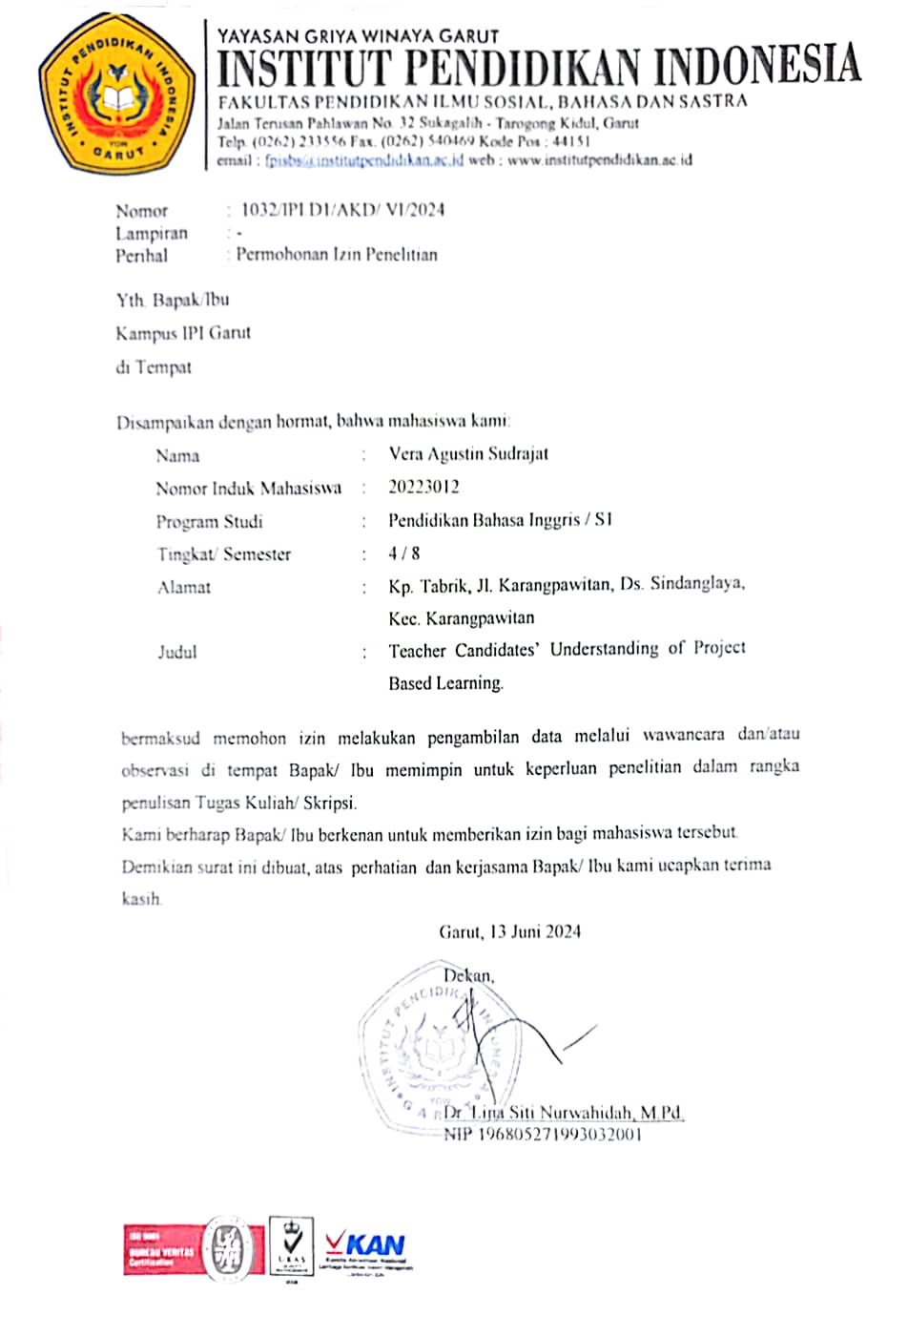

Dokumentasi

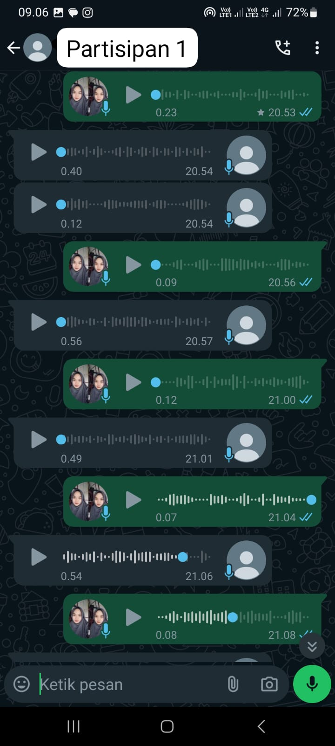
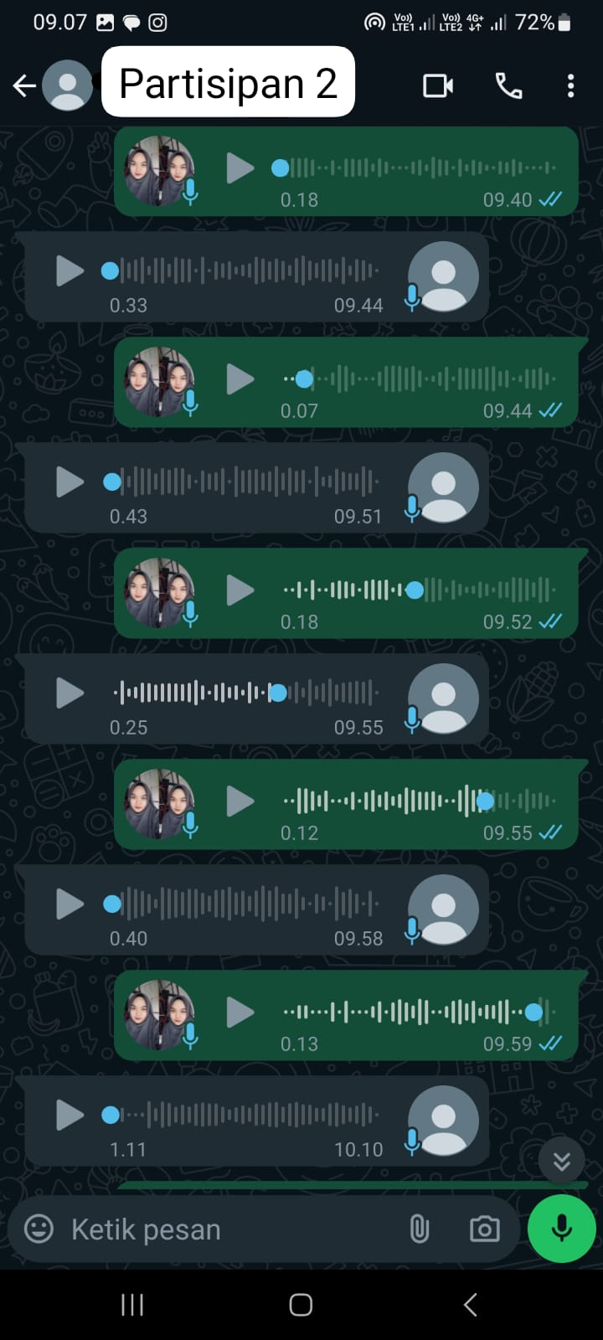
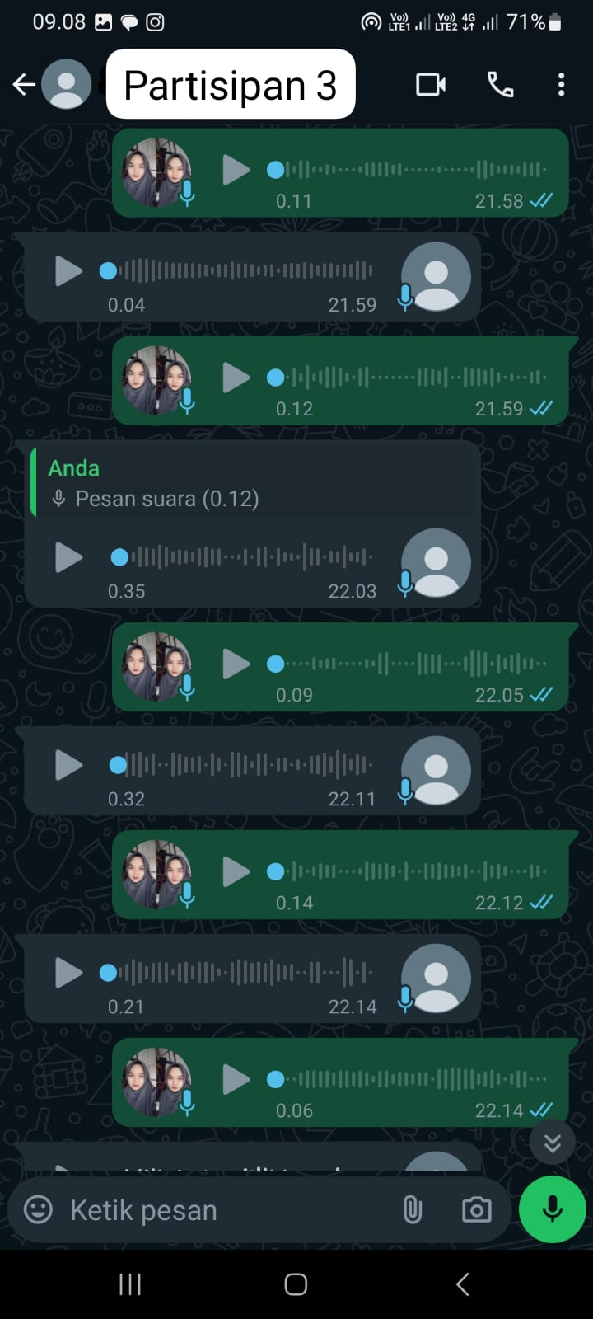
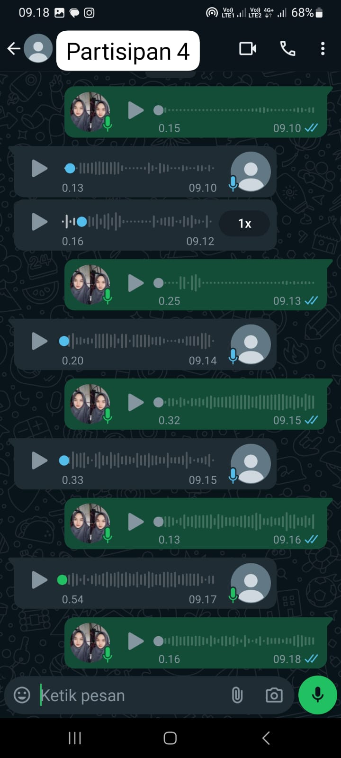
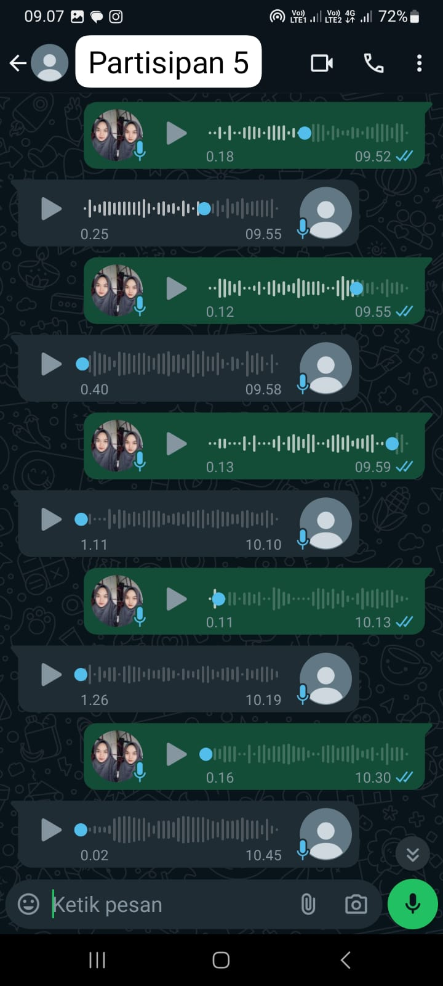
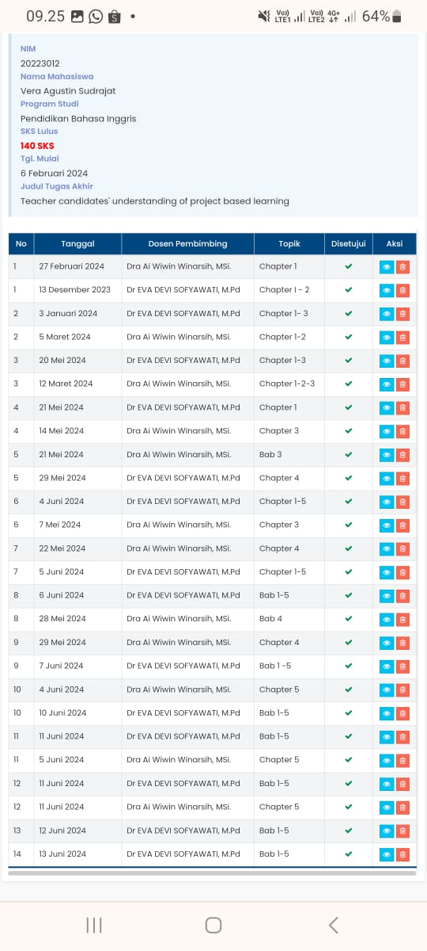

CURRICULUM VITAE

The writer's name is Vera Agustin Sudrajat. She was born in Garut, 24 August 2002. She is originally from Garut. she was a girl who studied at SDN Sindanggalih 1, continued her education at SMPN 3 Garut in 2014, then continued her education at SMAN 18 Garut and graduated in 2020. Then continued her studies at the Indonesian Education Institute (IPI) Garut, and took the English Language Education program . She also works as a volunteer teacher in the village, teaching elementary school. Then, she must graduate from the Indonesian Institute of Education in 2024 (S-1 Degree).

