THE USE OF DISCOVERY LEARNING MODEL TO DEVELOP STUDENTS’ SPEAKING SKILL IN SENIOR HIGH SCHOOL

A PAPER
Submitted to the English Education Program of IPI Garut as a Partial Fulfilment of the Requirements for Bachelor’s Degree in Education

By:
Neng Sri Mulyani
20222017



ENGLISH EDUCATION PROGRAM
FACULTY OF SOCIAL SCIENCE, LANGUAGE AND LITERATURE EDUCATION
INSTITUT PENDIDIKAN INDONESIA GARUT
2024

APPROVAL SHEET

THE USE OF DISCOVERY LEARNING MODEL TO DEVELOP STUDENTS’ SPEAKING SKILL AT SENIOR HIGH SCHOOL

By

Neng Sri Mulyani
NIM 20222017

Approved by:

First Supervisor Second Supervisor

Dr. Yustika Nur Fajriah, M.Pd. Anne Ratna S, M.Pd.
NIDN. 0412069004 NIDN. 0415038601

Acknowledged by:
Head of English Education Program

Anne Ratna Suminar, M.Pd
NIDN. 0415038601

LEGITIMATION OF EXAMINERS BOARD

THE USE OF DISCOVERY LEARNING MODEL TO DEVELOP STUDENTS’ SPEAKING SKILL AT SENIOR HIGH SCHOOL

By:
Neng Sri Mulyani
(20222017)

This paper has been examined on 30th of April 2024
First Examiner,  Irsyad Nugraha, M.Pd.  NIDN. 0408038304 | Second Examiner,  Dr. Eva Devi Sofyawati, M.Pd.  NIDN. 0409057803 | Third Examiner,  Anne Ratna S, M.Pd.  NIDN. 0415038601

Acknowledged by:
Dean of Faculty of Social Science,
Language and Literature Education

Dr. Hj. Lina Siti Nurwahidah, M.Pd
NIP. 196805271993032001

MOTTO

يُسْرًاۗ الْعُسْرِ مَعَ اِنَّ
Inna ma’al-‘usri yusra
“Indeed after difficulty there is convenience.”
(Q.S Al-Insyirah: 6)

PERNYATAAN
Dengan ini, saya menyatakan bahwa skripsi yang berjudul “THE USE OF DISCOVERY LEARNING MODEL TO DEVELOP STUDENTS’ SPEAKING SKILL AT SENIOR HIGH SCHOOL” ini benar-benar karya saya sendiri. Pengutipan dari sumber-sumber lain telah saya lakukan berdasarkan kaidah-kaidah pengutipan yang sesuai dengan etika keilmuan yang berlaku sehingga isi skripsi serta semua kelengkapannya ini merupakan karya asli. Apabila kemudian ditemukan hal-hal yang tidak sesuai dengan isi pernyataan saya ini, saya bersedia menerima risiko atau sanksi apapun.

Garut, April 2024
Yang Membuat Pernyataan,

Neng Sri Mulyani
NIM. 20222017

DECLARATION
The writer hereby conveys that this paper entitled "THE USE OF DISCOVERY LEARNING MODEL TO DEVELOP STUDENTS’ SPEAKING SKILL AT SENIOR HIGH SCHOOL" is really written by the writer and acknowledged as her own intellectual property. In accordance with the use of references, the quotations, and the citations of the related literatures have been conducted based on rightfully legal and scientific procedures. Therefore, the contents of this paper are an original work of the writer. In this case, if there are any complaints or if the writer breaks these statements, the writer will be fully responsible for all the consequences given.

Garut, April 2024

Neng Sri Mulyani
NIM. 20222017

PREFACE
Praise and deep gratitude to Allah SWT by His blessing and mercy, we are still given a chance to worship Him; peace and blessing be upon our prophet Muhammad SAW and also to his families, his friend, and to us as his loyal follower. By the blessing of Allah, the researcher has completed this paper entitled "The Use of Discovery Learning Model to Develop Students’ Speaking Skill at Senior High School".
The researcher realizes that this paper is still far from being perfect, there are many things that should be corrected both of its linguistics aspects and of its contents. For further improvement of this paper, comments and criticisms are expected. However, the writer hopes that this paper will be useful for further research.

Garut, April 2024

The researcher,

ACKNOWLEDGEMENTS
In the name of Allah the Beneficent the Merciful. All praise be to Allah Lord of the world, who has given strength and blessing for the writer to finish this paper entitled “The Use of Discovery Learning Model to Develop Students’ Speaking Skill at Senior High School”. Peace be upon our prophet Muhammad SAW, his family and companions.
In this glad opportunity, the writer would like to express her deepest gratitude and special thanks to:
- Dr. Nizar Alam Hamdani, M.M., M.T., as the Rector of Institute Pendidikan Indonesia.
- Anne Ratna S, M.Pd, as the Head of English Education Program of Institute Pendidikan Indonesia.
- Dr. Yustika Nur Fajriah M.Pd, as her first supervisor who has kindly and patiently given guidance, suggestion, advices, and corrections.
- Anne Ratna S, M.Pd, as her second supervisor who has kindly and patiently given guidance, suggestion, advices, and corrections.
- All the lecturers and staff members of the English Education Program of Institute Pendidikan Indonesia for their help.
- Thanks for her beloved mother (Hj. Eulis) and her beloved father (Alm. H. Aceng Sirojul Ulum) who have given their moral, material, support, and also their biggest love.
- Her brothers (Irham and Ripky Saeful Milah), and her sister (Iin Indriani) for their support.
- Her big family for their support.
- All her beloved friends (Alfushush Difla Athuroh, Mila Amelia, Japar Sidiq, Rika Hanifah, Putri Syifa Maulida, Hany Cima Safitry, Muhammad Ridwan, Shifa Aulia) and the classmates of B class, for support, togetherness, and memories.
- Also those people whose names are not mentioned one by one, thanks for help, kindness and motivation that given to her.
May Allah “Subhanallahu Wata’ala” bless them and their family. Finally, the writer realizes that this paper is still far from perfect. Therefore, if there are some suggestions to make this paper better, the writer will accept openly. At last, the writer hopes that this paper will give positive impact and be a valuable writing for others. Aamiin.

Garut, April 2024

The researcher,

ABSTRACT
This study aimed to investigate how the Discovery Learning model was employed in the high school classroom to enhance students' English language skills. To achieve this objective, a qualitative methodology with a case study research design was utilized. The study focused on an English teacher at a high school in Garut who had implemented the discovery learning model. The teacher actively participated in observations and semi-structured interviews. The data collected were analyzed qualitatively. The results revealed that the application of the Discovery Learning model in developing students' English language skills adhered to the principles and stages of discovery learning. However, students occasionally encountered difficulties when the teacher posed questions, leading to hesitancy in responding in English. In response to this challenge, the teacher provided guidance and encouragement to help students comprehend the questions and feel more confident in responding.
Keywords: Discovery learning, learning model, English speaking skill

ABSTRAK
Penelitian ini bertujuan untuk mengetahui bagaimana model Discovery Learning digunakan di kelas sekolah menengah untuk meningkatkan kemampuan bahasa Inggris siswa. Untuk mencapai tujuan ini, metodologi kualitatif dengan desain penelitian studi kasus digunakan. Penelitian ini difokuskan pada seorang guru bahasa Inggris di sebuah sekolah menengah atas di Garut yang telah menerapkan model discovery learning. Guru tersebut secara aktif berpartisipasi dalam observasi dan wawancara semi-terstruktur. Data yang dikumpulkan dianalisis secara kualitatif. Hasil penelitian mengungkapkan bahwa penerapan model Discovery Learning dalam mengembangkan kemampuan bahasa Inggris siswa telah mengikuti prinsip-prinsip dan tahapan discovery learning. Namun, siswa terkadang mengalami kesulitan ketika guru memberikan pertanyaan, sehingga menimbulkan keraguan dalam menjawab dalam bahasa Inggris. Menanggapi tantangan ini, guru memberikan bimbingan dan dorongan untuk membantu siswa memahami pertanyaan dan merasa lebih percaya diri dalam merespon.
Kata kunci: Discovery learning, model pembelajaran, keterampilan berbicara bahasa Inggris

TABLE OF CONTENTS
APPROVAL SHEET ii
LEGITIMATION OF EXAMINERS BOARD iii
MOTTO iv
PERNYATAAN v
DECLARATION vi
PREFACE vii
ACKNOWLEDGEMENTS viii
ABSTRACT x
ABSTRAK xi
TABLE OF CONTENTS xii
CHAPTER I INTRODUCTION 1
1.1 Background of the Study 1
1.2 Reasons for Choosing the Topic 4
1.3 Research Question 4
1.4 Research Objective 4
1.5 Scope and Limitation of the Study 4
1.6. Significance of the Study 5
1.7 Definition of Terminologies 5
CHAPTER II LITERATURE REVIEW 6
2.1 Discovery Learning 6
2.1.1 Definition of Discovery Learning 6
2.1.2 The Principles of Discovery Learning Model 9
2.1.3 The Step of Discovery Learning 10
2.1.4 Advantages and Disadvantages 11
2.2 Speaking 13
2.2.1 Definition of Speaking 13
2.2.2 Importance of Speaking 14
2.2.3 Characteristics of Speaking Skill 15
2.3 The Connection of Discovery Learning and Speaking Skill 16
2.4 Previous Studies 17
CHAPTER III RESEARCH METHODOLOGY 20
3.1 Research Method 20
3.2 Research Design 20
3.3 Research Setting and Participant 20
3.4 Technique of Data Collection 21
3.5 Technique of Data Analysis 21
3.6 Data Validation 22
3.7 Research Procedure 23
CHAPTER IV FINDING AND DISCUSSION 24
4.1 Research Finding 24
4.1.1 The Result of Observation in the Classroom 24
4.1.2 The Result of Teacher Interview 33
4.2 Discussion 34
4.2.1 Discussion of Observation in the Classroom 34
4.2.2 Discussion of Teacher Interview 34
4.3 Limitation 42
CHAPTER V CONCLUSIONS AND SUGGESTION 43
5.1 Conclusions 43
5.2 Suggestion 44
REFERENCES xiv
APPENDIX viii
APPENDIX 1 RESEARCH INSTRUMEN viii
APPENDIX 2 INTERVIEW TRANSCRIPT viii
APPENDIX 3 ADMINISTRATION LETTER viii
APPENDIX 4 DOCUMENTATION viii

CHAPTER I
INTRODUCTION
The researcher in this chapter covers the background of the study, the reason for choosing the topic, the research question, the research objective, the scope and limitations of the study, the significance of the study, and the definition of terminologies.

1.1 Background of the Study
The discovery learning model is a learning model that facilitates the acquisition of concepts, meanings, and relationships through an intuitive process, which ultimately leads to a conclusive understanding (Budianto, Azmi, and Putera 2021). The discovery learning model has distinct qualities, thus distinguishing it from other learning models. In particular, the process involves investigation and problem-solving to generate, combine and abstract information. In addition, student-focused tasks are used to integrate newly acquired knowledge with existing knowledge. The discovery model is an integral part of educational implementation, specifically as a heuristic learning approach. The model aims to engage students in active learning by encouraging them to lead, explore and reflect on their learning activities. Suminar and Meilani (2016) propose that students acquire knowledge by actively engaging in the application of concepts and principles. Students must engage in self-exploration to truly learn. Hajar (2017) outlines the stages of discovery learning as follows: 1) presenting a stimulus, 2) recognizing difficulties, 3) collecting data, 4) analyzing data, 5) verification, and 6) generalization.
The discovery learning model has numerous advantages in enhancing students' learning capacity. First, this model facilitates student learning through active participant listening in class (Mosca & Howard as cited in Castronova, 2002). In addition, students actively engage in expressing their thoughts and reinforcing learning concepts, hence enhancing student confidence (Febrian & Astuti as cited in Saptarini et al. 2022). Second, students engage in problem-solving by actively pursuing novel information. The inquiry learning model allows students to recognize existing problems or potential problems in the future and propose solutions based on their findings. Findings from processing data collected and obtained by students Burns and Ellis (1970) and Saab et al. (2005), as cited in Saidah (2020). Third, the discovery learning model engenders a sense of happiness and satisfaction among students when they engage in experiments facilitated by their collaborative efforts with their peers (Erdal & Ongel as cited in Balim, 2009). Fourth, the discovery learning model facilitates students' comprehension of fundamental principles and structure within scientific disciplines while also emphasizing the importance of autonomous student engagement (Nurdiansyah as cited in Asmara and Afriansyah, 2018). Lastly, the discovery learning model facilitates the application of learned knowledge to different contexts (Klahr & Nigam as cited in Cohen, 2008). In summary, students engage actively, experience satisfaction, demonstrate comprehension, exhibit independence, gain confidence, and directly resolve problems through the utilization of the discovery learning model. Students actively pursue new information as they engage in the learning process, which entails reflection, generation of ideas, investigation, and observation.
Nevertheless, there are still several issues in using the discovery learning model. The instructor mostly relies on traditional lecture and assignment methods and has not fully integrated active and creative learning techniques to engage students (Yuliana, 2018). Furthermore, both instructors and students continue to face difficulties in understanding and effectively applying this model (Khasinah, 2021). Furthermore, in order to concentrate on their acquired knowledge, pupils must possess the ability to effectively monitor and retain the techniques they have learned (Hajar, 2017). The implementation of the discovery learning model in the classroom is hindered by various factors within the current school system, such as standardized testing, class numbers, curriculum, and grade levels (Budianto et al., 2021). Furthermore, it is worth noting that a significant proportion of both students and teachers rely solely on verbal information. Additionally, previous research has not incorporated any specific listening model, such as discovery learning, which is widely regarded as a successful model. However, these models have not been widely utilized in listening pedagogy (Budianto et al., 2021). It is rare to find digital listening research that includes perspectives from both instructors and students when it comes to discovery learning in the context of English as a foreign language (Budianto et al., 2021). The inference is that there are still challenges associated with incorporating the discovery learning model into schooling.
Numerous researchers have concentrated their investigations on the influence of the discovery learning model on the process of learning. A comprehensive model for acquiring knowledge in all academic disciplines. Sunardi et al. (2019), Mardati et al. (2022), and Djono et al. (2018) their research centered on enhancing critical thinking skills in the learning process, as information uncovered throughout the search process is more memorable and easier to comprehend. In addition, Rahman (2017) and Handayani et al. (2017) conducted a study that specifically examined students' capacity for creative thinking in the classroom. Furthermore, Saban et al. (2022), Wahyuni & Rusijono (2015), and Puspitasari and Nurhayati (2019) conducted a study that specifically aimed to enhance classroom learning outcomes by utilizing this method to boost and augment student engagement and participation during class. Jana and Fatmawati (2020) in their study, specifically aimed to enhance students' problem-solving abilities in the subject matter covered during classroom instruction. In their study, Maruto et al. (2020) specifically investigate the application of this learning paradigm to enhance student learning outcomes in the classroom. In addition, Aristya et al. (2017) conducted a study specifically targeting the learning style, which was proven to have a significant influence on student motivation to learn in the classroom. Consequently, extensive research is being conducted on the discovery learning model.
A significant amount of research focuses on the implementation of Discovery Learning to enhance students' abilities in critical thinking, creative thinking, and problem-solving. Additionally, many researchers also investigate the impact of implementing the discovery learning model on learning outcomes, classroom effectiveness, and student motivation. Nevertheless, there is presently a scarcity of research on strategies to enhance student engagement in the classroom. A significant number of students become disengaged in their courses as a result of challenges in understanding and effectively implementing this model. The researcher must conduct a series of inquiries, each focusing on a distinct issue. This study aims to investigate the implementation of discovery learning in the instruction of speaking.

1.2 Reasons for Choosing the Topic
The reason for choosing this topic is that the researcher wants to find out how the discovery learning model is applied in learning and whether this model is effective for developing students' English language skills. It is a modern and innovative language teaching model that is in line with current educational trends and increases students' motivation by making the learning process fun and personally meaningful, which contributes to a sustained interest in developing English language skills.

1.3 Research Question
Based on the background of the problem that has been stated above, this study focuses on conducting empirical tests on the research problem:
“How is discovery learning implemented at senior high school level?”

1.4 Research Objective
Based on the problem formulation, this study aims to explore the use of the discovery learning model in students' speaking learning.

1.5 Scope and Limitation of the Study
The main focus of this research is limited to finding out the use of the discovery learning model in teaching and learning at senior high schools. This research focuses on the strategy of this learning model for students learning in the classroom by using the stages of discovery learning in teaching speaking.

1.6. Significance of the Study
The purpose of this study is to see how the discovery learning model is applied in learning for the development of speaking skills. The usefulness of this research is theoretically intended to enrich the understanding of language acquisition and teaching strategies. Practically, the findings from this study are expected to provide insights and references on how to improve English language teaching models, with potential practical implications for teachers, parents, and educational policymakers.

1.7 Definition of Terminologies
Based on the background of the problem stated above, the definition of terminologies includes discovery learning, learning model and speaking.
- Discovery Learning
The discovery learning is a learning strategy that promotes student inquiry, experimenting, and discovery (Bicknell-Holmes and Hoffman as cited in Castronova, 2002).
- Learning Model
Learning models organize learning experiences to achieve specific learning objectives and serve as guidelines for learning designers and teachers in planning teaching and learning activities (Malawi and Kandarwati as cited in Shaw, 2023).
- Speaking
According to Ladouse in Rokhayani and Cahyo (2015), speaking is an activity that is used to explain something to someone or to report something.

CHAPTER II
LITERATURE REVIEW
The researcher in this chapter provides an overview of this research. It includes the discovery of learning, the definition of discovery learning, the principle of discovery learning, the steps of discovery learning, advantages and disadvantages, speaking, the definition of speaking, the importance of speaking, the characteristics of speaking skills, the connection between discovery learning, and speaking skills, and previous study.

2.1 Discovery Learning
Discovery learning involves the presentation of incomplete material and requires students to be actively involved in discovering new, unknown concepts or principles. This model emphasizes students' proactive involvement in developing their learning through observation, experimentation and reflection procedures (Salmi 2019).

2.1.1 Definition of Discovery Learning
Discovery learning, as interpreted by various experts, encompasses a shared essence with distinct perspectives. First, Jerome Bruner (as cited in Rokhim, 2023) Discovery learning, according to Jerome Bruner, is a model that requires students to independently organize and solve problems, emphasizing the active role of learners in the learning process. Second, Richard (as cited in Rokhim, 2023) views discovery learning as a teaching model that engages students in mental activities such as discussions, seminars, and reading, fostering independent learning through the process of exchanging opinions and trying, enabling children to find knowledge on their own. Third, Bell (as cited in Rokhim, 2023) defines discovery as a learning process resulting from students manipulating, structuring, and transforming information, leading to the discovery of new knowledge through active engagement with the material. Fourth, Arends (as cited in Rokhim, 2023) characterizes discovery learning as a student-centered model that promotes active learning experiences. Students are encouraged to actively explore and express their ideas related to the topic being studied. Fifth, Hosnan (as cited in Rokhim, 2023) highlights discovery learning as a model designed to cultivate an active learning model where students discover and investigate for themselves, contributing to a deeper and more enduring understanding of the obtained results. Lastly, Rusman (as cited in Rokhim, 2023) describes discovery learning as a model that empowers individuals or groups to uncover knowledge based on their experiences actively, emphasizing the importance of active engagement and self-discovery. The consensus among various experts is that discovery learning is a dynamic process that prompts students to engage in creative thinking, motivating them to explore and acquire knowledge through a variety of experiences autonomously. This model underscores the importance of active participation, problem-solving, and the transformative aspects inherent in the learning journey.
Discovery learning is an educational model that prioritizes active and experiential learning opportunities for students (Dewey 1916-1997; Piaget 1954-1973, as referenced in Castronova, 2002). Bicknell-Holmes & Hoffmanin (Castronova, 2002) outline three main features of discovery learning:
- It involves exploration and problem-solving to generate, combine and apply knowledge.
- It involves student-led activities that match their interests, allowing them to determine the sequence and frequency of tasks.
- It includes activities that encourage the integration of new knowledge with the knowledge base students already possess.
The initial attributes of discovery learning are very important. Students actively engage in a process of inquiry and critical thinking to create, integrate and apply information through investigation and problem solving. Students improve their skills by engaging in activities that encourage them to take risks, solve problems, and explore new experiences rather than simply gaining knowledge through lectures or repetitive repetition. Bicknell-Holmes and Hoffman (as referenced in Castronova, 2002). Learning is more student rather than teacher, driven by this characteristic. The manifestation of this discovery of learning characteristics is significant.
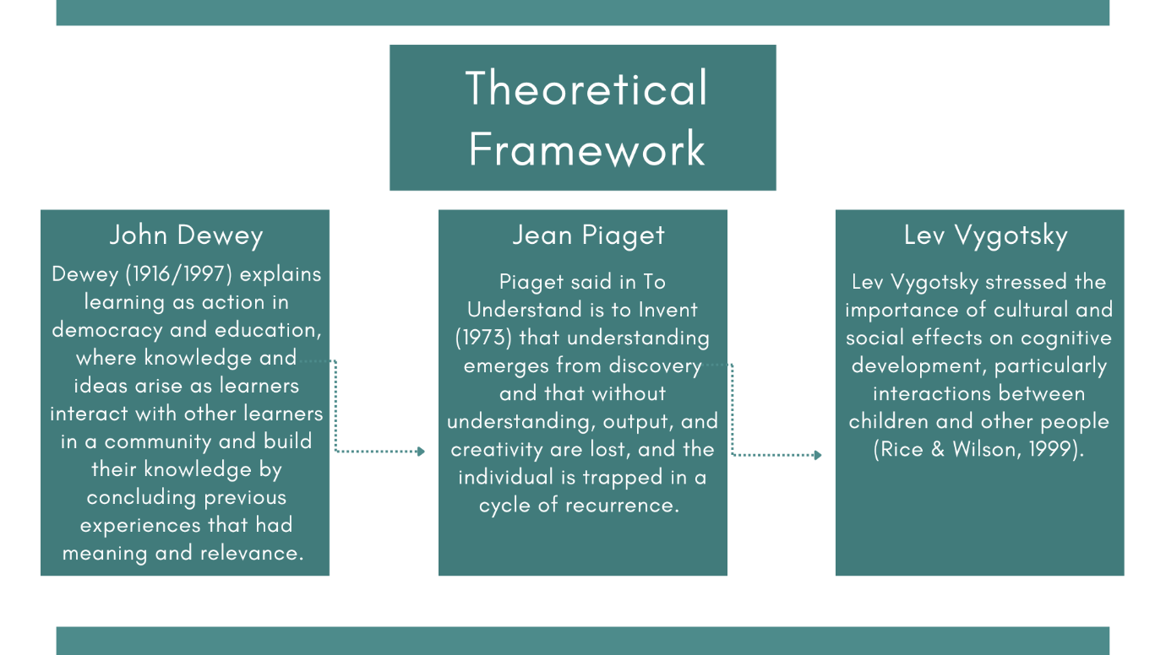

Figure 2.1 Theoretical Framework
The Discovery Learning model encourages active student involvement in the learning process by emphasizing discovery-based learning. Teachers ask students questions to facilitate the development of relationships, generalizations, or direct conclusions (Maruto et al., 2020). In addition, the guided discovery model is considered more effective because it assists students in fulfilling two important prerequisites in active learning: (1) activating or constructing knowledge to understand new information and (2) assimilating newly acquired information until they arrive at a correct. understanding (Tenenbaum et al., 2011; Leutner 1993 as cited in Rahman, 2017).
In short, the discovery learning model prioritizes learning activities that are engaging and hands-on for students. Three key attributes of this model include
- Study and problem solving,
- Student-driven activities aligned with their interests and
- Deliberate integration of new knowledge with pre-existing knowledge.
This model not only changes the conventional dynamic between instructors and students but also offers adaptability in learning pace, increases student motivation, and promotes the utilization of prior knowledge to build new knowledge. Applying a discovery learning model, particularly through a guided discovery model, can improve concept understanding and increase student engagement.

2.1.2 The Principles of Discovery Learning Model
The Discovery Learning Model incorporates the following five principles:
- Problem Solving.
Instructors should facilitate and inspire learners to integrate existing and newly acquired information and simplify their understanding to identify solutions. Learners are empowered to take control of their own learning, actively engage in the process, and apply their skills in a broader context through activities that encourage risk-taking, problem-solving, and inquiry (Pappas 2014).
- Learner management.
Instructors should give learners autonomy to choose between working independently or collaboratively and to progress at their own pace. The flexibility of the learning process allows for a dynamic and adaptable sequence of courses and activities, which minimizes unnecessary stress for learners and fosters a sense of ownership over their learning (Pappas, 2014).
- Integration and Connection.
Teachers should instruct students on the process of integrating existing knowledge with new information and motivate them to make connections with the real world. Existing situations serve as the foundation for acquiring new knowledge, motivating students to expand their understanding and uncover new insights (Pappas, 2014).
- Analysis and Interpretation of Information
Discovery-based learning emphasizes the examination and understanding of material rather than simply memorizing it. Instead of being concerned with a predetermined set of information, this approach regards learning as a continuous progression. Students acquire the skill of critically examining information rather than relying on memorizing accurate answers. Instead, they generate answers through a process of critical analysis and understanding of the available knowledge (Mirzoyan, 2021).
- Failure and Feedback
Discovery learning is as important as getting the right answer and the rewarding learning experience that comes from failure. Mistakes emerge as opportunities to understand what is effective and what is not. The coach has an important role in providing valuable feedback, ensuring that the learning process goes well and students gain significant knowledge from both their achievements and mistakes (Mirzoyan, 2021).

2.1.3 The Step of Discovery Learning
The discovery learning model consists of the following steps:
- Stimulation
At this juncture, students are presented with a comprehensive outline of circumstances that may lead to confusion and prompt them to inquire further, igniting a curiosity to go into deeper observation. The teacher provides instructions and poses inquiries or offers instructions for comprehending a book regarding the concept to be examined (Sinambela 2017 as referenced in Ridwan 2021).
- Problem Statement
In this scenario, the teacher permits pupils to recognize instances or events of challenges associated with the notion to be uncovered and subsequently choose one of the issues that may be formulated as a temporary hypothesis (Sinambela 2017, as referenced in Ridwan, 2021).
- Collecting data
This activity can be conducted by gathering extensive information through observations, investigations, experiments, studying educational resources, or engaging in conversations with knowledgeable others, and after that, taking appropriate actions (Sinambela 2017 as referenced in Ridwan, 2021).
- Data processing
At this stage, students analyze the data that has been gathered regarding the highlighted problem. Once the information and data have undergone processing, they are then interpreted (Rokhim, 2023).
- Verification
In this stage is the process of verification or providing evidence to confirm the accuracy or validity of something. Students meticulously analyze the processed and interpreted data, comparing it to the prepared hypothesis. The presence of similarities suggests that the hypothesis aligns with the analyzed data (Rokhim, 2023).
- Generalization
In the last stage, students are expected to derive conclusions or make generalizations based on their results. Once the hypothesis and processed data have been verified to agree, students are assigned the duty of formulating a comprehensive conclusion based on their results (Rokhim, 2023).

2.1.4 Advantages and Disadvantages
The advantages and disadvantages of the Discovery Learning model are as follows:
- Advantages of the Discovery Learning
- Promotes active student engagement in the learning process, fostering heightened attentiveness and participation (Mirzoyan, 2021).
- Encourages inquisitiveness and an innate inclination to investigate and comprehend topics (Mirzoyan, 2021).
- Encourages individual investigation to foster the development of lifelong learning skills (Mirzoyan, 2021).
- Enables individuals to tailor their learning experience, empowering them to personalize their approach to knowledge acquisition (Mirzoyan, 2021).
- Students are able to apply the principles and initial steps in problem-solving immediately. This approach facilitates targeted problem-solving, which can yield advantages for future endeavors (Nurcahyo et al., 2018).
- The discovery learning technique enhances students' breadth of knowledge (Rahmi & Dr. Ratmanida, 2014).
- The discovery learning strategy enhances pupils' vocabulary acquisition (Rahmi & Dr. Ratmanida, 2014).
- Disadvantages of Discovery Learning
- Students lacking a preliminary framework or basis for the subject topic may find it perplexing (Mirzoyan, 2021).
- The practical application is restricted, particularly when educational institutions solely depend on discovery learning for academic sessions (Mirzoyan, 2021).
- Consumes valuable time allocated for academic tasks, thus impeding the rate of learning (Mirzoyan, 2021).
- Teachers must be ready to make numerous corrections since self-discovered material may not always be true (Mirzoyan, 2021).
- Teaching and learning activities that incorporate the method of discovery learning require more time compared to direct instructional strategies. Comprehending this approach necessitates the possession of patience and proficient time-management abilities (Nurcahyo et al., 2018).
- The implementation of the discovery learning technique is time-consuming in terms of both preparation and learning (Rahmi & Dr. Ratmanida, 2014).
- The number of students. Due to the often huge number of students, it is often impractical to use discovery learning, especially while explaining a topic, as it is crucial to have individual interactions. Conversely, group contact is crucial for attaining the collective experiences of a group. Therefore, if the number of students is insufficient, the range of collective experiences would be restricted (Rahmi & Dr. Ratmanida, 2014).

2.2 Speaking
Speaking is an essential oral language ability that has a significant impact on our everyday lives. It functions as a potent instrument for communication, allowing us to express thoughts, ideas, and emotions efficiently. Speaking is not only useful but also essential for establishing and sustaining relationships, both in personal and professional contexts (Rokhayani & Cahyo, 2015).

2.2.1 Definition of Speaking
Researchers in language acquisition have put forth multiple definitions for the term "speaking." As per the Webster New World Dictionary, speaking refers to the act of articulating words verbally, engaging in communication through speech, making appeals, and delivering formal presentations (Nunan, as cited in Leong & Ahmadi, 2017). According to Chaney (as stated in Leong & Ahmadi, 2017), speaking is the process of generating and sharing significance through the use of both verbal and non-verbal symbols in various situations. Speaking can be defined as an interactive activity that involves creating meaning through the creation, receiving, and processing of information (Brown, 1994; Burns & Joyce, 1997, as quoted in Leong & Ahmadi, 2017).
Speaking, according to Bygate (as stated in Leong & Ahmadi, 2017), is the act of producing sounds that prompt various verbal reactions from listeners. This definition highlights the organized arrangement of sounds to create sentences with significance. Eckard & Kearny (1981), Florez (1999), Howard (2001), and Torky (2006), as stated in Leong & Ahmadi (2017), perceive speaking as a bilateral procedure that entails authentic exchange of viewpoints, information, or emotions. This perspective views spoken texts as a cooperative effort involving two or more individuals within a common timeframe and place.
Speaking is the act of generating and transmitting information using both spoken and non-spoken symbols in different situations. Speaking, or verbal communication, involves expressing thoughts, ideas, and emotions by articulating words, arranging them into coherent phrases or sentences, and using suitable vocabulary. Harwood (as referenced in Micheal et al., 2022) defines speaking as a unique form of communication that plays a fundamental role in all human relationships. Moreover, speaking is considered the main method of expressing and establishing one's identity. Essentially, the researchers defined speaking as the act of humans attempting to express their thoughts, emotions, and viewpoints, as well as share information, by using spoken statements.
Maryam and Reza (as cited in Micheal et al., 2022) assert that speaking plays a crucial role in the process of acquiring and instructing a second language. Language learning tactics should be employed to ascertain students' preferred learning styles in order to enhance their oral communication skills. This survey aims to examine and categorize the most probable tactics used by pupils, including memorization, cognitive, compensatory, metacognitive, emotive, and social methods. Teachers find it highly beneficial as it enables them to discern students' aptitudes and constraints, as well as determine suitable strategies to enhance their spoken language proficiency.

2.2.2 Importance of Speaking
In Effective communication is crucial for achieving success in all fields in the present-day global context. Language functions as a means of communication. Effective communication necessitates the use of language. Moreover, individuals are unable to achieve their goals and aspirations unless they engage in efficient communication. Linguistic proficiency is crucial for effective global communication. English, being a global language, enables effective communication between different regions, states, countries, and continents. (Rao, 2019). Rivers (quoted in Leong & Ahmadi, 2017) emphasized the widespread use of spoken language, noting that speaking happens twice as frequently as the combined activities of reading and writing. According to Brown (as stated in Leong & Ahmadi, 2017), listening and speaking are crucial strategies for language learners. Usmonov (as cited in Sudarmo, 2021) argues that in order to achieve advanced proficiency in verbal and written communication, students and the general public should acquire these foreign language skills.
Fluency in speaking is the most crucial aptitude for acquiring proficiency in a foreign or second language. Speaking is commonly recognized as the most important among the four primary language skills for acquiring proficiency in a foreign or second language. As stated by Brown and Yuke, According to Brown and Yuke (as referenced in Rao, 2019), students are most commonly evaluated on their speaking skills in real-life circumstances. Although speaking talents are crucial, the instruction of speaking skills has been underestimated by the majority of teachers.
Continuing to instruct in the development of speaking abilities by means of memorizing conversations or engaging in repetitive exercises. Proficiency in speaking is acquired and developed as a crucial aspect of utilizing a language as a means of communication. According to Brown (as cited in Ratih et al., 2017), there is a strong and inseparable connection between speaking talents and communication, and they mutually reinforce each other. The correlation between verbal communication and one's ability to effectively convey information is particularly significant in the context of interpersonal dialogue. Oral communication is the predominant skill employed in the classroom to promote active participation. Proficient speaking skills are highly advantageous in various social contexts, such as initial encounters with unfamiliar individuals, since they facilitate the creation of favorable impressions. Additionally, these skills are crucial in cultivating and sustaining professional connections inside the workplace. Effective communication plays a crucial role in language acquisition as it enables us to assimilate linguistic knowledge that would otherwise be beyond our ability to generate.

2.2.3 Characteristics of Speaking Skill
According to Mazouzi (as cited in Leong & Ahmadi, 2017) suggests that the design of learners' activities should focus on establishing a harmonious combination of fluency and accuracy, which are both essential elements of the communicative method. The effectiveness of classroom methods in developing learners' communicative competence relies on a thorough understanding of how the language system operates. Oral communication is an essential skill that students must acquire in order to interact in various situations properly. Brown (quoted in Riadil, 2020) highlights several speaking features that contribute to the difficulty of speaking, including colloquialisms, performance elements, reduced forms, velocity of delivery, redundancy groups, intonation, rhyming, and emphasis. The main objective of teaching speaking skills is to attain fluency, which is defined by Hughes (as referenced in Leong & Ahmadi, 2017) as the learners' capacity to express themselves clearly without interrupting communication while also maintaining the listener's interest. Additionally, fluency encompasses the ability to provide cohesive and connected responses, pronounce sounds clearly, and effectively utilize stress and intonation.
A strong command of grammar is crucial. Minimizing errors during speech improves speaking proficiency. Undoubtedly, as individuals learning a second language, we must get a high level of proficiency in the primary verb tenses. The last ability to be discussed is pronunciation, which is a complex topic. The sub-skills of pronunciation encompass word and phrase stress, intonation, rhythm, and enunciation (Micheal et al., 2022). Pronunciation, which Thornbury (as cited in Leong & Ahmadi, 2017) has identified as the most basic aspect of language that learners often focus on, is essential for speaking English accurately. In order to communicate in English accurately, individuals must acquire a thorough understanding of phonological principles, familiarize themselves with different phonetic sounds and their corresponding pronunciations, and comprehend aspects such as stress, intonation, and pitch. Mastery of these elements collectively allows learners to communicate in English effortlessly and efficiently.

2.3 The Connection of Discovery Learning and Speaking Skill
The discovery learning model is beneficial for enhancing students' communication skills since it provides them with ample opportunities to engage in conversation. PG Dikdas (as cited in Khasinah, 2021) outlines that the process of discovery involves observation, classification, measurement, prediction, determination, and inference. The procedure above is referred to as the cognitive process, which entails the mental assimilation of concepts and principles. The procedure above is referred to as the cognitive process, whereas discovery itself entails the mental process of incorporating thoughts and principles into the mind. The discovery learning model also includes a series of phases. 1). Stimulation (stimulation) refers to the act of providing a stimulus or provoking a response. 2). Problem identification (problem statement) involves clearly defining and articulating the issue or challenge at hand. 3). Data collection (data collection) refers to the process of gathering information or facts for analysis and interpretation. 4). Data processing, where the collected information is analyzed and organized. 5). Verification, where the accuracy and validity of the findings are checked. 6). Generalization, where the overall results and implications are summarized. To effectively communicate in English, students require behavioral cues that demonstrate confidence. Implementing the discovery learning model can enhance student confidence levels (Yuliati & Susianna, 2023).

2.4 Previous Studies
This section discusses several studies on the discovery learning model that have been conducted by previous researchers with different focuses. Examples are discovery learning as a learning model used to improve students' critical thinking skills, as an approach in teaching, and others. Here are some previous studies related to this research.
The first research conducted by Sunardi et al. (2019) was entitled "Discovery Learning Method for Training Critical Thinking Skills of Students." The researcher focused on the use of the discovery learning model by training students to think critically through the stages of this learning model. Then the results showed that the discovery learning model in the learning process was able to train students' critical thinking skills because what was found in the search process would be more memorable and easier to form an understanding.
The second study conducted by Rahman (2017) entitled "Using Discovery Learning to Encourage Creative Thinking." The researcher focused on the application of the discovery learning model in learning and teaching strategies to encourage students' creative thinking. The results of this study indicate that the discovery learning model can encourage students' creative thinking skills in teaching and learning strategies courses.
The third research conducted by Puspitasari and Nurhayati (2019) entitled "The Effect of Discovery Learning Model on Student Learning Outcomes". The researchers focused on the effect of the discovery learning model on student learning outcomes. Learning outcomes are changes that occur in students in both cognitive, affective, and psychomotor aspects as a result of learning activities. The results showed that the results of the research conducted as a whole were supported by accurate data that there was an influence of the discovery learning model on student learning outcomes.
Another study was conducted by Jana and Fatmawati (2020) entitled "Model Discovery Learning Untuk Meningkatkan Kemampuan Pemecahan Masalah." The researchers focused on using the discovery learning model to improve students' ability to solve problems. The results showed that discovery-based learning proved effective in improving students' problem-solving skills. The results of the research obtained are the achievement of a high category in the application of the Discovery Learning model, the average test score for each cycle has increased, and the score for each aspect of mathematical problem-solving ability has increased.
The last research was conducted by Putri, Lesmono, and Aristya (2017) entitled "Pengaruh Model Discovery Learning Terhadap Motivasi Belajar dan Hasil Belajar Fisika Siswa MAN Bondosowo." The researchers focused on the effect of discovery learning on student learning motivation and determined the effect of the discovery learning model on student learning outcomes. The results showed that the discovery learning model had a significant effect on student learning motivation in learning and a significant effect on student learning outcomes in learning.
In addition, this section also discusses research on the discovery learning model that has been conducted by previous researchers with the same focus. For example, discovery learning as a learning model is used to describe the effect of using the discovery learning model on the understanding of speaking material. The following are previous studies related to this research.
The research conducted by Pirdayanti et al. (2022) entitled "The Impact of Video-Based Discovery Learning Towards Young Learners' Speaking Skill During Pandemic COVID-19." The researcher focused on investigating the impact of discovery learning-based videos on young learners' speaking skills during the COVID-19 pandemic. The results showed that there was a significant positive impact of video-based discovery learning on learners' speaking skills during the COVID-19 pandemic. This previous research has the same focus, namely the discovery of learning speaking skills, which distinguishes this research from this research, namely that this research focuses on developing speaking skills.
The research was conducted by (Rasyid et al., 2021) entitled "The Effect of the Discovery Learning Method on Students' Learning Results and Understanding Speaking Materials." The researcher focuses on describing the effect of using the discovery learning method on student learning outcomes for understanding speaking materials. Then, the results show that the use of the discovery learning method has a significant effect on student learning outcomes in understanding speaking materials. This previous research has the same focus, but this previous research focuses on understanding speaking material using discovery learning, while this research focuses on developing speaking skills using discovery learning.
In conclusion, the research discussed collectively emphasizes the positive impact of discovery learning models on various aspects of student skills and outcomes. However, this research is different from previous studies that have been reviewed. In this study, researchers analyzed the use of the discovery learning model in English as a foreign language class. The focus of this research is on the use of discovery learning models in teaching English in high schools. This research is different from other research because most of it analyzes students' critical thinking abilities. Meanwhile, this research focuses on describing how the discovery learning model is used in teaching English speaking in high schools.

CHAPTER III
RESEARCH METHODOLOGY
The researcher in this chapter explains the research method, research design, research setting and participants, technique of data collection, technique of data analysis, data validation, and research procedure.

3.1 Research Method
The method used in this research was qualitative. The reason for choosing a qualitative research method was because this method was in accordance with the research objectives, namely to gain an understanding of a particular case study by investigating, providing solutions, and analyzing phenomena that exist in an environment. Additionally, qualitative research collects information about individuals' experiences, perceptions, and behavior. This review introduces readers to some basic qualitative research concepts, definitions, terminology, and applications (Brannan et al., 2022). Therefore, this qualitative research method was used because it suits the objectives of this research.

3.2 Research Design
The design of this research was a case study. The reason for using this research design was because the research is conducted with a more in-depth examination of the intricacies of a complex phenomenon by involving the research population and offering an extensive description of the process and qualitative results from their perspective (Ellis & Hart, 2023). Therefore, this research design was in accordance with the research objective, namely to conduct deeper research into the specific conditions of using the discovery learning model in teaching speaking skills.

3.3 Research Setting and Participant
The setting of this research was one of the senior high schools in Garut, where the teacher who teaches English in this school has used the discovery learning model. Moreover, the participant in this study was English teacher. The selection of participant used purposive sampling. The selection in this study was done by

choosing English teacher who have implemented the discovery learning model in teaching English in the classroom.

3.4 Technique of Data Collection
In this part, the researcher outlines the techniques used to collect data. Data collection was conducted using observation and interviews.
- Observation
In this study, data collection used observation. The observations made in this study were based on theories relevant to the research. Systematic observation was used, where observations are made in a planned and systematic manner, often using a checklist or specific format. This observation was carried out with the aim of obtaining conclusions about the observed object and is carried out systematically, structured, and according to predetermined procedures. As emphasized by Adler and Adler (as cited in Hashanah, 2017), observation has a fundamental position among data collection methods in qualitative research, especially in the context of social sciences and human behavior studies.
- Interview
In this study, data collection used semi-structured interviews were used as a data collection strategy because this instrument allows researchers to get more in-depth information because, in addition to prepared questions, the interviewer can also explore the topic more broadly. According to Wallen (as cited in Sumarni et al., 2018), the purpose of an interview was to find out what was on someone's mind, what they believed, and how they felt. Furthermore, interviews are useful in detecting misconceptions since they might disclose in-depth comprehension (Gurel et al., as cited in Sumarni et al., 2018).

3.5 Technique of Data Analysis
In analyzing the data, the researcher used inductive analysis. The inductive approach was commonly used in qualitative data analysis (Hsieh and Shannon, as cited in Zhang and Wildemuth, 1998). The researcher chose this technique because it can provide deep insights into the dynamics and patterns that emerge from observational data and semi-structured interviews suitable for qualitative research. In addition, the use of analysis in this inductive way is because it avoids manipulation of research data so that based on new data, it is adjusted to the theory. The analysis process undertaken by the researcher comprised two distinct stages:
- Descriptive
The descriptive stage, the main purpose of which was to provide a comprehensive picture of the impact of discovery learning implemented on the development of English-speaking skills. Furthermore, the application of the descriptive approach in this case study, as defined by Whitney (as cited in Fajarwati, 2011), is the search for facts with suitable interpretation.
- Interpretive
In the interpretation stage, the researcher aims to explain the intent and impact seen in each category. Inherently interpretive, qualitative research offers your personal and theoretical perspective on the topic (Hsieh and Shannon, as cited in Zhang and Wildemuth, 1998). Through interpretation, data was carefully organized and structured to reveal patterns of relationships, enhancing overall understanding. In addition, humans create meaning from their experiences in life, which enables interpretation to make sense of the facts (Anderson, 2017; Rose & Johnson 2020, as cited in Ellis and Hart, 2023).

3.6 Data Validation
To test the validity of data related to the use of the discovery learning model to develop students' speaking skills at senior high school using consistency checks, the step used is to check and compare the information obtained. Checking how the teacher's knowledge about the use of the discovery learning model to develop students' speaking skills at senior high school is validated by conducting observations and semi-structured interviews. Then compare the results of observation data with interviews to determine whether they are appropriate or not. After that, they are associated with relevant theories. The step of preparing data for validity is needed in research with the intention of proving and strengthening that the series of data obtained by researchers is in accordance with what happened in the field.

3.7 Research Procedure
The research process was conducted in several stages. First, the researcher looked for a school where the English teacher had used the Discovery Learning model. Then, the researcher asked permission from the school concerned to conduct research, made an agreement, and asked permission from the English teacher to conduct research. Then, the researcher researched on February 1, 2024, namely observation and interviews. Observation—that is, the researcher observed the English subject class to collect data, and the teacher became the object of research. After that, the researcher conducted interviews, in which the researcher interviewed teachers who had used the discovery learning model to strengthen data collection. After the data collection process was completed, the researcher said goodbye and thanked the teacher for being willing and allowing the research to be conducted. Finally, the researcher processed the data that had been found in written form.

CHAPTER IV
FINDING AND DISCUSSION
In this chapter, the results of observation and interview data have answered the research question, namely, how to use the discovery learning model to develop students' English-speaking skills at senior high school. In addition, the research results are discussed in the research discussion.

4.1 Research Finding
In this section, the researcher discusses and presents the results of observations and interviews to answer the research questions. There are two parts to this section. The first part of the observation results focuses on the use of the discovery learning model in teaching and learning English in high school. The second part of the interview results focuses on whether the use of the discovery learning model could develop students' speaking skills. The participants are teachers who teach using the discovery learning model.

4.1.1 The Result of Observation in the Classroom
This part discusses how to use the discovery learning model in class and the principles and stages of discovery learning.
4.1.1.1 Principles of Discovery Learning
The findings show that there are five principles in teaching and learning using the discovery learning model, including;
- Problem Solving
In the principle of problem-solving, the teacher provided opportunities for students to take risks and involve themselves in investigations to find solutions. This principle was carried out by giving students tasks or problems and giving them opportunities to find answers or solutions independently. The teacher did this principle in the study. The teacher asked, "Why was the beach called pink?" Students actively answered questions from the teacher. Students answered, "Because the beach sand is pink". However, there were still students who had difficulty answering the questions given by the teacher.
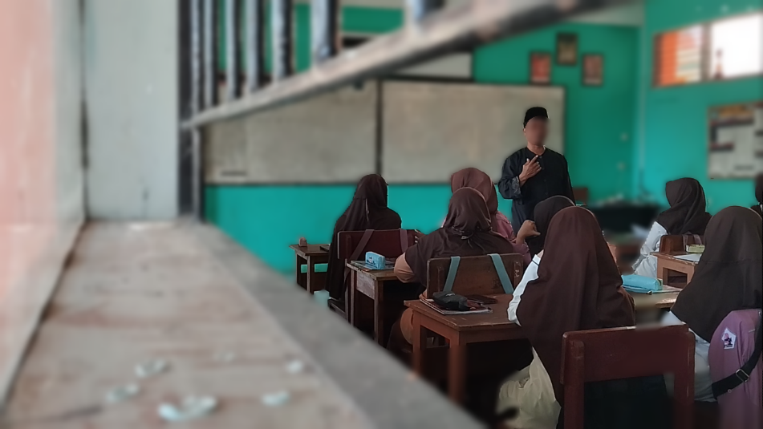
Figure 4.1 Problem Solving
- Learner Management
In the principle of learner management, the teacher gave freedom to students to choose whether to learn in groups or alone. He also allowed students to learn at their own pace when studying material about descriptive text. The teacher implemented this principle in facilitating the learning process. The teacher said, "Well, then I will give you an assignment. Do you want to work in groups or individually?" Students chose to work together in groups when completing the task and said, "Okay, sir, we are in a group." The teacher gave permission and supported the choice. This principle could also stimulate collaboration between students and enrich their learning experience.
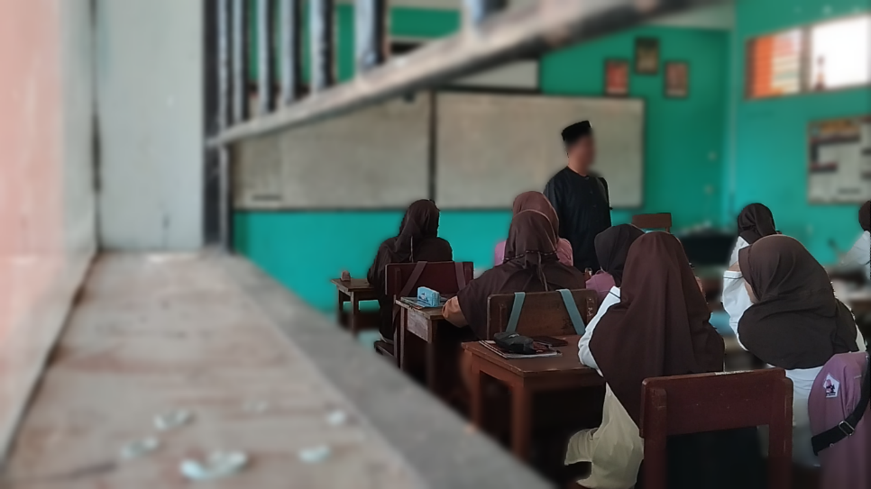
Figure 4.2 Learner Management

- Integration and Connection
In the principle of integration and connection, when teaching descriptive texts with the theme of the pink beach, the teacher combined students' existing knowledge about beaches with new information about the pink beach. This principle aimed to encourage students to connect their existing knowledge with unfamiliar concepts, facilitating the expansion of their understanding of the world around them. The teacher accomplished this by incorporating effective teaching strategies. The teacher asked, "If you had been to the beach, which beaches have you visited?" Students actively participated in answering the teacher's question by sharing their personal experiences. Furthermore, the teacher complemented the interaction by providing additional knowledge. This principle created an interactive learning atmosphere where collaboration between teachers and students resulted in an exchange of ideas and deeper understanding.
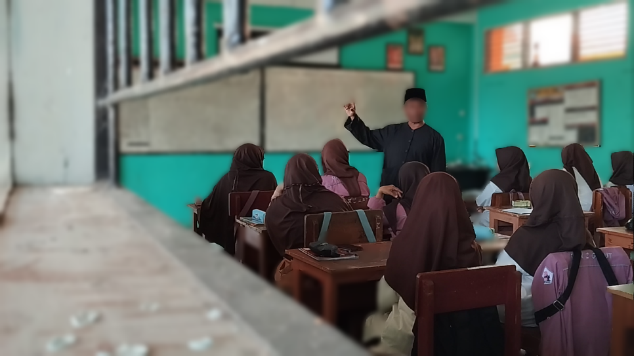
Figure 4.3 Integration and Connection
- Analysis and Interpretation of Information
In the principle of analyzing and interpreting information, the teacher asked questions about the descriptive text, and students answered the teacher's questions with the results of their analysis, interpreting the information about the pink beach they had read and understood. Students were able to interpret it not only by memorizing the correct answers but also by understanding the content they encountered in learning. The students achieved this principle during the classroom research. The teacher asked, "Where did the pink color come from?" students actively responded, "The pink color of the beach was a mixture of the color of the white beach sand mixed with coral flakes, shells, calcium carbonate from very small marine invertebrates, and also Foraminifera, microscopic amoebas that had red shells." Students answered the question based on their understanding. This principle provided space for students to express their comprehension, creating a reflective and participatory learning environment.
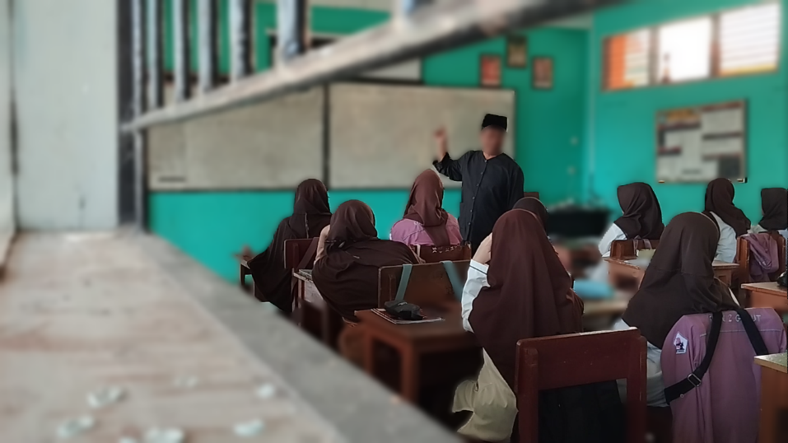
Figure 4.4 Analysis and Interpretation of Information
- Failures and Feedback
In the principle of failure and feedback, the teacher provided an understanding that learning did not only occur when finding the correct answer but also through failure. The teacher also provided constructive feedback because, without feedback, learning is incomplete. The teacher did this principle in the study. The teacher said, "In the pronunciation of 'island,' not 'is-land,' okay, repeat." The teacher gave an example of the wrong pronunciation uttered by the students, and the students could well follow and correct the pronunciation. This principle provided an opportunity for students to actively participate in developing their speaking skills through hands-on learning and proper practical understanding.
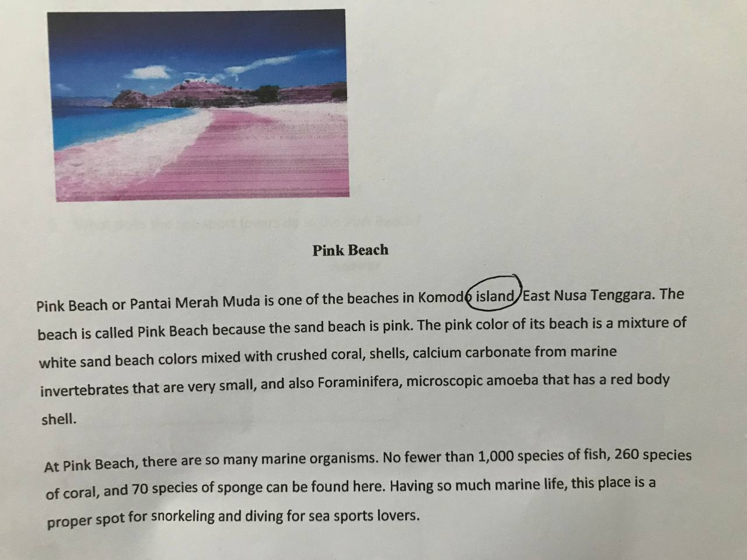
Figure 4.5 Failures and Feedback
4.1.1.2 Stages of Discovery Learning
The findings show that there are six stages in teaching and learning using the discovery learning model, including;
- Stimulation
In the stimulation stage, learning began with the teacher asking questions to assess students' prior knowledge about the descriptive material with the theme of the pink beach. The teacher posed questions about beaches to determine whether or not students were already familiar with the pink beach that would be studied. The teacher said, "Okay, students, it has been a long time since we have not seen you here. Where do you go when you are on holiday?" However, some students did not respond to the question. Teachers needed to create a supportive environment so that every student felt comfortable participating without fear of judgment, aiming to build their confidence in speaking in class.
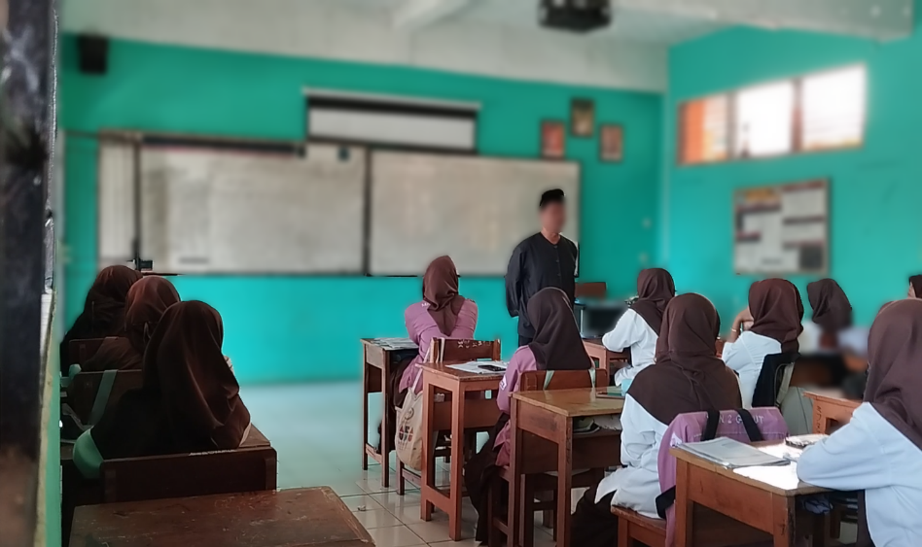
Figure 4.6 Stimulation
- Problem Statement
In the problem formulation stage, the teacher posed a question about beaches in general before presenting students with a descriptive text centered around a pink beach. The students were then afforded the opportunity to tap into their existing knowledge about beaches. Moreover, they were asked to supply tentative answers pertaining to the conclusions drawn from the questions posed by the teacher. The teacher said, "So, the beach we know is blue. However, it turns out there are so many kinds of colors of beaches. So, the beach is colorful, for example, like?" Students participated in this process by answering the teacher's questions using the knowledge they already had. This stage not only strengthened students' understanding but also promoted active classroom interaction.
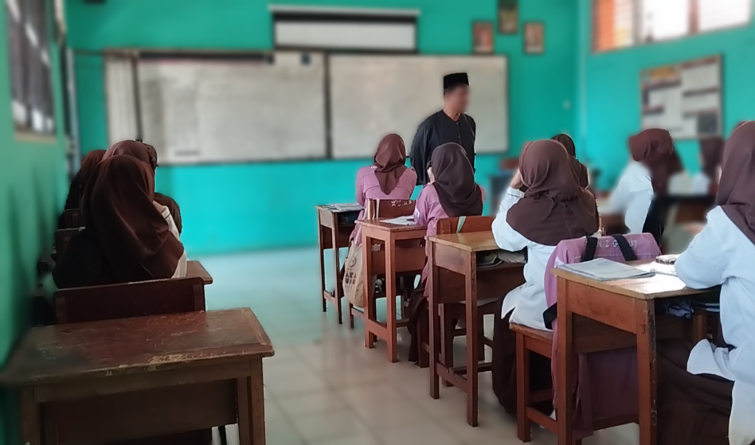
Figure 4.7 Problem Statement
- Data Collection
The data collection stage was carried out by allocating time for students to read descriptive texts with the theme of pink beach that had been distributed in groups. This stage allowed them to analyze and comprehend the information about the pink beach. The teacher said, "Okay, I will give you the text, then you read it, answer the questions first, and then we will discuss it together." Students collaborated with their groups to collect data from the descriptive text provided by the teacher. However, obstacles arose because the reading text was limited, preventing all students from fully understanding the material within the restricted time given by the teacher.
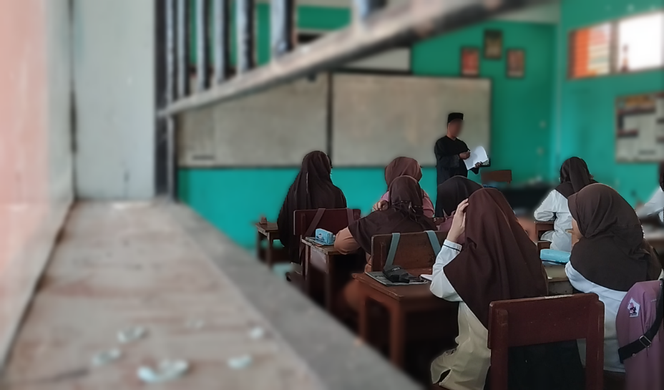
Figure 4.8 Data Collection
- Data Processing
In the data processing stage, data analysis was conducted through discussion. The teacher appointed one student to attempt to answer the question about the pink beach based on the descriptive text that students had read and encouraged others to respond as well. Additionally, the teacher inquired about any difficulties students encountered in understanding the descriptive text material. If any challenges were identified, the teacher's role was to assist students in overcoming these obstacles. The teacher said, "You got it? Okay, I have a question: where is the pink beach location?" Although some students actively responded to

the teacher's questions in English after receiving the descriptive text, there were still students who did not answer, possibly due to a lack of full comprehension of the text's content.
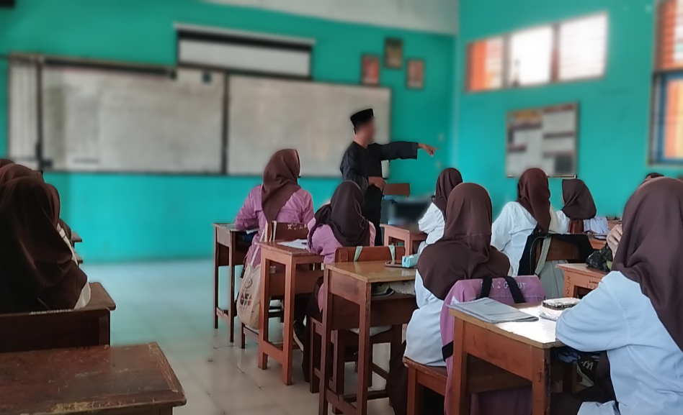
Figure 4.9 Data Processing
- Verification
At the verification stage, the teacher played a crucial role in elucidating the descriptive text that students had read. Following the teacher's inquiry, students were prompted to address any misconceptions or inaccuracies in their comprehension of the material during the analysis of the descriptive text. The teacher had explained the material and asked “Okay students, what are we learning about?" then correct the misconception teacher said, "In the pronunciation of 'island,' not 'is-land,' okay, repeat." The teacher, with wisdom, provided guidance when students made mistakes in pronunciation and offered correct examples as a guide. This stage helped students improve their pronunciation by providing effective guidance.
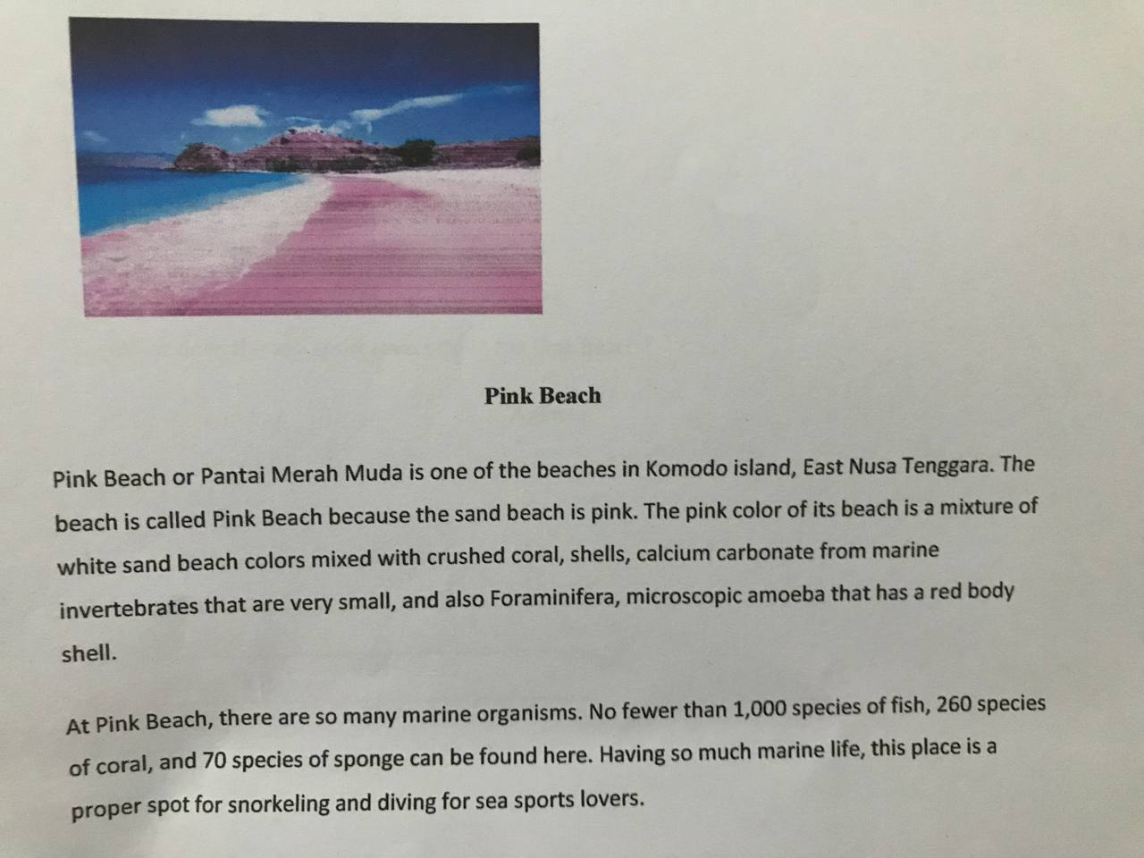
Figure 4.10 Verification
- Generalization
The generalization stage was conducted with the teacher asking students to draw conclusions based on the verification results obtained from their understanding of the descriptive text material themed around pink beaches that they had encountered during the learning process. The teacher encouraged students to raise their hands if they wished to attempt summarizing the material they had learned. The teacher said, "Okay students, try to summarize the material you have studied today." However, there was a tendency for the teacher to provide limited opportunities for many students to conclude the material independently.
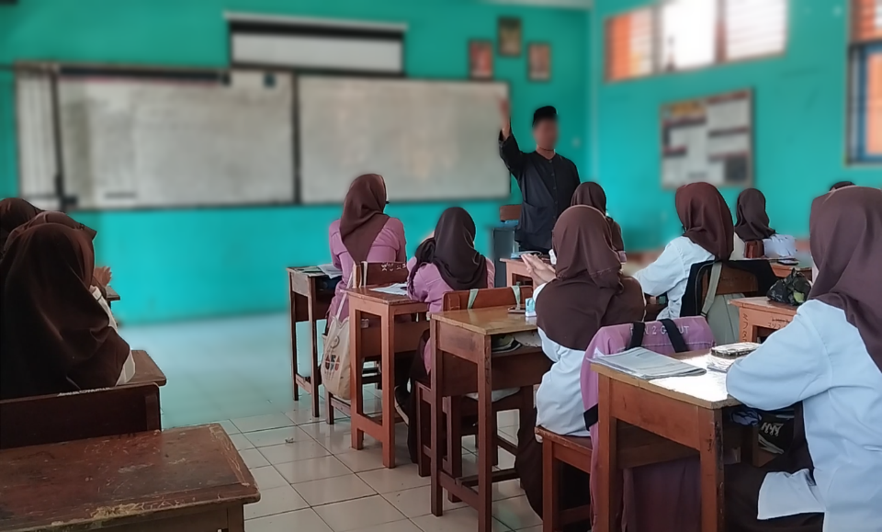
Figure 4.11 Generalization

4.1.2 The Result of Teacher Interview
This part would discuss the use of discovery learning model in classroom learning to develop students speaking skills.
4.1.2.1 The Use of Discovery Learning Model in Classroom Learning to Develop Students' Speaking Skill.
This finding showed that the use of a discovery learning model for the development of students' speaking skills was assumed to be good. By following the principles and stages of the discovery learning model, students were given the opportunity to express their opinions orally, encouraging active participation in the learning process. The teacher played a key role by providing constructive feedback when students made mistakes in pronunciation and gave examples of correct pronunciation to rectify the errors. This model helped students improve their speaking ability in English and also provided hands-on experience in language use.
“Well, first we ask questions to brainstorm with students; after being caught, we also provide parables so that students will understand what we will explain. Well, after that, for example, because the teacher's own questions are about speaking activities, students also answer with speaking activities using English. Then the level of curiosity is high; for example, there is what we said earlier about Pink Beach. Finally, we gave the text, but it turns out that it is located on Komodo Island. So it turns out that on Komodo Island, there is a beach, so their curiosity about the pink beach was resolved. There is also something that happens, so he continues the answer, but we just lure what is the easiest word according to him, so it's like, why is it pink? Why do you know that the beach is coloured? Students answer because it turns out there are micro-amoebas. So like that, if there is something wrong in the pronunciation, we correct it and give direction on how to say it correctly.".”.
Additionally, the findings also showed that the use of the discovery learning model in learning could make the development of students' speaking skills more effective because, in discovery learning, students had to be active.
“Yes, it's really good to improve because the students are active.”.
The use of the discovery learning model in English language teaching and learning had various advantages, with one of the main benefits being that it encouraged students' active involvement in the classroom. This model brought excitement to learning, which, in turn, contributed to the effective development of students' speaking skills.

4.2 Discussion
This section provides an analysis of the research results. The study investigates the application of the discovery learning model for enhancing high school students' speaking skills. Through observations and interviews, several key findings emerged from this research. The initial discovery pertains to observations, which are categorized into two aspects: the principles of discovery learning and the stages involved in the process. The second finding is related to the interview, where the teacher explained how the use of the discovery learning model contributes to and is applied to learning to develop students' speaking skills.

4.2.1 Discussion of Observation in the Classroom
In this section, discuss the results of classroom observations, which are divided into two discussions, the first relating to the principles of discovery learning and the second relating to the stages of discovery learning.
- Principles of Discovery Learning
- Problem Solving
From the findings above, it can be observed that the principle of problem-solving was implemented by the teacher, who presented a problem to the students and tasked them with solving it or finding a solution based on their understanding. The statement is consistent with Pappas (2014), who emphasizes that teachers should offer guidance and inspiration to motivate learners to discover solutions. This principle involves integrating both existing and newly acquired information, ultimately simplifying complex knowledge. Such an approach empowers learners to take charge of their learning journey, actively engage in their education, and extend the applications of their skills through activities that encourage risk-taking, problem-solving, and inquiry. Through this approach, learners not only absorb information but actively contribute to shaping their understanding and applying their knowledge in various meaningful contexts. Moreover, Lynch (2023) stated that educators should have inspired and encouraged students to explore solutions by integrating familiar and new content while simplifying complex information. Learners became catalysts for their learning when they actively participated in creating broader applications of skills through activities that encouraged risk-taking, problem-solving, and thorough exploration.
- Learner Management
From the findings above, it is evident that the principle of learner management was implemented by the teacher, who provided students with the freedom to choose whether to study individually or in groups. Additionally, the learning process was tailored to the student's pace, emphasizing individual progress. This principle is in line with Pappas (2014), who suggested that teachers should have granted learners the flexibility to work independently or collaboratively, adapting to their pace of learning. This flexibility transformed the learning experience from a rigid sequence of lessons into a dynamic and adaptable process. It alleviated undue stress for learners and fostered a sense of ownership over their educational journey. Empowering learners with the autonomy to choose their learning approach encouraged a more personalized and meaningful engagement with the material, promoting a positive and self-directed learning environment. Moreover, Mirzoyan (2021) stated that by facilitating easier learner management, discovery learning allowed participants to collaborate with peers or progress independently at their preferred pace. This flexibility not only reduced undue stress but also fostered a higher sense of personal ownership during the learning journey.
- Integration and Connection
From the findings above, it is evident that the principle of integration and connection was implemented by the teacher, who taught students by combining their existing knowledge with new information they discovered. It is in line with Pappas (2014), who suggested that teachers should have instructed learners in the art of synthesizing prior knowledge with new information and motivation. They establish connections with the real world. By using familiar scenarios as the foundation for acquiring new information, learners were stimulated to broaden their existing knowledge and uncover novel insights. This model not only enhanced their understanding of the subject matter but also instilled a curiosity that drove them to explore and discover beyond their current knowledge boundaries. It encouraged a holistic approach to learning, where knowledge was not isolated but interconnected, fostering a deeper and more meaningful understanding of the material. Moreover, Mirzoyan (2021) stated that teachers assisted students in integrating existing knowledge with new information, encouraging them to connect concepts with real-world scenarios. This model involved using familiar situations as a basis for new content, urging students to link prior knowledge with the material being studied. Building these connections enhanced understanding, fostering creative and analytical thinking among participants.
- Analysis and Interpretation of Information
From the findings above, it is evident that the principle of analysis and interpretation of information was implemented by teachers, ensuring that students genuinely understood the material by relying on their comprehension rather than memorizing correct answers. In line with Mirzoyan (2021), discovery learning transformed the educational emphasis from mere memorization to the critical analysis and interpretation of information. In contrast to prioritizing a static set of facts, this approach perceived learning as a dynamic and ongoing process. Students were guided to cultivate analytical skills, steering away from the rote memorization of predefined answers. Instead, the focus was on developing the ability to derive solutions by critically examining and comprehending the information presented, fostering a deeper and more sustainable understanding of the subject matter. This model encouraged students to engage actively with the learning process, promoting intellectual curiosity and the application of acquired knowledge in real-world contexts. Moreover, Lynch (2023) stated that discovery learning was centered on process rather than content, emphasizing that learning went beyond the mere accumulation of information. Instead of memorizing for correct answers, learners were involved in analyzing and interpreting the information they acquired.
- Failures and Feedback
From the findings above, it is apparent that the principle of failure and feedback was implemented by teachers, offering understanding to students and providing feedback on their learning outcomes. In line with Mirzoyan (2021), in the framework of discovery learning, the focus extended beyond merely identifying the correct answers; it also emphasized the invaluable learning experiences derived from mistakes. Errors were viewed as opportunities for understanding what proved effective and what did not. Within this context, the facilitator assumed a crucial role in delivering constructive feedback, ensuring a comprehensive learning process. Through both successes and failures, students gained meaningful insights that contributed to their overall understanding. This model fostered a growth mindset, where challenges and setbacks were seen as integral to the learning journey, promoting resilience and a deeper grasp of the subject matter. Moreover, Lynch (2023) asserted that learning was not solely linked to obtaining the correct answer; it could also stem from setbacks and failures. In the realm of discovery learning, the focus lies on the fresh insights acquired throughout the learning process rather than solely achieving the end goal. Instructor feedback played a crucial role, as the learning experience would have been incomplete without it.
- Stages of Discovery Learning
- Stimulation
From the findings above, it is evident that at this stage, the teacher asked several questions to assist in initiating learning and connecting students' initial knowledge during the stimulation stage, in accordance with Sinambela (As cited in Ridwan, 2021). Students were provided an overview of conditions that might cause them to become puzzled and ask questions, sparking a desire to observe more deeply. The teacher-directed and asked questions or gave guidelines for reading a text about the idea to be explored. At this point, some students could answer the teacher's questions fluently, while others still had difficulty. The function of this stage was to provide learning interaction conditions that could develop and help students explore the material. In this case, Syah (As cited in Andriani, 2019) provided stimulation using questioning techniques. When students were faced with situations that aroused curiosity, this learning model directed them not to make immediate generalizations. Rather, the goal was to cultivate a desire to investigate further. By exploring the questions that arose, students were encouraged to develop their understanding without coming to conclusions that were too general.
- Problem Statement
From the findings above, it can be seen that at this stage, the problem statement stage was in accordance with Sinambela (As cited in Ridwan, 2021); the teacher encouraged pupils to identify instances or issues linked to the idea being studied. Students were encouraged to discover issues and select a specific problem from these occurrences, resulting in temporary hypotheses as part of the learning process. This level promoted critical thinking and problem-solving abilities by having students actively engage with the information by examining real-world problems and developing hypotheses to address them. The teacher's responsibility was to promote this process and encourage a student-centered model to learning through the Discovery Learning model. Then, the teacher asks students to analyze the descriptive text they have read and ask questions about the material. The teacher also asks students to give reasons why they chose that answer. This stage serves to provide students with the opportunity to identify as many problem agendas as possible related to the material, then choose one of them and arrange it in the form of a hypothesis. According to Syah (As cited in Andriani, 2019), the problem formulation is chosen and then formulated in the form of a question or hypothesis, namely a temporary answer to the question. This stage takes place after students are given the opportunity to identify as many problem agendas as possible that are relevant to the lesson material. The problem statement describes the basic facts of the problem: what happened, when it happened, where it happened, who observed it, how it was discovered, how big the problem is and why the problem is important.
- Data Collection
From the findings above, it can be seen that this stage was carried out through the data collection stage. The teacher gave descriptive text to read and analyze to students who worked on it in groups with their friends. This stage provided students with the possibility of obtaining information based on their understanding. The statement is consistent with Sinambela (As cited in Ridwan, 2021); the statement indicated that this activity involved collecting comprehensive information through various methods, such as observation, investigation, experimentation, reading learning material, or dialogue with competent sources. After that, students took concrete steps based on the insights gained from these sources. This model emphasized the importance of acquiring knowledge through various means and applying it through practical action. Then, according to Syah (As cited in Andriani, 2019), during the data collection stage, teachers gave students the opportunity to collect as much relevant information as possible to test the truth of the hypothesis. In this phase, students had the responsibility to answer questions or test the validity of the hypotheses that had been proposed. In this way, students were given the opportunity to collect a variety of relevant information, carry out literature studies, observe objects, conduct interviews with sources, carry out their experiments, and so on. The result of this stage was active learning for students, who inadvertently linked the problems they faced with the knowledge they had previously acquired. The function of this stage was to answer questions or prove whether a hypothesis was true or not, so students were given the opportunity to collect much relevant information, read literature, observe objects, interview, and conduct experiments.
- Data Processing
From the findings above, it can be seen that this stage was carried out through the data processing stage, where the teacher and students discussed the descriptive text that they had read and analyzed. This stage was done by the teacher asking about the text, and the students answered according to what they understood about the descriptive text. In line with the theory of Rokhim (2023), at the data processing stage, students processed the data that had been collected related to the identified problem. After the processing process, the information and data were then interpreted. In this process, students not only grouped data but also detailed the meaning and relevance of the information they had obtained, helping them understand the implications and formulate findings that could support solutions to the problems they faced. Data processing was also called coding or categorization, which functioned as concept formation and generalization. From this generalization, students gained new knowledge about alternative answers or solutions that needed to be proven logically. Then, according to Djamarah (As cited in Ilyas et al., 2020), data processing involves various steps such as processing, randomization, classification, tabulation, and even, if necessary, calculation using specific methods. All information gathered through reading, interviewing, observing, and other methods was systematically processed. The data was randomized to avoid bias, classified for ease of analysis, tabulated to detail patterns or trends, and if required, calculated using specific methods. Subsequently, the results of data processing were interpreted with a certain level of confidence, ensuring that the generated information was both valid and relevant.
- Verification
From the findings above, it can be seen that this stage was carried out through the verification stage. The teacher checked students' understanding by asking questions about the material, and if there were errors in speaking or understanding, the teacher corrected errors in the students' reading or understanding. The teacher asked what students found in the descriptive text. At this stage, the teacher asked students to be able to answer in English. In line with Rokhim (2023) suggests that in the verification or validation stage, which was the fifth step, students meticulously examined the processed and interpreted data. They compared it with the hypothesis they had formulated earlier. Similarities between the examination results of the data and the hypothesis indicated that the hypothesis aligned with the processed data, ensuring its accuracy and reliability. This process was a crucial step in validating findings and confirming the consistency between the hypothesis and the results of data processing. Verification data provided the details necessary to confirm the accuracy of the information with the same level of security as all other verification data. Moreover, Syah (As cited in Nizhomi et al., 2022) stated that verification is a step where students conduct a careful examination to prove the truth or untruth of the hypothesis that had been previously determined. This process involved finding alternatives that could be linked to the results of data processing.
- Generalization
From the findings above, it can be seen that this stage was carried out through the generalization stage. The teacher asked students to be able to conclude their understanding of the material that had been obtained, and the teacher's task there was to strengthen the conclusions that students had made. In line with Rokhim (2023), that the generalization stage required students to conclude or generalize their findings. Once they had confirmed the correspondence between the hypothesis and the processed data, students were responsible for formulating overall conclusions based on their findings. This stage involved synthesizing the information gathered, identifying patterns, and drawing broader implications from aligned hypotheses and processed data. It marked the culmination of the inquiry process, requiring students to express the significance of their findings and their broader applicability. Moreover, Syah (As cited in Nizhomi et al., 2022) emphasized that generalization was the stage where a conclusion was formulated, intended to serve as a broad principle applicable to various situations or issues. This process involved deriving a general understanding based on the outcomes of thorough verification processes.

4.2.2 Discussion of Teacher Interview
Based on the interview conducted by the researcher with the teacher in one of the high schools in Garut Regency, it was found that in using the discovery learning model in developing students' speaking skills, he followed the principles and stages of the discovery learning model. Because of the discovery learning model, learning was student-centered. This interview encouraged students to actively participate in speaking English, such as by expressing opinions and asking questions if there was something they did not understand. Through this model, students had more opportunities to speak and interact in English, and if there were mistakes in pronunciation, but the teacher gave correct examples so that their speaking skills could develop well. In line with Jerome Bruner (as cited in Rokhim 2023), discovery learning was a learning model that encouraged students to organize and solve problems independently. This model emphasized the proactive role of the learner in the entire learning process, where students were not only recipients of information but also active in gaining knowledge through exploration and problem-solving on their own. This model emphasized students' independence in designing their understanding through a learning process centered on exploration and hands-on experience. Moreover, Bicknell-Holmes and Hoffman (As cited in Castronova, 2000) emphasized the significant role of discovery learning in the learning process. This model actively engaged students in exploration and problem-solving, enabling them to construct, integrate, and apply knowledge. Instead of passively receiving information through lectures or repetitive exercises, students developed a deeper understanding by participating in activities that encouraged risk-taking, problem-solving, and the exploration of diverse experiences.
In addition, there were also opinions regarding the use of the discovery learning model in developing students' speaking skills from the teacher's point of view. From the teacher's point of view, the use of the discovery learning model in English learning to develop students' speaking skills was considered effective because this model required students to be more active in learning so that students were encouraged to speak English actively. In line with Ridwan (2021), by using the Discovery Learning model, students were actively involved in making observations, collecting the necessary data, participating in group discussions, interacting through question-and-answer activities, and demonstrating the ability to work together without feeling awkward. Apart from that, students were also able to create work and present it through simple reports, and they dared to make presentations in front of the class. All of this reflected students' progress in developing their skills and courage, which the Discovery Learning model supported. In addition, according to Mosca & Howard (As cited in Castronova, 2000), learning is more than just passively absorbing information from spoken or written sources; it involves actively pursuing new knowledge. Students participate in practical, problem-solving activities that mirror real-life situations. Their objective is to discover solutions and expand their understanding.

4.3 Limitation
The limitations of this research concern data collection. Researchers collected data through observation and interviews but only involved one participant. Apart from that, this problem has not been detailed in specific English learning activities but is still general.

CHAPTER V
CONCLUSIONS AND SUGGESTION
After presenting the research findings and discussion in the previous chapter, the writer came into the last chapter. In this chapter, the writer presented conclusions and suggestions.

5.1 Conclusions
The implementation of the discovery learning model in the English language teaching process at the senior high school level has adherence to the principles and key stages of discovery-based learning. The principles, which included problem-solving, learner management, integration and connection, analysis and interpretation of information, and acceptance of failure with constructive feedback, guided teachers in organizing learning in the classroom. In addition to these principles, the teacher also applied the stages of discovery learning systematically. He started from stimulation, problem statement, data collection, data processing, verification, and generalization. All these steps were carried out in accordance with the order determined in the curriculum. However, there are still some obstacles that must be considered, such as when applying the principle of problem solving, there are still some students who have not responded optimally to the teacher's questions. In addition, in implementing the stages of discovery learning, obstacles often arise. For example, at the stimulation stage, some students still find it difficult to provide answers or respond to questions from the teacher. In addition, at the generalization stage, teachers tend not to provide sufficient opportunities for students to conclude the material that has been learned.
From the interview results, it was mentioned that the use of the discovery learning model in developing students' speaking skills was assumed to be good, as it focused on students' active participation in the learning process. The interview also revealed that the success of using the discovery learning model in developing students' speaking skills could be attributed to the student-centered learning orientation. Students not only acted as recipients of information but were also actively involved in learning, encouraging them to speak English actively. Thus, the application of the discovery learning model at the high school level proved its effectiveness as a method that stimulated students' participation and significantly developed their English-speaking skills. Teachers, as learning facilitators, integrated principles such as problem-solving, learner management, integration, analysis, and feedback to create a learning environment that supported the development of students' speaking skills. Thus, this model provided concrete evidence that discovery learning was not only an appropriate learning model but could also produce positive results in developing English-speaking competence at the senior high school level.

5.2 Suggestion
From the above conclusions, there are several suggestions that can be considered for various institutions.
- For Schools
The researcher expects that for the discovery learning model to be used effectively in schools, it is important to ensure that teachers receive thorough training on its principles, effective teaching strategies, and managing active student engagement. In addition, resources and learning materials that support this model should be available, designed to stimulate critical thinking, facilitate data collection, and support analysis and synthesis. Paying attention to these aspects will ensure successful implementation and maximize benefits for student development.
- For Teachers
The researcher hopes that teachers need to understand more deeply what the principles of discovery learning are and what the stages of discovery learning are. With a comprehensive understanding of these principles and stages, teachers can effectively guide students in the discovery learning process.
- For Future Researchers
For other researchers who want to examine the use of the discovery learning model, this study can be used as an additional reference for further. The researcher hopes that future researchers can use more than one data collection method and involve many participants to find more information about the use of the discovery learning model, which can provide some things that are not contained in this study.

REFERENCES

Andriani, Lina Atika. 2019. “Proses Penerapan Model Pembelajaran Discovery Learning.” Blog Unesa 1. Retrieved (http://linaatikaandriani.blog.unesa.ac.id/proses-penerapan-model-pembelajaran-discovery-learning).
Anik Dwi Nurmawati, Ana Fitrotun Nisa, Ahniasari Rosianawati, Budi Artopo, Riska Ashar Luthfia Erva, and Bestiana Nizhomi. 2022. “Implementasi Ajaran Tamansiswa ‘Tri Nga’ Melalui Model Pembelajaran Discovery Learning Dalam Pembelajaran Ipa Kelas Iv Sekolah Dasar.” TRIHAYU: Jurnal Pendidikan Ke-SD-An 8(2):1366–72. doi: 10.30738/trihayu.v8i2.11832.
Asmara, Riska, and Ekasatya Aldila Afriansyah. 2018. “Perbedaan Peningkatan Kemampuan Komunikasi Matematis Siswa Antara Model Eliciting Activities Dan Discovery Learning.” 4(2):78–87.
Balım, Ali Günay. 2009. “The Effects of Discovery Learning on Students ’ Success and Inquiry Learning Skills.” Eurasian Journal of Educational Research 35(35):1–20.
Budianto, Langgeng, Minatul Azmi, and Alam Aji Putera. 2021. “The Implementation of Digital Storytelling Using Discovery Learning in EFL Listening Class: Middle School Students’ and Teachers’ Voices.” Journal on English as a Foreign Language 11(2):381–99. doi: 10.23971/jefl.v11i2.3036.
Castronova, Joyce A. 2000. “Discovery Learning for the 21st Century: What Is It and How Does It Compare to Traditional Learning in Effectiveness in the 21st Century?”
Castronova, Joyce A. 2002. “Discovery Learning For The 21st Century: What Is It And How Does It Compare To Traditional Learning In Effectiveness In The 21st Century?” Academia 1(1):1–12.
Cohen, M. T. 2008. “The Effect of Direct Instruction versus Discovery Learning on the Understanding of Science Lessons by Second Grade Students.” NERA Conference Proceedings Paper 30:2–37.
Ellis, Jeri, and David Hart. 2023. “Strengthening the Choice for a Generic Qualitative Research Design.” The Qualitative Report 28(6):1759–68. doi: 10.46743/2160-3715/2023.5474.
Fadlilah, Nur, Dwi Sulisworo, and Guntur Maruto. 2020. “The Effectiveness of a Video-Based Laboratory on Discovery Learning to Enhance Learning Outcomes.” Universal Journal of Educational Research 8(8):3648–54. doi: 10.13189/ujer.2020.080843.
Fahmi, Iswan Setiadi, Diah Elmawati, and Sunardi. 2019. “Discovery Learning Method for Training Critical Thinking Skills of Students.” European Journal of Education Studies 342–51. doi: 10.5281/zenodo.3345924.
Fajarwati. 2011. “Analisis Kesulitan Belajar Membaca Dan Menulis Permulaan Pada Anak Usia Dini Di Ba Aisyiyah I Grogol.” (2003):26–33.
Hajar, Siti. 2017. “Learning Geometry through Discovery Learning Using a Scientific Approach.” International Journal of Instruction 10(1):55–70.
Hasanah, Hasyim. 2017. “TEKNIK-TEKNIK OBSERVASI (Sebuah Alternatif Metode Pengumpulan Data Kualitatif Ilmu-Ilmu Sosial).” At-Taqaddum 8(1):21. doi: 10.21580/at.v8i1.1163.
Hidayah, Lailatul Umi, Kasmadi Imam Supardi, and Woro Sumarni. 2018. “Penggunaan Instrumen Lembar Wawancara Pendukung Tes Diagnostik Pendeteksi Miskonsepsi Untuk Analisis Pemahaman Konsep Buffer-Hidrolisis.” Jurnal Inovasi Pendidikan Kimia 12(1):2075–85.
Inde, Kristina Herliana, Melkyanus B. U. Kaleka, and Ilyas Ilyas. 2020. “The Effect of Discovery Learning Model on Learning Outcome of Grade-Vii Students of Smpn 5 Nangapanda.” Journal of Science Education Research 4(1):11–14. doi: 10.21831/jser.v4i1.34233.
Jana, Padrul, and Amirul Anisa Nur Fatmawati. 2020. “Model Discovery Learning Untuk Meningkatkan Kemampuan Pemecahan Masalah.” Jurnal Program Studi Pendidikan Matematika 9(1):213–20.
Khasinah, Siti. 2021. “Discovery Learning: Defnisi, Sintaksis, Keunggulan, Dan Kelemahan.” MUDARISUNA: Media Kajian Pendidikan Agama Islam 11(3):402–13.
Leong, Lai-Mei, and Sayedeh Masoumeh Ahmadi. 2017. “An Analysis of Factors Influencing Learners’ English Speaking Skill.” International Journal of Research in English Education 2(1):34–41.
Lynch, Matthew. 2023. “Implementing the Discovery Learning Model.” The Teach Edvocate 1. Retrieved (https://www.thetechedvocate.org/implementing-the-discovery-learning-model).
Mardati, Asih, Hanum Hanifa Sukma, Febby Karmila, and Yeyen Febrilia. 2022. “Efektivitas Perangkat Pembelajaran Tematik Discovery Learning Terhadap Kemampuan Berpikir Kritis Siswa Kelas III.” Jurnal Fundadikdas (Fundamental Pendidikan Dasar) 4(3):256–64.
Micheal, Nafthalyeonna, Ranjitham Sanmugavelan, Teoh Phaik Jan, Kueh Lee Mei, and Harwati Hashim. 2022. “The Use of Metacognitive and Social Language Learning Strategies in Improving Speaking Skills among Upper Secondary Students.” International Journal of Academic Research in Business and Social Sciences 12(6):343–56. doi: 10.6007/ijarbss/v12-i6/13976.
Mirzoyan, Vera. 2021. “Discovery-Based Learning: Definition, Principles, Techniques.” Uteach 1. Retrieved (https://uteach.io/articles/discovery-based-learning-definition-principles-and-techniques).
Nurcahyo, Edi, Leo Agung S, and Djono. 2018. “The Implementation of Discovery Learning Model with Scientific Learning Approach to Improve Students’ Critical Thinking in Learning History.” International Journal of Multicultural and Multireligious Understanding 106–12.
Pappas, Christopher. 2014. “Instructional Design Models and Theories: The Discovery Learning Model.” ELearning Industry 1. Retrieved (https://elearningindustry.com/discovery-learning-model).
Pirdayanti, Ni Putu Ayu, Putu Kerti Nitiasih, Luh Gd Rahayu Budiarta, and Ni Luh Putu Era Adnyayanti. 2022. “The Impact of Videos Based Discovery Learning Towards Young Learners’ Speaking Skill During Pandemic Covid-19.” Jurnal Pedagogi Dan Pembelajaran 5(2):285–92. doi: 10.23887/jp2.v5i2.45556.
Puspitasari, Yesi, and Siti Nurhayati. 2019. “Pengaruh Model Pembelajaran Discovery Learning Terhadap Hasil Belajar Siswa.” STKIP PGRI Situbondo 91–106.
Putri, Rizka Hartami, Albertus Djoko Lesmono, and Pramudya Dwi Aristya. 2017. “Pengaruh Model Discovery Learning Terhadap Motivasi Belajar Dan Hasil Belajar Fisika Siswa MAN Bondowoso.” Jurnal Pembelajaran Fisika 6:173–81.
Rahman, Mardia Hi. 2017. “Using Discovery Learning to Encourage Creative Thinking.” 4(2). doi: 10.23918/ijsses.v4i2sip98.
Rahman, Mardia Hi, Saiful Latif, and Mariana Saban. 2022. “Implementasi Model Discovery Learning Untuk Meningkatkan Kemampuan Literasi Sains Siswa Kelas XI MAN 2 Halmahera Utara.” JPF (Jurnal Pendidikan Fisika) FKIP UM Metro 10(2):259–70.
Rahmi, Yunisa, and M. E. Dr. Ratmanida. 2014. “The Use of Discovery Learning Strategy in Teaching Reading Report Texts to Senior High School Students.” Jelt 17(3):1–26.
Rao, Parupalli Srinivas. 2019. “The Importance of Speaking Skills in English Classrooms.” Alford Council of International English & Literature Journal(ACIELJ) 2(2):9.
Rasyid, Yulianti, Hermawati Syarif, and Agustina. 2021. “The Effect of the Discovery Learning Method On Students’ Learning Results Understanding Speaking Materials.” Proceedings of the 4th International Conference on Language, Literature, and Education (ICLLE-4 2021) 604:335–39. doi: 10.2991/assehr.k.211201.050.
Ratih Inayah, and Ida Lisdawati. 2017. “Exploring Srudents’Difficulties in Speaking English and Their Attitude In Speaking English.” Acuity: Journal of English Language Pedagogy, Literature and Culture 2:7823–30.
Riadil, Ikrar Genidal. 2020. “EFL Students in Speaking Skill: Identifying English Education Students’ Perceptions of the Psychological Problems in Speaking.” JETAL: Journal of English Teaching & Applied Linguistic 2(2):8–20. doi: 10.36655/jetal.v2i2.266.
Ridwan, Siti Luthfah. 2021. “Peningkatan Kemampuan Berpikir Kritis Dan Hasil Belajar Peserta Didik Melalui Model Pembelajaran Discovery Learning.” Jurnal Didaktika Pendidikan Dasar 5(3):637–56. doi: 10.26811/didaktika.v5i3.201.
Rokhayani, Atik, and Agung Dwi Nur Cahyo. 2015. “Peningkatan Keterampilan Berbicara (Speaking) Mahasiswa Melalui Teknik English Debate.” 2015:1–239.
Rokhim, Nur. 2023. “Model Pembelajaran Discovery Learning: Pengertian & Tahapan.” Deepublish Store 1. Retrieved (https://deepublishstore.com/blog/materi/discovery-learning/).
Saidah, Siti. 2020. “Discovery Learning to Improve English Achievement: A Classroom Action Research to the Seventh Graders of SMPN 1 Kedung Jepara.” IJOTL-TL, 5(2):109–22. doi: 10.30957/ijotl-tl.v5i2.
Salmi. 2019. “Penerapan Model Pembelajaran Discovery Learning Dalam Meningkatkan Hasil Belajar Ekonomi Peserta Didik Kelas XII IPS.2 SMA Negeri 3 Palembang.” Jurnal Profit 6:1.
Saptarini Dewi, Sukirman, and Santoso. 2022. “The Effectiveness of Discovery Learning Model on Students’ Metacognitive.” Journal of Physics: Conference Series 2309(1):40–46. doi: 10.1088/1742-6596/2309/1/012041.
Sartono, Nurmasari, Rusdi, and Rizkia Handayani. 2017. “Pengaruh Pembelajaran Process Oriented Guided Inquiry Learning (Pogil) Dan Discovery LearningTerhadap Kemampuan Berpikir Analisis Siswa SMAN 27 Jakarta Pada Materi Sistem Imun.” Biosper: Jurnal Pendidikan Biologi (Biospejpb) 10(1):58–64.
Shaw, Amie. 2023. “Learning Style.” Encyclopedia of Human Resource Management, Second Edition 243–44. doi: 10.1145/1595496.1562948.
Steven Tenny, Janelle M. Brannan, and Grace D. Brannan. 2022. “Qualitative Study.” National Library of Medicine 1. Retrieved (https://www.ncbi.nlm.nih.gov/books/NBK470395/).
Sudarmo, Sudarmo. 2021. “Importance of Speaking in English as a Foreign Language between Skillful and Thoughtful Competencies: Studying Sociolinguistics Perspectives.” Linguistics and Culture Review 5(S1):113–24. doi: 10.21744/lingcure.v5ns1.1321.
Sugiyono. 2012. Metode Penelitian Kuantitatif Kualitatif dan R&D. Alfabeta: Bandung
Suminar, Serra Oktafoura, and Rini Intansari Meilani. 2016. “Pengaruh Model Pembelajaran Discovery Learning Dan Problem Based Learning Terhadap Prestasi Belajar Peserta Didik.” Jurnal Pendidikan Manajemen Perkantoran 1(1):80. doi: 10.17509/jpm.v1i1.3339.
Wahyuni, Nita Dwi, and Rusijono. 2015. “Pengembangan Media Video Pembelajaran Mata Pelajaran Produktif Kompetensi Dasar Menjelaskan Teknik Pengoperasian Pesawat Penyipat Datar (PPD) Untuk Meningkatkan Hasil Belajar Siswa Kelas X Geomatika SMK N 1 Nganjuk.” Jurnal Teknologi Pendidikan 6(2):1–8.
Yuliana, Nabila. 2018. “Penggunaan Model Pembelajaran Discovery Learning Dalam Peningkatan Hasil Belajaran Siswa Di Sekolah Dasar.” Jurnal Imiah Pendidikan Dan Pembelajaran 2(1):21–28. doi: 10.23887/jipp.v2i1.13851.
Yuliati, Christina Lina, and Nancy Susianna. 2023. “The Implementation Of Discovery Learning Model In Improving Science Process Skills, Critical Thinking, And Self-Confidence Grade I F Students At Xyz Elementary School Tangerang.” Jurnal Pendidikan Dan Kebudayaan 13(1):48–58.
Zhang, Yan, and Barbara m. Wildemuth. 1998. “Qualitative Analysis of Content.” Journal of Geophysical Research: Solid Earth 103(4):7069–77. doi: 10.1029/97jb03577.

APPENDIX

APPENDIX 1
RESEARCH INSTRUMEN
Research Instrument Grid for Teacher
Observation Checklist
The Use of Discovery Learning Model to Develop Student’s Speaking Skills at Senior High School
- Principles
No. | Principles | Criteria | Practice Checklist |  | Notes
No. | Principles | Criteria | Yes | No | Notes
1. | Problem solving  Instructors should guide and motivate learners to find solutions by combining existing and newly acquired information and simplifying knowledge. In this way, learners become drivers of learning, take an active role, and form broader applications for skills through activities that encourage risk, problem solving, and inquiry (Pappas 2014).  Discovery learning encourages student-driven problem solving. In this model, instructors encourage students to search for solutions independently, utilizing existing and newly acquired information. This active engagement empowers students and develops important skills such as problem solving and investigation, preparing them to face the demands of a rapidly evolving world (Mirzoyan 2021). | - The teacher provides guidance and motivation for students to find solutions by combining existing and newly acquired information.  - Learning activities are designed to encourage students to take an active role, take risks, and conduct investigations to solve problems. | √  √ |  | Some students still find it difficult to answer the teacher's questions.
2. | Learner Management  Instructors should allow learners the flexibility to work alone or with others, and learn at their own pace. This flexibility makes learning the opposite of a static sequence of lessons and activities, reduces unnecessary stress for learners, and makes them feel ownership of the learning (Pappas 2014).  Discovery learning facilitates easier learner management by allowing participants to work collaboratively or progress at their own pace. This flexibility reduces unnecessary stress and increases ownership in the learning process. In addition, Learning Management System (LMS) software can streamline administrative and creative tasks, providing a centralized platform for effective management (Mirzoyan 2021). | - Teachers give students the flexibility to work alone or with others and learn at their own pace. | √
3. | Integration and Connection  Instructors should teach learners how to combine prior knowledge with new, and encourage them to connect with the real world. Familiar scenarios become the basis of new information, encouraging learners to expand what they know and discover something new (Pappas 2014).  Teacher guide students in integrating prior knowledge with new information and encourage connections to the real world. Using familiar scenarios as a basis for new concepts, learners are asked to connect existing knowledge with newly acquired material. This approach enhances creative and analytical thinking, encouraging a deeper understanding of the subject (Mirzoyan 2021). | - The teacher teaches students how to combine prior knowledge with the new and encourages them to connect with the real world.  - Familiar scenarios become the basis of new information, encouraging students to expand their knowledge and discover new things. | √  √
4. | Analysis and Interpretation of Information  Discovery learning is process-oriented rather than content-oriented, and is based on the assumption that learning is not simply a collection of facts. Learners actually learn to analyze and interpret the information obtained, not just memorize the correct answers (Pappas 2014).  Discovery-based learning shifts the focus from memorization to analysis and interpretation of information. Rather than emphasizing a fixed set of facts, this model views learning as a process. Students learn to analyze information, avoiding memorization of correct answers. Instead, they derive solutions by critically examining and understanding the information at hand (Mirzoyan 2021). | - Students really learn to analyze and interpret the information obtained, not just memorize the correct answer. | √
5. | Failure and Feedback  Learning does not only happen when we find the right answer. It also happens through failure. Discovery learning does not focus on finding the correct end result, but rather on the new things we discover in the process. And it is the instructor's responsibility to provide feedback, because without it the learning is incomplete (Pappas 2014).  In discovery learning, the emphasis is not only on finding the correct answer but also on the valuable learning experience gained through failure. Mistakes become opportunities to understand what works and what does not. The trainer plays an important role in providing constructive feedback, ensuring that the learning process is comprehensive and students gain meaningful insights from successes and failures (Mirzoyan 2021). | - The teacher provides an understanding that learning does not only occur when finding the correct answer but also through failure.  - The teacher provides constructive feedback, as without it, learning is incomplete. | √  √

- Stages
No. | Stages | Criteria | Practice Checklist |  | Notes
No. | Stages | Criteria | Yes | No | Notes
1. | Stimulation  Where the teacher can begin teaching and learning activities by asking questions, making book recommendations, and other learning activities that lead to problem-solving preparation. Stimulation at this stage is used to create interactive learning environments that encourage students to be more engaged in investigating the topic Djamarah (Inde et al. 2020). The initial stage is where the teacher begins the learning process by asking questions, suggesting readings, and engaging students in preparatory activities for problem solving (Rokhim 2023). | - The teacher starts the teaching and learning activity by asking questions that stimulate verbal responses from students.  - Students actively participate in teacher-initiated discussions during the stimulation phase.  - Teachers create an interactive learning environment where students verbally share their thoughts and ideas. | √  √  √ |  | Some students do not answer the teacher's questions.
2. | Problem statement  Where the teacher gives pupils opportunities to highlight faults with learning materials. Then, one of these problems is chosen and formulated as a hypothesis (a temporary answer to the problem question), and our students are allowed to identify problems Djamarah (Inde et al. 2020). The second stage focuses on problem identification. Students are encouraged to identify relevant problems in the subject matter. From a range of problem questions, one question is selected, and students are asked to develop a hypothesis or provisional answer (Rokhim 2023). | - Students engage in verbal discussion to select and formulate hypotheses based on the problem that has been identified.  - Students are encouraged to articulate their thoughts and ideas verbally during problem statement activities.  - Students discuss and share the identified problem verbally with their peers. | √  √  √
3. | Data collection  Students undertake experiments or investigations while the teacher allows them to gather as much relevant information as possible to test the hypothesis's validity. Data can be gathered through reading books, studying objects, interviewing sources, doing tests, and so on Djamarah (Inde et al. 2020).  Based on the identified problem and hypothesis, students are given the opportunity to gather information and data related to the chosen problem. This involves methods such as literature studies, field observations, and interviews with various sources (Rokhim 2023). | - The teacher provides opportunities for students to gather relevant information.  - Student observations actively participate in data collection.  - Teacher observation provides guidance and support throughout the data collection process. | √  √  √ |  | Reading the text is limited so there are some students who do not understand the text.
4. | Data processing  All information obtained through reading, interviewing, observing, and other means is processed, scrambled, classified, tabulated, and, if necessary, calculated and analyzed Djamarah (Inde et al. 2020).  At this stage, students process the data that has been collected related to the problem that has been identified. After processing, the information and data are interpreted (Rokhim 2023). | - Ensure that students direct the data processing according to the identified problem.  - The teacher provides clear and effective guidance during data processing activities. | √  √
5. | Verification  The formulated hypothesis is then checked based on the findings of processing and verification Djamarah (Inde et al. 2020).  The fifth stage is verification, or proof. Students carefully examine the data that has been processed and interpreted, comparing it with the hypothesis that has been formulated. Similarities indicate that the hypothesis matches the processed data (Rokhim 2023). | - Students are encouraged to explain their verification findings orally.  - There is an opportunity for students to present their verified hypotheses orally in front of the class. | √  √
6. | Generalization  Students learn to conclude in the following stage, which is based on the verification results Djamarah (Inde et al. 2020).  The final stage requires students to draw conclusions or generalize their findings. After confirming the alignment between the hypothesis and the processed data, students are tasked with making an overarching conclusion based on their findings (Rokhim 2023). | - Students are given the opportunity to infer based on the verification results and express their conclusions.  - The teacher facilitates a class discussion where students share and discuss their generalizations orally. | √ |  | The teacher does not provide many opportunities for students to conclude on their own.

The Use of Discovery Learning Model to Develop Student’s Speaking Skills at Senior High School
Topic | Surbvariable | Indicator |  | Data Collection | Data Source
The Use of Discovery Learning Model to Develop Students’ Speaking Skill in Senior High School | Knowledge | Explaining the knowledge of discovery learning | - Definition of discovery learning  - The stages of discovery learning model | Interview | Teacher
 | Experience | Explaining the experience of discovery learning | - The problem of teaching English use discovery learning model  - The solution of problem in teaching English use discovery learning model | Teacher | Teacher
 | Belief | Providing opinions about discovery learning | - The effectiveness of teaching English use discovery learning model | Interview | Teacher

Guided Question
No. | Theories | Subvariable | Question
1. | Discovery learning is extremely important. Students take an active part in creating, integrating, and generalizing knowledge through exploration and problem solving. Instead of passively acquiring material through lecture or drill and practice, students build broader applications for abilities through activities that stimulate risk-taking, problem solving, and an assessment of unique experiences (Bicknell-Holmes & Hoffman, 2000). | Knowledge | Mengapa Ibu/Bapak memilih untuk menggunakan model discovery learning?
1. |  | Knowledge | Menurut Ibu/Bapak Bagaimana model pembelajaran Discovery Learning diterapkan dalam pengembangan keterampilan berbicara bahasa Inggris siswa di kelas?
1. | The discovery learning model has several stages: stimulation, problem statement, data collection, data processing, verification, and generalization (Djamarah Inde et al. 2020) | Knowledge | Apa saja langkah-langkah konkrit yang dapat di gunakan dalam menerapkan model discovery learning?
2. | Students are encouraged to be active agents in their learning processes through discovery learning. The teacher directs the question to the problem, allowing pupils to develop simple links, generalizations, or conclusions (Maruto et al., 2020). | Experience | Bagaimana cara Bapak/Ibu menghadapi siswa yang kesulitan pada saat mengajar menggunakan discovery learning model?
3. | The guided discovery model is thought to be more effective because it can assist students in meeting two important requirements in active learning: (1) activating or building knowledge to make understanding of new information and (2) integrating the acquired new information until they discover the correct knowledge (Alfieri, Brooks, Aldrich, & Tenenbaum, 2011; Leutner, 1993). | Belief | Menurut Bapak/Ibu apakah pembelajaran menggunakan discovery learning model itu efektif untuk meningkatkan kemampuan berbicara bahasa inggris siswa?

Guided and Additional Question
- Mengapa Ibu/Bapak memilih untuk menggunakan model discovery learning?
- Menurut Ibu/Bapak Bagaimana model pembelajaran Discovery Learning diterapkan dalam pengembangan keterampilan berbicara bahasa Inggris siswa di kelas?
- Apa saja langkah-langkah konkrit yang dapat di gunakan dalam menerapkan model discovery learning?
- Bagaimana cara Bapak/Ibu menghadapi siswa yang kesulitan pada saat mengajar menggunakan discovery learning model?
- Menurut Bapak/Ibu apakah pembelajaran menggunakan discovery learning model itu efektif untuk meningkatkan kemampuan berbicara bahasa inggris siswa?

Adapted (self constructed interview but follows the criteria from theories chapter II)

APPENDIX 2
INTERVIEW TRANSCRIPT

Trancript Interview

Pewawancara | Assalamualaikum warahmatullahi wabarakatuh
Narasumber | Waalaikumsalam warahmatullah
Pewawancara | Bapak saya ingin meminta waktu bapak untuk melakukan wawancara apakah bapak bersedia?
Narasumber | Insyaallah
Pewawancara | Jadi saya ingin menanyakan mengenai discovery learning langsung saja ya pak pertanyaannya, yang pertama saya ingin menanyakan mengapa bapak memilih untuk menggunakan discovery learning?
Narasumber | Iya discovery learning itu adalah siswa mampu menemukan ide cerita atau ide pembelajaran itu, maka guru yang mengajarkan harus bisa membuat pertanyaan, clue tentang yang akan diajarkan, nah jadi pertanyaannya juga harus menuju ke apa yang di diajarkan, maka siswa dibentuklah oleh pertanyaan gurunya itu yaitu membentuk brainstorming itu, ya setelah pengetahuan seperti tadi saya praktekan, ternyata siswa karena digiring oleh kita bahwa pantai itu ada beberapa warna sampai dia juga mengatakan ada yang pink katanya. tetapi dia tidak tahu di mana, maka dari itu sebenarnya secara keseluruhan bahwa discovery learning itu seperti tadi sudah tercapai sebenarnya cuma tinggal dibuktikan apa sih itu eh pink e beach pink itu di mana gitu nah maka diberikanlah teks.
Pewawancara | Baik, pertanyaan kedua menurut bapak bagaimana model pembelajaran discovery learning diterapkan dalam pengembangan keterampilan berbicara bahasa inggris siswa di kelas?
Narasumber | Ya bagus sekali seperti tadi saya membuat grup gitu nah setiap grup diberikannya eh apa pink beach itu hanya dua paragraf maka saya langsung saja secara pribadi gitu memberikan pertanyaan-pertanyaan sehingga terpancinglah anak-anak untuk berbahasa. Dia sendiri gitu, karena ada yang campur, ada yang bahasa Indonesia, ada yang bahasa inggris gitu, tapi ya secara keseluruhan mereka mampu kalau menggunakan discovery learning, mereka akan lebih aktif berbicara bahasa inggris, karena pertanyaan-pertanyaan kita asal pertanyaan kita mudah dicerna oleh mereka gitu.
Pewawancara | Baik, selanjutnya pak apa saja langkah-langkah konkrit yang dapat digunakan dalam menerapkan model discovery learning?
Narasumber | Nah, pertama-tama kita memberikan pertanyaan untuk brainstorming dengan siswa, setelah ketahuan, kita juga memberikan perumpamaan agar siswa paham dengan apa yang akan kita jelaskan. Nah, setelah itu, misalnya karena pertanyaan guru sendiri tentang speaking activities, siswa juga menjawab dengan speaking activities menggunakan bahasa Inggris. Kemudian tingkat keingintahuannya tinggi, misalnya ada yang tadi kita bilang tentang Pink Beach. Akhirnya kita kasih teksnya, ternyata itu terletak di Pulau Komodo. Jadi ternyata di Pulau Komodo itu ada pantai, jadi rasa penasaran mereka tentang pantai pink itu terselesaikan. Ada juga yang terjadi, jadi dia melanjutkan jawabannya, tapi kita pancing saja apa kata yang paling gampang menurut dia, jadi kayak, kenapa warnanya pink? Kenapa kamu tahu kalau pantai itu berwarna? Siswa menjawab karena ternyata ada mikro-amuba. Jadi seperti itu, kalau ada yang salah dalam pengucapannya, kita koreksi dan beri arahan bagaimana cara mengucapkan yang benar.
Pewawancara | Baik, pertanyaan terakhir menurut bapak apakah pembelajaran menggunakan discovery learning itu efektif untuk meningkatkan kemampuan berbicara bahasa ingris siswa?
Narasumber | Iya bagus banget meningkatkan sekali karena ya aktif siswa yang aktif gitu.
Pewawancara | Baik pak mungkin itu saja untuk pertanyaan wawancaranya, terima kasih untuk bapak yang telah meluangkan waktunya,
Narasumber | Sama-sama, mudah-mudahan ada manfaatnya.
Pewawancara | Amin…

RENCANA PELAKSANAAN PEMBELAJARAN
(RPP)
Sekolah : MAN 2 Garut
Mata Pelajaran : Bahasa Inggris
Kelas/Semester : X/ Ganjil
Tahun Ajaran : 2022/2023
Materi Pokok : Descriptive Text
Alokasi Waktu : 2x30 (Menit)

- Kompetensi Inti
  - KI-1 dan KI-2: Menghayati dan mengamalkan ajaran agama yang dianutnya. Menghayati dan mengamalkan perilaku jujur, disiplin, santun, peduli (gotong royong, kerjasama, toleran, damai), bertanggung jawab, responsif, dan pro-aktif dalam berinteraksi secara efektif sesuai dengan perkembangan anak di lingkungan, keluarga, sekolah, masyarakat dan lingkungan alam sekitar, bangsa, negara, kawasan regional, dan kawasan internasional”.
  - KI 3: Memahami, menerapkan, dan menganalisis pengetahuan faktual, konseptual, prosedural, dan metakognitif berdasarkan rasa ingin tahunya tentang ilmu pengetahuan, teknologi, seni, budaya, dan humaniora dengan wawasan kemanusiaan, kebangsaan, kenegaraan, dan peradaban terkait penyebab fenomena dan kejadian, serta menerapkan pengetahuan prosedural pada bidang kajian yang spesifik sesuai dengan bakat dan minatnya untuk memecahkan masalah
  - KI4: Mengolah, menalar, dan menyaji dalam ranah konkret dan ranah abstrak terkait dengan pengembangan dari yang dipelajarinya di sekolah secara mandiri, bertindak secara efektif dan kreatif, serta mampu menggunakan metode sesuai kaidah keilmuan

- Kompetensi Dasar dan Indikator Pencapaian Kompetensi
Kompetensi Dasar | Indikator Pencapaian Kompetensi  (IPK)
3.4 Membedakan fungsi sosial, struktur teks, dan unsur kebahasaan beberapa teks deskriptif lisan dan tulis dengan memberi dan meminta informasi terkait tempat wisata dan bangunan bersejarah terkenal, pendek dan sederhana, sesuai dengan konteks penggunaannya | 3.4.1 Mengidentifikasi fungsi sosial teks deskriptif.  3.4.2 Menetukan struktur teks deskriptif.  3.4.3 Memahami unsur kebahasaan teks deskriptif.
4.4.1 Menangkap makna secara kontekstual terkait fungsi sosial, struktur teks, dan unsur kebahasaan teks deskriptif, lisan dan tulis, pendek dan sederhana terkait tempat wisata dan bangunan bersejarah terkenal | 4.4.1 Menyusun tek tulis sederhana.  4.4.2 Mempresentasikan teks deskriptif secara lisan.
4.4.2 Menyusun teks deskriptif lisan dan tulis, pendek dan sederhana, terkait tempat wisata dan bangunan bersejarah terkenal, dengan memperhatikan fungsi sosial, struktur teks, dan unsur kebahasaan, secara benar dan sesuai konteks

- Tujuan Pembelajaran
Setelah mengikuti proses pembelajaran dengan menggunakan model discovery learning, peserta didik diharapkan dapat:
  - Memahami struktur teks ungkapan memberi dan meminta informasi terkait tempat wisata dan bangunan bersejarah terkenal.
  - Memahami unsur kebahasaan dari ungkapan memberi dan meminta informasi terkait tempat wisata dan bangunan bersejarah terkenal.
  - Menjawab pertanyaan tentang tempat wisata dan bangunan bersejarah terkenal yang diajukan kepadanya.

- Materi Pembelajaran
Descriptive Text (Describing Place)
  - Topik (Topic)
  - Fungsi Sosial (Social Function)
  - Strukture Teks (Generic Structure)
  - Unsur Kebahasaan (Language features)

- Metode Pembelajaran
  - Pendekatan : Saintifik
  - Model Pembelajaran : Discovery Learning
  - Metode : Tanya jawab, diskusi

- Media Pembelajaran
  - Media
    - Worksheet atau lembar kerja (siswa)
    - Lembar Penilaian
  - Alat/Bahan
    - HP, Tripod
    - Laptop, LCD Projector

- Langkah-Langkah Pembelajaran
PENDAHULUAN | DESKRIPSI KEGIATAN | ALOKASI  WAKTU
Pendahuluan | 1. Guru membuka pelajaran dengan salam pembuka dan dilanjutkan dengan doa Bersama.  2. Guru memeriksa kehadiran siswa.  3. Menyiapkan peserta didik secara psikis dan fisik untuk mengikuti proses pembelajaran.  4. Memberi motivasi belajar.  5. Mengajukan pertanyaan-pertanyaan yang mengaitkan pengetahuan sebelumnya dengan materi yang akan dipelajari.  6. Menjelaskan tujuan pembelajaran atau kompetensi dasar yang akan dicapai; dan menyampaikan cakupan materi dan penjelasan uraian kegiatan sesuai silabus. | 10 menit
Kegiatan inti | 1. Siswa mengamati gambar/ foto/ video yang relevan dengan materi yang akan di ajarkan.  2. Siswa diberi kesempatan untuk mengidentifikasikan sebanyak mungkin pertanyaan yang berkaitan dengan gambar yang telah disajikan.  3. Siswa mencatat semua informasi tentang pengertian, tujuan, struktus teks dan contoh teks deskriptif.  4. Siswa mengolah informasi dari materi terkait yang sudah dikumpulkan dengan bantuan pertanyaan- pertanyaan pada lembar kerja.  5. Siswa mendiskusikan hasil pengamatannya dan menjawab pertanyaan tentang pengertian, penggunaan dan contoh teks deskriptif secara berkelompok.  6. Siswa dan guru secara bersama-sama membahas jawaban soal-soal yang telah dikerjakan oleh peserta didik.  7. Siswa saling memberikan umpan balik hasil evaluasi pembelajaran yang telah dicapai. | 30 menit
Kegiatan penutup | 1. Dengan bimbingan dan arahan guru siswa menyimpulkan materi pembelajaran yang telah dipelajari.  2. Siswa merefleksi penguasaan materi yang telah dipelajari.  3. Guru menutup pembelajran dengan salam.  4. Dengan bimbingan dan arahan guru siswa menyimpulkan materi pembelajaran yang telah dipelajari.  5. Siswa merefleksi penguasaan materi yang telah dipelajari.  6. Guru menutup pembelajran dengan salam | 10 menit

- Sumber Belajar
  - Buku Referensi : Mustriana, Bachtiar Bima dan Putra, Sony Irawan. 2018. Bahasa Inggris Untuk SMA/MA Mata Pelajaran Wajib Kelas X Semester 1. Yogyakarta: PT. Intan Pariwara.
  - Buku Referensi : Astuti, Eka Mulyani.2018. Practice Your English Competence 1 Untuk SMK/MK Kelas X. Jakarta: Erlangga.

  - Kamus Bahasa Inggris
  - Pengalaman peserta didik dan guru

- Penilaian Hasil Pembelajaran
  - Teknik Penilaian
    - Penilaian Sikap
    - Penilaian Pengetahuan
  - Program remedial dan pengayaan
1. Program Remidial
- Untuk peserta didik yang memperoleh hasil Tes Formatif kurang dari KKM, peserta didik tersebut harus mempelajari ulang materi dari indikator yang belum tuntas. Belajar ulang dipandu oleh guru pengajarnya. KKM mata pelajaran Bahasa Inggris adalah 75
- Setelah belajar ulang, peserta didik dapat melakukan tes remidial untuk indikator yang belum tuntas.
2. Program Pengayaan
- Pengayaan diberikan kepada peserta didik yang memperoleh hasil Tes Formatif minimal sesuai KKM.
- Pengayaan berupa pengembangan materi yang telah dipelajari peserta didik.

Garut, Januari 2024
Mengetahui,
Kepala MAN 2 Garut Guru Mata Pelajaran

Drs. Wawan Sofyan Ali Nugraha, S.Pd.

LAMPIRAN 1

MODUL 3.4 UNDERSTANDING DESCRIPTIVE TEXT
Tujuan Pembelajaran:
- Memahami struktur teks ungkapan memberi dan meminta informasi terkait tempat wisata dan bangunan bersejarah terkenal.
- Memahami unsur kebahasaan dari ungkapan memberi dan meminta informasi terkait temoat wisata dan bangunan bersejarah terkenal.
- Menjawab pertanyaan tentang tempat wisata dan bangunan bersejarah terkenal yang diajukan kebudayaan.
Descriptive Text
Social Function:
To describe a particular person, place or thing
Generic Structure
Identification: Introduce of person, place or thing that will be described
Description: Describe parts, qualities, or characteristics
Language Features
- Using Simple Present Tense
Example: It is beautiful place
- Using adjective
Example: Near, beautiful, unique
- Using relating verb
Example: to be (am, is, are, was, were, will be, was being, has been.), appear, become, feel, look, seem, smell, sound, taste, etc.

Example
Borobudur Temple
Identification : Borobudur temple is one of the most beautiful tourist resorts in Indonesia. It is situated in central Java. Borobudur temple is one of the seven wonders of the world which needs to be preserved its circumstances. The people all over the world know that Borobudur is one of the greatest arts works that ever known since long time ago.
Borobudur temple was built by Syailendra Dynasty during the eighth century. It needed more than two million river stones. It is the biggest temple in the world. After going into some restorations.
Description : Borobudur is visited by more and more tourists, both domestic and foreign tourists. Most of them admire Borobudur temple because of its beauty, its elegance and the story of the relief on its walls.
Domestic tourists usually go there by bus or private cars, while foreign tourists like to join travel bureau because they don’t need to think of the transportation, accommodation, and itinerary. There are some money changers around the location. It makes them easier to change their money.
But some of them like to bring credit cards and checks.
Activity 1
Read the text below and then fill in the list with correct answer!


Pink Beach
Pink Beach or Pantai Merah Muda is one of the beaches in Komodo island, East Nusa Tenggara. The beach is called Pink Beach because the sand beach is pink. The pink color of its beach is a mixture of white sand beach colors mixed with crushed coral, shells, calcium carbonate from marine invertebrates that are very small, and also Foraminifera, microscopic amoeba that has a red body shell.
At Pink Beach, there are so many marine organisms. No fewer than 1,000 species of fish, 260 species of coral, and 70 species of sponge can be found here. Having so much marine life, this place is a proper spot for snorkeling and diving for sea sports lovers.
- What the picture is it?
- Where is it?
- How does it look like?
Activity 2
Answer the questions based on te text above!
- What does the text tell us about?
- Where does the location of the beach?
- Why is the beach called the Pink Beach?
- What organisms can be found in the beach?
- What does the sea sport lovers do in the Pink Beach?
No | Elements of Story | Details
 | Social Function
Generic Structure:
a. Identification
b. Description
 | Simple Present Tense
 | Adjective
 | Relating verb

LAMPIRAN 2
LKPD BAHASA INGGRIS (WAJIB)

Name : …
Class/ No : …/…
Unit : 4
Topic : Descriptive Text
Sub Topic : Describing Place

Tujuan Pembelajaran:

- Memahami struktur teks ungkapan memberi dan meminta informasi terkait tempat wisata dan bangunan bersejarah terkenal.
- Memahami unsur kebahasaan dari ungkapan memberi dan meminta informasi terkait tempat wisata dan bangunan bersejarah terkenal.
- Menjawab pertanyaan tentang tempat wisata dan bangunan bersejarah terkenal yang diajukan kepadanya.

Activity 1
Read the text below and then fill in the list with correct answer!


Pink Beach

Pink Beach or Pantai Merah Muda is one of the beaches in Komodo island, East Nusa Tenggara. The beach is called Pink Beach because the sand beach is pink. The pink color of its beach is a mixture of white sand beach colors mixed with crushed coral, shells, calcium carbonate from marine invertebrates that are very small, and also Foraminifera, microscopic amoeba that has a red body shell.
At Pink Beach, there are so many marine organisms. No fewer than 1,000 species of fish, 260 species of coral, and 70 species of sponge can be found here. Having so much marine life, this place is a proper spot for snorkeling and diving for sea sports lovers.
No | Elements of Story | Details
 | Social Function
Generic Structure:
a. Identification
b. Description
 | Simple Present Tense
 | Adjective
 | Relating verb

Activity 2
Answer the questions based on text above!
- What does the text tell us about?
- Where does the location of the beach?
- Why is the beach called the Pink Beach?
- What organisms can be found in the beach?
- What does the sea sport lovers do in the Pink Beach?

LAMPIRAN 3
RUBRIK PENILAIAN
- Penilaian Sikap
No | Nama Siswa | Aspek Prilaku yang Dinila |  |  |  | Jumlah skor | Skor Sikap | Predikat
No | Nama Siswa | BS | JJ | TJ | DS | Jumlah skor | Skor Sikap | Predikat
1.
2.
3.

Keterangan:
- BS : Bekerja Sama
- JJ : Jujur
- TJ : Tanggung Jawab
- DS : Disiplin
Catatan:
- Aspek perilaku dinilai dengan kriteria:
      - : Kurang
      - : Cukup
      - : Baik
      - : Bagus
- Skor maksimal = jumlah sikap yang dinilai dikalikan jumlah kriteria = 4 x 4 = 16
- Skor sikap = Jumlah Skor Sikap x 100

- Kode nilai / Predikat:
75,01 – 100,00 | = Sangat Baik (SB)
50,01 – 75,00 | = Baik (B)
25,01 – 50,00 | = Cukup (C)
00,00 – 25,00 | = Kurang (K)

- Pengetahuan
Indikator Pencapaian Kompetensi | Penilaian
Indikator Pencapaian Kompetensi | Teknik | Bentuk | Contoh Instrument
- Mengidentifikasi fungsi sosial, struktur teks dan unsur kebahasaan dari teks | Tes Tulis | Essay | a. Terlampir (Activity 1)  Read the the text below and and then fill in the list with correct answer!
- Deskriptif sederhana tentang orang/ tokoh sesuai dengan konteks penggunaannya. |  |  | b. Terlampir (Activity 2)  Answer the questions based on the text above!

- Rubrik penilaian
Activity 1
No | Elements of Story | Kunci Jawaban | Bobot Soal
 | Social Function | To describe a Pink Beach. | 10
 | Generic Structure:  a. Identification  b. Description | Pink Beach or Pantai Merah Muda is one of the beaches in Komodo island, East Nusa Tenggara. The beach is called Pink Beach because the sand beach is pink. The pink color of its beach is a mixture of white sand beach colors mixed with crushed coral, shells, calcium carbonate from marine invertebrates that are very small, and also Foraminifera, microscopic amoeba that has a red body shell | 20
 | Generic Structure:  a. Identification  b. Description | At Pink Beach, there are so many marine organisms. No fewer than 1,000 species of fish, 260 species of coral, and 70 species of sponge can be found here. Having so much marine life, this place is a proper spot for snorkeling and diving for sea sports lovers. | 20
 | Simple Present Tense | - Pink Beach or Pantai Merah Muda is one of the beaches in Komodo island, East Nusa Tenggara.  - The beach is called Pink Beach because the sand beach is pink.  - There are so many marine organisms. etc | 20
 | Adjective | Small, proper, fewer, pink, red, etc. | 20
 | Relating verb | Is, are | 10
Skor Maksimal |  |  | 100

Activity 2
No | Soal | Kunci Jawaban | Bobot Soal
1. | What does the text tell us about? | The text tell us about Pink Beach | 20
2. | Where does the location of the beach? | The location of the beach in in Komodo island, East Nusa Tenggara. | 20
3. | Why is the beach called the Pink Beach? | The beach is called Pink Beach because the sand beach is pink. | 20
4. | What organisms can be found in the beach? | There are so many marine organisms. No fewer than 1,000 species of fish, 260 species of coral, and 70 species of sponge can be found here. | 20
5. | What does the sea sport lovers do in the Pink Beach? | They can do some activity like snorkeling and diving in the beach. | 20
Skor Maksimal |  |  | 100

APPENDIX 3
ADMINISTRATION LETTER

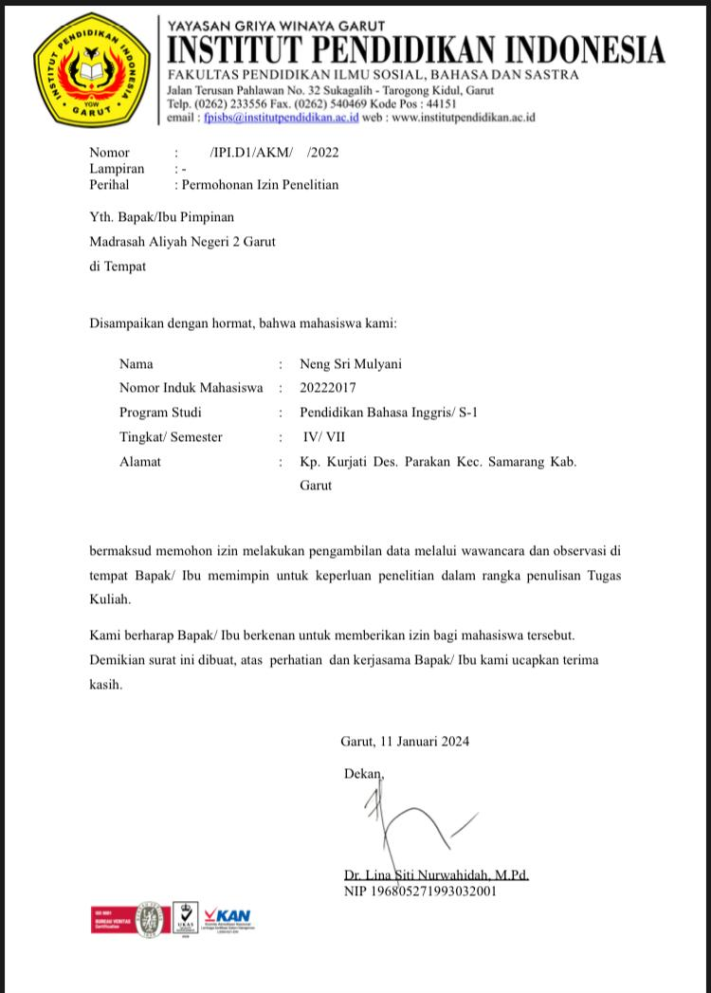

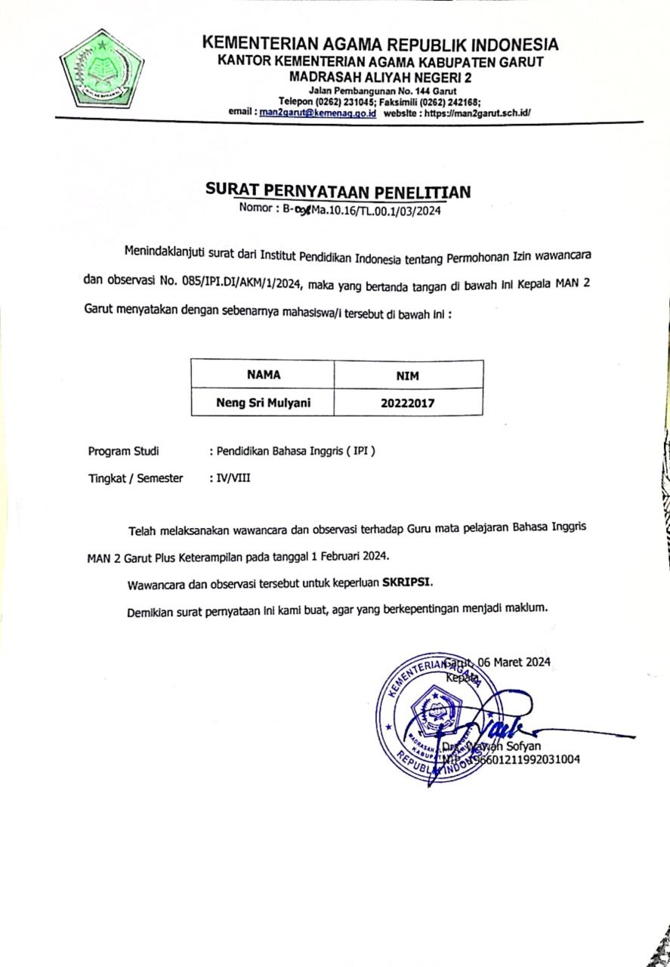

APPENDIX 4
DOCUMENTATION

- Documentation Interview
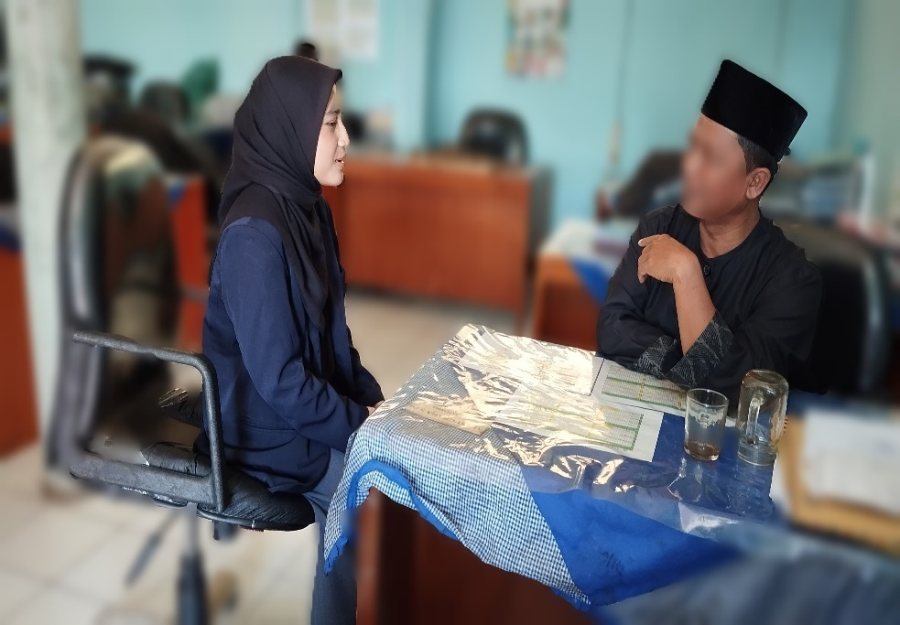

- Documentation Observation
