THE STUDENTS’ CHALLENGES IN USING THE MEMRISE APPLICATION IN PROBLEM-BASED LEARNING IN SENIOR HIGH SCHOOL

A PAPER

Submitted to the English Education Program of IPI Garut as Partial Fulfillment of the Requirements for the Bachelor Degree in Education


Written by:
Khopipah Andini Riahi
20224005

ENGLISH EDUCATION PROGRAM
FACULTY OF SOCIAL SCIENCE LANGUAGE AND LITERATURE EDUCATION
INSTITUT PENDIDIKAN INDONESIA GARUT
2024

APPROVAL SHEET
THE STUDENTS’ CHALLENGES IN USING THE MEMRISE APPLICATION IN PROBLEM-BASED LEARNING IN SENIOR HIGH SCHOOL

By:
Khopipah Andini Riahi
20224005

First Supervisor | Second Supervisor
Ateng Kurnia, Drs., M.Pd  NIP.1963032331994031002 | Mohammad Soni, M.Pd  NIDN. 0425069104

Acknowledged by:
Head of English Education Program

Anne Ratna Suminar, M.Pd
NIDN. 0415038601

LEGITIMATION OF EXAMINATION BOARD
THE STUDENTS’ CHALLENGES IN USING THE MEMRISE APPLICATION IN PROBLEM-BASED LEARNING IN SENIOR HIGH SCHOOL

By:
Khopipah Andini Riahi
20224005

This paper was examined on 1st July 2024

First Examiner |  | Second Examiner | Third Examiner
Muhamad Taufik Hidayat, M.Pd. |  | Amir Hamzah, S.S., M.Pd. | Anne R. Suminar, M.Pd.
NIDN. 0423038501 |  | NIDN.0402057606 | NIP. 0415038601
 |  | Acknowledged by:
Dean of Faculty of Social Science,
Language and Literature Education
 | Dr. Lina Siti Nurwahidah, M.Pd.
 | NIP. 196805271993032001

PERNYATAAN
Dengan ini saya menyatakan bahwa skripsi ini merupakan karya asli saya yang berjudul “The Students' Challenges in Using the Memrise Application in Problem-Based Learning in Senior High School”. Semua data, gambar, dan kutipan teks yang direproduksi dari sumber lain, termasuk Internet, telah diakui secara eksplisit.
Dengan ini saya menyatakan bahwa sepanjang pengetahuan saya, isi skripsi ini adalah hasil karya saya. Skripsi ini belum dikirimkan untuk tujuan atau gelar apa pun. Saya menyatakan bahwa isi intelektual skripsi ini adalah hasil karya saya dan segala bantuan yang diterima dalam penyusunan skripsi ini serta sumbernya diakui.

Garut, 20 June 2024
Penulis,
Khopipah Andini Riahi
NIM. 20224005

DECLARATION
I hereby declare that this paper represents my original work titled “The Students' Challenges in Using the Memrise Aplication in Problem-Based Learning in Senior High School”. All data, images, and text excerpts reproduced from other sources, including the Internet, have been explicitly acknowledged.
I hereby declare that, to the best of my knowledge, the contents of this paper are my work. This paper has not been submitted for any degree or purpose. I declare that the intellectual content of this paper is the product of my work and that all assistance received in preparing this paper and its sources is acknowledged.

Garut, 20 June 2024
The researcher,
Khopipah Andini Riahi
NIM. 20224005

MOTTO
“Allah does not burden a person but according to his/her ability."
(QS. Al-Baqarah 286)

"Success begins with the courage to try."
(Walt Disney)

PREFACE
All praise be to Allah SWT, the Most Gracious and Merciful. He has been blessing me with completing this research paper. Then, may Allah SWT bless our prophet Muhammad SAW, and peace be upon Him and His family, friends, and followers forever. With the blessing of Allah, the researcher has completed this paper entitled “The Students' Challenges in Using the Memrise Application in Problem-Based Learning in Senior High School”. This paper mainly discusses students' challenges regarding the implementation of problem-based learning using the Memrise application in high school. This paper aims to describe students' challenges in implementing problem-based learning using the Memrise application in high school.
Researchers acknowledge that there is still much work to be done on this publication. Both the language and content areas require much improvement. Therefore, the researcher anticipates useful criticisms and recommendations to improve the current work and provide guidance for future research. The aim of this research is that this publication can be useful, both for other scholars and the general public.

Garut, 20 June 2024
The researcher,
Khopipah Andini Riahi
NIM. 20224005

ABSTRACT
The study explores the challenges students face in implementing problem-based learning using the Memrise application in senior high schools. Surveys and interviews revealed technical issues, difficulty understanding complex problems, time management, and collaboration issues. Despite these, students recognized the benefits of problem-based learning and the Memrise application's potential. Recommendations include providing technical support, designing clear problem scenarios, emphasizing time management, and fostering a collaborative learning environment. The findings contribute to future problem-based learning implementations. The results will inform instructional practices and enhance the implementation of PBL with the Memrise application, ensuring the integration of PBL and the Memrise application is optimized for effective language learning experiences.
Keywords: Memrise Application, Problem-Based Learning, Students Challenges

ABSTRAK
Penelitian ini mengeksplorasi tantangan yang dihadapi siswa dalam menerapkan pembelajaran berbasis masalah menggunakan aplikasi Memrise di sekolah menengah atas. Observasi dan wawancara mengungkapkan permasalahan teknis, kesulitan memahami permasalahan yang kompleks, manajemen waktu, dan permasalahan kolaborasi. Meskipun demikian, siswa menyadari manfaat pembelajaran berbasis masalah dan potensi aplikasi Memrise. Rekomendasinya mencakup pemberian dukungan teknis, perancangan skenario masalah yang jelas, penekanan pada manajemen waktu, dan pengembangan lingkungan pembelajaran yang kolaboratif. Temuan ini berkontribusi pada implementasi pembelajaran berbasis masalah di masa depan. Hasilnya akan menginformasikan praktik pembelajaran dan meningkatkan penerapan PBL dengan aplikasi Memrise, memastikan integrasi PBL dan aplikasi Memrise dioptimalkan untuk pengalaman belajar bahasa yang efektif.
Kata Kunci: Aplikasi Memrise, Pembelajaran Berbasis Masalah, Tantangan Siswa

ACKNOWLEDGMENTS
Praise be to the presence of Allah SWT, the King of kings, who has bestowed mercy and grace on all humanity so that the author can complete her research for this final assignment. Our Prophet Muhammad SAW, his family, companions, and followers are always the recipients of our prayers and greetings.
The writer would like to thank the following esteemed parties for their support, encouragement, and countless contributions during this research:
- Prof. Dr. Nizar Alam Hamdani, SE., M.M., M.T., M.Si., M.Kom, as Rector of the Institut Pendidikan Indonesia (IPI) Garut.
- Dr. Hj. Lina Siti Nurwahidah, M.Pd, as the dean of the Faculty of Social Science, Language and Literature Education of Institut Pendidikan Indonesia (IPI) Garut.
- Anne Ratna Suminar, M.Pd, as the head of the English Language Education Program.
- Ateng Kurnia, Drs, M.Pd, as the first supervisor. Thank you for taking the time to provide advice, suggestions, and guidance while working on and compiling this paper.
- Mohammad Soni, M.Pd, as the second supervisor. Thank you for taking the time to provide advice, suggestions, and guidance while working on and compiling this paper.
- My First Love and My Hero, Budi Riahi, and My Beloved Mother, Feni Kustini. Thank you for all the support, sacrifices, and advice given to the writer so she can complete her studies and obtain a bachelor's degree. It is an honor to have parents who always give me full love and take good care of me. I dedicate this paper to my parents.
- My Beloved Grandmother and Grandfather, Eti Rusnaeti and Engkus Hidayat. Thank you for always being a place to tell stories, always treating you well, and most importantly, having educated you very well since the writer was little. Maybe thank you alone is insufficient, but the author is very grateful to have such good grandparents and grandfathers.
- My Aunt and My Uncle, Desi Kusnita Santi and Dian R. Ramadan, S.Pd. Thank you for the support and advice given to the writer.
- My Beloved Sister, Aurellia Nur Fadilah. Even though she looks indifferent and likes to be angry, the writer wants to say thank you for always being there and always accompanying me wherever I go.
- My little best friend, Putri Hafidzoh Nurul Jannah. Thank you for being a friend who always entertains, supports, and listens to the author's stories.
- My best friends: Sindi Sri S, Zia Rahmawati, Widiya Ayu S, and Devi Oktaviani. Thank you for always listening to the author's complaints, supporting me, and writing this final assignment.
- Friends in arms: Ummi Kuslum, Sari Safitri, Indira Fathia, Siti Hafsoh, Siti Masitoh, Rai Tri, Nadia Nurazmi, Razita. Thank you for always accompanying us from the start of the lecture to the end, strengthening each other, and providing solutions when we were stuck with writing this.
- My friend, Wulan Anggraeni. Thank you for always listening to stories about the confusion of love, the writer's complaints while working on this final assignment, and other stories.
- My friends from class C and friends from the class of 2020. Thank you for always being with us and encouraging each other.
- The owner of NIM 2003074. Thank you for always being there and providing support. Thank you for always defending and being available when the writer needs anything.
- All parties that the author cannot mention one by one, either directly or indirectly. Thank you for being so helpful in writing this.

TABLE OF CONTENTS

APPROVAL SHEET i
LEGITIMATION OF EXAMINATION BOARD ii
PERNYATAAN iii
DECLARATION iv
MOTTO v
PREFACE vi
ABSTRACT vii
ABSTRAK viii
ACKNOWLEDGMENTS ix
TABLE OF CONTENTS xi
LIST OF FIGURE xiv
CHAPTER I INTRODUCTION 1
1.1 Background of the Study 1
1.2 Reason for Choosing the Topic 5
1.3 Research Questions 6
1.4 Research Objectives 6
1.5 Significance of Study 6
1.6 Definition of Terminologies 7
1.6.1 Problem-Based Learning 7
1.6.2 Memrise Application 7
1.6.3 Students Challenges 8
CHAPTER II LITERATURE REVIEW 9
2.1 Problem-Based Learning (PBL) 9
2.1.1 Definition of Problem-Based Learning 9
2.1.2 The Purpose of Problem-Based Learning 10
2.1.3 The Implementation of Problem-Based Learning 11
2.1.4 The Challenges of Problem-Based Learning 12
2.2 Memrise Application 13
2.2.1 Definition of Memrise Application 13
2.2.2 The Procedures of Using Memrise Application 15
2.2.3 The Implementation of Memrise Application in Senior High School 19
2.2.4 Memrise Application in Language Learning 20
2.2.5 Potential Benefits and Challenges of Memrise Application 23
2.3 The Students’ Challenges of Problem-Based Learning with Application 24
2.4 Previous Study 27
CHAPTER III RESEARCH METHODOLOGY 31
3.1 Research Method 31
3.2 Research Design 31
3.3 Research Site 31
3.4 Participant 32
3.5 Data Collection 32
3.6 Data Analysis 34
3.6.1 Data Reduction 35
3.6.2 Data Display 35
3.6.3 Draw Conclusions 35
3.7 Research Procedure 35
CHAPTER IV FINDING AND DISCUSSION 37
4.1 Findings 37
4.1.1 Observation Checklist Result 37
4.1.2 Interview Result 38
4.2 Discussion 44
4.2.1 Observation 44
4.2.2 Interview 45
CHAPTER V CONCLUSION AND SUGGESTION 50
5.1 CONCLUSION 50
5.2 SUGGESTION 51
5.3 RESEARCH LIMITATION 52
REFERENCES 53
APPENDICES 57
APPENDIX 1 RESEARCH INSTRUMENT 58
Interview List 62
Interview Transcript 63
Observation Checklist 78
APPENDIX 2 84
LESSON PLAN 84
APPENDIX 3 86
LETTER AND INFORMED CONSENT 86
APPENDIX 4 98
THE THESIS GUIDANCE CARD 98
APPENDIX 5 DOCUMENTATION 99
CURRICULUM VITAE 102

LIST OF FIGURE
Page
Figure 2. 1 Creating an Account 14
Figure 2. 2 Choosing a Course 15
Figure 2. 3 Select the Theme to be Studied 15
Figure 2. 4 Starting the Learning 16
Figure 2. 5 Audio Pronounce of Vocabulary, Typing Test, and Pronunciation Test 17
Figure 2. 6 Chat feature in the Memrise application 17

CHAPTER I
INTRODUCTION
This chapter presents the background of this research, the research question, the research objective, the research significance, and the operational definition of the term discussed in this chapter.

Background of the Study
The student-centered approach method in the teaching and learning process or student-centered instruction is a popular term used in the education sector today to signify important changes in the education of what is teacher-centered (Tang, 2023). One student-centered learning method is Problem-Based Learning (PBL) in senior high school. In senior high school, the implementation of problem-based learning (PBL) has grown in acceptance in recent years (DeChambeau & Ramlo, 2017). Problem-based learning, or PBL, is widely recognized as a significant and effective teaching approach in a range of educational settings, including senior high schools. In order to strengthen students' critical thinking and problem-solving skills, problem-based learning exposes them to real-world situations and guides them through the process of addressing them. Thus, by putting problem-based learning into practice, students may become autonomous and creative learners while also developing the abilities necessary to deal with obstacles in the real world.
In implementing PBL, it is very important to emphasize that PBL is learning in harmony with important scientific learning, as stressed by Sofyan and Komariah (2016, p. 269) (Hidayati & Wagiran, 2020). PBL encourages students to find new solutions to the problems presented. (Arends, 2008, p. 55) In (Hidayati & Wagiran, 2020), there are five phases in implementing PBL: (1) introducing the problem to the students; (2) setting up the research group; (3) facilitating independent inquiry and communication; (4) creating and presenting the work; and (5) assessing and evaluating the process of problem-solving, particularly learning-related problems in cyberspace. The research was carried out using these procedures. This explanation makes it clear that PBL learning is a model of learning that may be used
to enhance problem-solving abilities. Thus, it is hoped that problem-solving skill can be improved with the Problem-Based Learning (PBL) method. Therefore, PBL is an effective learning approach for improving students' problem-solving skills. PBL allows students to learn actively, develop creativity, and gain a deeper understanding of scientific concepts.
Eva Cwynar (2020) underlined that the use of PBL is necessary to improve academic achievement and assist students in overcoming difficulties and finding solutions to all issues pertaining to PBL implementation strategies. Despite all of PBL's advantages, integrating it into instruction is not simple. Challenges and problems can arise in various aspects, such as according to (Mansor et al., 2015) PBL has brought about great challenges to teachers. Teacher monitoring and individual or group counseling take a lot more time than traditional instruction does. Another issue is sustaining and ensuring the efficacy of instruction when there are several groups in a class. The teachers discovered that it was difficult to shift from their position of content provision to one of student learning facilitation. This issue was exacerbated by their lack of comprehension as a result of their little PBL experience. PBL was also time-consuming for the teachers, requiring them to give up their own spare time in order to meet the requirements of the pupils. Another significant challenge for these teachers was encouraging pupils to engage in active learning. Therefore, to improve learning effectiveness, it is crucial to have a thorough grasp of the difficulties and issues that come up while adopting PBL in high schools.
According to (Tanjung et al., 2022), PBL may be connected to technology to improve the efficacy of learning. Technology, information, and communication are all used in problem-based learning to help students tackle environmental challenges. Using a variety of learning models along the process is essential to getting students interested in and understanding what they are learning. According to (Tanjung et al., 2022), it was a great success and really enjoyable to apply the Problem-Based Learning Model with a Technology approach. As a result, using technology in PBL can improve learning outcomes as it facilitates information gathering, issue analysis, and the creation of workable solutions by students. In this way, the use of technology in PBL can improve learning outcomes by facilitating information gathering, problem analysis, and the creation of solutions that students can complete.
One technology that can be used to implement PBL is the Memrise application. According to Rahmah (2022) Memrise is an online and mobile educational resource that covers a wide range of subjects. Students can use Memrise, particularly while learning a language, to acquire various skills and requirements, including grammar and vocabulary. Students may find Memrise engaging since it employs interval repetition on flashcards to accelerate learning. Additionally, it enables users to pick up a lot of vocabulary from a specific language or industry. The vocabulary lists include definitions, synonyms, antonyms, and pronunciation guides. Memrise is a helpful tool for improving student learning standards in the classroom since it enables students to grasp new concepts in a more dynamic and engaging way when used as an application in Problem-Based Learning (PBL).
Through the use of educational techniques and resources such as the Memrise app, students are expected to improve their understanding and retention of vocabulary. Problem-based learning is a teaching method that utilizes the Memrise application to provide students with the opportunity to acquire the necessary vocabulary. One innovation in using the Memrise application for learning is problem-based learning. Therefore, in learning to write clearly, this ability is developed optimally through group work or systematic work assignments, thereby enabling students to learn, grow, and develop their ability to write clearly over a long period of time. According to (Darling-Hammond & Associates, 2020), cited in Fadilla et al. (2021), Memrise gives users access to definitions, synonyms, antonyms, and even pronunciations for a wide variety of terms in a given language or field. Teachers can use Memrise to organize specific groups of students and build their own curriculum with the help of this app. Teachers can also assign students to use Memrise user-generated content to learn vocabulary. Over the course of a week or month, teachers can measure each student's progress by monitoring their performance. Students will have access to additional resources from Memrise in addition to the main information teachers explain in class because they can use the app at any time and from any location. Therefore, students can learn vocabulary and language in certain disciplines using Memrise.
There are also several previous studies related to Problem-Based Learning and Memrise Application. One of them was conducted by Rahmah (2020) Entitled “Student’s Perception of Memrise Application to Improve Vocabulary Mastery at Senior High School”. The findings of this research explore the theories and research on students' perceptions of the Memrise application for improving vocabulary mastery in English. It highlights the importance of vocabulary in English language mastery and suggests that online learning media, such as Memrise, can help students learn independently and provide an enjoyable learning experience. The paper also addresses why students should use Memrise and how they apply the application and provides suggestions for effective mobile-assisted language learning.
Another previous study was conducted by Rohim & Gumelar (2023) entitled “The Effect of Memrise Application Towards Students’ Vocabulary Mastery”. The finding in this research investigates the impact of the Memrise Application on vocabulary mastery among eighth-grade students at MTs Mathla'ul Anwar Malingping. The study uses a quantitative research design with experimental methods, with 71 students in two classes: experimental (VIII-A) and control (VIII-B). Data is collected through pre-tests and post-tests and analyzed using SPSS 22. Results show a significant effect of Memrise application on vocabulary mastery, with a minimum score of 44 in the experimental class and 52 in the control class. The t-test results indicate a significant effect of Memrise application on vocabulary mastery. The last research related to the Memrise Application was carried out (Oberlander & Talbert-Johnson, 2004) entitled “Using Technology to Support Problem-Based Learning”. The findings in this research The influence of pedagogy and instructional design on learners' belief and cognitive systems, information transfer, and significant change in attempts to plan, support, and assess learning activities in classroom settings are frequently discussed. As learning systems move from activities that make up problem-based learning (PBL), there has been a noticeable change in attention recently from those based on directive methods to constructivist concepts and practices. A change in technology has coincided with this change in pedagogy. Applications of technology that are reliable, interactive, and self-directed are encouraged. This research looks into PBL as a change agent that helps students become active knowledge builders through cooperative, group-based projects. Additionally, the study illuminates the critical junctures at which PEL, as a technological tool, impacts the beliefs of graduate students and, ultimately, their classroom practice.
Several studies that have been conducted have similarities with this research in that they share a similar focus on the integration of problem-based learning and the application of Memrise in the context of secondary school education. It can address the challenges students face when implementing this blended approach and provide insight into how to effectively utilize technology, such as the Memrise app, to support problem-based learning in the middle school environment. However, previous research was more oriented towards effectiveness and implementation, resulting in a lack of focus on students' perspectives in facing certain challenges that arise when implementing PBL using the Memrise application. Therefore, the author explores in more depth the perceptions or challenges faced by students when learning PBL using the Memrise application.

1.2 Reason for Choosing the Topic
Based on the background that has been explained, there are the reason why the researcher choose the topic.
In the current digital and technological era, using learning applications such as Memrise can be an interesting approach in implementing Problem-Based Learning in high school. This topic is interesting, because there has not been much researcher that significantly addresses students’ challenges in using Memrise in a PBL context.

Research Questions
Based on the background of the study, the problem can be formulated as the following question: “What are the students' challenges in using the Memrise Application in problem-based learning in senior high school?”

Research Objectives
According to the research question, this study attempts to investigate and describe the challenges faced by students in using the Memrise Application in problem-based learning in senior high school.

Significance of Study
This study has significance that is expected to be beneficial both theoretically and practically, which is explained in the following section:
- Benefits for Teachers;
- Teachers can better understand the challenges faced by students while implementing PBL by using the Memrise app in the upper grades.
- The teacher may use this information to tailor their lesson plans so that they are more effective and relevant to the needs of the students.
- Teachers can improve student quality by increasing the use of technology in the classroom.
- The teacher can recommend appropriate actions to increase the use of Memrise in PBL contexts in the school.
- Benefits for Students;
- Students might benefit from more effective instruction that is tailored to their needs.
- In order to overcome the challenges of learning in school, students might benefit from more support from teachers and educational administrators.
- Through the use of the Memrise application, students may improve their ability to use technology in their education and increase their proficiency in English.
- Benefits for School;
- Schools may raise the standard of instruction and ensure that students can handle challenging material with more skill.
- Memrise is an application that schools may use to improve PBL design and implementation so that it is more effective and relevant to students' needs.
- Schools can increase the use of technology in instruction and raise the standard of education.

Definition of Terminologies
To avoid misunderstanding to understand this study, the definition of terms that are often found in this study is as follows:

1.6.1 Problem-Based Learning
According to (Azer, 2016), problem-based learning is an approach to learning that uses a problem to drive the learning13,14 rather than a lecture on the subject matter that is taught.15 In PBL programs, a set of problems is used to engage the students in learning in small groups. A framework for the PBL curriculum is usually designed by an executive group, which sets the scope and major theme for each semester. Students then identify the salient features of the problem, the areas in which they lack the information needed to understand the problem, and how best to approach and deal with it.

1.6.2 Memrise Application
According to Ngoc & Quyen (2022), Memrise is an online application for learning foreign languages that has quite several users. Memrise is a free online language learning platform that provides attractive features and designs that make learning fun. This application was chosen for two main reasons. First, it provides users with many different topics and courses to improve student vocabulary. Second, it is the free mobile version of the famous Memrise web tool. According to Rohim et al (2022), Memrise is one of interesting ways in teaching and learning vocabulary because it could motivate the students in learning English. By using the Memrise application as a learning media, students will be more interested in learning activities. Teachers can increase student interest and make students more enthusiastic about learning activities.

1.6.3 Students Challenges
According to (Widayanti & Suarnajaya, 2021), Students' challenges are impediments or difficulties that they encounter when studying at a college or at school to achieve their academic and personal objectives. These difficulties can result from a wide range of internal and external sources and have a big effect on students' general well-being, mental health, and learning quality.

CHAPTER II
LITERATURE REVIEW
A literature review contains a description of theories, findings, and other research materials obtained from reference materials to serve as a basis for research activities. In this chapter, the researcher provides an analysis of the data that has been collected from observations and interviews. Researchers explore findings and discussion of research results regarding the implementation of problem-based learning using the Memrise application in high school.

Problem-Based Learning (PBL)

Definition of Problem-Based Learning
According to (Ali, 2019), problem-based learning is a student-centered educational method that aims to develop problem-solving skills through self-directed learning as a lifetime habit and as a teamwork skill. A collection of issues is used in PBL programs to get students thinking and working in small groups. An executive panel often creates the structure for PBL curricula, determining the main subject and scope for each semester. Then, the students pinpoint the key elements of the issue, the knowledge gaps that need to be filled in order for them to fully comprehend the situation, and the most effective way to approach and resolve it. Students are given these issues to solve before being taught any basic science or other knowledge required to solve the problem. Therefore, PBL recognizes that students may have prior knowledge from previous PBL cases, secondary school education, or other academic programs in the science, medical, or psychosocial fields. On a "need to know" basis, further information is obtained, allowing the student to choose their own learning requirements. Acquired knowledge is fed back into the issue. PBL gives students the opportunity to choose subjects and disciplines that are relevant to the issue at hand.
According to Barrows (1986), depending on how the teaching technique is designed and how skilled the instructor is, the word PBL may indicate many
different things. According to Barrows (1986), there is no one PBL version. However, he has made an effort to categorize PBL variations using a taxonomy. According to other writers, PBL may take many different forms, and in order to allow students to go further, modifications to the framework and problem models may be made. Despite the fact that these definitions appear to address a common ground, they present a number of points of disagreement over the definition of PBL. For example, there is disagreement about the idea that PBL facilitates the process of developing problem-solving abilities. It has recently come up to debate whether PBL should satisfy the requirements listed in these definitions. It's also interesting to note that multiple PBL models have been established, and there is continuous debate over which models are genuine implementations of the principles and which are different enough to fall outside of PBL's accepted domain.
Barrows & Tamblyn (1980) stated that PBL mainly depends on two important presumptions. First, learning through problems creates scenarios that are far more useful and beneficial as a body of knowledge than learning through traditional memory-based methods like reading books or listening to lectures. Secondly, the skills learned through problem-solving are typically those used in patient treatment (PBL was first used in medical education). As a result, PBL reflects actual experience (Barrows & Tamblyn, 1980a). The majority of scholarly literature that critiques PBL comes from the medical or health fields. Still, the axial principles and practices that have been developed from this experience have been applied to a variety of fields, including professional learning and higher education, including business, management, engineering, social work, accounting, architecture, construction, and legal training. Located in (Sinaga, 2021) (Boud & Feletti, 2013).

The Purpose of Problem-Based Learning
According to (Gijbels et al., 2013), the primary purpose of problem-based learning (PBL) is to make students more ready for the real world by making them solve issues. This improves learning outcomes by encouraging the application of information, higher-order thinking, problem-solving, and self-directed learning. This method was first created in the 1950s in reaction to the poor clinical performances of medical students, which were linked to traditional health science education's emphasis on memorizing disjointed biological knowledge. In the 1960s and 1970s, McMaster University's medical school established the structure and procedures of PBL. In short, problem-based learning (PBL) is an instructional strategy that aims to give students the tools they need to solve problems in the real world and improve their learning outcomes by applying knowledge, critical thinking, problem-solving, and self-directed learning.
According to (Fadilla et al., 2021), the PBL approach is founded on the broad concepts of adult education and cognition. This method is essentially different from the conventional method, which has students gain foundation information in the basic sciences early in the course and use that knowledge to diagnose and treat clinical issues later in the program. There are several reasons why the conventional method has been questioned. The main points of criticism are as follows: the traditional approach artificially divides the basic sciences from clinical practice; academic institutions prioritize scientific research over the competencies required in practice; time is wasted learning knowledge that is later forgotten or found to be irrelevant; applying knowledge learned in the basic sciences can be challenging; and learning and retaining information that is boring and of limited value over time.

The Implementation of Problem-Based Learning
Problem-based learning (PBL) is an instructional approach that emphasizes active, student-centered learning through the exploration and resolution of complex, authentic problems (Barrows & Tamblyn, 1980) cited in (Rahmah, 2020). In PBL, students work in small groups to analyze and solve problems that are relevant to their lives or future careers. The problems are often ill-structured, meaning that they do not have a single correct answer and require students to use critical thinking and problem-solving skills to develop solutions (Savery & Duffy, 1995).
PBL has been shown to help students in a number of ways, including greater learning retention and transfer, enhanced critical thinking and problem-solving abilities, and more motivation and engagement (Hmelo-Silver, 2004). Furthermore, PBL has demonstrated efficacy in fostering deep learning, as it motivates students to delve deeply into concepts and cultivate a comprehensive comprehension of the subject matter (Dochy et al., 2003). However, as PBL necessitates a substantial change in teaching methods, educators may find it difficult to adopt. According to Dolmans et al. (2005), educators are required to design real-world issues that have a bearing on students' lives or future jobs, lead conversations in groups and during problem-solving exercises, and offer encouragement and feedback all along the way. All things considered, PBL is an effective teaching strategy that encourages students to actively engage in their learning by investigating and solving challenging real-world issues. Although it might be difficult to put into practice, the advantages it offers pupils make it a worthwhile strategy to take into account in educational contexts.

The Challenges of Problem-Based Learning
According to (Gijbels et al., 2013), the challenges associated with problem-based learning (PBL) are many and fall under various headings. The necessity for substantial adjustments to the educational setting and the role of teachers is one major obstacle. Teachers now have to take on a more facilitative role, helping pupils solve problems instead of giving them direct instruction. For educators who are used to traditional teaching approaches, this transition may be challenging.
Another challenge, according to (Yew & Goh, 2016), that students must learn how to learn on their own, which may be a big adjustment for those who are accustomed to having instructions on what to do and how to do it. Students need to be able to take responsibility for their education, recognize issues, and devise solutions. Instructor assistance and a substantial time investment are needed for this, which can be difficult to manage. Furthermore, PBL may be resource-intensive, including large expenditures for infrastructure, labor, and technology. This might be a major obstacle for establishments with little funding. Furthermore, because PBL requires ongoing scaffolding and assistance, it can be challenging to install and sustain. Teachers need to be ready to modify their techniques and offer continuous support as students advance through the problem-solving process. It might be challenging to maintain this over time because it takes a lot of time and work. Lastly, it might be difficult to properly examine and evaluate PBL. The skills and information acquired by PBL may not be well-measured by conventional evaluation techniques, which can make assessing the strategy's efficacy challenging.

Memrise Application

Definition of Memrise Application
The education system has been profoundly influenced by technological advancements in many facets of society. Teaching strategies have changed as a result of technology, becoming more contemporary. Educators may now employ a variety of media to help pupils become self-sufficient learners. It is anticipated that millennial students will use technology to further their education. It is essential for children to learn how to use technology efficiently in their daily lives. Teaching, technical learning, and research are just a few of the sectors of education that are developing as a result of technology. Students may find it simpler to study English if they have access to internet learning tools like Memrise. Memrise is a mobile learning program that can help pupils increase their vocabulary outside of the classroom, claims Rahmah (2022). According to et al. (2019), Memrise is one of the online applications that can help students from various majors learn English, especially new vocabulary. Memrise is also integrated into the instructional program, so students will benefit from an engaging learning environment.
Memrise helps users learn numerous words from a specific language or area and speeds up learning by using interval repetition on flashcards. Memrise is accessible from anywhere at any time, and its tools and interactive design encourage self-directed learning. The benefits of independent learning include equitable chances, fostering self-assurance, accountability, and attentional concentration. Memrise employs interval repetition on flashcards to speed up learning, according to Rahmah, n.d. (2022). Additionally, it enables users to pick up a lot of vocabulary from a specific language or industry. This vocabulary includes definitions, synonyms, antonyms, and even pronunciations.
According to (Karjo & Andreani, 2018) Memrise is an application that helps people learn languages in a fun and effective way by combining elements of textbook instruction. They claim that Ben Whately, a Princeton neurologist who specializes in the study of memory and forgetting, Ed Cooke, a Grand Master of Memory, and Greg Detre developed Memrise in 2005 and published it in 2013. Memrise combines many ways to make online learning attractive (Hasan Affandi & Syafi ’i2, 2018). The learning method in memrise is:
- Repetition
Memrise employs a drill method that involves repeating questions.
Depending on how accurate a user's response is, a word may be asked five to eight times. The Flower icon, which begins with the seed icon and ends with the blossoming flower icon, indicates the repeat outcome. This indicator shows people who, out of a total of 20 repeated questions, were able to correctly answer questions about the same term 80% of the time.
- Multiple Choice
Memrise offers a drill approach with multiple-choice questions. There are four to eight possible answers for each multiple-choice question. Words from the previous session, as well as words that will be learned in that session, are included in each response option. Pupils should select the right response from the list of options to estimate the accurate response.
- Short Essay
Short essays are used as a teaching tool where students are given words in their home tongue and then asked to fill in the blanks. One way to translate a word from the mother tongue is to use the blank word. You may either type the short essay or choose each help letter individually from the list at the foot of the typing column.
- Listening
Listening is an additional technique. Students must "click the sound icon" in order to listen to the audio. Based on the sound that is produced, the pupils are required to select the proper response. There are two ways to listen: one way is to predict a sound, and the other way is to match the sound to the word in the question.
- Chatbot/Membot
MemBot in the application Memrise is a computer tool that facilitates textual or visual interaction and makes it easier for users to learn by using relevant keywords. MemBot, a chatbot Al developed by Memrise, enables users to communicate silently or write with the application so they may learn by using language that fits the context. Using natural language processing and artificial intelligence technology, MemBot can provide relevant responses and assist users in improving their English language proficiency through engaging and interactive interactions.

The Procedures of Using Memrise Application
In order to start using Memrise:
Students must ensure they have downloaded the program before establishing an account. The Memrise app is available for students to download and install from the Google Play store. Students can pick a username, establish an account, or sign in using a Facebook or Google account when the application is open. Students should create a profile since this will ensure that their work is preserved even if they switch devices.
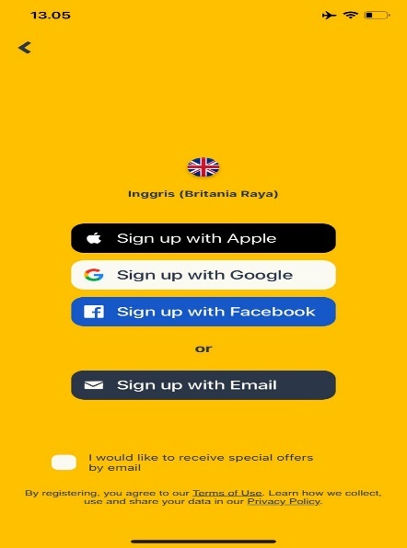
Figure 2. 1 Creating an Account
Students can log in using their Google or Facebook accounts as well. Similar to a report card, the profile page lists the number of words that students have learned, the badges they have achieved, their current learning level, and leadership boards.
- Choosing a Course
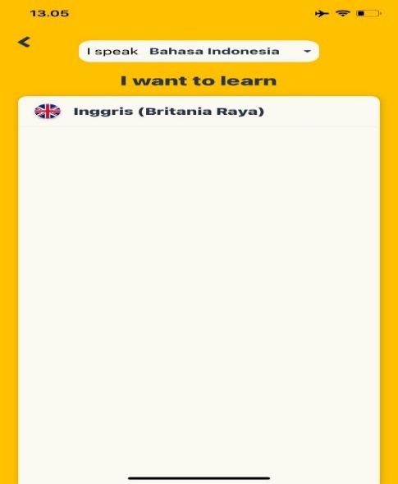
Figure 2. 2 Choosing a Course
There are courses accessible on the website in more than 200 languages alone in the language department. The estimated number of hours needed to finish should be displayed on the course screen. To make a course easier to handle, it might be separated into levels. The students select a course by clicking the 'Browse' button located at the top of the website. After that, the students may search for keywords or filter the courses by popularity or language. The students decide to study English.
- Select the Theme to be Studied
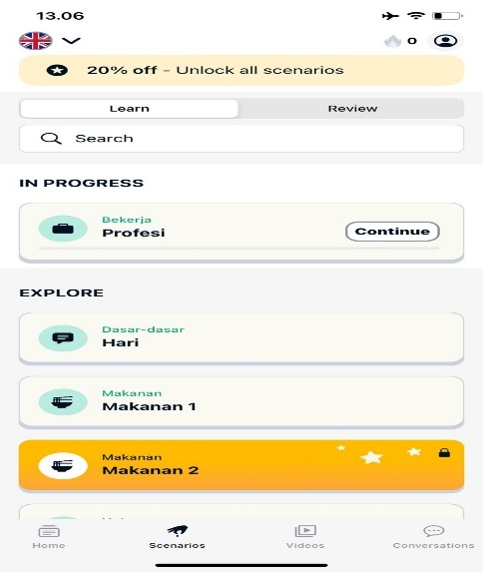
Figure 2. 3 Select the Theme to be Studied
After selecting a course, students can choose the theme to be studied or adjust it to the student's level and interests. There are various choices of basic themes/topics for beginners and those who are more focused on certain themes.
- Starting the Learning
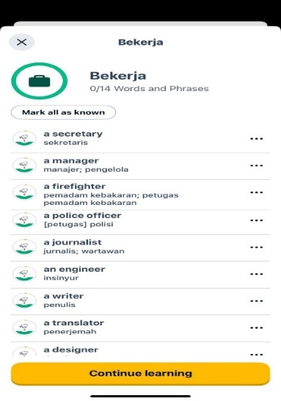
Figure 2. 4 Starting the Learning
After selecting "Mulai belajar" from the menubar and pausing for a while, the students click the middle of the button (Kajian Cepat) to view the menubar for each level of the application.
- Learning vocabulary by using the Memrise Application
Students can view the vocabulary list in the menubar by clicking on 'Mulai Belajar'. Memrise uses a garden as a metaphor for memory. The vocabulary words will be sown as "seeds" in the minds of students when they first begin a course. The vocabulary will be repeated several times. Begin with the simpler, intermediate, and more challenging route. Every vocabulary word has an audio pronunciation available. The multiple-choice, typing, and pronunciation tests are administered to the pupils.
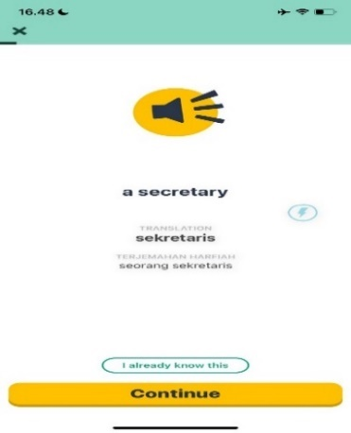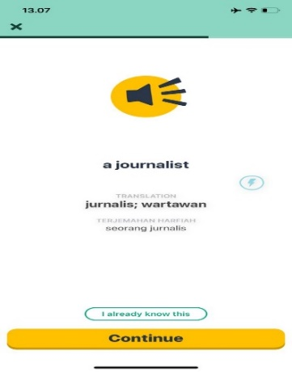
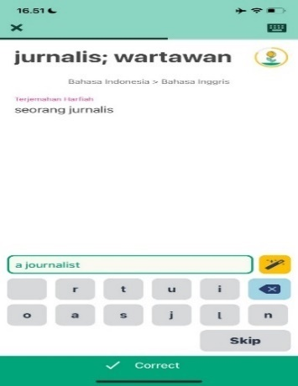
Figure 2. 5 Audio Pronounce of Vocabulary, Typing Test, and Pronunciation Test
Memrise's home screen gives the impression that the user, or student, is traveling through space, with each level represented by a planet. Every level has a distinct theme. Before moving on to the next level, users or students must master a predetermined number of words and phrases that were there when they first entered the level. As they successfully respond to the questions, students go from one screen to the next. In the event that pupils provide an incorrect response, they will need to repeat the word or phrase, which will need additional steps to advance through the level.
- Chat feature in the Memrise application
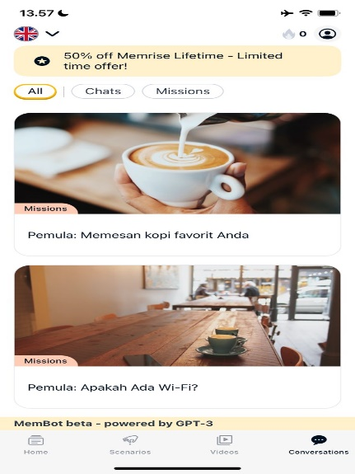
Figure 2. 6 Chat feature in the Memrise application
The chat feature of the Memrise application allows you to practice speaking foreign languages with native speakers or other users. To use it, open the Memrise application, select the language you want to learn, click the chat icon, select the side chat, and begin the lesson. Engage in a conversation with your peers about various topics, utilize the language you have learned in Memrise, and take advantage of the cross-referencing feature to improve your language skills and comprehension. Be diligent in order to achieve the best results. This feature is ideal for teaching you to speak English as a second language in an engaging and interactive manner.

2.2.3 The Implementation of Memrise Application in Senior High School
The steps in applying problem-based learning using the Senior High School memrise application are as follows:
- The teacher explains the learning objectives, highlights the benefits of problem-based learning using a memrise application, and encourages students to actively solve identified problems. The first type of topic that is identified is "profession," and the second topic is "vacation abroad."
- The teacher assists students in defining and organizing tasks and learning activities related to the above problem (such as adjusting topics, tasks, division groups, and so on).
- After each student has been given a task in each group, the instructor will answer questions or provide situations such as these:
- The first meeting:
      - Students look for any profession in the Memrise application
      - Students can pronounce and write a chosen profession in the Memrise application.
      - Students can mention what vocabulary is possible in this profession. (examples, teacher: teaching, class, school)
      - Students can write tense sentences on the given topic
- The second meeting:
- Students are instructed to undertake an exchange program abroad.
- After that, students can use Memrise to learn travel-related vocabulary and expressions, such as how to book a hotel, ask for directions, and make meal plans.
- Afterward, students can use the message feature to discuss their strategies for solving the presented problems using grammatically correct tense sentences.
- Students can use Memrise to convey the solutions to the problems.
- The teacher motivates students to gather pertinent data via the Memrise app, conduct experiments to find answers and work through current issues.
- The teacher helps students organize and prepare assignments and other suitable tasks, as well as share completed work with group members.
- When students are giving presentations in front of the class, the teacher assists them in reflecting on or evaluating the research and procedures they used.
This paper outlines a problem-based learning (PBL) strategy for senior high school students that makes use of the Memrise app. Students are given real-world challenges to solve, such as picking a career or organizing a trip overseas. They then investigate, debate, and resolve these issues using Memrise's vocabulary learning capabilities and group collaboration tools. The teacher serves as a mentor, encouraging dialogue, offering extra materials, and assisting students in thinking back on their education. With this method, children are encouraged to work cooperatively with their peers, use technology to learn languages, and actively solve challenges.

Memrise Application in Language Learning
The power of portable computing in the form of mobile devices is accessible to everyone, and it is time to consider using mobile devices for education. (Godwin-Jones, 2011). Besides, (Hubbard, 2013), it is of the opinion that people across the world wish to access learning materials on their mobile phones rather than acquire another technology to receive learning materials. One technology that can be used for mobile learning is Memrise, an application that utilizes problem-based learning. Memrise provides a range of interactive and captivating educational resources, such as mobile-friendly videos, chatbots, polls, and quizzes. Given that students are more likely to participate in learning when instructional information is presented in an engaging and dynamic way, this strategy can raise motivation and engagement levels among students.
According to (Quyen, 2021), there were two primary reasons this application was selected. To start, it offers a wide range of course subjects to help students' vocabularies. Second, this is the well-known mobile version of the Memorise online application, which helps students practice pronouncing words correctly and speaking confidently while utilizing chatbots to enhance their conversational skills. Furthermore, Google has chosen this program as the Best Overall Application Winner at the 2017 Google Play Awards. As a consequence, this software's dependability is assured. He offers consumers a variety of courses, each covering a number of vocabulary subjects. Every lesson includes pronunciation, semantics, and spelling taught by native speakers. Languages like Arabic, Ancient Greek, Chinese, English, French, German, Icelandic, Italian, Japanese, Klingon, Korean, Latin, Portuguese, Russian, Spanish, Swahili, Swedish, Turkish, and more may be learned by utilizing this program. Nevertheless, the study's only focus was on English language acquisition. Additionally, individuals studying English on Memrise have the option to pronounce words in either UK or US English.
Memrise's entertaining structure and varied course options are only two aspects of its appeal as a language-learning tool. Spaced repetition is a scientifically validated technique for improving long-term memory, and it is incorporated into this application. Memrise speeds up learning and improves memory by delivering new language at more frequent intervals. This approach reduces the likelihood that pupils will eventually forget new words while also improving their comprehension of them. Spaced repetition, along with Memrise's gamified features and interactive elements, makes for a potent and successful language learning environment.
Memrise offers a compelling and effective platform for mobile language learning. With its engaging interface, diverse course options, and incorporation of spaced repetition, Memrise caters to a variety of learning styles and promotes long-term memory retention. While the study focused on English language acquisition, Memrise's vast course selection caters to learners interested in a multitude of languages. The gamified elements and interactive features further enhance the learning experience, making Memrise a powerful tool for language learners on the go. Technologies and the media have an impact on education. For example, the internet, computers, and smartphones have all affected how people study these days. Technology facilitates teaching and learning by helping to arrange and structure curriculum for students and enabling communication between them and their parents from anywhere at any time. Thus, "technology" in this study refers to a program that might be used as English learning media. One free tool for learning languages is Memrise. The Memrise Application category selected for this research is Computers and Programming, as explained above.
According to Thornbury (2008) cited in (Arifin, 2020), when students can articulate a term's form and meaning, they are considered to have a basic comprehension of it. However, linguistic comprehension and knowledge are more than just the memorization of words. It should be possible for the student to understand the definitions of the terms, use them effectively in context, remember them, pronounce them correctly, and spell them. Understanding a term entails comprehending its three facets: definition, application, and form. Here, the students must comprehend the meaning, pronunciation, and application of the term. (Harmer & Thornbury, 2002). It is evident from the previous explanation that vocabulary is more than just a list of words. It has developed into an essential instrument for communication since ideas cannot be communicated without it.
Technologies and the media have an impact on education. For example, the internet, computers, and smartphones have all affected how people study these days. Technology facilitates teaching and learning by helping to arrange and structure curriculum for students and enabling communication between them and their parents from anywhere at any time. Thus, "technology" in this study refers to a program that might be used as English learning media. One free tool for learning languages is Memrise. As explained above, the Memrise Application category selected for this research is Computers and Programming.

Potential Benefits and Challenges of Memrise Application
According to (Mubarok & Asri, 2021), the Memrise application has several benefits, such as:
- Increasing motivation and confidence
The application has the potential to increase pupils' confidence and drive. It speaks to kids' innate drive to learn with Android; they study what they find interesting and what makes them feel at ease. Additionally, because it offers them games and puzzles that engage and thrill them, the pupils may be more motivated. Because it offers a reward in the form of students' accomplishment growth, it can also increase their confidence in their ability to study.
- Easy and Simple
Learning English with the app is also straightforward and uncomplicated; no complex learning phases or sequences are required. Furthermore, because they use Android regularly in their everyday lives, the students are already accustomed to and like the operating system. It does not include the intricate requirements standards (such as syllabus and lesson plan) seen in traditional learning; instead, it focuses on the students and the application itself. The learners' personal requirements and learning level—for example, advanced, upper-intermediate, etc.—determine the assessment and benchmark they wish to meet.
- Practical and Entertaining
It is not only easy, but it is also useful and enjoyable. For the learners, using the application is practical since it provides them with many opportunities to experience learning through technology and the Android application system. It is also interesting since it provides pupils with games and fun language-learning resources. For example, offers us a game in the writing area to motivate us to finish it by filling in the blanks. We have to avoid the five birds in the program while playing the game. One bird will fly away when the gap is filled, and the remaining birds will fly away after the exam is over.
- Sustainability
The application has been demonstrated to help the environment in addition to individuals. Compared to traditional or conventional learning, which requires a lot of paper supplies and pencils, it is far more environmentally friendly. There is no need to purchase new materials while completing many training or exercise sessions using a mobile app. It's one of the learning strategies that might lead to a significant decrease in the annual number of trees cut down for paper.
While Memrise offers a multitude of benefits, it's important to acknowledge potential challenges. Students face a variety of challenges while implementing problem-based learning at the senior high school level using the Memrise program. According to (Karjo et al., 2022), technological proficiency, poor network connections, independent learning, teamwork, motivation, and adaptation are some of these challenges. Instructors may improve PBL implementation with the Memrise app by addressing these issues with focused instructional techniques, training, and support. This will help students become more engaged in their learning process and develop their critical thinking and problem-solving skills. To properly address these issues, further research is required to investigate new tactics and solutions.

The Students’ Challenges of Problem-Based Learning with Application
According to (Ismail et al., 2018), using problem-based learning to identify challenges in students' thinking and involving them in the process of using educational applications ' problem-based learning strategy. A learning strategy that puts the needs of the student first and promotes critical thinking and active participation is called problem-based learning (PBL). For students, there are additional challenges when adopting PBL with apps. Students may encounter a number of challenges when utilizing programs to carry out Problem-Based Learning (PBL), including:
- Lack of Technological Capabilities
A primary obstacle to executing application-based Problem-Based Learning (PBL) is students' inadequate technical proficiency. This might show up as a number of different things, such as trouble using the program because of a complex UI, unclear features, or confusing navigation. Furthermore, it's possible that students lack fundamental digital abilities like typing, utilizing the internet, and conducting online research, which might impede their ability to learn and participate in application-based PBL. In addition, disparate access to technology, dependable internet connections, and sufficient data plans should be taken into account. As a result, there may be a digital gap and fewer students using apps for learning (Millen & Gable, 2016).
- Low Motivation
A significant challenge impacting student motivation in Memrise-based PBL is a lack of clear direction and connection. The first challenge in implementing Problem-Based Learning (PBL) using the Memrise application is low student motivation. Research by Kerdprasop et al. (2016), suggests that some students may experience reduced motivation due to the repetitive nature of gamification elements in applications. This may lead to a decrease in student involvement and learning outcomes as a result of boredom and disengagement. Reduced student motivation can also result from unclear learning objectives, assignments with a difficulty level that is too high, and the lack of social support that comes with Memrise-based PBL. In order to overcome these obstacles, teachers must establish precise learning objectives, adapt their teaching to each student's requirements, and provide chances for cooperation throughout the PBL process. By putting these techniques into practice, teachers may build more stimulating and engaging learning environments that make the most of Memrise and PBL to enhance student results.
- Limited Social Interaction
Students who do not work well together may find it difficult to have a thorough grasp of the issues they encounter and to come up with original solutions. According to (Samala et al., 2022), students' motivation and excitement for learning may suffer as a result of feeling alone and cut off from classmates and teachers while using PBL software for independent study. Furthermore, insufficient online engagement might impede the growth of students' verbal and nonverbal communication abilities, including problem-solving, active listening, and providing and receiving feedback.
- Accessibility Limitations
Beyond impediments to motivation, learners could encounter constraints while trying to access and use Memrise for problem-based learning. Unreliable internet connections and device incompatibilities may hinder certain students from engaging to the fullest extent possible. According to (Ameri, 2020), students may also have difficulty accessing several Memrise features, which are paid monthly fees. Finally, students who are not proficient in using digital tools and applications may find it difficult to use Memrise to its full potential and facilitate successful learning within a PBL framework.
- Lack of Adaptation to Applications
One additional challenge is getting pupils to adjust to the application itself. Memrise's features and UI might be difficult to use, especially for people not accustomed to learning applications. According to (Pilar et al., 2013), a poor comprehension of the capabilities provided and how they might be implemented within the PBL framework can exacerbate this lack of familiarity. Moreover, not all students will find Memrise's informational format in line with their preferred learning method, making it more difficult for them to take in and remember the knowledge needed to participate in the PBL process.
- Limited Time Management Abilities
In addition to the difficulties already mentioned, students who use Memrise for PBL encounter considerable difficulties in time management and attention span maintenance. They may feel as though they don't have enough time due to a high workload in other disciplines, which makes it challenging to put in the necessary effort to finish PBL tasks and thoroughly study the content on Memrise. Inadequate time management abilities might make it challenging to do PBL projects and use Memrise efficiently, even when you have plenty of time. The digital age's intrinsic diversions exacerbate this issue even further. Instant chats, social media updates, and other online activities can quickly divert students' attention from Memrise, fragmenting their study sessions and decreasing the efficacy of their education overall (Zimmerman, 2000).
- Limited Analytical Capabilities
Beyond concerns about accessibility, motivation, and program modification, students can find it challenging to engage with the analytical components of Memrise-based PBL. Inadequate critical thinking abilities may impede their capacity to analyze issues and devise efficient resolutions within the context of Problem-Based Learning. Memrise may also display facts and information that have to be interpreted. Students who are not proficient in data interpretation may find it difficult to decipher the significance of the data and use it to solve problems. Lastly, PBL demands the synthesis of data from several sources (Smith & Jones, 2021). It may be challenging for students with low synthetic abilities to combine information from Memrise with information from other sources, which will make it more difficult for them to answer the challenges in the PBL tasks.

Previous Study
Several studies have been conducted in terms of Problem-Based Learning and Memrise Application.
- A study by Surif and Ibrahim Mokhtar (2013) entitled “Implementation of Problem-Based Learning in Higher Education Institutions and Its Impact on Students’ Learning”. These studies demonstrate that PBL has a positive impact in increasing students’ motivation, self-learning, and soft skills. It is because PBL uses learning problems as a catalyst to encourage students to think critically. Group learning activities and leadership roles help to develop students' communication and collaboration skills. Thus, this strategy is suitable for implementation in higher education. However, there were complaints from some students about the challenges they faced in solving problems and mastering the content. Time constraints and multiple tasks that must be completed for each course created these issues. In this case, the lecturer has an important role in motivating students and providing effective guidance to them. Among the guidance that can be implemented include:
- Submit a strategy to understand the problems presented using cognitive tools such as table learning issues (what is known, what is not known, what needs to be known). Cognitive tools help the student understand the problem as a whole and realize the task that must be executed to solve the problem effectively.
- gives a hint (hint) to students in the monitoring process implemented during the lecturer-student meeting, as well as providing encouragement and motivation that encourages them to learn to be more active and organized.
- Arrange a meeting schedule and monitor the progress of students from time to time. Use social forums such as e-learning for this purpose, as well as group discussions throughout the learning process.
Overall, it can be concluded that many students agree with the implementation of PBL in higher education institutions due to its effectiveness in the learning process. Finally, the students are satisfied if problem-based learning continues to be implemented in chemistry education courses, but many of them agree that PBL should be used for all courses in higher education institutions.
- A study from (Faizal Rohim & Elang Gumelar, n.d.) conducted a study entitled “The Effect of Memrise Application Towards Students’ Vocabulary Mastery”. This study found a couple of issues there; similar to the normal understudies' scores, which are exceptionally low, the understudies' inspiration in learning English is also extremely low. A large portion of the causes that cause them to be somewhat exceptionally low in English are overwhelmed by shortcomings of dominating jargon. The shortcomings here are on the grounds that the understudies feel troublesome on retaining jargon. Besides, the restricted media and dreary education are likewise causing the understudies to feel apathetic and exhausted. Like this, the analyst feels that the educator needs to track down better techniques to make learning vocabulary more pleasant. There are numerous powerful learning media, one of them being Memrise. Memrise is a free online foreign language learning app. Memrise can be accessed via the link www.memrise.com or can be downloaded via the Playstore application on every Android. The learning systems programmed by Memrise range from beginner to advanced. This application is packaged by combining several elements, namely science, fun in learning, and the learning community. Memrise Application is an online learning application that is good, fast, fun, and high in quality.
- A study from (Mansor et al., 2015), about “Managing Problem-based Learning: Challenges and Solutions for Educational Practice”. This study explored These challenges are: interpretation, empowerment and motivation. Interpretation is affected by inter-group and intra-group communication. The facilitator’s role of guiding and triggering curiosity, instead of fulfilling the traditional role of a content provider, may be wrongly perceived by some students as unhelpful and uncommunicative. Students also questioned the credibility of some peer group members, thus undermining the benefits of collaborative learning. The research team recommended the creation of a strategic system that fosters rigorous learning, promotes peer tutoring and peer assessment, and encourages greater teacher involvement as content experts and guidance to help enhance the level of interpretation. The study also found that years of the conventional learning mode have negative effects on students’ learning process. They are not prepared for the empowerment of taking responsibility for their own learning, which involves sourcing information independently and collaboratively. Additionally, trust between group members is usually not firmly established. Chakravarthi and Heleagrahara suggest a structure that firmly establishes boundaries in the relationships between students as well as those with teachers. Another baffling challenge is the mindset of students. Teachers at the medical school found it difficult to convince students of the benefits of PBL, especially in an environment where conventional teaching approaches remain predominant. The research team suggested an alignment of strategic goals throughout the institution so that the vision of PBL is understood and perceived clearly by all parties concerned.
- A study from (Albiladi et al., 2018) called “Measuring the Effectiveness of Using "Memrise" on High School Students' Perceptions of Learning EFL”. The findings of this research suggest that Memrise is an effective method of English language instruction. It is important to note that Memrise is not meant to replace direct language instruction, but its purpose is to serve as an effective supplement to state language instruction. This study also has implications beyond the student's research. It is recommended that this study be replicated with a larger experimental group of students. Research using a longitudinal approach and multiple groups with larger numbers of students across grade levels and school districts from state to state would yield the most reliable results. Further research using a number of teachers to implement the intervention could reduce possible bias in data collection data for the survey.

Several studies that have been conducted have similarities with this research in that they share a similar focus on the integration of problem-based learning and the application of Memrise in the context of secondary school education. It can address the challenges students face when implementing this blended approach and provide insight into how to effectively utilize technology, such as the Memrise app, to support problem-based learning in the middle school environment. However, previous research was more oriented towards effectiveness and implementation, resulting in a lack of focus on students' perspectives in facing certain challenges that arise when implementing PBL using the Memrise application. Therefore, the author explores in more depth the perceptions or challenges faced by students when learning PBL using the Memrise.

CHAPTER III
RESEARCH METHODOLOGY
The research methodology includes research method, research design, research site, participant, research instrument, data collection, data analysis, and research timeline. The researcher describes all these things below.

Research Method
This research aims to determine students' challenges in implementing problem-based learning with the Memrise application in high school. Therefore, this research uses qualitative methods. This research uses a qualitative methodology to describe the various phenomena studied by describing students' challenges in implementing problem-based learning using the Memrise application in high school. This research discusses the challenges faced by students. According to (Cresswell, 2018), the main goal of qualitative research is to understand and record all phenomena from a person's point of view or frame of reference in everyday life, as well as how participants interpret the encounter.

Research Design
A case study was conducted on the design. When viewed from its purpose, case studies are a qualitative research method based on human understanding and behavior based on differences in values, beliefs, and scientific theory (Polit & Beck, 2004; Borbasi, 2004). Yin (2003) also defines a case study as a method for conducting research on phenomena that occur with a focus on a person's life experience (real-life context), when there is a gap between the phenomenon and the existing context, or when using multiple sources of evidence (Borbasi, 2004).

Research Site
This research took place in a public senior high school in Garut. High schools in Garut are considered to represent the student population in the wider area or have characteristics that are relevant to this research. In this case, the high school in Garut can be a representative example of the challenges students face in
implementing problem-based learning with the Memrise application. Apart from that, this research wants to explore the challenges faced by students in implementing problem-based learning using the Memrise application and why students have these challenges. The upper secondary education level is the educational stage where students begin to prepare themselves to face national exams and enter college. Therefore, choosing a high school as a research location can provide insights that are relevant to the research topic.

Participant
Participants in this research were 10th-grade students of MIPA 3 Senior High School students in Garut. Researchers observed one class, namely 10th-grade MIPA 3, consisting of 32 students. The researcher took 10 students from the class to become research samples for interviews. The researcher chose high school students because the students had challenges in implementing problem-based learning with the Memrise. Several factors suggest researchers use high school students as participants because they are a suitable target group for the research topic. This research wants to explore the challenges high school students face in implementing problem-based learning using the Memrise application. Because high school students are a group that generally participates in learning at the high school level, they can provide valuable insight into the experiences and difficulties they face when using these applications in the context of problem-based learning. By involving high school students as participants, this research can better understand the challenges students face in adopting and integrating the Memrise application into their learning.

Data Collection
Researchers used several steps to collect data. To collect data, this research uses classroom action research or observation and interviews. Researchers observed teachers who implemented problem-based learning using the Memrise application in class during two meetings. Then, observe how students interact with the app, their level of engagement, any challenges they face, and their response to the learning method. After that, interviews with students will be conducted to find out more about the challenges and benefits of problem-based learning with the Memrise application. Interview participants can share their knowledge and experiences.
To obtain data, the author used two data collection techniques. Because this research is a case study, the author uses classroom observation techniques and continues with in-depth interviews as the main technique. To achieve the goal of structured observation, problem-based learning was carried out using the Memrise application because the researcher knew exactly what information would be obtained. Therefore, when conducting observations, researchers have prepared interview instruments in the form of written questions.
Data are pieces of information collected during research. Researchers need to use special methods to collect data in order to obtain reliable results. Because data collection is the main goal of research, data collection techniques are important. Data can be collected from any source, in any environment and by any means. Researchers will carry out observations using Problem Based Learning using the Memrise application and interviews with students to collect data for this research.
- Observation
In order to collect data for this study, observers created an observation list. (Cresswell, 2018) defines observation as a kind of inquiry in which behavior, occurrences, and phenomena in the natural world are methodically observed and documented. The purpose of this study's research instrument is to identify and characterize the challenges that students have when utilizing the program.
The researcher observed a number of elements of this research instrument related to speaking activities during the learning process, such as the learning media used, the teaching and learning strategies employed by teachers and students in accordance with the topics covered, the way the class is set up during the learning process, and the behavior of the students during the process.
- Interview
Interviews use various questions to find out the interviewee's problems. Interviews are used to get crucial information about the sentiments and perspectives of students that are revealed via observation, as well as specific facts and viewpoints (Cresswell, 2010). Based on research-related assumptions, researchers create interview questions. Open-ended questions are useful for gathering detailed answers on people's experiences, views, opinions, sentiments, and knowledge, which is why researchers utilized them in this study. The researcher conducted interviews in Indonesian and asked a number of questions, including what difficulties students were having using the Memrise app to learn English.

Data Analysis
Qualitative research is multimethod in focus, involving an interpretative, naturalistic approach to its subject matter. This means that qualitative researchers study things in their natural settings, attempting to make sense of or interpret phenomena in terms of the meanings people bring to them. Qualitative research involves the studied use and collection of a variety of empirical materials – case studies, personal experiences, introspection, life stories, interviews, observational, historical, interactional, and visual texts – that describe routine and problematic moments and meanings in individuals’ lives. (Denzin and Lincoln 2005:2). There were four steps to analyze the data:
- PBL Implementation and Persistence Using Memrise App:
Prepare a learning implementation plan (RPP) regarding the application of problem-based learning (PBL) using the Memrise application during two meetings. After that, implement PBL using Memrise in high school classes by the previously agreed learning objectives or lesson plans.
- Gathering Information:
Assessing student interactions with Memrise applications throughout two PBL sessions. Then, the student's performance in class and their response to problem-based learning will be analyzed using Memrise.
- Interview:
After two PBL sessions, interview the students to understand the challenges they face when implementing PBL using Memrise.
- Data Analysis:
Examine the results to identify the problems students encountered when using Memrise in the context of problem-based learning throughout the two sessions.
This part presents the data analysis techniques applied to the gathered data to address the study questions. The data analysis method evaluated the interview transcript, observation note, and document review. Miles and Huberman (1994) put forward the interactive model of analysis.
There are three steps to analyze data based on the theory of Mile and Huberman (1994) as presented below:

Data Reduction
In this study, the researcher decreased part of the data after the interview data was gathered. Data reduction is a method used by academics to choose and arrange raw data. Data that is not relevant to the research problem is discarded. Meanwhile, new transcriptions of data pertinent to the study topic were made. Transcribing raw data, coding it, and arranging it according to research needs are the steps involved in data reduction.

Data Display
A view is an arrangement or compilation of data that facilitates decision-making and action. Following classification, the data was divided into three categories: student comprehension, student perspectives of the advantages and difficulties of utilizing the MISE program to execute problem-based learning, and student views. Researchers present data as descriptions.

Draw Conclusions
The final step in the series of analysis activities is concluding. Researchers are developing conclusions regarding this study. Researchers describe students' challenges when implementing problem-based learning using the Memrise application in EFL classes as a media/tool ​​.

Research Procedure
In this research, researchers used several steps to obtain the necessary data. These steps include:
1. Researchers collect information about the school that is the research location by interviewing and observing various parties, such as students and teachers who teach at the school.
2. The researcher visited the school concerned to ask for information and present the research letter that had been prepared previously. On April 22, 2024, the researcher sent a research permit letter from the campus to School A and determined a schedule for conducting the research.
3. After obtaining permission, the researcher prepared several equipment to collect data.
4. Then, the researcher met the teacher and participants, namely the 10th-grade students of School A, on April 25, 2024, to observe the implementation of Problem-Based Learning using the Memrise application. Observation with the application of Problem-based Learning using the Memrise application and all interview questions have been completed. The researcher confirmed whether the interview process had been completed on May 2, 2024.
5. After all the data has been collected, the researcher will start processing it by selecting and sorting it according to the rules.
6. Finally, the researcher processes the data and concludes the data collection results.

CHAPTER IV
FINDING AND DISCUSSION
This chapter discusses research findings and discussion. The findings include identifying students' challenges in implementing problem-based learning using the Memrise application in high school. The data in this research are based on classroom observations and interviews with ten 10th-grade high school students. This chapter discusses research findings with the following research question: "What are the students' challenges towards implementing problem-based learning with the Memrise application at senior high school?"

Findings
In this section, the researcher describes the results of the analysis based on the problem formulation. This research uses checklist observation by observing the classroom situation during learning during two meetings. Then, the researchers interviewed participants to investigate their challenges in implementing problem-based learning using the Memrise application. Specifically, the Memrise application is used as a tool/media in English in class 10 EFL. There were 10 participants from the site in this research to fulfill the research objectives, taken from their experiences learning English by implementing problem-based learning using the Memrise application. The participants answered questions according to their experience of implementing the Memrise application using the Memrise application as a tool/media in carrying out classroom learning.
The findings were separated into two aspects: 'student knowledge' and 'student experiences'.

Observation Checklist Result
The results of the observation checklist for using the Memrise application in Problem-Based Learning in class 10 MIPA 3 during two meetings can be interpreted as; 1) Several students actively participated in discussions, completed assignments, and worked on solving problems presented in the PBL session. This can be seen from their involvement and enthusiasm in the learning process in class during two meetings; 2) Although some students still need further explanation. Overall, they demonstrated that they understand the essence of PBL; 3) Students' problem-solving abilities are sufficient, but in reality, there are still some who do not understand how to solve problems; 4) Students demonstrate their familiarity with the tool by being able to access and operate the Memrise program. However, there are several problems with the slow internet network, so some students cannot access the application; 5) Some students work effectively in groups to solve challenges, demonstrating their capacity to communicate, share ideas, and support each other; 6) Students successfully incorporate the Memrise program into their learning, demonstrating its benefits as an additional learning tool; 7) In the PBL session, students demonstrated excellent group communication skills. They are able to participate well in conversations, voice their opinions, and listen to the opinions of others; 8) Even though they are able to provide answers to the problems given, students can be seen facing challenges such as; feeling lazy and not developing the ability to solve problems creatively and effectively; 9) Students learn a lot from PBL experiences using Memrise. However, deeper contemplation and learning identification can benefit certain students.
The results after implementing Problem-Based Learning (PBL) with Memrise in class 10 MIPA 3 during two meetings showed positive results. Students showed that they understood PBL ideas and were eager to participate in class. Their ability to solve problems was sufficient, but it might be improved. Students found Memrise to be an easy-to-use program, and they effectively incorporated it into their learning process. Students demonstrated effective group teamwork and communication skills by coming up with answers to the difficulties that were given to them.

Interview Result
Researchers interviewed participants to find out students' challenges in implementing problem-based learning using the Memrise application. Based on interviews conducted by researchers, students face many challenges during learning. Researchers focused on three component aspects (knowledge and challenges).
- Students’ Knowledge
This was done to measure students' knowledge of English by implementing problem-based learning using the Memrise application. Most participants stated that they had used the Memrise application when studying Problem-Based Learning. A detailed answer can be seen below about problem-based learning:
S3: "What if it's problem-based learning when studying? I understand that it's a method of learning to solve problems so that students can think critically to solve the problem."
S5: “So that's why problem-based learning includes methods that ask students to solve a problem given by the teacher."
S8: "Problem-based learning is a learning model for solving a problem such as a story problem that has been given by the teacher."
To conclude, students understand the concept of PBL as a learning method that invites students to solve problems given by the teacher so that they can solve them themselves.
In other interviews, students also knew the purpose of problem-based learning. Each student had a different answer, but three students almost had the same answer. they said that:
S2: "The goal of problem-based learning is that students think critically to solve problems."
S5: "Problem-based learning aims to develop students' abilities in solving problems while students also learn independently and think critically."
S9: "The goal is for those rich people to be able to think critically about how to solve problems easily because they are assisted by applications and working together with groups."
In conclusion, this shows a good understanding of students regarding the purpose and benefits of implementing problem-based learning with the support of applications such as Memrise in English language learning in upper secondary schools.
In other interviews about the Memrise application, the students learned about the definition of the Memrise application after the intervention of the application that the teacher gave in the classroom. All the students answered similar answers, for example:
S1: "An application to find out vocabulary and how to pronounce it and how to translate it and there are also quizzes, perhaps as practice, and there is a chat feature so you can know how to show directions, for example"
S3: “Euu, the application is for learning vocabulary, and there's a theme like that. If you want to go into a profession, for example, there will be vocabulary about professions and you can chat too.”
S4: "The Memrise application is for learning vocabulary and pronunciation and also has a quiz."
This shows that using Memrise as an English learning application can help students understand vocabulary, pronunciation, and translation concepts, as well as improve their overall English proficiency.
Thus, it can be said that students' knowledge and English learning experience are improved when problem-based learning is implemented using the Memrise program. The idea of problem-based learning (PBL), which encourages students to solve issues on their own and exercise critical thinking, was well understood by the pupils.
- Students Experiences
      - The Students’ Challenges when using the Memrise application in PBL
This research was conducted by implementing PBL using the Memrise application to measure students' experiences using the Memrise application in problem-based learning. In this case, students were asked how often they used the Memrise application when learning English and what challenges they faced when learning problem-based using the Memrise application. Details of the presentation can be seen below:
Based on the interview, the students have different answers about their experience when implementing problem-based learning using the memories application. For example, how often do students use the Memrise application during problem-based learning in English lessons:
S2: "It's time to study English, and I like to use it quite often at home when I'm bored."
S5: "Sometimes I study together in my free time."
S6: "I sometimes like to use it when I need to look up vocabulary about certain material."
These results indicate that the use of Memrise in problem-based learning in the classroom is not always consistent and is dependent on the preferences and needs of each student.
In another interview, the students’ challenges with the use of the Memrise application in problem-based learning in the classroom. Most of them have similar challenges, for example:
S1: "If the challenge is the first time, maybe it's because new users don't understand how to use it, and there's a network that tends to be slow, so they tend to miss out on learning, and the application has to be online, there's rarely a quota, that's the only challenge."
S2: "The challenge is that in the beginning, the internet often has errors, and then there's not enough time to study, so I like to rush when studying, but then the quota is not adequate, which is also a challenge."
S7: "The challenge is that the memory is full, and the quota is always slow; sometimes we also have difficulty understanding features like the quizzes and those in the application."
Based on the test results, the students pointed out that there was a problem with using Memrise in the problem-based learning section of the class. One of the main issues that are encountered is related to technological failures, such as slow internet connections, malfunctioning internet routers, and difficulty understanding some application features, such as quizzes. In addition to this, a few students also experience difficulty with the application's first use since, as new users, they are unfamiliar with its interface. Based on the challenges encountered by these students, it can be inferred that in order to improve and streamline the learning process for users, educators and application developers should focus on the technical and usability components of the Memrise program. Work has to be done to make the Memrise app more accessible, to give clear instructions on how to use it, and to make sure there are enough internet connections available to facilitate problem-based learning using the app in the classroom.
Meanwhile, other students stated the challenges of the use of the Memrise application in problem-based learning in the classroom.
S6: "The challenge is that the language is British, right? Sometimes the pronunciation isn't clear on the internet, sometimes it just lags, so I'm lazy like that, and sometimes I don't understand how to analyze the problem."
S5: "I feel that sometimes it's difficult to motivate myself to use the Memrise application consistently. Sometimes, I don't understand this application, but it's quite fun. There's a chat feature, so it's easy to find out what problems there are, and sometimes I'm too lazy to use the application."
S10: "The challenge is that you don't have enough time to solve problems so you have to be assigned to work at home, so you feel lazy when you're at home, you have to be more enthusiastic so you don't feel lazy about using the application, the same is true when you're a new user, you can't adapt to the application, so you're basically less able to adapt."
Based on interviews with students, there are a few issues that arise while using Memrise in problem-based learning in the classroom. A few students mentioned that they were experiencing difficulties related to the differences in British English used in the applications, making it sometimes difficult to understand the terms and phrases that are used. In addition, the need for self-motivation to overcome difficulties in using the Memrise application is a hindrance for many students, who find it difficult to use the app consistently.
Furthermore, self-motivation is a challenge for many students, who find it difficult to consistently use the Memrise application. Additional features include a little reduced understanding of the application's features and a slightly reduced amount of time needed to complete the tasks offered by the application in question. Based on these interview results, it is important for educators to provide students with support and guidance that will help them overcome challenges that arise when using Memrise. In addition, efforts must be made to increase students' motivation to use the application consistently and to provide them with adequate time and conducive conditions so they may make the best use of it during their English language learning process.
B. The Benefit when use the Memrise application in PBL
Based on the data interview, the students mentioned that there is the benefit when use the Memrise application in PBL:
S1: "It's interesting because you can learn to solve these problems, but it's just fun while playing."
S3: "Useful or because the application can help in solving problems, so it's also fun to learn while playing"
S6: "In my opinion, the Memrise application could be a useful application for PBL learning and there are games that are really fun so don't take the learning too seriously and enjoy it"
Based on the results of the interviews, the students stated that there were significant benefits from using the Memrise application in PBL. They feel happy and happy because they can learn to solve problems while playing so that the learning process becomes more fun and less serious. In this way, using Memrise as an application in a PBL context can increase student engagement and make learning more enjoyable.
The students also mentioned the another benefit of implemented PBL with Memrise application, for example:
S8: "Useful because it teaches vocabulary and English speakers can easily improve other skills such as reading, translating and listening")
S2: "In my opinion, the application can be used easily because the Memrise application can increase vocabulary and there are ways to pronounce it too, and you can learn to solve problems and you can also use the application, for example, the problem is looking for vocabulary related to the theme given by the teacher.”
S7: "It's useful because you can learn while playing, it's just more fun."
Based on the results from the survey, the students also mentioned other benefits of using PBL with Memrise, such as improving writing skills and English language proficiency, which may help improve other skills like reading, writing, and speaking. They believe that the Memrise application is easy to use as it can adjust text size and writing style and assist in problem-solving by finding text size that matches the instructor's suggested theme. In this way, using Memrise as an application in PBL not only increases language proficiency but also makes learning more engaging and interactive.

Discussion
This research aims to explore students' experiences and challenges in implementing problem-based learning using the Memrise application. Based on data analysis, it can be concluded that problem-based learning using the Memrise application has several significant challenges and student experiences.

Observation
The results of the observation checklist show that several actively participated in class discussions, completed the assignments given, and solved problems with full interest and enthusiasm for problem-based learning. They also demonstrated a strong understanding of the idea of ​​problem-based learning, although there were still certain details that required explanation. While there are some areas that need improvement, they also have the skills needed to solve problems. Students' motivation and passion for using Memrise for problem-based learning (PBL) are generally quite high. PBL ideas are well understood by students, and problem-solving skills are competent. These results rely on previous research by Surif and Mokhtar (2013), PBL with technology positively impacts students’ motivation, learning independence, and soft skills.
Additionally, the Memrise app is another useful tool for students to aid their learning. However, students still face challenges when using this application, namely slow internet networks. Additionally, a number of areas require improvement, including students' understanding of Memrise's capabilities, their capacity to generate original and implementable solutions to challenges, and their capacity to draw lessons from their PBL experiences with Memrise. Although some functions of the Memrise program still need to be understood, some students have no difficulty accessing and using it. It's supported by (Ameri, 2020); students may also experience difficulty accessing some Memrise features because the internet network is slow, and there are features that are paid for every month.Although they did not fully understand some aspects, they also demonstrated a good understanding of using the application functions. They also demonstrated effective use of the program during the learning process by actively participating in Memrise-based activities. As highlighted by Albiladi et.al (2018), it is important to note that Memrise is not intended to replace live language teaching. However, its aim is to serve as an effective complement to state language teaching.
Students demonstrate good group collaboration in problem-solving, effective communication, and sharing ideas. Supported by Ali (2019), problem sets are used in PBL programs to make students think and work in small groups. Within a problem-based learning framework, they also demonstrate strong communication skills, demonstrating their capacity to convey thoughts, listen to others, and have polite conversations. The PBL session using Memrise was successful, although there was still room for development in understanding Memrise's features, generating original answers, and reflecting on their learning. PBL ideas are clearly understood by students who also demonstrate good problem-solving skills. When working on PBL assignments together, they demonstrated excellent communication and collaboration skills in addition to their enthusiasm for using Memrise. As highlighted by (Harmer & Thornbury, 2002), technology has developed into an important instrument in communication because ideas cannot be communicated without technology. All things considered, This lesson shows how effective PBL with Memrise can be as a teaching strategy.

Interview
The results of the interview data analysis show that several students have different and similar perceptions and challenges in implementing problem-based learning using the Memrise application. These include students' positive and negative perceptions when learning to speak using the Memrise Application. However, researchers explain several student challenges that are relevant for discussion, such as:
            - Low Motivation
Based on interview data, five out of ten students experience difficulties in implementing problem-based learning in class using the Memrise application, mainly due to lack of desire or feeling lazy. This shows that challenges must be overcome to increase student involvement and activity in the learning process. Therefore, it is important for teachers to understand the root causes of students' lack of motivation or laziness. It relates to (Fan et al., 2023), that low motivation is an important psychological problem that is a challenge and influences the use of applications in language learning. While Memrise offers a promising tool for problem-based language learning, student motivation can be a significant obstacle to its effectiveness. By understanding the reasons behind students' lack of desire or laziness, teachers can develop strategies to improve student engagement and ultimately promote better language learning outcomes. It also relied on the research (Risma, 2021), which found that students are very dependent on how the learning environment and tools support their motivation to learn a language. Having good interlocutors and tools or platforms in this global era is very important to stimulate motivation because most students learn using technology, so it will help them understand correctly and efficiently, thereby eliminating bad emotions such as fear, anxiety, and lack of motivation to learn. So, in implementing problem-based learning using the Memrise application, it is important to understand the causes of students' low motivation or lack of interest so that teachers can develop strategies to increase student participation and activities in the learning process and improve student performance in language learning.
            - Accessibility Limitations
Based on interview data, almost all students experience challenges when using the Memrise application, such as unstable internet networks and limited internet quota. It is crucial for educators to address these technical challenges faced by students when using online learning platforms like Memrise. One possible solution could be to provide alternative offline resources or activities that do not rely heavily on internet connectivity. So, this is in line with (Samala et al., 2022), she found that 86% of students reported difficulty carrying out learning using online applications because it was expensive and difficult to buy internet quota. Students also reported having trouble understanding the material without additional instructional videos, and online learning limited student interaction. In addition, infrastructure problems like uneven internet network distribution and slow networks made it impossible to conduct online learning effectively. Addressing technical challenges such as unstable internet networks and limited internet quota is crucial for enhancing students' experience with online learning platforms like Memrise. And also, according to Octaberlina and Muslimin (2020) cited in (Nguyen, 2023), it focuses on online application courses, the challenges students face, and solutions to overcome them. They stated that students faced various difficulties when learning applications online, including a lack of understanding of e-learning and poor internet connections. As a result, there is a disconnect between favorable outcomes and students' significant challenges when engaging in online learning. Additionally, as online learning relies on apps, they can occasionally have problems such as server outages, loading errors, and lost connections to the Internet. Conducting online application classes presents additional challenges due to the app's recent release and widespread adoption by educational institutions and schools, which has caused the server to malfunction and become unable to load and connect to the program. According to (Ghavifekr et al., 2006), concerns about technological aspects of teaching and learning applications using online applications need to be improved.
            - Limited Time Management Abilities
Based on the data from the interview, the students mentioned that their challenge when implementing problem-based learning with the Memrise application is the lack of time during the learning process in class. This indicates the need for educators to carefully consider and possibly adjust the time allocation for implementing problem-based learning activities with the Memrise application. Understanding and addressing the time constraints faced by students is essential to ensure the effective implementation of this learning approach and to maximize the benefits of utilizing the Memrise application for language learning. It is relevant to (Ameri, 2020) that one of the challenges in using learning applications is the potential to increase students' study time significantly. Even if we actively work to limit the amount of time kids, especially younger ones, spend in front of computers, smartphones, or tablets, mobile learning is still necessary for students to spend time studying. Additionally confusing is the usage of apps for learning.
The findings from the interview suggest that students face challenges in implementing problem-based learning with the Memrise application due to time constraints during the learning process in class. This highlights the need for educators to carefully consider and adjust the time allocation for implementing problem-based learning activities with the Memrise application to ensure effective implementation and maximize the benefits of utilizing the application for language learning.
            - Lack of Adaptability
The data from the interview shows that the students have challenges due to a lack of adaptability when using this application. This lack of adaptability makes it difficult for users to interact with the application's features and learning strategies to the fullest, which eventually affects how well they learn in general. In order to get beyond this obstacle, teachers must provide pupils with direction and encouragement so they may grow more adaptive and at ease using the program. Students can improve their abilities and get the most out of utilizing the program for language learning by solving the adaptation issue. As highlighted by (Pilar et al., 2013), the increasing difficulty of students' adaptability in using applications for learning in the digital age is one of the issues. Utilizing educational applications yields several benefits, such as convenient access to information and flexible learning schedules. However, in another context, applications can also provide anxiety for students who are not yet fully capable of adjusting to new developments and technologies. Their inability to adapt makes learning more difficult for them, which highlights the necessity for teachers to support and encourage their pupils to overcome this challenge. Students can enhance their abilities and optimize the advantages of utilizing the program for language learning by resolving the adaptation issue.
            - Limited Analytical Capabilities
Based on the data from the interview, the next challenge is the students’ limited analytical capabilities. This presents a serious obstacle to their capacity for knowledge synthesis, critical evaluation, and meaningful application of concepts. It’s believed that one of the biggest obstacles to educating children for a future when these skills are necessary for success is their lack of analytical ability. This can hinder their ability to critically evaluate information, synthesize knowledge, and apply concepts in a meaningful way. According to a study conducted by (Smith & Jones, 2021), students often struggle with higher-order thinking skills such as analysis, evaluation, and synthesis, which are essential for deep learning and problem-solving. Changes in learning applications might have an impact on students' declining analytical skills. Even if the app makes it easier to access information and learn, it sometimes hinders the development of critical thinking and analytical skills that students need (Voykina et al., 2019). As a result, there appears to be a significant gap in the pupils' analytical skills, which hinders their ability to study deeply and solve problems. It's critical that we conquer this challenge. Instructors must strike a balance between utilizing technology's ease of access and helping students acquire the critical thinking abilities needed for success. Through the application of techniques that promote information processing, assessment, and synthesis, we may enable students to develop into self-directed learners and proficient problem solvers.
Although observation gives a broad idea of the dynamics in the classroom, interviews paint a more complex picture of the difficulties faced by the students. An encouraging environment with strong engagement and problem-solving abilities is suggested by observations. Interviews, on the other hand, go further and reveal problems like low motivation for some students, nearly universal problems with internet access, and poor time management skills. The discovery of fresh difficulties is where the biggest distinction may be found. Interviews reveal issues with adjusting to the characteristics of the program, a lack of analytical power, and an incapacity to come up with novel solutions. Ultimately, observations depict effective learning, but interviews highlight underlying issues that must be resolved to maximize PBL's utilization with Memrise.

CHAPTER V
CONCLUSION AND SUGGESTION
This chapter presents the core of the research. Several things are discussed consisting of research conclusions, research limitations, research recommendations, and challenges faced by students when learning problem-based using the Memrise application.

CONCLUSION
Problem-based learning (PBL) is an effective teaching approach that increases students' ability to solve problems in a challenging classroom setting. Formation of research groups, facilitation of independent investigations, creation and presentation of work, assessment and evaluation of problem-solving processes looking at problem recognition. Utilizing technology in PBL can help students overcome environmental stress, improve learning outcomes, and facilitate information gathering, issue analysis, and solution creation.
Memrise is an effective tool in PBL to raise the bar for student learning. Memrise is a smartphone-based learning tool that can help students in improving their outside-of-class communication skills. However, when using the Memrise application, students may encounter a number of difficulties in implementing PBL at the high school level. When utilizing the Memrise app for problem-based learning, students encounter a number of challenges, such as low motivation, accessibility issues, poor time management skills, inflexibility, and insufficient analytical capacity. While accessibility problems like erratic internet networks and finite internet quotas might make studying boring for students, low motivation can also have this effect. In order to increase student engagement and language learning results, teachers should address these problems.
Furthermore, learners could have challenges with flexibility, perhaps impeding their capacity to engage completely with the program. To maximize Memrise's advantages and ensure successful adoption, these issues must be resolved.Therefore, teachers must create clear learning goals, modify their teaching to meet each student's needs, and provide opportunities for collaboration throughout the PBL process to overcome these barriers. By using this strategy, educators can make maximum use of Memrise and PBL to improve student learning outcomes while creating a more engaging learning environment.

SUGGESTION
After collecting the research findings, the researcher would like to offer some recommendations in this area for English teachers, students, and other researchers.
      - For the English Teacher
- Assess students' technological proficiency to make sure they are prepared to use Memrise effectively.
- Establish online discussion and cooperation forums to give students social support throughout the PBL process.
- In line with the PBL's threshold for difficulty, the student's ability to overcome obstacles and ensure mastery.
      - For the Students
- Students should use the online forums that their teacher allow them to interact with one another, exchange resources, and help one another out.
- Don't be afraid to approach your teacher for assistance if you need it to use Memrise or other PBL projects.
- Engage fully in the PBL process by participating in Memrise exercises that promote cooperation and problem-solving.
      - For Other Researcher
- Investigate further the impact of Memrise on student learning achievement in problem-based learning.
- Acquire efficient pedagogical techniques for incorporating Memrise into problem-based English language instruction.
- Look at how students perceive using Memrise for problem-based learning and what factors affect their involvement in the learning process.

5.3 RESEARCH LIMITATION
Based on the researcher's direct experience in the research process. However, some limitations may be caused by several things that require more attention from future researchers, because this research has shortcomings that need to be corrected in future research. This research has several shortcomings, including:
- Evaluation of learning outcomes: In PBL with Memrise, there may be a reduced emphasis on measuring and evaluating student learning outcomes.
- Level of student engagement: The approach doesn't address methods for assessing and enhancing student engagement during PBL.
- Analysis of challenges: This research does not discuss the potential challenges teachers face when implementing PBL with Memrise.

REFERENCES

Ali, S. S. (2019). Problem Based Learning: A Student-Centered Approach. English Language Teaching, 12(5), 73. https://doi.org/10.5539/elt.v12n5p73
Ameri, M. (2020). The Use of Mobile Apps in Learning English Language. Budapest International Research and Critics in Linguistics and Education (BirLE) Journal, 3(3), 1363–1370. https://doi.org/10.33258/birle.v3i3.1186
Arifin, I. (2020). The effectiveness of memrise application and tinycards by duolingo application to teach adjective (a quasy experimental research at the 11th grade students of sma kartika III-1 banyubiru in the academic year of 2019/2020). 57.
Astria. (2016). Implementation Of The Pbl (Problem Based Learning) Model To Improve The Reading Skills Of Class Iv Students Of Insan Teladan Primary School, Parung Bogor.
Azer, S. A. (2016). Problem-based learning with application. Saudi Medical Journal, Vol. 22 (4(June).
Cresswell. (2018). Qualitative Inquiry & Research Design. In Analytical Biochemistry (Vol. 11, Issue 1). http://link.springer.com/10.1007/978-3-319-59379-1%0Ahttp://dx.doi.org/10.1016/B978-0-12-420070-8.00002-7%0Ahttp://dx.doi.org/10.1016/j.ab.2015.03.024%0Ahttps://doi.org/10.1080/07352689.2018.1441103%0Ahttp://www.chile.bmw-motorrad.cl/sync/showroom/lam/es/
Fadilla, N., Nurlaela, L., Rijanto, T., Ariyanto, S. R., Rahmah, L., & Huda, S. (2021). Effect of problem-based learning on critical thinking skills. Journal of Physics: Conference Series, 1810(1). https://doi.org/10.1088/1742-6596/1810/1/012060
Faizal Rohim, R., & Elang Gumelar, R. (2022). The Effect of Memrise Application Towards Students’ Vocabulary Mastery. Journal of English Language Learning (JELL), 6(2), 194–198. www.memrise.com
Fan, X., Liu, K., Wang, X., & Yu, J. (2023). Exploring Mobile Apps in English Learning. Journal of Education, Humanities and Social Sciences, 8, 2367–2374. https://doi.org/10.54097/ehss.v8i.4996
Ghavifekr, S., Kunjappan, T., Ramasamy, L., Anthony, A., & My, E. (2006). Teaching and Learning with ICT Tools: Issues and Challenges from Teachers’ Perceptions. 4(2), 38–57. www.mojet.net
Gijbels, D., Van Den Bossche, P., & Loyens, S. (2013). Problem-Based Learning. International Guide to Student Achievement, 382–384. https://doi.org/10.4324/9780203850398-126
Godwin-Jones, R. (2011). Emerging technologies: Mobile apps for language learning. Language Learning and Technology, 15(2), 2–11.
Hasan Affandi, M., & Syafi ’i2, A. (2018). Memrise As A Builder Students Vocabulary. 5, 32–38. http://ojs.unpkediri.ac.id
Hidayati, R. M., & Wagiran, W. (2020). Implementation of problem-based learning to improve problem-solving skills in vocational high school. Jurnal Pendidikan Vokasi, 10(2). https://doi.org/10.21831/jpv.v10i2.31210
Hubbard, P. (2013). Making a case for learner training in technology enhanced language learning environments. CALICO Journal, 30(2), 163–178. https://doi.org/10.11139/cj.30.2.163-178
Ismail, N. S., Harun, J., Zakaria, M. A. Z. M., & Salleh, S. M. (2018). The effect of Mobile problem-based learning application DicScience PBL on students’ critical thinking. Thinking Skills and Creativity, 28, 177–195. https://doi.org/10.1016/j.tsc.2018.04.002
Karjo, C. H., & Andreani, W. (2018). Learning foreign languages with Duolingo and Memrise. ACM International Conference Proceeding Series, 45, 109–112. https://doi.org/10.1145/3231848.3231871
Karjo, C. H., Andreani, W., Herawati, A., Ying, Y., Yasyfin, A. P., & Marie, K. (2022). Technological Challenges and Strategies in Implementing e-Learning in Higher Education. 2022 10th International Conference on Information and Education Technology, ICIET 2022, June 2023, 184–188. https://doi.org/10.1109/ICIET55102.2022.9778948
Mansor, A. N., Abdullah, N. O., Wahab, J. A., Rasul, M. S., Nor, M. Y. M., Nor, N. M., & Raof, R. A. (2015). Managing problem-based learning: Challenges and solutions for educational practice. Asian Social Science, 11(4), 259–268. https://doi.org/10.5539/ass.v11n4p259
Millen, R. A., & Gable, R. (2016). Closing the gap between technological and best practice innovations: TPACK and DI. K-12 Education, Winter 201(Paper 33). http://scholarsarchive.jwu.edu/k12_ed%5Cnhttp://scholarsarchive.jwu.edu/k12_ed/33
Mubarok, F. U., & Asri, A. N. (2021). The Benefits of Android Applications for an Independent Learning in Learning English Language. Journal of Language, Literature, and English Teaching (JULIET), 2(2), 8–15. https://doi.org/10.31629/juliet.v2i2.3692
Oberlander, J., & Talbert-Johnson, C. (2004). Using Technology to Support Problem-Based Learning. Action in Teacher Education, 25(4), 48–57. https://doi.org/10.1080/01626620.2004.10648296
Pilar, R.-A., Jorge, A., & Cristina, C. (2013). The Use of Current Mobile Learning Applications in EFL. Procedia - Social and Behavioral Sciences, 103, 1189–1196. https://doi.org/10.1016/j.sbspro.2013.10.446
Quyen, P. T. T. N. and T. N. Q. (2021). Improving Vocabulary Learning With Memrise Mobile Application for. University of Foreign Language Studies, The University of Danang, Vietnam, 4, 61–75.
Rahmah, L. (n.d.). STUDENT’S PERCEPTION ON MEMRISE APPLICATION TO IMPROVE VOCABULARY MASTERY AT SENIOR HIGH SCHOOL. In JELLi JOURNAL OF ENGLISH EDUCATION (Vol. 5, Issue 1).
Samala, A. D., Marta, R., Anori, S., & Indarta, Y. (2022). Online Learning Applications for Students: Opportunities & Challenges. Educational Administration: Theory and Practice, 28(3), 1–12. https://doi.org/10.17762/kuey.v28i03.409
Tang, K. H. D. (2023). Student-centered Approach in Teaching and Learning: What Does It Really Mean? Acta Pedagogia Asiana, 2(2), 72–83. https://doi.org/10.53623/apga.v2i2.218
Tanjung, S., Baharuddin, Ampera, D., Farihah, & Jahidin, I. (2022). Problem Based Learning (PBL) Model with Technological, Pedagogical, and Content Knowledge (TPACK) Approach. International Journal of Education in Mathematics, Science and Technology, 10(3), 740–752. https://doi.org/10.46328/ijemst.2510
Voykina, E. A., Gagiev, N. N., & Shubenkova, E. V. (2019). The impact of digital technologies on the effectiveness of learning material by students in the educational process. January. https://doi.org/10.2991/mtde-19.2019.135
Widayanti, N. K. A., & Suarnajaya, I. W. (2021). Students Challenges in Learning English Online Classes. Jurnal Pendidikan Bahasa Inggris Undiksha, 9(1), 77. https://doi.org/10.23887/jpbi.v9i1.34465
Yew, E. H. J., & Goh, K. (2016). Problem-Based Learning: An Overview of its Process and Impact on Learning. Health Professions Education, 2(2), 75–79. https://doi.org/10.1016/j.hpe.2016.01.004
Zimmerman, B. J. (2000). Attaining Self-Regulation : A social cognitive perspective. In M. Boekaerts, P. R. Pintrich, & M. Zeidner (Eds.), Handbook of Self-Regulation. Cambridge, MA : Academic Press, 13–39

APPENDICES

APPENDIX 1
RESEARCH INSTRUMENT
- Instrument Grid
Topic | Sub-Variable | Indicator |  | Data collection | Data Source | Research Instrument
The Students' Challenges in Using the Memrise Application in Problem-Based Learning in Senior High School | Knowledge | Explaining the knowledge of Implementation of Problem-Based Learning with Memrise Application in Senior High School. | - Definition of Problem-based learning  - Definition of Memrise Application  - The purpose of implementation of PBL | Interview | Students | 1

 | Experience | Explaining an experience of challenges towards Implementation of Problem Based Learning with Memrise Application in Senior High School. | - The students’ challenges in implementation PBL and Memrise Application
 | PBL Method | The Procedure of Using PBL  with Application | - Know how to procedure of using PBL with application | Observation | Students | 1
- Guide Questions
Theories | Sub-Variable | Questions
- According to (Ali, 2019) Problem-based learning is a student-centered educational method that aims to develop problem-solving skills through self-directed learning as a lifetime habit and teamwork skills.  - According to Rahmah (2022) Memrise is an online and mobile educational resource that covers a wide range of subjects. | Knowledge | - What do you know about problem-based learning in learning?  - What do you think is the purpose of problem-based learning?  - What do you know about the Memrise application next?  - What do you think about using the Memrise application in PBL learning?
- According to Chen (2013), some problems and problems require further improvement in the context of implementing PBL using mobile technology, such as screen size and limited storage space, as well as PBL activities themselves which are difficult to complete using technology.  - According to (Mustari 2023), one of the technological challenges faced by students when using educational applications is slow internet access. | Experience | - Have you ever used the Memrise application before? If so, how often do you use it?  - What challenges do you face when using the Memrise application in PBL learning?  - Are there certain aspects of the Memrise application that are difficult to understand or use? If there is, please mention it!  - Have you experienced any technical problems when using the Memrise application? If there is, please mention it!  - What type of support do you need to overcome challenges in using the Memrise application in PBL learning?  - Do you feel there is a need for guidance or training in using the Memrise application? If necessary, why?  - What suggestions or feedback to improve the use of the Memrise application in PBL learning?

Interview List
- Apa yang anda ketahui tentang pembelajaran berbasis masalah dalam pembelajaran?
- Menurut Anda apa tujuan pembelajaran berbasis masalah?
- Apa yang selanjutnya anda ketahui tentang aplikasi Memrise?
- Bagaimana pendapat anda mengenai penggunaan aplikasi Memrise dalam pembelajaran PBL?
- Apakah Anda pernah menggunakan aplikasi Memrise sebelumnya? Jika ya, seberapa sering Anda menggunakannya?
- Tantangan apa saja yang anda hadapi saat menggunakan aplikasi Memrise dalam pembelajaran PBL?
- Apakah ada aspek tertentu pada aplikasi Memrise yang sulit dipahami atau digunakan? Jika ada, harap sebutkan!
- Apakah Anda mengalami kendala teknis saat menggunakan aplikasi Memrise? Jika ada, harap sebutkan!
- Dukungan apa saja yang diperlukan untuk mengatasi tantangan penggunaan aplikasi Memrise dalam pembelajaran PBL?
- Apakah Anda merasa perlu adanya bimbingan atau pelatihan dalam menggunakan aplikasi Memrise? Jika perlu, mengapa?
- Apa saran atau masukan untuk meningkatkan penggunaan aplikasi Memrise dalam pembelajaran PBL?

Interview Transcript
Student 1
Interviewer: Apa yang anda ketahui tentang problem based learning dalam pembelajaran?
Interviewee: eumm, yang saya ketahui tentang problem based learning itu eumm itu teh inii cara belajar dengan cara memecahkan suatu masalah seperti memecahkan masalah dalam soal cerita gituuu.
Interviewer: Menurut anda apa tujuan dari pembelajaran problem-based learning?
Interviewee: untuk tujuannya eumm mungkin agar siswa lebih terbiasa yaa dengan memecahkan masalah karena kan masalah tuh akan selalu ada dikehidupan kita kan tiap orang tuh pasti punya masalah gitu.
Interviewer: Selanjutnya apa yang kamu ketahui tentang aplikasi Memrise?
Interviewee:yang saya ketahui saat menggunakannya eummm jadi aplikasi untuk mengetahui kosa kata dan bagaimana cara pengucapan terus terjemahnya terus ada juga quiznya mungkin sebagai latihannyaa.
Interviewer: Bagaimana pendapat anda tentang penggunaan aplikasi Memrise dalam pembelajaran PBL?
Interviewee: menarik sihh, karena bisa belajar memecahkan masalah tersebut gitu tetapi sambil bermain jadi seru ajaa.
Interviewer: Apakah anda sudah pernah menggunakan aplikasi Memrise sebelumnya? Jika pernah, seberapa sering anda menggunakannya?
Interviewee: sudah pernah beberapa kali waktu belajar Bahasa inggris dan lumayan sering.
Interviewer: Apa tantangan yang Anda hadapi saat menggunakan aplikasi Memrise dalam pembelajaran PBL?
Interviewee: eummm kalo untuk tantangannya adalah waktu pertama sih mungkin karena pengguna baru jadi belum ngerti gitu kan cara menggunakannya terus ada jaringan yang suka lambat jadi suka ketinggalan pas belajarnya terus juga aplikasinya kan harus online jarang ada kuota gituu paling itu aja tantangannya.
Interviewer: Apakah ada aspek tertentu dari aplikasi Memrise yang sulit dipahami atau digunakan? Jika ada sebutkan!
Interviewee: awalnya ada sih kayak gimana cara menggunakannya, cuman karena udah sering pake jadi mulai mudah buat digunakan gitu.
Interviewer: Apakah ada kendala teknis yang Anda alami saat menggunakan aplikasi Memrise? Jika ada sebutkan!
Interviewee:ada sih karena kan online yaa jadi suka lag gitu jaringannya
Interviewer: Apa jenis dukungan yang Anda butuhkan untuk mengatasi tantangan dalam penggunaan aplikasi Memrise dalam pembelajaran PBL?
Interviewee: agar aplikasinya bisa offline sih biar gampang untuk diakses.
Interviewer: Apakah Anda merasa perlu adanya panduan atau pelatihan dalam penggunaan aplikasi Memrise? Jika perlu, mengapa?
Interviewee: iyaa harus apalagi untuk pennguna baru itu sangat sulit jadi harus ada panduannya.
Interviewer: Apa saran atau umpan balik untuk meningkatkan penggunaan aplikasi Memrise dalam pembelajaran PBL?
Interviewee: emm untuk saran sih emm apa yaaa mungkin lebih dijelasin tutorialnya gitu biar cepet ngerti buat pengguna baru ajaa sih.

Student 2
Interviewer: Apa yang anda ketahui tentang problem based learning dalam pembelajaran?
Interviewee: kalo menurut saya problem based learning itu proses belajar yang bisa memecahkan masalah euu jadi kayak intinya mah belajar tentang memecahkan masalah seperti itu mungkin.
Interviewer: Menurut anda apa tujuan dari pembelajaran problem-based learning?
Interviewee: Tujuan problem based learning itu yang tadi sih kayanya jadi agar siswa itu berpikir dengan kritis buat mecahin masalahnya.
Interviewer: Selanjutnya apa yang kamu ketahui tentang aplikasi Memrise?
Interviewee: kalo menurut saya euu aplikasinya tuh bisa digunakan dengan mudah sih karena aplikasi memrise itu bisa menambah kosa kata terus ada cara pengucapannya juga, terus kan belajar memecahkan masalah juga bisa menggunakan aplikasi itu kaya contoh masalahnya mencari kosa kata yang berkaitan dengan tema yang diberikan guru.
Interviewer: Bagaimana pendapat anda tentang penggunaan aplikasi Memrise dalam pembelajaran PBL?
Interviewee: seru sih karena kan sambil bermain gitu kan euu terus jadi ga bosen juga pas belajarnyaa
Interviewer: Apakah anda sudah pernah menggunakan aplikasi Memrise sebelumnya? Jika pernah, seberapa sering anda menggunakannya?
Interviewee: sudah waktu belajar pelajaran bahasa inggris sama ms andin dan lumayan sering sih kan suka digunakan juga kalo dirumah gitu kalo lagi bosen aja
Interviewer: Apa tantangan yang Anda hadapi saat menggunakan aplikasi Memrise dalam pembelajaran PBL?
Interviewee: euu tantangan yaa kalo itu sih waktu awalnya aja jadi internetnya suka error gitu terus sama waktu juga kan kurang banyak pas belajar jadi suka keburu-buru pas belajar teh nah abis itu kuota yang kurang memadai sih itu juga jadi tantangan.
Interviewer: Apakah ada aspek tertentu dari aplikasi Memrise yang sulit dipahami atau digunakan? Jika ada sebutkan!
Interviewee: yang sulit dipahami sejauh ini euuu gaada kayaknya
Interviewer: Apakah ada kendala teknis yang Anda alami saat menggunakan aplikasi Memrise? Jika ada sebutkan!
Interviewee: euu kayaknya karena aplikasinya online jadi suka banyak iklan gitu jadi lag deh
Interviewer: Apa jenis dukungan yang Anda butuhkan untuk mengatasi tantangan dalam penggunaan aplikasi Memrise dalam pembelajaran PBL?
Interviewee: dukungan nya kayaknya lebih ke offline aja sii gitu aplikasinya biar gampang aja terus ga boros kuota sih
Interviewer: Apakah Anda merasa perlu adanya panduan atau pelatihan dalam penggunaan aplikasi Memrise? Jika perlu, mengapa?
Interviewee: harusnya ada euuu kan apalagi baru pertama menggunakan jadi aga susah pakenya.
Interviewer: Apa saran atau umpan balik untuk meningkatkan penggunaan aplikasi Memrise dalam pembelajaran PBL?
Interviewee: euu sarannya adalah dibimbing aja sampe paham gitu terus harus komsisten juga biar lebih paham cara gunakan apliksinya pas pembelajaran pbl.

Student 3
Interviewer: Apa yang anda ketahui tentang problem based learning dalam pembelajaran?
Interviewee: apa yaa kalo itu sih problem based learning itu waktu belajar kan dijelasin yang saya tangkap gitu kan itu teh euu metode belajar memecahkan masalah biar euu siswa teh bisa berpikir kritis gitu buat mecahin masalah tersebut.
Interviewer: Menurut anda apa tujuan dari pembelajaran problem-based learning?
Interviewee: tujuannya euu biar siswa tuh bisa memecahkan masalah tersebut jadi siswa itu bisa bekerja sama buat memecahkan masalah di kelompok misalkan kayak gitu aja.
Interviewer: Selanjutnya apa yang kamu ketahui tentang aplikasi Memrise?
Interviewee: euu aplikasinya teh buat belajar kosa kata euu terus ada temanya gitu kalo mau ke profesi misalkan euu nanti ada kosa kata tentang profesi.
Interviewer: Bagaimana pendapat anda tentang penggunaan aplikasi Memrise dalam pembelajaran PBL?
Interviewee: bermanfaat euu karena kan aplikasinya bisa membantu dapm memecahkan masalah gitu terus kan seru juga belajar sambil bermain
Interviewer: Apakah anda sudah pernah menggunakan aplikasi Memrise sebelumnya? Jika pernah, seberapa sering anda menggunakannya?
Interviewee: sudah dan lumayan sering juga
Interviewer: Apa tantangan yang Anda hadapi saat menggunakan aplikasi Memrise dalam pembelajaran PBL?
Interviewee: eu tantangannya eu jadi kan kayak males gitu gunainnya jadi harus melawan rasa males itu, euu apalagi yaa ohh iyaa terus koneksi internet kadang ga stabil sama kuota yang kurang banyak hehe.
Interviewer: Apakah ada aspek tertentu dari aplikasi Memrise yang sulit dipahami atau digunakan? Jika ada sebutkan!
Interviewee: gaada sih euu lumayan gampang juga
Interviewer: Apakah ada kendala teknis yang Anda alami saat menggunakan aplikasi Memrise? Jika ada sebutkan!
Interviewee: buat kendala gaada juga sih
Interviewer: Apa jenis dukungan yang Anda butuhkan untuk mengatasi tantangan dalam penggunaan aplikasi Memrise dalam pembelajaran PBL?
Interviewee: dukungan yang dibutuhkan kayaknya harus disemangatin biar lebih semangat aja sama waktunya juga harus diperpanjang biar konsisten belajarnya kan apalagi pelajaran nya udah siang kadang ngantuk
Interviewer: Apakah Anda merasa perlu adanya panduan atau pelatihan dalam penggunaan aplikasi Memrise? Jika perlu, mengapa?
Interviewee: ada tapi lumayan mudah da
Interviewer: Apa saran atau umpan balik untuk meningkatkan penggunaan aplikasi Memrise dalam pembelajaran PBL?
Interviewee: sarannya mungkin euu kaya tadi sih waktunya diperpanjang aja biar enak kan pelan pelan pahamnya.

Student 4
Interviewer: Apa yang anda ketahui tentang problem based learning dalam pembelajaran?
Interviewee: problem based learning itu euu metode yaa? metode belajar buat mecahin permasalahan
Interviewer: Menurut anda apa tujuan dari pembelajaran problem-based learning?
Interviewee: euu tujuan euu biar siswa bisa mecahin masalah yang ada jangan menghindar dari masalah nanti eu masalahnya terus bermunculan
Interviewer: Selanjutnya apa yang kamu ketahui tentang aplikasi Memrise?
Interviewee: euu aplikasi memrise itu buat belajar kosa kata sama ada pengucapan terus terjemahnya juga ada kuisnya
Interviewer: Bagaimana pendapat anda tentang penggunaan aplikasi Memrise dalam pembelajaran PBL?
Interviewee: menggunakan aplikasi saat belajar seru kan biar bisa belajar sambil bermain jadi ga bosen euu dikelas walaupun udah siang.
Interviewer: Apakah anda sudah pernah menggunakan aplikasi Memrise sebelumnya? Jika pernah, seberapa sering anda menggunakannya?
Interviewee: pernah, sering sih pas belajar bahasa inggris aja
Interviewer: Apa tantangan yang Anda hadapi saat menggunakan aplikasi Memrise dalam pembelajaran PBL?
Interviewee: tantangannya adalah euu kurang konsentrasi saat belajar, kadang sulit buat paham materinya, yang paling penting tantangannya itu di koneksi internet euu kadang kan suka lambat sama kuota yang cepet abis
Interviewer: Apakah ada aspek tertentu dari aplikasi Memrise yang sulit dipahami atau digunakan? Jika ada sebutkan!
Interviewee: kayaknya gaada
Interviewer: Apakah ada kendala teknis yang Anda alami saat menggunakan aplikasi Memrise? Jika ada sebutkan!
Interviewee: gaada juga kecuali jaringan internet yang lag
Interviewer: Apa jenis dukungan yang Anda butuhkan untuk mengatasi tantangan dalam penggunaan aplikasi Memrise dalam pembelajaran PBL?
Interviewee: gaada juga
Interviewer: Apakah Anda merasa perlu adanya panduan atau pelatihan dalam penggunaan aplikasi Memrise? Jika perlu, mengapa?
Interviewee: ada euu biar lebih paham aja waktu pakai aplikasinya
Interviewer: Apa saran atau umpan balik untuk meningkatkan penggunaan aplikasi Memrise dalam pembelajaran PBL?
Interviewee: sarannya euu lebih pelan pelan aja buat ngajarnya biar paham semua.

Student 5
Interviewer: Apa yang anda ketahui tentang prolem based learning dalam pembelajaran?
Interviewee: jadi itu eu problem based learning termasuk metode yang menyuruh siswa untuk memecahkan sebuah masalah yang diberikan oleh guru.
Interviewer: Menurut anda apa tujuan dari pembelajaran problem-based learning?
Interviewee: tujuan dari problem based learning itu euu buat ngembangin kemampuan siswa euu dalam mecahin masalah terus siswa juga mandiri belajarnya dan berpikir kritis.
Interviewer: Selanjutnya apa yang kamu ketahui tentang aplikasi Memrise?
Interviewee: aplikasi belajar mengulang kosakata sama bisa ngapalin kosa kata dalam berbagai topik
Interviewer: Bagaimana pendapat anda tentang penggunaan aplikasi Memrise dalam pembelajaran PBL?
Interviewee: cukup nyaman karena bisa memperluas pengetahuan siswa dalam kosakata baru
Interviewer: Apakah anda sudah pernah menggunakan aplikasi Memrise sebelumnya? Jika pernah, seberapa sering anda menggunakannya?
Interviewee: pernah, kadang kadang saat belajar sama kalo waktu luang
Interviewer: Apa tantangan yang Anda hadapi saat menggunakan aplikasi Memrise dalam pembelajaran PBL?
Interviewee: Saya merasa kadang sulit untuk memotivasi diri sendiri biar konsisten menggunakan aplikasi memrise, saya juga kadang kurang paham sama aplikasi ini tapi lumayan serulah, sama kadang suka males buat menggunakan aplikasinya.
Interviewer: Apakah ada aspek tertentu dari aplikasi Memrise yang sulit dipahami atau digunakan? Jika ada sebutkan!
Interviewee: gaada
Interviewer: Apakah ada kendala teknis yang Anda alami saat menggunakan aplikasi Memrise? Jika ada sebutkan!
Interviewee: ada koneksi internet yang kurang bagus
Interviewer: Apa jenis dukungan yang Anda butuhkan untuk mengatasi tantangan dalam penggunaan aplikasi Memrise dalam pembelajaran PBL?
Interviewee: euu saya butuh dukungan kaya panduan gitu pas belajarnya
Interviewer: Apakah Anda merasa perlu adanya panduan atau pelatihan dalam penggunaan aplikasi Memrise? Jika perlu, mengapa?
Interviewee: iyaa betul harus ada karena kan masih baru pake apliksi tersebut
Interviewer: Apa saran atau umpan balik untuk meningkatkan
penggunaan aplikasi Memrise dalam pembelajaran PBL?
Interviewee: saran sih lebih banyak materinya aja biar lebih menarik sama tambahin bahasa daerah

Student 6
Interviewer: Apa yang anda ketahui tentang problem based learning dalam pembelajaran?
Interviewee: euu problem based learning itu seperti cara bagaimana untuk memecahkan sebuah masalah melalui kerja kelompok atau diskusi sama temen sekelompok
Interviewer: Menurut anda apa tujuan dari pembelajaran problem-based learning?
Interviewee: tujuannya euu biar siswa bisa memecahkan masalah yang ada sama siswa juga bisa ningkatin pemahamannya karena kan belajar bareng-bareng jadi harus bisa memecahkan masalahnya
Interviewer: Selanjutnya apa yang kamu ketahui tentang aplikasi Memrise?
Interviewee: aplikasi yang bisa dipelajari untuk pemgulangan terus pengucapan kosa kata jadi kita tuh tau eu gimana cara ngucapin nya.
Interviewer: Bagaimana pendapat anda tentang penggunaan aplikasi Memrise dalam pembelajaran PBL?
Interviewee: menurut saya aplikasi memrise bisa jadi aplikasi yang bermanfaat dalam euu pembelajaran PBL terus kan ada game nya gitu seru dehh jadi ga terlalu serius belajarnya juga enjoy
Interviewer: Apakah anda sudah pernah menggunakan aplikasi Memrise sebelumnya? Jika pernah, seberapa sering anda menggunakannya?
Interviewee: pernah kadang kadang suka digunakan kalo lagi butuh cari kosa kata tentang materi tertentu
Interviewer: Apa tantangan yang Anda hadapi saat menggunakan aplikasi Memrise dalam pembelajaran PBL?
Interviewee: tantangan nya euu jadi kan bahasanya tuh pake british yaa nah kadang tuh suka ga jelas sama pengucapannya sama internet juga yang eu kadang suka lag aja gitu jadi suka males kalo gitu teh.
Interviewer: Apakah ada aspek tertentu dari aplikasi Memrise yang sulit dipahami atau digunakan? Jika ada sebutkan!
Interviewee: yang sulit dipahami kayanya kan aplikasinya lebih ke pengulangan gitu sama pengucapan jadi kadang kurang gitu pengucapannya kurang jelas
Interviewer: Apakah ada kendala teknis yang Anda alami saat menggunakan aplikasi Memrise? Jika ada sebutkan!
Interviewee: euu kendala sih kayanya internet yang jelek jadi terhambat gitu
Interviewer: Apa jenis dukungan yang Anda butuhkan untuk mengatasi tantangan dalam penggunaan aplikasi Memrise dalam pembelajaran PBL?
Interviewee: euu terus dibimbing aja buat memahami fitur fitur yg ada di aplikasi
Interviewer: Apakah Anda merasa perlu adanya panduan atau pelatihan dalam penggunaan aplikasi Memrise? Jika perlu, mengapa?
Interviewee: ada karena kan ga semua siswa bisa memanfaatkan aplikasi itu dengan baik
Interviewer: Apa saran atau umpan balik untuk meningkatkan penggunaan aplikasi Memrise dalam pembelajaran PBL?
Interviewee: saran nya euu mungkin lebih meningkatkan dalam penggunaan aplikasinya gitu biar siswa juga saling dukung saat memecahkan masalah

Student 7
Interviewer: Apa yang anda ketahui tentang problem based learning dalam pembelajaran?
Interviewee: euu jadi itu teh materi belajar tapi buat memecahkan masalah yang dikasih sama guru terus sama kita sekelompok dipecahin masalah tersebut
Interviewer: Menurut anda apa tujuan dari penerapan pembelajaran problem-based learning?
Interviewee: tujuannya eu gini eu biar kita lebih bisa paham gimana caranya untuk memecahkan masalah yang ada
Interviewer: Selanjutnya apa yang kamu ketahui tentang aplikasi Memrise?
Interviewee: aplikasi buat eu biasanya lebih ke ngapalin kosa kata tapi ada tema temanya kayak alat transportasi teh apa aja tah di situ teh ada cara ngucapin nya juga
Interviewer: Bagaimana pendapat anda tentang penggunaan aplikasi Memrise dalam pembelajaran PBL?
Interviewee: bermanfaat, euu karena bisa belajar sambil bermain lebih menyenangkan ajaa gitu
Interviewer: Apakah anda sudah pernah menggunakan aplikasi Memrise sebelumnya? Jika pernah, seberapa sering anda menggunakannya?
Interviewee: sudah, kadang kadang digunakan
Interviewer: Apa tantangan yang Anda hadapi saat menggunakan aplikasi Memrise dalam pembelajaran PBL?
Interviewee: tantangan nya euu ini suka memori penuh sama kuota terus internet juga kan kadang lambat, kita juga kadang sulit memahami fitur-fitur kayak quiznya sama yang ada diaplikasinya.
Interviewer: Apakah ada aspek tertentu dari aplikasi Memrise yang sulit dipahami atau digunakan? Jika ada sebutkan!
Interviewee: ga ada tapi aga sulit digunain pas awal mah
Interviewer: Apakah ada kendala teknis yang Anda alami saat menggunakan aplikasi Memrise? Jika ada sebutkan!
Interviewee: ada kayak jaringan lemot gitu
Interviewer: Apa jenis dukungan yang Anda butuhkan untuk mengatasi tantangan dalam penggunaan aplikasi Memrise dalam pembelajaran PBL?
Interviewee: lebih memperdalam pemahaman tentang aplikasinya sama metode belajar pbl
Interviewer: Apakah Anda merasa perlu adanya panduan atau pelatihan dalam penggunaan aplikasi Memrise? Jika perlu, mengapa?
Interviewee: perlu kan buat awal mh masih ga paham cara gunakannya
Interviewer: Apa saran atau umpan balik untuk meningkatkan penggunaan aplikasi Memrise dalam pembelajaran PBL?
Interviewee: saran sih hilangin iklan nya

Student 8
Interviewer: Apa yang anda ketahui tentang problem based learning dalam pembelajaran?
Interviewee: problem based learning eu adalah eu model pembelajaran eu untuk mememcahkan suatu masalah seperti soal cerita yang telah diberikan oleh guru
Interviewer: Menurut anda apa tujuan dari pembelajaran problem-based learning?
Interviewee: tujuannya untuk mengetes sejauh mana eu pemahaman kita kalo memecahkan masalah
Interviewer: Selanjutnya apa yang kamu ketahui tentang aplikasi Memrise?
Interviewee: aplikasi untuk eu menambah kosa kata yang belum diketahui eu kayak misalnya profesi gitu
Interviewer: Bagaimana pendapat anda tentang penggunaan aplikasi Memrise dalam pembelajaran PBL?
Interviewee: bermanfaat karena mengajarkan kosa kata dan pembicara bahasa inggris jadi mudah bisa meningkatkan skill lain eperti membaca, menerjemahkan, dan mendengarkan
Interviewer: Apakah anda sudah pernah menggunakan aplikasi Memrise sebelumnya? Jika pernah, seberapa sering anda menggunakannya?
Interviewee: sudah, jarang digunakan
Interviewer: Apa tantangan yang Anda hadapi saat menggunakan aplikasi Memrise dalam pembelajaran PBL?
Interviewee: bahasanya yang menggunakan inggris british eu jadi sulit untuk dimengerti sama jaringan lambat dan susah buat login pake email, kurang bimbingan dan pemahaman yang diberikan dari guru juga euu dapat menjadi sebuah tantangan jadi harus lebih mandiri pake aplikasinya
Interviewer: Apakah ada aspek tertentu dari aplikasi Memrise yang sulit dipahami atau digunakan? Jika ada sebutkan!
Interviewee: ada di awal-awal menggunakan aplikasi dan cara pengucapan yang kurang jelas
Interviewer: Apakah ada kendala teknis yang Anda alami saat menggunakan aplikasi Memrise? Jika ada sebutkan!
Interviewee: tidak ada eh tapi jaringan suka lag sih
Interviewer: Apa jenis dukungan yang Anda butuhkan untuk mengatasi tantangan dalam penggunaan aplikasi Memrise dalam pembelajaran PBL?
Interviewee: tentunya kuota dan aplikasi tersebut membimbing supaya lebih paham
Interviewer: Apakah Anda merasa perlu adanya panduan atau pelatihan dalam penggunaan aplikasi Memrise? Jika perlu, mengapa?
Interviewee: iya, karena daya ingat kadang lupa
Interviewer: Apa saran atau umpan balik untuk meningkatkan penggunaan aplikasi Memrise dalam pembelajaran PBL?
Interviewee: supaya nanti gratis gak pake internet, suaranya juga lebih jelas lagi, dan saya berterima kasih pada aplikasi memrise ini krena membantu eu meringankan pengguna untuk memahami bahasa asing.

Student 9
Interviewer: Apa yang anda ketahui tentang problem based learning dalam pembelajaran?
Interviewee: euu kita bisa memecahkan masalah yang ada mengerjakan soal cerita dengan mudah
Interviewer: Menurut anda apa tujuan dari pembelajaran problem-based learning?
Interviewee: tujuan nya eu kaya tadi bisa berpikir kritis bagaimana memecahkan masalah dengan mudah karena dibantu dengan aplikasi sama bekerja sama dengan kelompok
Interviewer: Selanjutnya apa yang kamu ketahui tentang aplikasi Memrise?
Interviewee: kalo itu aplikasi yang bisa digunakan agar bisa belajr tulisan yang benar dengan bahasanya
Interviewer: Bagaimana pendapat anda tentang penggunaan aplikasi Memrise dalam pembelajaran PBL?
Interviewee: eu bermanfaat karena bisa cepat hapal kosakata yang ada di aplikasi
Interviewer: Apakah anda sudah pernah menggunakan aplikasi Memrise sebelumnya? Jika pernah, seberapa sering anda menggunakannya?
Interviewee: pernah tapi jarang digunakan
Interviewer: Apa tantangan yang Anda hadapi saat menggunakan aplikasi Memrise dalam pembelajaran PBL?
Interviewee: tantangannya eu harus mengingat kembali kata dan tejemahan terus pengucapannya juga saat diberikan soal cerita, jadi bisa jawab pas ada quiznya, sama jaringan juga suka lambat terus juga memori card penuh dan membutuhkan kuota
Interviewer: Apakah ada aspek tertentu dari aplikasi Memrise yang sulit dipahami atau digunakan? Jika ada sebutkan!
Interviewee: tidak ada sejauh ini
Interviewer: Apakah ada kendala teknis yang Anda alami saat menggunakan aplikasi Memrise? Jika ada sebutkan!
Interviewee: tidak ada
Interviewer: Apa jenis dukungan yang Anda butuhkan untuk mengatasi tantangan dalam penggunaan aplikasi Memrise dalam pembelajaran PBL?
Interviewee: bantuan dari guru pembimbing
Interviewer: Apakah Anda merasa perlu adanya panduan atau pelatihan dalam penggunaan aplikasi Memrise? Jika perlu, mengapa?
Interviewee: perlu, karena pas login tuh susah pake email
Interviewer: Apa saran atau umpan balik untuk meningkatkan penggunaan aplikasi Memrise dalam pembelajaran PBL?
Interviewee: tidak, cukup mudah untuk dipahami

Student 10
Interviewer: Apa yang anda ketahui tentang prolem based learning dalam pembelajaran?
Interviewee: metode pembelajaran untuk membantu menyelesaikan dalam masalah
Interviewer: Menurut anda apa tujuan dari pembelajaran problem-based learning?
Interviewee: tujuannya eu jadi kita sebagai siswa bisa dengan mudah memecahkan masalah tersebut gitu
Interviewer: Selanjutnya apa yang kamu ketahui tentang aplikasi Memrise?
Interviewee: aplikasi yang bisa membantu menyelesaikan soal masalah yang diberikan guru
Interviewer: Bagaimana pendapat anda tentang penggunaan aplikasi Memrise dalam pembelajaran PBL?
Interviewee: bermanfaat karena mudah digunakan terus gratis juga kan kadang aplikasi lain mh suka berbayar
Interviewer: Apakah anda sudah pernah menggunakan aplikasi Memrise sebelumnya? Jika pernah, seberapa sering anda menggunakannya?
Interviewee: sudah, kadang digunakan
Interviewer: Apa tantangan yang Anda hadapi saat menggunakan aplikasi Memrise dalam pembelajaran PBL?
Interviewee: tangangannya adalah waktu yang kurang saat menyelesaikan masalah sehingga harus ditugaskan dirumah eu jadi suka males kalo dirumah harus lebih semangat lagi biar ga males menggunakan apliksinya
Interviewer: Apakah ada aspek tertentu dari aplikasi Memrise yang sulit dipahami atau digunakan? Jika ada sebutkan!
Interviewee: eu tidak ada sepertinya
Interviewer: Apakah ada kendala teknis yang Anda alami saat menggunakan aplikasi Memrise? Jika ada sebutkan!
Interviewee: ada jaringan yang suka lemot
Interviewer: Apa jenis dukungan yang Anda butuhkan untuk mengatasi tantangan dalam penggunaan aplikasi Memrise dalam pembelajaran PBL?
Interviewee: dukungan adalah harus lebih gampang aja kalo ngasih soal gitu ehhe jadi ke siswanya mudah juga
Interviewer: Apakah Anda merasa perlu adanya panduan atau pelatihan dalam penggunaan aplikasi Memrise? Jika perlu, mengapa?
Interviewee: ada karena harus ada kalo belum paham harus ada bimbingan dari guru atau kasih tutorial
Interviewer: Apa saran atau umpan balik untuk meningkatkan penggunaan aplikasi Memrise dalam pembelajaran PBL?
Interviewee: kurangi iklan karena menggunakan kuota sendiri jadi harus beli kuota lagi

Observation Checklist
This observation is adapted from (Astria, 2016).

No | Indicator | Qualification |  |  | Information
No | Indicator | Yes | Sometimes | No | Information
1. | Students show interest and enthusiasm in problem-based learning |  |  |  | Several students showed high interest and enthusiasm in participating in problem-based learning. This can be seen from their participation in discussions, carrying out assignments, and solving problems given.
2. | Students have sufficient knowledge about the concept of problem-based learning |  |  |  | Students have a sufficient understanding of the concept of problem-based learning, but there are still several things that they do not fully understand.
3. | Do students have the necessary skills in problem-solving? |  |  |  | Some students already have sufficient problem-solving skills, but there are still several things that need to be improved.
4. | students can access and use the application smoothly |  |  |  | Some students can access and use the Memrise application, but there are still some students who experience difficulties due to slow internet networks.
5. | students understand how to use the features in the application |  |  |  | Students have a sufficient understanding of the features of the Memrise application, but several features remain unexplored.
6. | Students are able to utilize the application in the learning process. |  |  |  | several students were able to make good use of the Memrise application in the learning process. This can be seen from their participation in learning activities using the Memrise application.
7. | Can students work together in groups to solve problems? |  |  |  | Some students are able to work together well in groups to solve problems. This can be seen from their ability to communicate, exchange ideas, and help each other in completing tasks. However, some students seemed lazy and did not pay attention during group discussions.
8. | students can communicate well in groups in the context of problem-based learning |  |  |  | Some students are able to communicate well in groups in the context of problem-based learning. This can be seen in his ability to convey ideas, listen to other people's opinions, and discuss politely.
9. | students can produce creative and effective solutions to given problems |  |  |  | Students are able to produce solutions to given problems, but their solutions are not yet fully creative and effective.

Catatan Lapangan Observasi
Setting : Kelas 10 MIPA 3
Observer : Khopipah Andini Riahi
Peran : Mengamati subjek penelitian (siswa kelas 10 MIPA 3 SMAN 14 Garut)
Tanggal : 25 April 2024
Durasi : 90 Menit
12.30 - 12.35 : Guru memasuki kelas dan kemudian menyapa siswa
12.35-12.45 : Guru mengenalkan observer kepada siswa dan menjelaskan maksud dan tujuan observer ke kelas tersebut. Setelah itu siswa memperkenalkan diri mereka masing-masing sambil guru mengabsen.
12.45-12.50 : Guru menjelaskan apa yang akan dipelajari pada hari ini yaitu materi tentang tense. (pembelajaran PBL dan aplikasi memrise)
12.50-13.00 : Guru memperkenalkan aplikasi memrise dan menyuruh siswa agar mendownload terlebih dahulu aplikasi tersebut
13.00-13.10 : Murid selesai mendownload dan sudah masuk ke aplikasi tersebut. Namun beberapa siswa kesulitan untuk mendownload dan masuk ke aplikasi karena ada sedikit kendala jaringan internet. Akhirnya guru menyuruh untuk membuat kelompok masing-masing kelompok terdiri dari 5 orang tujuannya agar disetiap kelompok ada 3 siswa yang bisa mendownload dan masuk ke aplikasi tersebut.
13.10-13.20 : Guru menjelaskan cara menggunakan aplikasi memrise, kemudian guru menyuruh siswa untuk belajar kosa kata tentang profesi dan siswa menghafalkan kosa kata, meniru pengucapan, intonasi dan ritme pembicara pada aplikasi tersebut. Pada saat menggunakan aplikasi ada beberapa siswa yang sangat antusias dan ada juga siswa yang diam saja tidak mengikuti perintah dari guru.
13.20-13.25 : Guru memberikan tugas tentang pemecahan masalah tentang suatu profesi yang telah dipilih di aplikasi memrise dan guru menyuruh siswa untuk membuat kalimat yang sesuai đengan tense grammatical yang benar tentang dream job/profesi yang telah dipilih pada aplikasi. Guru hanya memberikan waktu 15 menit untuk mengerjakan dan berdiskusi kelompok.
13.25-13.40 : Siswa berdiskusi dan menyelesaikan tugas tersebut. Tetapi pada saat berdiskusi ada sebagian siswa yang tidak ikut berpartisipasi dalam diskusi kelompok.
13.40-14.00 : Siswa mempresentasikan hasil dari tugas mereka, namun hanya beberapa siswa yang berani saat berbicara di depan kelas. Pada saat mempresentasikan hasil tersebut beberapa kelompok telah mengerjakan dengan baik dan mereka bisa memecahkan masalah tersebut, namun Sebagian kelompok masih ada yang belum paham saat memecahkan masalahnya.
14.00-14.10 : Guru memberikan feedback dan memberikan kesimpulan untuk pembelajaran hari ini. Setelah itu menutup pertemuan dan berdoa pulang.
Catatan Lapangan Observasi
Setting : Kelas 10 MIPA 3
Observer : Khopipah Andini Riahi
Peran : Mengamati subjek penelitian (siswa kelas 10 MIPA 3 SMAN 14 Garut)
Tanggal : 02 Mei 2024
Durasi : 90 Menit
12.30-12.35 : Guru masuk membuka kelas dan menyapa siswa
12.35-12.40 : Guru menanyakan kabar siswa sambil mengabsen siswa.
12.40-12.45 : Guru mengulang kembali materi yang telah dipelajari pada minggu kemarin tentang tense dan bagaimana menggunakan aplikasi memrise pada saat pembelajaran berbasis masalah.
12.45-12.50 : Guru menyuruh siswa agar kembali ke kelompok masing-masing sebelum memulai pelajaran pada topik selanjutnya.
12.50-12.55 : Guru berkata “Sekarang saatnya kita praktik! Kita akan bagi kelompok untuk mengerjakan permasalahan pertama”
Permasalahan:
- Bayangkan kalian sedang berlibur ke luar negeri. Namun, kalian lupa beberapa kosakata dasar. Bagaimana cara kalian bisa belajar kosakata tersebut dengan cepat dan efektif menggunakan PBL dan Memrise?
- Selanjutnya bagaimana kalian bisa bertahan hidup di sana untuk berkomunikasi dengan orang di sana?
Guru melanjutkan : nah dengan cara menggunakan fitur membot/chatbot yang ada di aplikasi memrise tetapi tetap harus sesuai dengan tense dan grammatical karena materi kita tentang tense
12.55-13.00 : Guru menyuruh siswa agar berdiskusi dan tidak lupa guru menyuruh siswa untuk menggunakan fitur chatbot/membot agar mereka bisa memecahkan permasalahan tersebut. Caranya menggunakan fitur chatbot yang ada di memrise adalah dengan memilih apa saja yang akan kalian lakukan saat berlibur di luar negeri (contohnya: cara memesan hotel) kalian bisa berlatih untuk berdialog di fitur chatbot tersebut. Guru memberikan waktu 25 menit untuk mengerjakan tugas kelompok tersebut.
13.00-13.25 : Setiap kelompok saling berpikir dan berdiskusi. Terlihat beberapa siswa aktif dalam berdiskusi, namun tetap saja ada siswa yang tidak berdiskusi dan hanya diam saja dan juga beberapa siswa mengobrol di luar topik pembelajaran yang sedang berlangsung.
13.25-13.50 : Siswa telah selesai mengerjakan tugas tersebut dan telah mempresentasikan hasil yang telah dikerjakan bersama kelompoknya. Namun seperti pertemuan sebelumnya hanya siswa yang itu itu saja saat presentasi di depan kelas. Namun pada pertemuan ini terlihat meningkat saat pemecahan masalah 5 dari 6 kelompok mereka dapat memecahkan masalah yang diberikan dengan baik.
13.50-13.55 : Guru memberikan feedback, kesimpulan dan penutup untuk pembelajaran hari ini. Selanjutnya guru menjelaskan hari ini akan ada beberapa siswa kelas 10 MIPA 3 untuk diwawancarai oleh observer.
13.55-selesai : Observer mewawancarai 10 siswa kelas 10 MIPA 3

APPENDIX 2

LESSON PLAN
RENCANA PELAKSANAAN PEMBELAJARAN
(RPP)
Sekolah : SMAN 14 GARUT
Mata Pelajaran : Bahasa Inggris
Materi : Tense
Alokasi Waktu : 2 x pertemuan
- Tujuan Pembelajaran
Setelah mengikuti proses pembelajaran, peserta didik diharapkan dapat:
- Memahami serta mampu memberikan informasi terkait dengan materi Tense, mulai dari definisi, tujuan, serta unsur kebahasaanya, serta terhadap penggunaannya.
- Mengidentifikasi ungakapan-ungkapan Tense (Past, Present and Future)
- Memahami struktur kalimat dan dapat menuliskan kalimat Tense (Past, Present and Future)
- Membuat kalimat sesuai dengan unsur kebahasaan tentang Tense (Past, Present and Future)
- Media/alat, Metode dan Sumber Belajar
Media : Worksheet atau lembar kerja (siswa)
Alat/bahan : Spidol, papan tulis
Sumber Belajar : Internet/Aplikasi Memrise
Metode : Problem Based Learning
- Langkah-Langkah Pembelajaran
- Kegiatan Pendahuluan
- Melakukan pembukaan dengan salam pembuka dan berdoa untuk memulai pembelajaran
- Melakukan absensi melalui kehadiran peserta didik
- Menyampaikan motivasi tentang apa yang dapat diperoleh (tujuan & manfaat) dari pembelajaran.
- Menjelaskan hal-hal yang akan dipelajari, kompetensi yang akan dicapai, serta metode belajar yang akan ditempuh.
- Kegiatan Inti
- Guru dan peserta didik membuat kesimpulan tentang hal-hal yang telah dipelajari.
- Memberikan materi tenses dan beberapa contoh penggunaannya;
- Peserta didik memahami materi yang diberikan serta diberi kesempatan untuk menanyakan hal yang belum di pahami;
- Peserta didik diberikan latihan tentang tenses
- Memberikan kesempatan kepada peserta didik untuk membuat kalimat penggunaan materi tenses
- Peserta didik diberikan tugas terkait materi tenses
- Peserta didik dapat mempresentasikan hasil kerja kelompok atau individu secara klasikal.
- Kegiatan Penutup
- Guru memberikan feedback berupa nilai terhadap hasil pembelajaran.
- Guru membuat rangkuman/simpulan pelajaran.tentang point-point penting yang muncul dalam kegiatan pembelajaran yang baru dilakukan.

Mengetahui,
Garut, Oktober 2022

Kepala SMA Negeri 14 Garut Guru Mata Pelajaran

Engkus Kusnadi, M.Pd. Dewi Siti Juhriah S.pd
NIP. 196606081990031004 NIP.19750122008012005

APPENDIX 3

LETTER AND INFORMED CONSENT

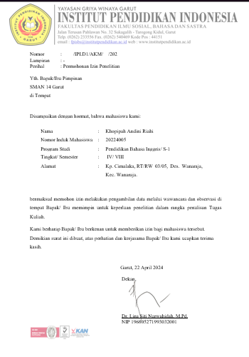
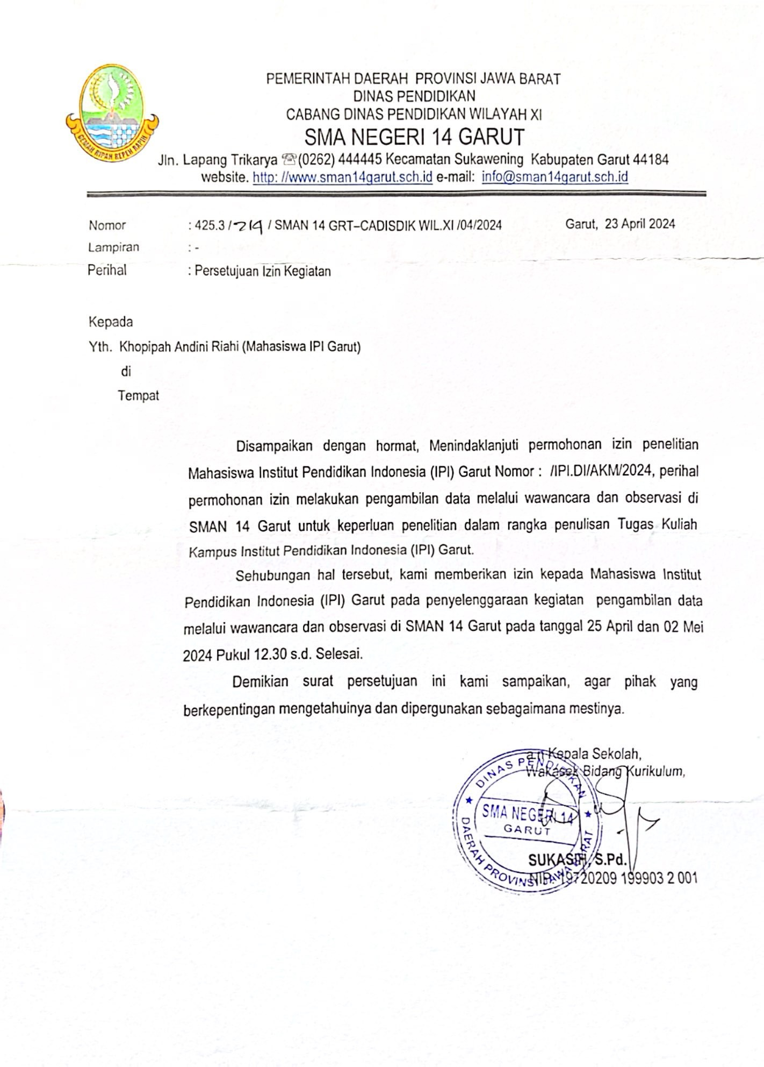

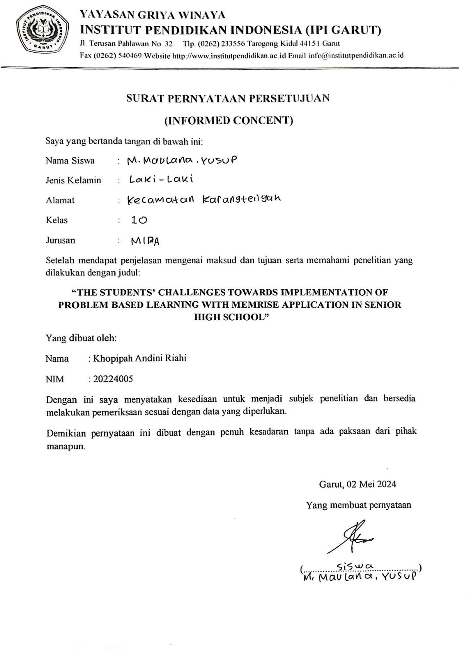
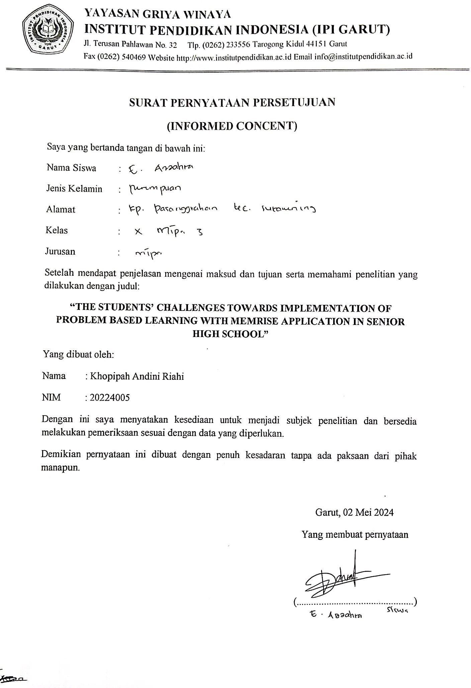
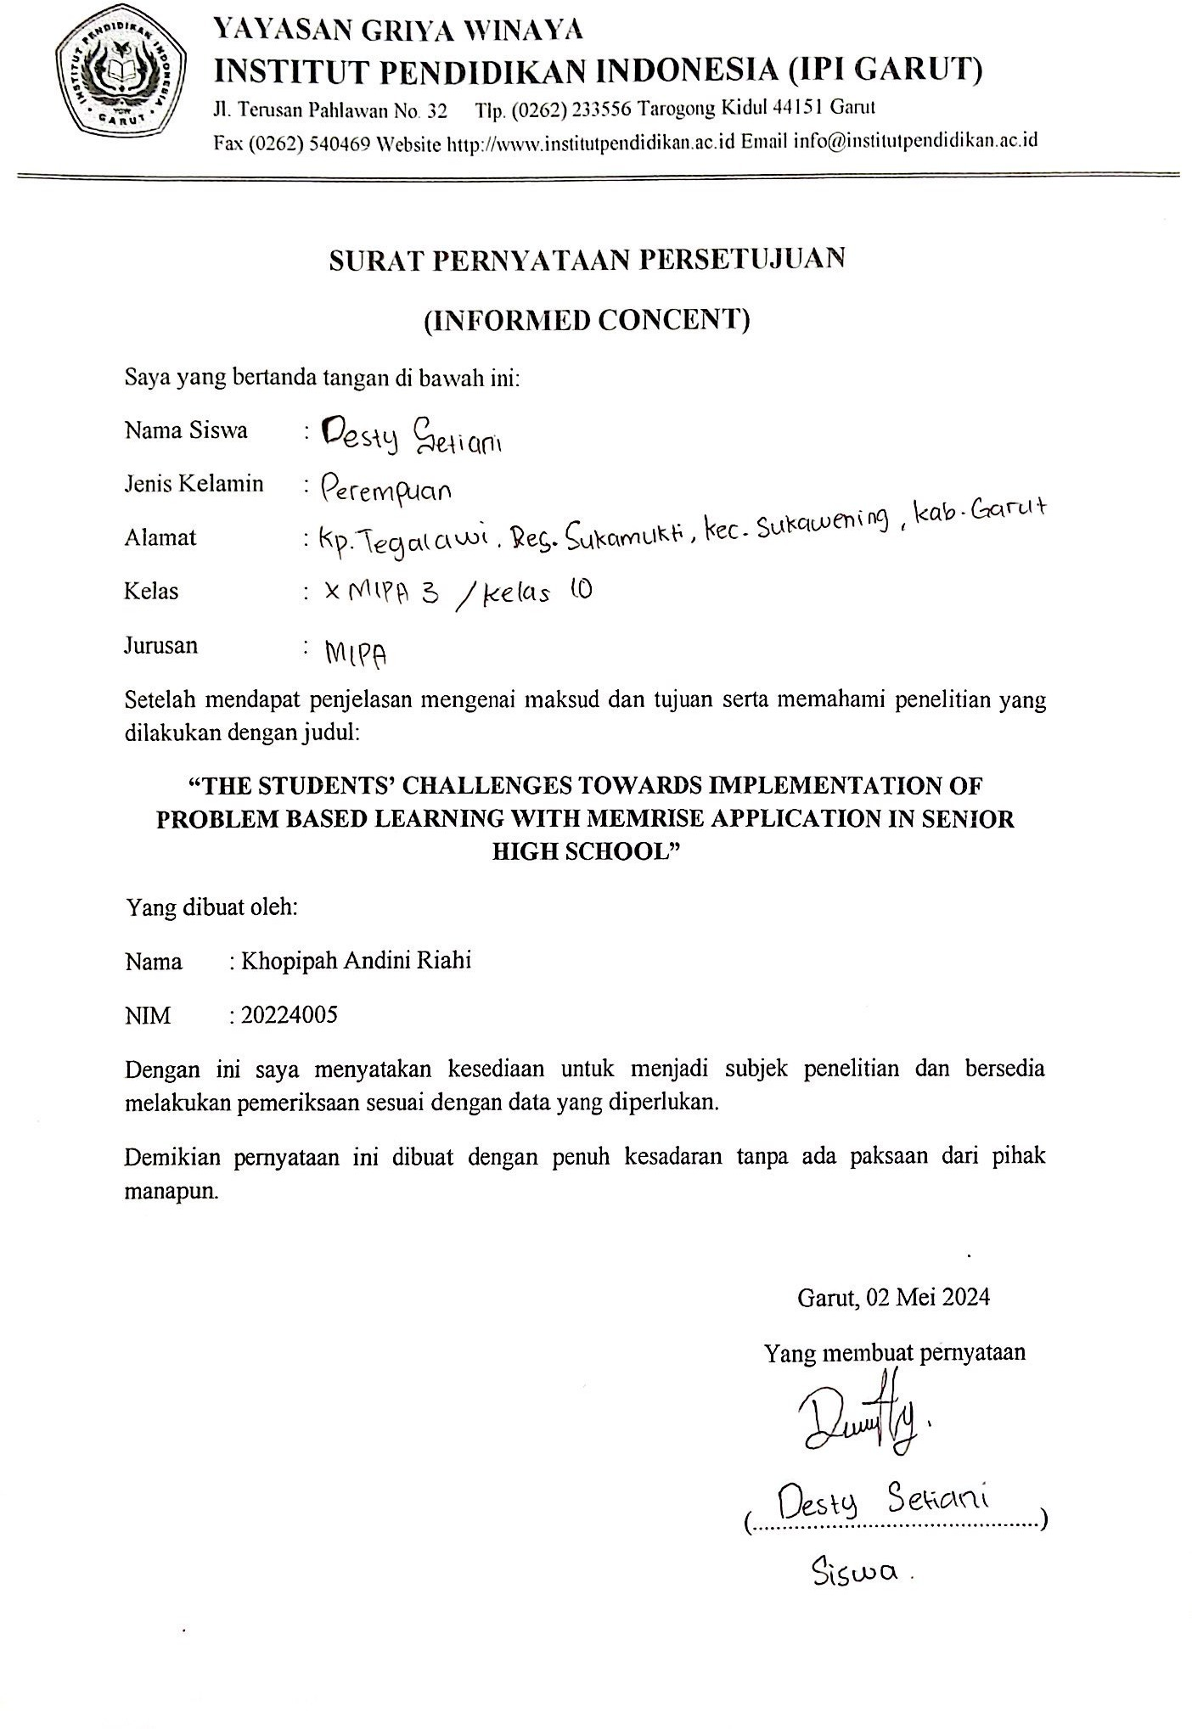
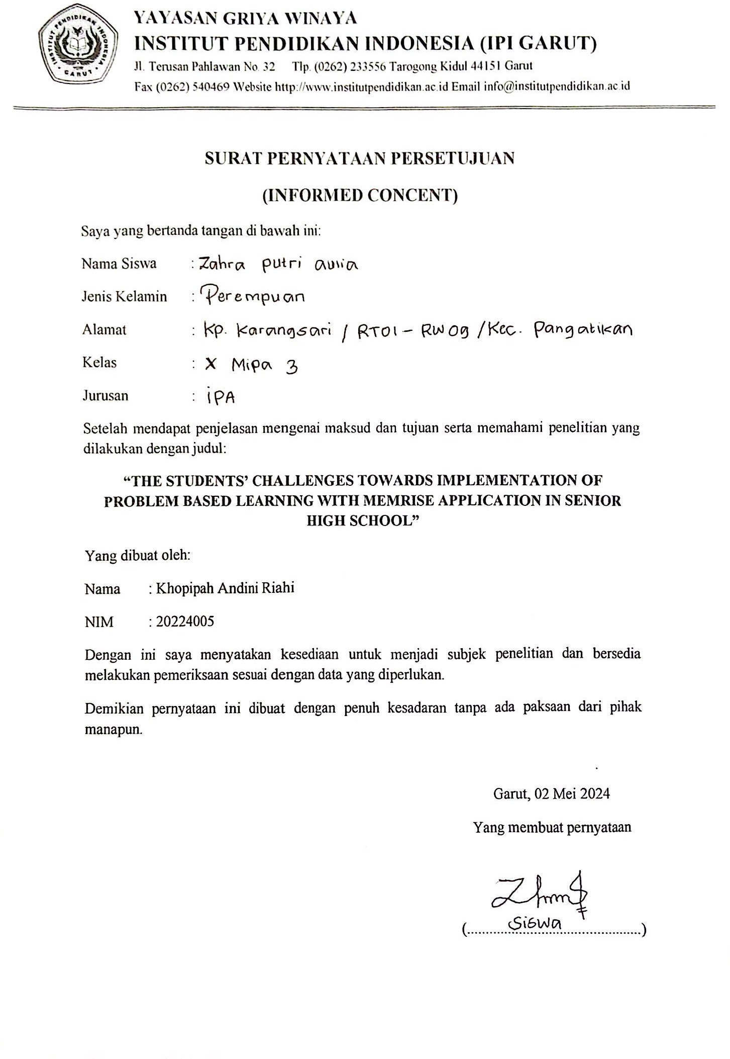
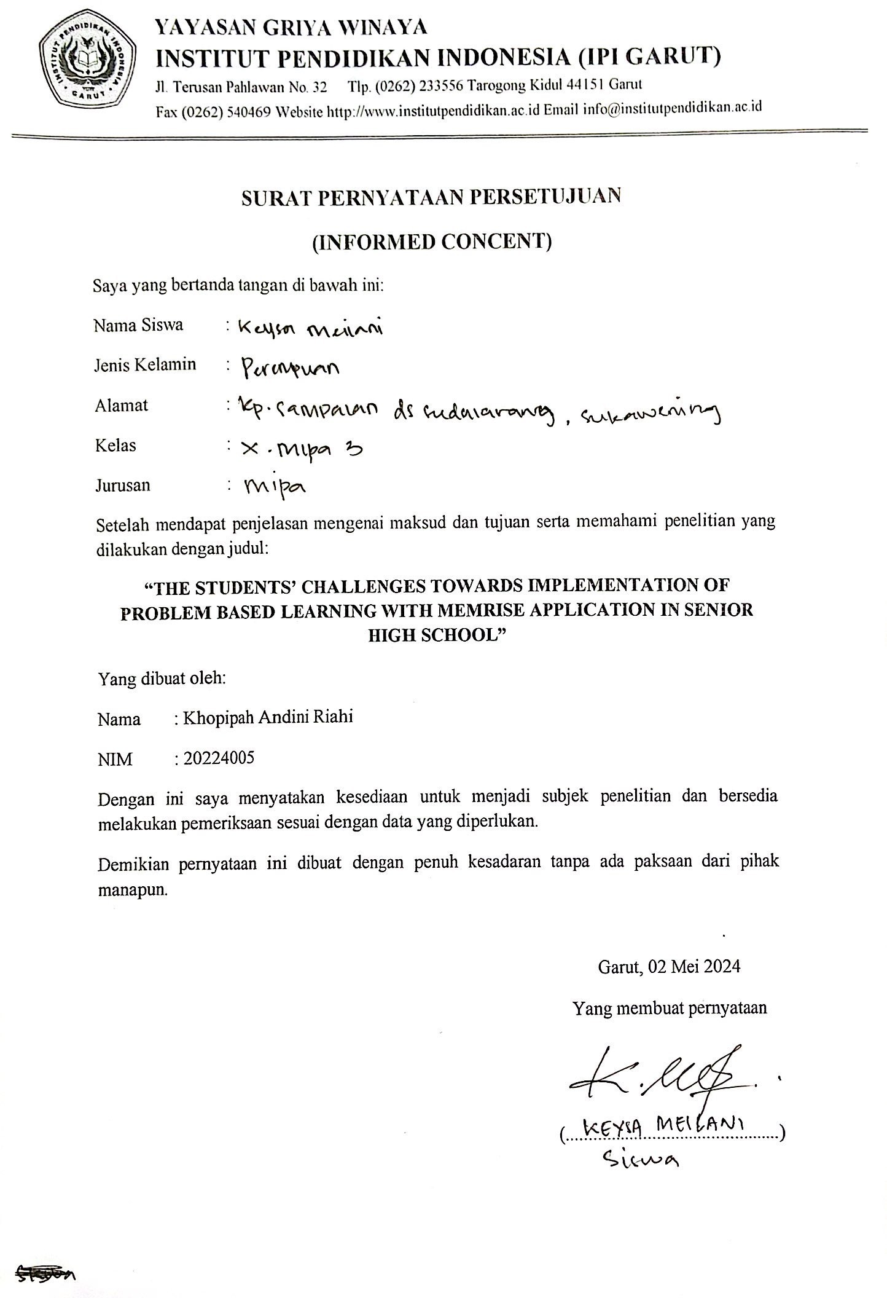

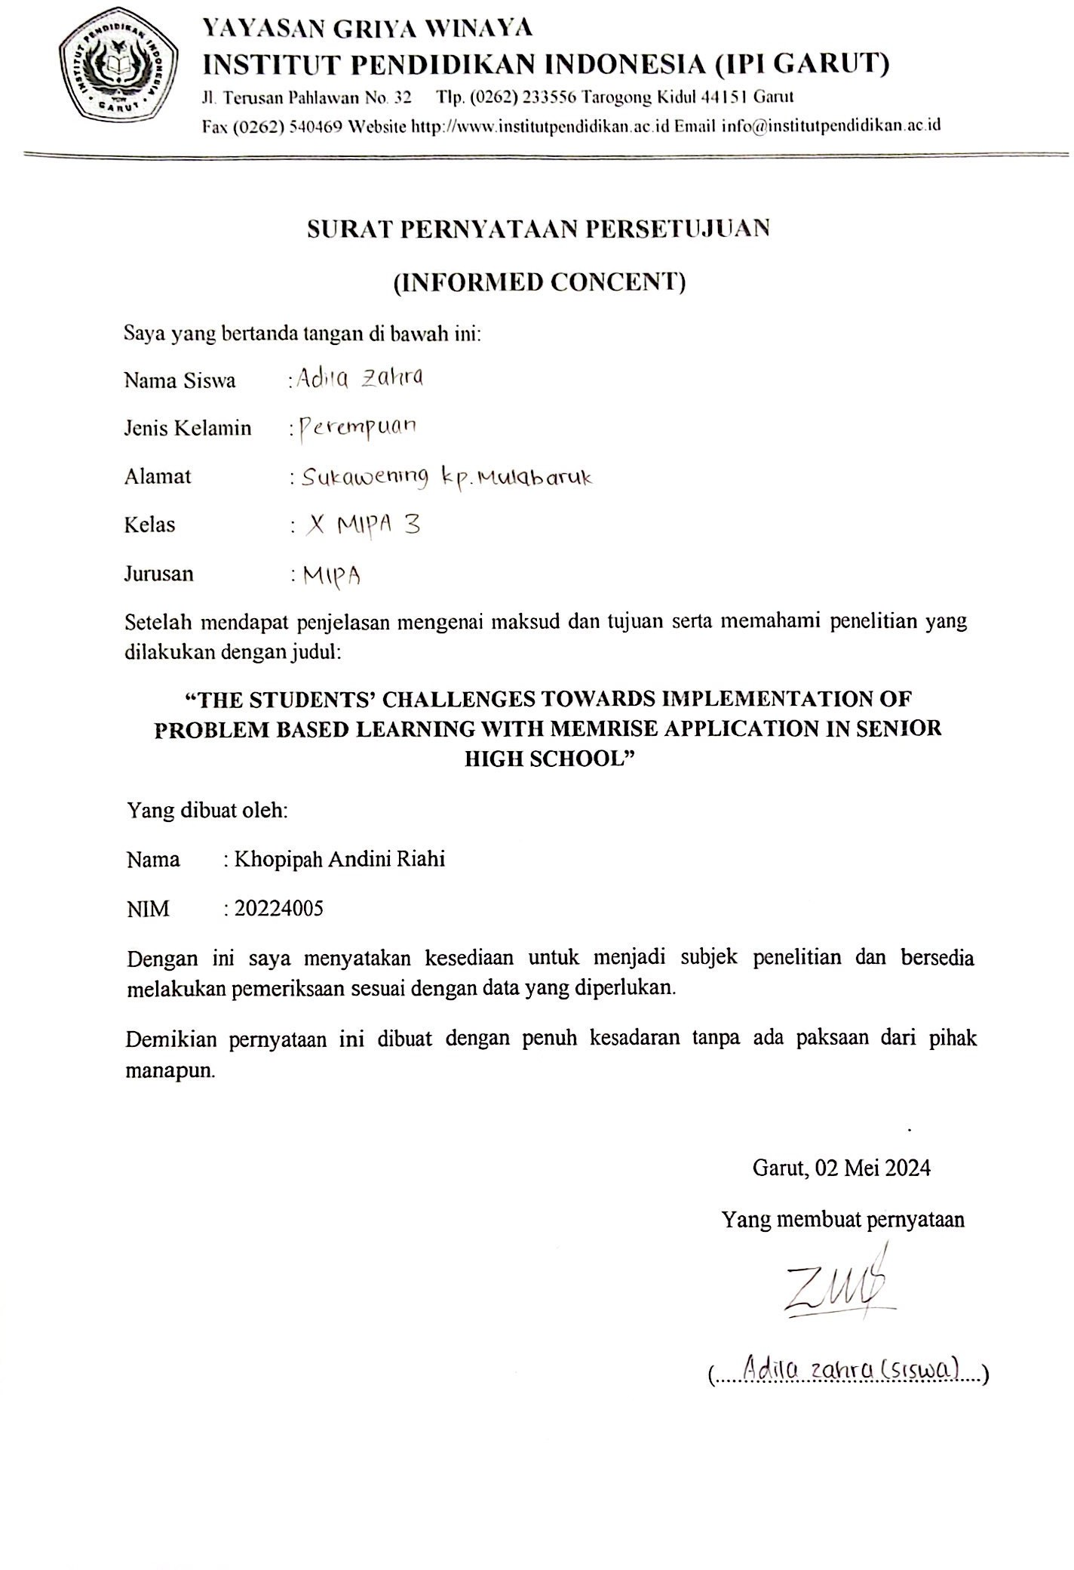
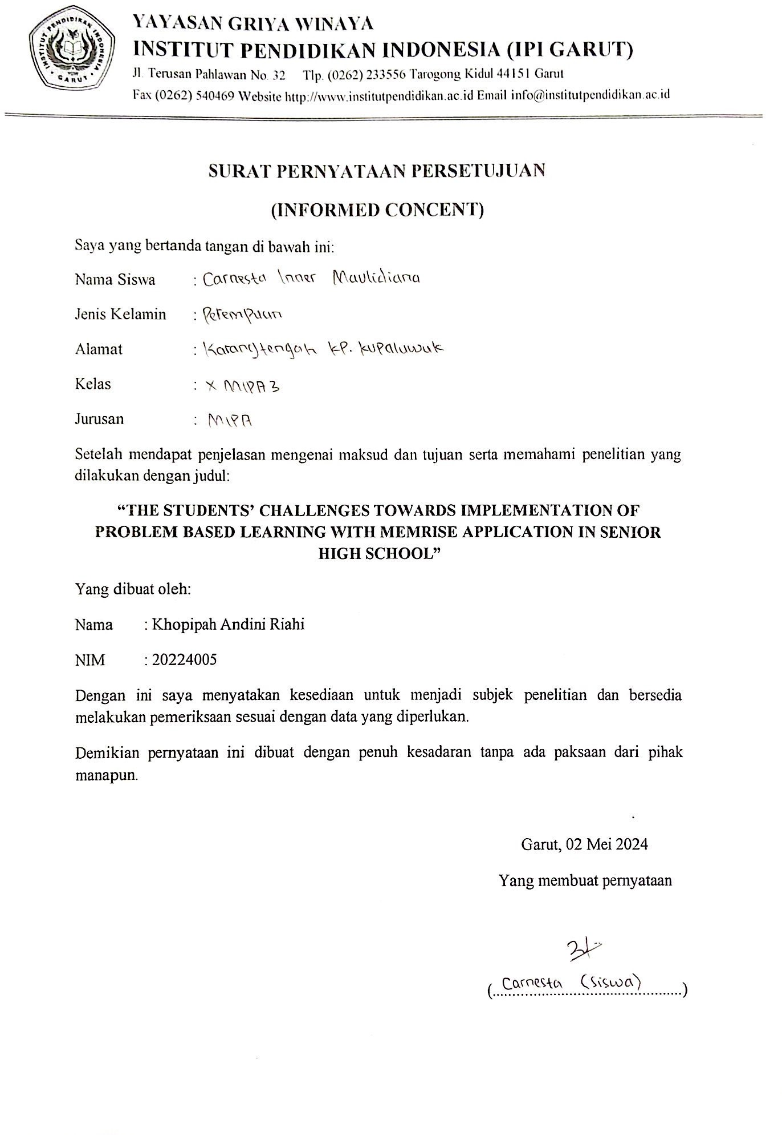
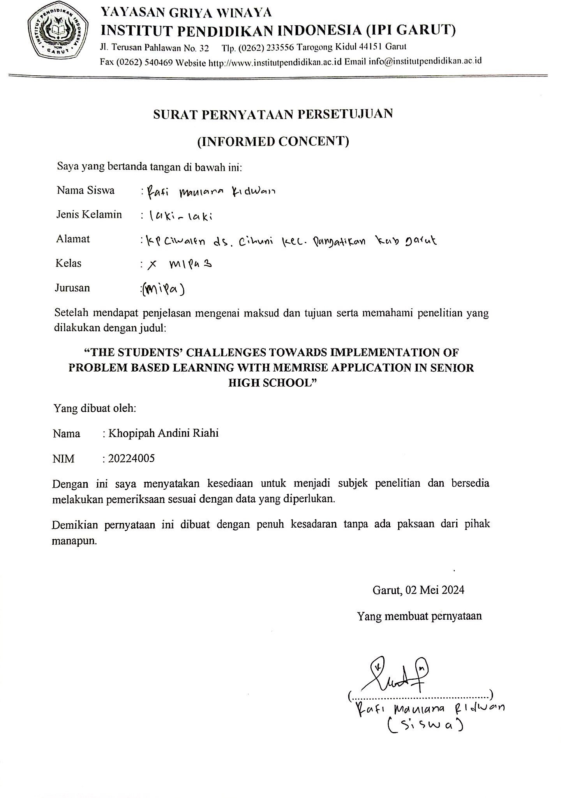
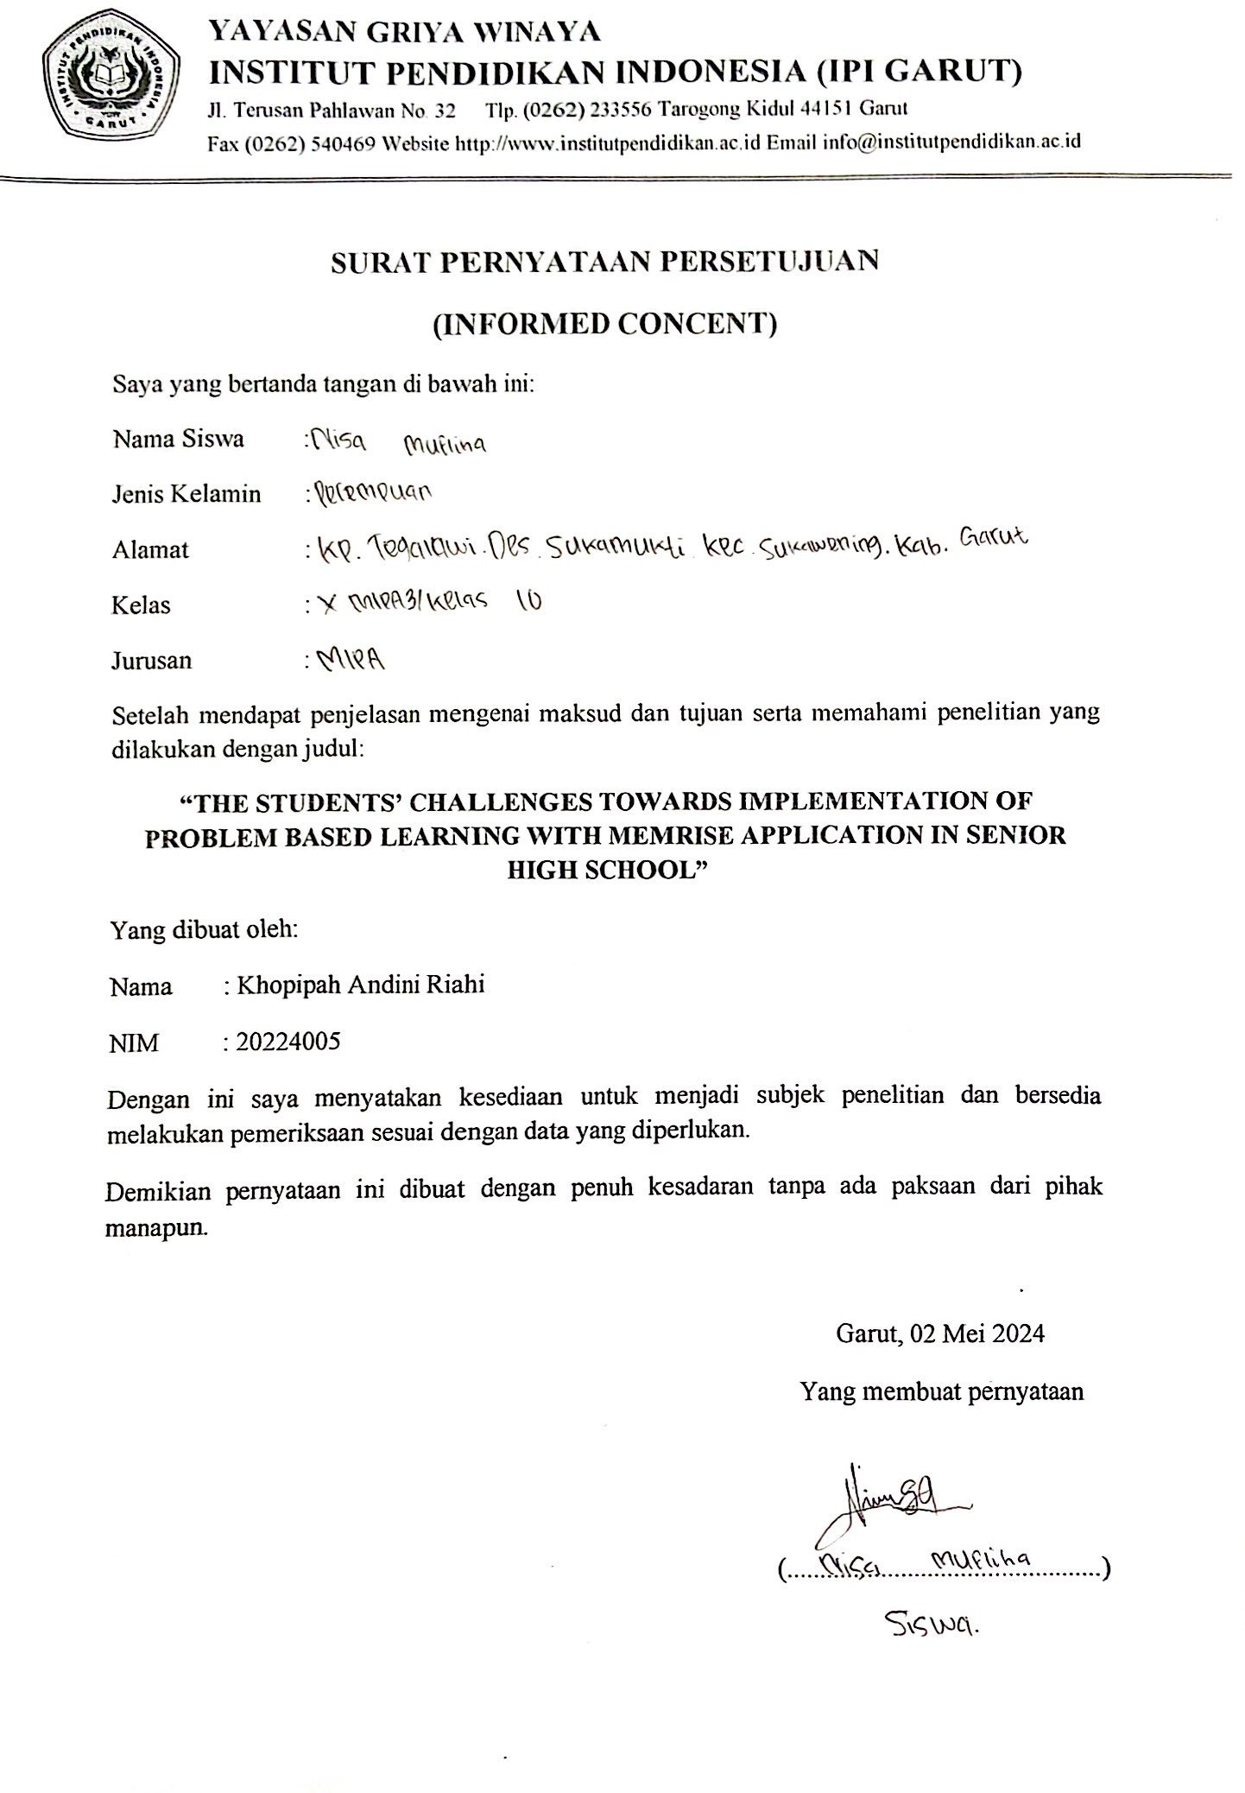

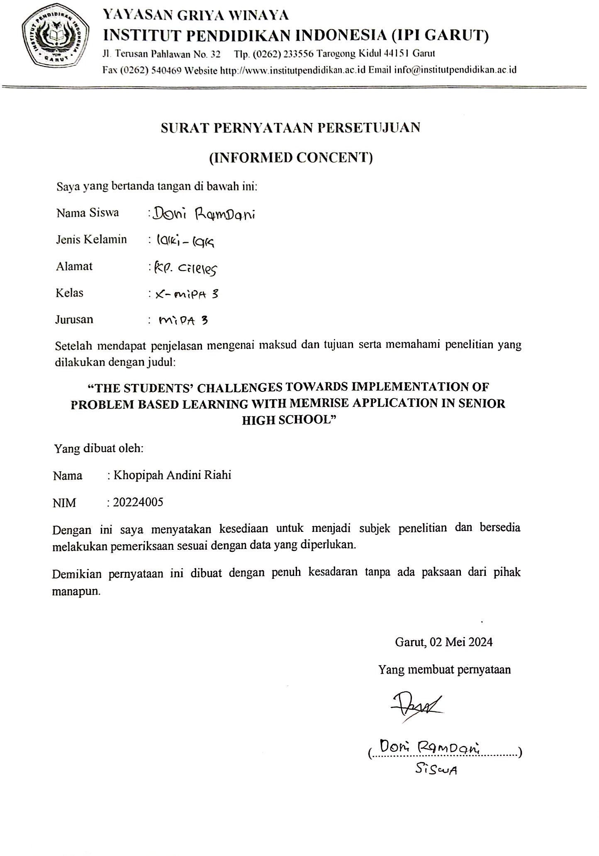

APPENDIX 4

THE THESIS GUIDANCE CARD

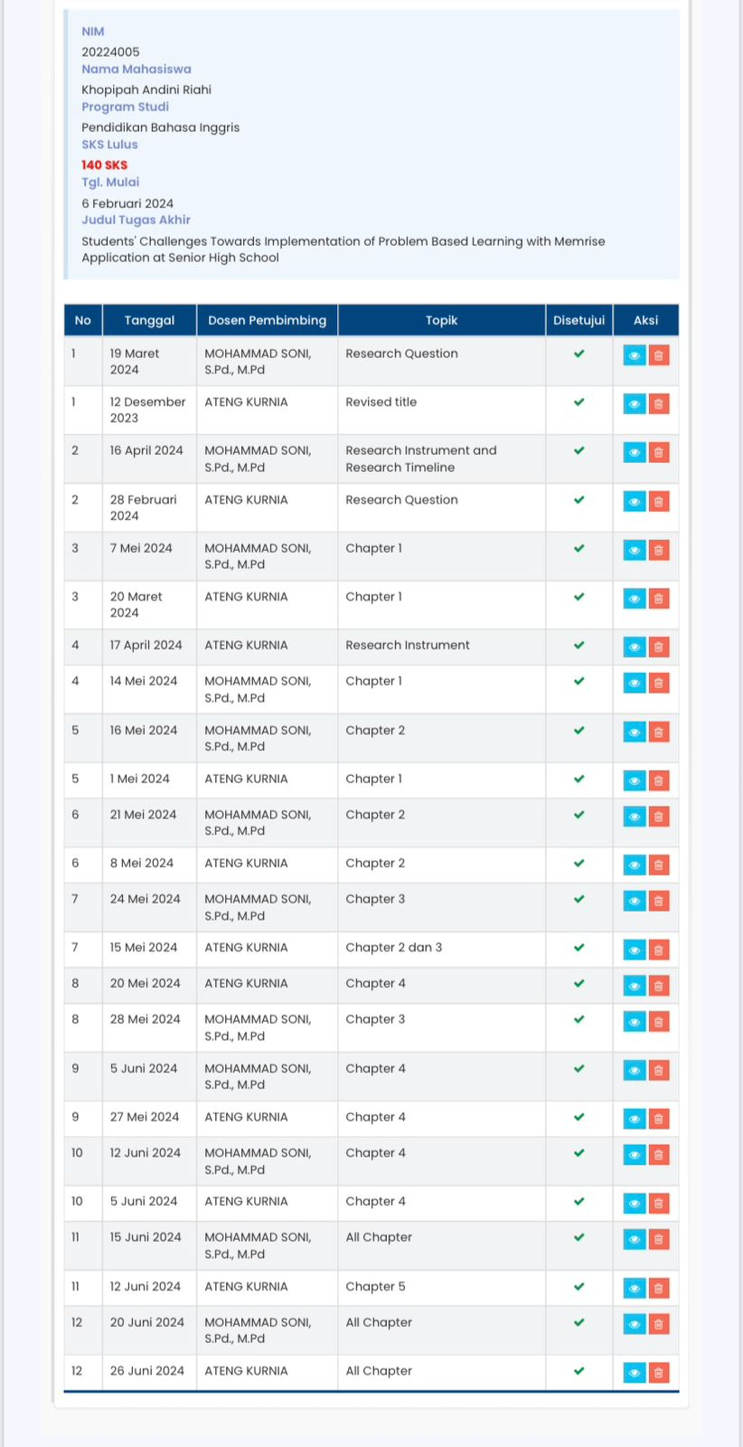

APPENDIX 5
DOCUMENTATION

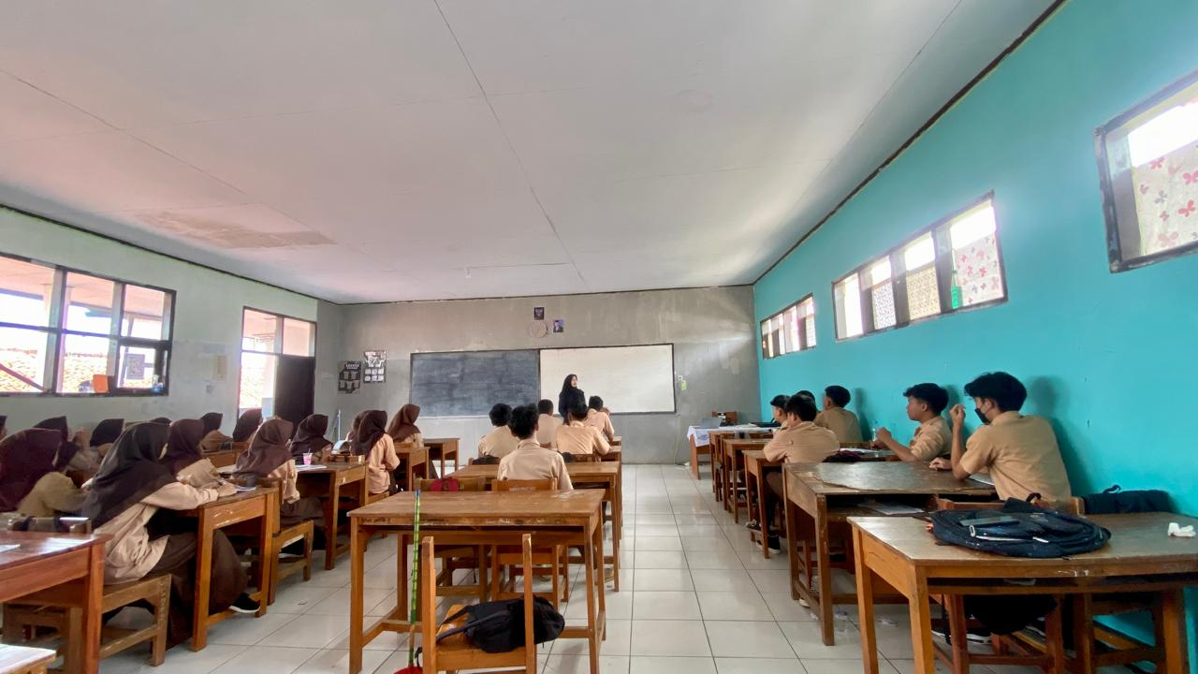

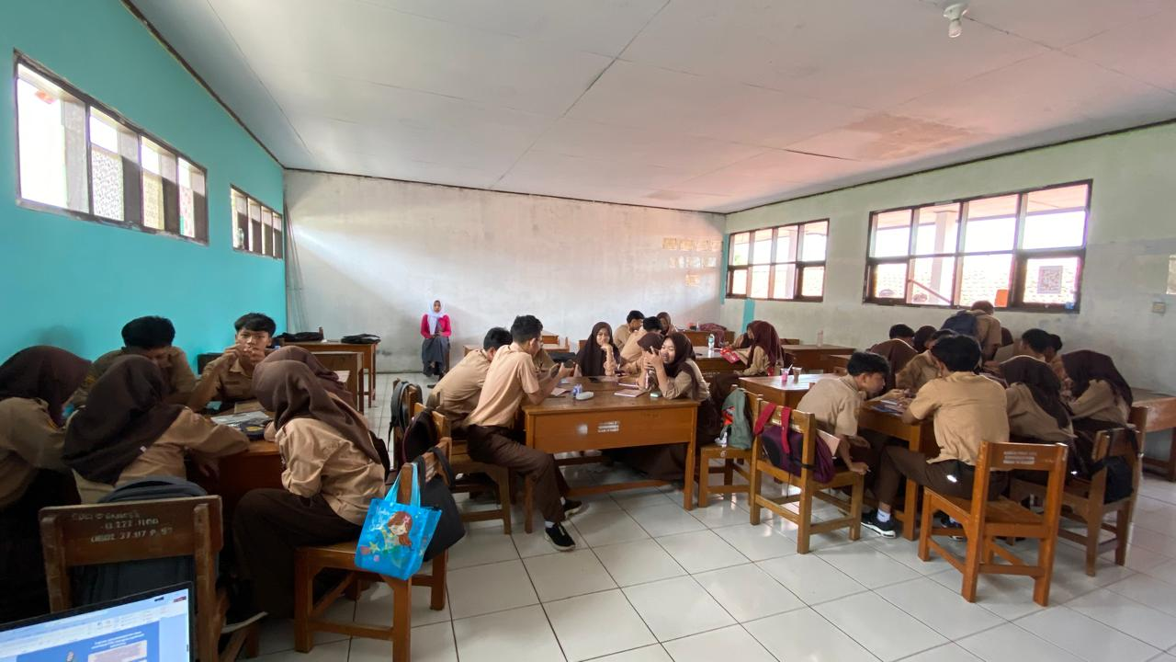

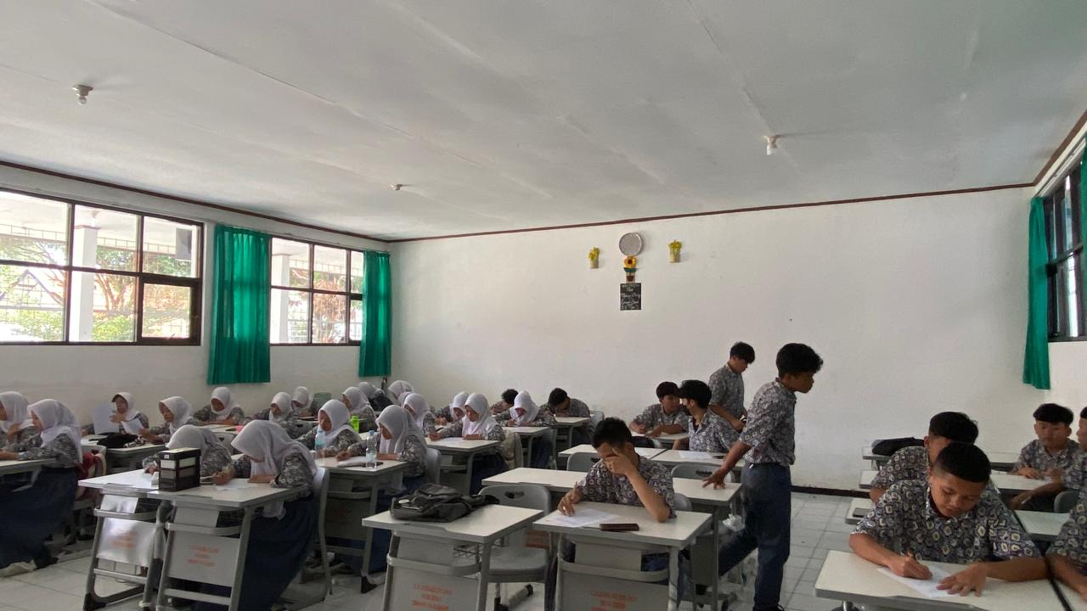
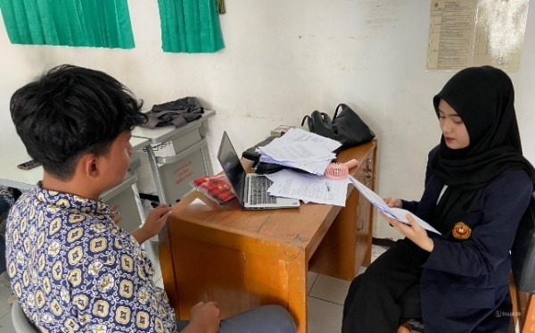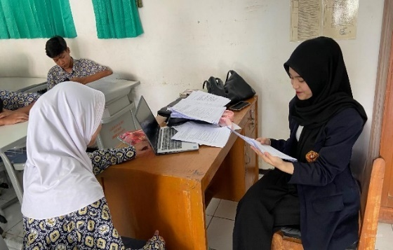

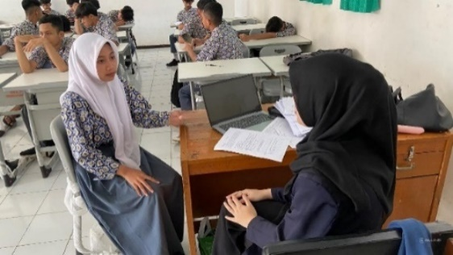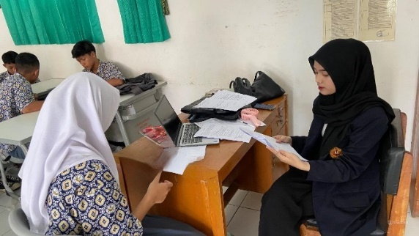

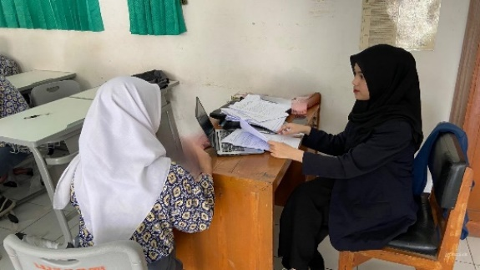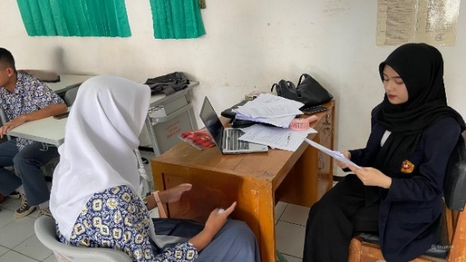

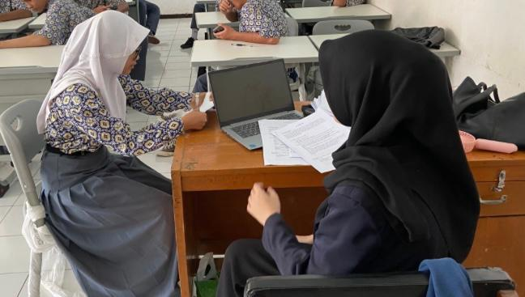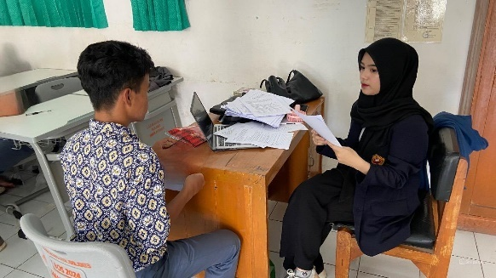

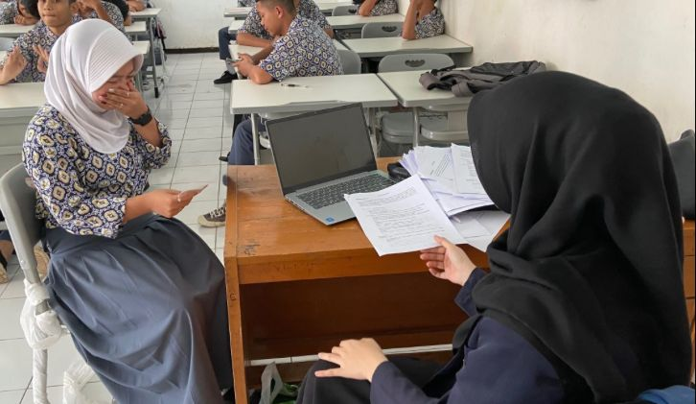

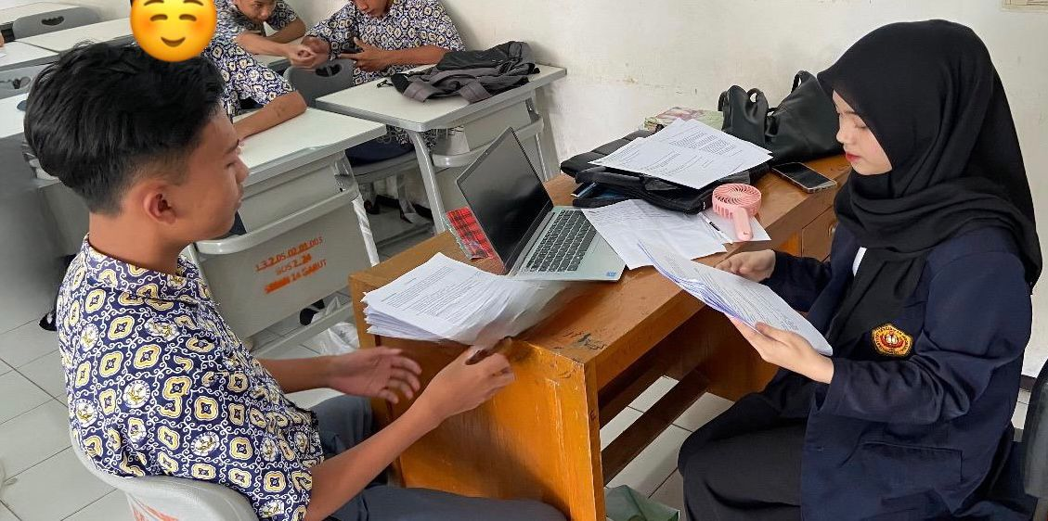

CURRICULUM VITAE

The writer's full name is Khopipah Andini Riahi. She was born on October 20th, 2001, in Garut. She is the first daughter of her beloved parents, Mr. Budi Riahi and Mrs. Feni Kustini. She has one sister (Aurellia Nur Fadilah). Although her parents live in Garut, she lives with her beloved grandma (Eti Rusnaeti) and grandfather (Engkus Hidayat). The writer has hobbies such as playing badminton and watching movies with her family.
She graduated from the Elementary School of SDN 1 Tegalpanjang Garut in 2014. She continued her study in SMPN 1 Wanaraja in 2017. And she graduated from SMAN 18 Garut in 2020. In 2020, she registered as a college student in Institut Pendidikan Indonesia (IPI) Garut. She took English Education and proposed a degree in English Education Program at Institut Pendidikan Indonesia (IPI) Garut.

