TEACHER’S PERCEPTION OF MERDEKA CURRICULUM TOWARD ENGLISH LANGUAGE LEARNING IN JUNIOR HIGH SCHOOL IN GARUT

A PAPER
Submitted to the English Education Program of Institut Pendidikan Indonesia (IPI) Garut as a Partial Fulfillment of the Requirements for Bachelor of Education Degree

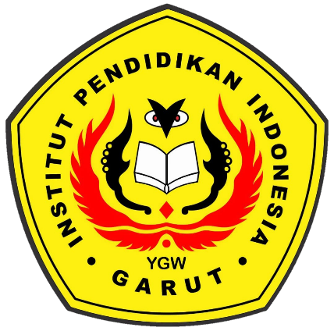

By:
Fadli Muhamad Padilah
NIM. 20222019

ENGLISH EDUCATION PROGRAM
FACULTY OF SOCIAL STUDIES, LANGUAGE AND LITERATURE EDUCATION
INSTITUT PENDIDIKAN INDONESIA GARUT
2024

APPROVAL SHEET
TEACHER’S PERCEPTION OF MERDEKA CURRICULUM TOWARD ENGLISH LANGUAGE LEARNING IN JUNIOR HIGH SCHOOL IN GARUT
A Paper
Written by
Fadli Muhamad Padilah
NIM. 20222019

First Supervisor, | Second Supervisor,
Lucky Rahayu Nurjamin, M.Pd.  NIDN. 0410098901 | Mohammad Soni, M.Pd.  NIDN. 0425069104

Acknowledged by:
Head of English Education Program,
Anne Ratna Suminar, M.Pd.
NIDN. 0415038601

LEGITIMATION OF EXAMINATION BOARD

TEACHER’S PERCEPTION OF MERDEKA CURRICULUM TOWARD ENGLISH LANGUAGE LEARNING IN JUNIOR HIGH SCHOOL IN GARUT

Written by
Fadli Muhamad Padilah
NIM. 20222019

First Examiner, | Second Examiner, | Third Examiner,
Dr. Yustika Nur Fajriah, M.Pd.  NIDN. 0412069004 | Irsyad Nugraha, M.Pd.  NIDN. 0408038304 | Anne Ratna Suminar, M.Pd.  NIDN. 0415038601
This paper has been examined on 27 of July 2024
Acknowledged by:
Dean of Faculty of Social Science, Language and Literature Education

Dr. Lina Siti Nurwahidah, M.Pd.
NIP. 196805271993032001

DECLARATION
The researcher hereby agrees that the thesis entitled “Teacher’s Perception of Merdek Curriculum Toward English Language Learning in Junior High School in Garut ” was written by the researcher. In connection with the use of references and citations from the relevant literature has been carried out based on legal procedures and scientific procedures that are valid. Therefore, the content of this paper is the original work of the researcher. In this case, if there is a complaint or if the researcher violates the statement, then the researcher is fully responsible for any consequences given.

Garut, 27 July 2024
The researcher,
Fadli Muhamad Padilah
NIM. 20222019

PERNYATAAN
Peneliti dengan ini menyetujui bahwa skripsi yang berjudul “Teacher’s Perception of Merdek Curriculum Toward English Language Learning in Junior High School in Garut”ini ditulis oleh peneliti. Sehubungan dengan penggunaan referensi, kutipan dan sitasi dari literatur terkait telah dilakukan berdasarkan prosedur hukum dan prosedur ilmiah yang sah. Oleh karena itu, isi makalah ini merupakan karya asli peneliti. Dalam hal ini, jika ada keluhan atau jika peneliti melanggar pernyataan, maka peneliti bertanggung jawab penuh atas segala akibat yang diberikan.

Garut, 27 Juli 2024
Yang membuat pernyataan,
Fadli Muhamad Padilah
NIM. 20222019

MOTTO
”Maximum Effort.”

DEDICATIONS
This paper is dedicated to the following:
My loyal parents and grandparents,
My beloved sister,
My dearest bestfriends,
My futures,
and myself

PREFACE
The writer says thanks to God Almighty, who has bestowed His mercy and guidance, so that the writer can finish writing the paper, although it is still far from being perfect. The paper entitled “Teacher’s Perception of Merdeka Curriculum Toward English Language Learning in Junior High School in Garut” is submitted to fulfill the requirement to get the Education Bachelor Degree of the English Education Program of IPI Garut. The writer should admit her imperfection in writing this paper. Therefore, she would be very grateful to receive any suggestion and critic. I hope that it can be useful, especially for personal and general readers.
Garut, 27 July 2024
The researcher,
Fadli Muhamad Padilah
NIM. 20222019

ABSTRACT
Curriculum is the most important thing in education that involves teachers and students in learning. The curriculum is a crucial aspect of education, which guides teachers and students in implementing learning programs. Merdeka curriculum promotes free learning. However, each teacher's perception of the Merdeka curriculum varies, some think that the Merdeka curriculum is positive and there are also those who think that the Merdeka curriculum is negative. This research aims to analyze how teachers perception to Merdeka Curriculum towards their teaching and learning process. This research data was collected qualitative using semi-structured interviews with two junior high school teachers in Garut. The data shows that teacher A gives a predominantly positive answer to the Merdeka curriculum, teacher A agrees with the Merdeka curriculum because the Merdeka curriculum is a revolution that makes teachers and students creative and innovative, as well as teacher B who gives a predominantly positive answer, teacher B supports the existence of the Merdeka curriculum because it can encourage teachers and students to think critically, creatively and innovatively during learning, and also provides freedom for students in the teaching and learning process. However, the two teachers had negative assumptions, such as in the teaching modules, assessments and learning models that the teachers were not used to. From these results, it is recommended that teachers participate more in seminars and meetings held by the school and the government.

Keywords:Merdeka Curriculum, Teacher Perception, Learning

ABSTRAK
Kurikulum merupakan hal terpenting dalam pendidikan yang melibatkan guru dan siswa dalam pembelajaran. Kurikulum merupakan aspek krusial dalam pendidikan yang menjadi pedoman guru dan siswa dalam melaksanakan program pembelajaran. Kurikulum Merdeka mengedepankan pembelajaran gratis. Namun persepsi masing-masing guru terhadap kurikulum Merdeka berbeda-beda, ada yang menganggap kurikulum Merdeka positif dan ada juga yang menganggap kurikulum Merdeka negatif. Penelitian ini bertujuan untuk menganalisis bagaimana persepsi guru terhadap Kurikulum Merdeka terhadap proses belajar mengajarnya. Data penelitian ini dikumpulkan secara kualitatif dengan menggunakan wawancara semi terstruktur terhadap dua orang guru SMP di Garut. Data menunjukkan bahwa guru A memberikan jawaban yang dominan positif terhadap kurikulum Merdeka, guru A setuju dengan kurikulum Merdeka karena kurikulum Merdeka merupakan revolusi yang menjadikan guru dan siswa kreatif dan inovatif, serta guru B yang memberikan jawaban dominan positif. , Guru B mendukung adanya kemandirian kurikulum karena dapat mendorong guru dan siswa berpikir kritis, kreatif dan inovatif dalam pembelajaran, serta memberikan kebebasan bagi siswa dalam proses belajar mengajar. Namun kedua guru tersebut mempunyai asumsi negatif seperti pada modul pengajaran, penilaian dan model pembelajaran yang belum biasa digunakan oleh guru. Dari hasil tersebut, disarankan agar guru lebih banyak berpartisipasi dalam seminar dan pertemuan yang diadakan oleh sekolah dan pemerintah.
Kata kunci: Kurikulum Merdeka,Persepsi Guru,Pembelajaran

ACKNOWLEDGEMENTS
Alhamdulillah, by the grace of Allah the Cherisher and Sustainer of the world, the Lord of all power in this universe and hereafter, this paper could be finished after passing through various moments. In this chance, the writer would like to acknowledge her sincere, deepest and profound gratitude to these following people:
- Dr. H. Nizar Alam Hamdani, M.M., M.T., M.Si. M.Kom. as Rector of Indonesian Institute of Education (IPI) Garut;
- Dr. Hj. Lina Siti N, M.Pd., the Dean of the Faculty of Social Science, Language, and Literature Education in Indonesian Institute of Education (IPI) Garut;
- Anne Ratna Suminar, M.Pd., the Head of English Education Program in Indonesian Institute of Education (IPI) Garut and the lecturer guardian of class C;
- Lucky Rahayu Nurjamin, M.Pd., as the first supervisor in completing this paper;
- Mohammad Soni, M.Pd., as the second supervisor in completing this paper;
- All the lecturers of English Education Program that had given the precious knowledge, advices, motivation, and experiences to the writer;
- The writer's parents, thank you so much for your love, support, pray, and everything that have been given to the writer in writing this paper;
- My Friend the one and only “Big Three”, Harits, Hafizh for your support, motivation, and inspiration;
- My friend in collage, Marini Zaizahaini and Sylva Nova , who have supported with encouraged the writer throughout college and who have been there for the happiest and worst moments.
- My friends ASBAL, which cannot be listed individually because 10 people are too many but 10 years is too short, for serving as a helpful reminder, a place to turn to and a support system for the writer when she is uncertain of his life's direction;
- Friends of Elementary school, which cannot be listed individually because 6 people are too many for always have been there and supporting the writer over the past 12 years;
- Class B and the family of HIMADIKSARIS, who have shared the best knowledge, good experiences and the biggest lesson;
- Thank you for “her” to keep me strong even have long distance but your support is good for me
- Last, I want to thank myself for enduring so much sadness and joy, especially for going through so many difficult situations. Much appreciated to myself, who has consistently advanced and processed gradually to complete this paper..

TABLE OF CONTENTS

APPROVAL SHEET i
LEGITIMATION OF EXAMINATION BOARD ii
PERNYATAAN iv
MOTTO v
PREFACE vi
ABSTRACT vii
ABSTRAK viii
ACKNOWLEDGEMENTS ix
TABLE OF CONTENTS xi
CHAPTER I INTRODUCTION 1
1.1 Background of the Study 1
1.2 Reason for Choosing the Topic 6
1.3 Research Question 6
1.4 Research Objective 6
1.5 Significance of Study 6
1.6 Definition of Terminologies 6
1.6.1. The Merdeka Curriculum 6
1.6.2. Teacher Perception 7
CHAPTER II REVIEW OF LITERATURE 8
2.1 Merdeka Curriculum 8
2.1.1 Implementation Merdeka Curriculum 9
2.1.2 Learning Model in Merdeka Curriculum 10
2.1.3 Learning Module in Merdeka Curriculum 12
2.1.4 Advantages and Disadvntages Merdeka Curriculum 13
2.2 Techer Perception 14
2.3 Previous Studies 16
CHAPTER III RESEARCH METHOD 18
3.1. Research Method 18
3.2. Research Design 18
3.3. Research Site and Participant 18
3.4. Research Instrument 19
3.5. Technique of Data Collection 20
3.6. Data Analysis 20
3.7. Research Procedure 21
CHAPTER IV RESEARCH FINDING AND DISCUSSION 22
4.1 Research Finding 22
4.1.1 Perception of Merdeka Curriculum, Model and Role 22
4.1.2 Implementing Model Merdeka Curriculum 29
4.1.3 Obstacle in Merdeka Curriculum (Model,Modul and Assesment) 31
4.2 Research Discussions 35
4.2.1 Perception of Merdeka Curriculum, Model and Role 35
4.2.2 Implementing Model Merdeka Curriculum 37
4.2.3 Obstacle Merdeka in Model , Modul and Assesment 39
CHAPTER V CONCLUSION AND SUGGESTION 41
5.1 Conclusion 41
5.2 Suggestion 42
REFERENCES 43
APPENDICES 48
APPENDIX 1 Indicator and Question 49
APPENDIX 2 Transcript 53
APPENDIX 3 Documentations 64
APPENDIX 4 Research Agreement Letter 66

CHAPTER I
INTRODUCTION
This introduction chapter provides the background of the study, research question, research objective, significance of the study and definition of terminologies.
  - Background of the Study
Curriculum is the most important thing in education that involves teachers and students. according to (Macalister & Nation, 2019) the curriculum is a set of guidelines designed in a learning program consisting of principles, environment and needs in accordance with the program targets, learning carried out. The curriculum is an important aspect of the educational process (Insani, 2019). The aim of implementing the curriculum at the educational unit is a reference for the realm of carrying out education at the educational unit level (Restiana et all,2022). According Hidyani (2018) Curriculum is an important part of the entire educational process. Merdeka Curriculum is learning promotes the development of a free spirit in which teachers and students can freely and enthusiastically explore their knowledge, attitudes, and skills (Daga,2021). A learning tool that is crucial to the implementation of formal and informal education programs is the curriculum ( Hidayah et all,2022). When planning learning activities to meet national education goals, educators refer to the curriculum, which is a collection of plans and arrangements pertaining to objectives, content, learning resources, and techniques (Rahmawati et al., 2023). The curriculum is a crucial aspect of education, guiding teachers and students in implementing learning programs. It promotes free learning, encourages exploration, and serves as a learning tool for meeting national education goals.
The curriculum has evolved over time. According Mulenga et all, (2019) These days, the curriculum includes information on learning experiences in addition to lesson plans. Furthermore, as change is a natural part of life, both the curriculum and teachers must be prepared to adjust to these changes (Rahmawati et al., 2023). According Andriani (2022) Individuals with a strong
desire to learn more will advance and evolve in order to better equip themselves to deal with the constantly shifting circumstances of our day. The management of Indonesia's educational curriculum has evolved in tandem with the education ministers policy changes (Rosita et all, 2023). Numerous curriculum modifications have occurred in Indonesia, including those that occurred in 1947, 1964, 1968, 1973, 1975, 1984, 1994, 1997, 2004, 2006, and 2013, the most recent of which was in 2013. Political factors often impact curriculum modifications (Muhammedi, 2023). Preschool, elementary, secondary, and postsecondary education all need to be included in a sustainable education system (National Education Research Agency, 2014). According to Bahri, (2011) Even with a very well-structured curriculum, there comes a point at which it must be modified or enhanced. The frequent modifications to Indonesia's national education curriculum have sparked rumors and unfavorable perceptions among the public that these changes, or replacements, are more often motivated by political considerations than by pressing requirements (Julaeha, 2019). Curriculum modifications take place in response to advances in science and technology as well as the growing expectations of society for formal education (Nuraini,2020). Curriculum modifications take place in response to advances in science and technology as well as the growing expectations of society for formal education (Aprillia et al., 2023). Indonesia curriculum evolves annually, incorporating learning experiences and lesson plans. Changes are natural and require teachers and curriculum managers to adapt. Political factors often influence curriculum modifications, but they are necessary for a sustainable education system. These changes are driven by science, technology, and societal expectations.
In indonesia during Covid-19 the government used the new curriculum the name is "Emergency Curriculum" for the student because the student cant go to school during Pandemic Covid-19, after pandemic the government have policy the name is new normal and change the curriculum for the student the name is Merdeka Curriculum. In the realm of Indonesian education, the transition from the Emergency Curriculum to the Merdeka Curriculum is revolutionary. The Emergency Curriculum offers a solid foundation for overcoming educational obstacles in trying times. It was developed in response to emergency situations. But with things becoming more stable and the need for education that is more comprehensive and flexible growing, the move to the Merdeka Curriculum is essential. A change toward a learning strategy that is more inclusive, collaborative, and results-oriented is marked by the Merdeka Curriculum. Through a focus on fostering 21st century abilities and enhancing creativity and innovation, the Merdeka Curriculum equips students with the necessary skills to become future leaders who can adjust and make valuable contributions to a constantly evolving society. Furthermore, the Merdeka Curriculum guarantees that education is about more than just academic success rather, it's about developing good, responsible people by bolstering moral principles and character. It is envisaged that this transfer will enable Indonesian education to keep up with modern needs and significantly advance the country.
Perception is a person understanding in interpreting something. According Kotler (2000), who clarified that the act of choosing, organizing, and interpreting data to produce a meaningful thought is known as perception. Since teachers have a significant influence on education, it is crucial to investigate how they view the new autonomous curriculum (Saputra & Hadi, 2022). Teacher Perception to the Merdeka Curriculum might differ based on a number of variables, including their background in education, how well they comprehend the curriculum's ideas, and the resources and circumstances of the school where they work. Because the Merdeka Curriculum offers more flexibility and independence in creating lessons that meet the needs and interests of students, some teachers may find it appealing. They can view it as a chance to create a more creative and interesting teaching strategy. However, sufficient assistance and instruction from pertinent stakeholders will be crucial to guaranteeing the efficacious execution of the Merdeka Curriculum at the educational institution.

Many previous studies has studied teacher perception of merdeka curriculum. For example Dendi et al (2022) investigated Persepsi Guru Sekolah Jakarta Utara dan Kepulauan Seribu Tentang Kurikulum Merdeka an found that 1) Background of the teacher. 2) level of education. 3) teacher's degree. 4) Training followed by the teacher. 5) teacher teaching experience.
In Line with mai et al (2023), Faisal et al (2023), and Rosita et al (2023) investigated and found The advantges that (1) the Merdeka curriculum has several advantages over the Merdeka curriculum, the Merdeka curriculum emphasizes student creativity, students are more creative and teachers have freedom in carrying out learning. (2) the changes felt by teachers in learning are that students are more active, creative and innovative , directed learning, there is no connection in providing material. (3) the socialization and provision of teachers has not been optimal and further guidance is still needed (4) The implementation of the Merdeka curriculum in schools has undergone many changes. Among them, in the administration of learning activity plans, teachers prepare simplified lesson plans. So that teachers can carry out their duties, namely teaching in class and focusing on learning in class. The Merdeka curriculum is relatively more effective in learning, where the learning process carried out through project activities will also be more extensive, providing opportunities for students to further develop their competencies and character. In this case, educators are given the freedom to design learning creatively and students are also given sufficient time to explore concepts. (5) The teacher agrees with the learning of Pancasila student profiles and projects. (6) the learning models that teachers often use are problem based learning, project based learning, cooperative learning, discovery learning and contextual learning. (7) Can develop teaching material modules and adapt learning to student achievement stages and characteristics.
Mai et al (2023), Faisal et al (2023), and Rosita et al (2023) found the obstacle that (1) obstacles experienced by teachers, namely lack of infrastructure, difficulty in determining the depth of material to be taught because in (Capaian Pembelajaran) CP only general material is given, lack of teaching materials, determining (Proyek Penguatan Profil Pelajar Pancasila) P5, making modules. Apart from that, there are teachers who have problems with the internet network in their area to access the (Platform Merdek Mengajar) PMM application in their area. (2) Some teachers feel they are not ready to implement learning in the classroom. (3) Some teachers feel they are not ready for rapid or sudden changes in the curriculum. (4) The curriculum structure is the same. (5) There are still many teachers who are having problems accessing information via the internet. (6) The obstacles to the Merdeka curriculum are that everything must be digital. (7) The availability of infrastructure is not yet available evenly in schools. (8) The previous curriculum has not been completed to lead to success, but has been changed to a new curriculum, and there are no indicators that support the success of the curriculum.
Although from the previous studies above, an investigation into the teacher perception of Merdeka curriculum was carried out investigations regarding the perception of Merdeka curriculum in English language learning in junior high school is still under research. Therefore, this research aimed to understand the importance of teachers’ perceptions of the implementation of the Merdeka Curriculum, the latest education policy in Indonesia, in the context of English learning at the junior high school level. Given the very central role of teachers in the success of the curriculum, this study aims to explore their experiences, challenges, and expectations regarding the curriculum changes, especially in Garut which has unique social and cultural characteristics. By focusing on the English learning aspect, this study is expected to provide deeper insight into the impact of the curriculum on the quality of education and provide recommendations for improving the implementation of the curriculum in schools.
in line with this, this research attempts to fill this gap by investigating The Teacher Perception of Merdeka Curriculum in English Language Learning.

  - Reason for Choosing the Topic
The Researcher choose this topic because he wanted to know on provide deeper insight into the impact of the curriculum on the quality of education, provide recommendations for improving the implementation of the curriculum in schools and discusses the perception of teacher in Merdeka curriculum.
  - Research Question
Based on the background the study above, the problem that will be discussed in this study is “How are the teachers perceptions on Merdeka Curriculum to their teaching and learning process?”
  - Research Objective
Concerning on the research question above, the research of this study is aimed to investigate the perception of merdeka curriculum in english language learning in junior high school.
  - Significance of Study
This research is expected to impact theoretically and practically elaborated in the following section:
1. Theoretically : The result of the research can be reference for teachers to anticipate the strategies in facing students’ in learning process.
2. Practically : This study is expected to be able giving solution teacher to comprehend and internalize the values of character education in the teaching process
This research can determine the comparison of teachers perceptions regarding the Merdeka Curriculum.

  - Definition of Terminologies

To avoid the controversial or ambiguous terminologies which are used on this research, the researcher presents several specialized terms. Those are:
    - The Merdeka Curriculum

is a new policy program of the Ministry of Education and Culture of the Republic of Indonesia (Kemendikbud RI), which was introduced by the Advanced Indonesia Cabinet, the Minister of Education and Culture of the Republic of Indonesia. believed that teachers had to learn the fundamentals of freedom of thought before they could impart them to their students (Evi 2020).
    - Teacher Perception

Perception is a person understanding in interpreting something. The process of choosing, arranging, and interpreting data to generate a meaningful thought is called perception (Kotler 2000). asserts that the significance of an Teachers perceptions is equivalent to that of their views, which are deeply held opinions about the subjects they teach, their responsibilities, their students, the curriculum, and their classroom (Pajares 1992).

CHAPTER II
REVIEW OF LITERATURE
In this chapter, the researcher presents about theoretical description, previous study, rationale, and hypothesis..
  - Merdeka Curriculum
The merdeka Curicculum is new curriculum in indonesia. The Merdeka Curriculum is a new policy program of the Ministry of Education and Culture of the Republic of Indonesia (Kemendikbud RI,2022), which was introduced by the Advanced Indonesia Cabinet, the Minister of Education and Culture of the Republic of Indonesia. Nadiem believed that teachers had to learn the fundamentals of freedom of thought before they could impart them to their students (Evi 2020). The merdeka curriculum is implemented with the help of a number of programs, such as the high school of excellence and the movers school program (Kemendikbud, 2022). One of the new programs run by the Ministry of Education and Culture of the Republic of Indonesia is the Merdeka curriculum, which was started by Nadiem Anwar Makarim, the Minister of Education and Culture of the Republic of Indonesia during the Advanced Indonesia Cabinet period (Hattarina et al., 2022). There are measures in this curriculum aimed at raising pancasila student profiles performance levels, after that, production is based on the government selected topics. According Eni (2022) The Ministry of Education, Culture, Research, and Technology only released a policy on the use of an Merdeka curriculum at the start of the 2022 academic year, prior to that, Indonesia employed the Emergency curriculum, which is a shortened version of the 2013 curriculum, from the start of the pandemic until 2021. The Ministry of Education and Culture is also working to address the long-standing learning issue brought on by the pandemic by implementing an Merdeka curriculum (Yuni et al, 2022). According Rahmat (2022), The Merdeka curriculum places an emphasis on teachers and students creativity rather than restricting the idea of learning outside of the classroom. The Merdeka Curriculum is a new policy program in Indonesia, introduced by the Ministry of Education and Culture to promote freedom of thought and improve pancasila student performance levels, following the pandemic's impact on education.
    - Implementation Merdeka Curriculum
After curriculum is a refinement of the previous curriculum after pandemic. According Tono (2022) The Ministry of Education and Culture implemented the 2013 Curriculum and Emergency Curriculum during the 2020-2021 pandemic. COVID-19 has impacted school teaching and learning, posing challenges like limited technology proficiency, inadequate facilities, internet access, and budget constraints (Amalia & Sa’dah, 2020). Providing resource personnel from the movement school/vocational high school center of excellence that has implemented the merdeka curriculum using a strategic approach (Nugrah 2022).The implementation of post-pandemic education will be greatly aided by the internet, big data, artificial intelligence, 5G, and cloud computing during this recovery period (Zhu & Liu, 2020). The Merdeka curriculum, refined post-pandemic, utilizes internet, big data, artificial intelligence, 5G, and cloud computing to enhance post-pandemic education, addressing challenges like limited technology proficiency and budget constraints. In order to restore learning during 2022–2024, educational units are provided with an alternative choice in the form of the Merdeka Curriculum, which is developed by the Ministry of Education, Culture, Research, and Technology (Kemendikburistek, 2020). The Ministry of Education and Culture implemented the 2013 Curriculum and Emergency Curriculum during the pandemic, utilizing internet, big data, artificial intelligence, 5G, and cloud computing to enhance post-pandemic education.

    - Learning Model in Merdeka Curriculum
There are learning models in the Merdeka curriculum. Acoording Dewi (2022), the learning strategies used in the Merdeka curriculum are Discovery Learning (DL), Inquiry Learning (IL), Problem Based Learning (PBL), Project Based Learning (PjBL) and Cooperative Learning (CL). According to Arsyad (2014) the model learning process in merdeka curriculum :
- Discovery Learning (DL)
Discovery learning is a learning model that emphasizes the process of actively and independently understanding a material concept to draw conclusions. In this learning model, students are expected to be more active in learning activities where the teacher acts as a supervisor. The teacher only asks students a series of questions related to the material. Students are then assigned to find, research and decide on their observations as capital to answer the teacher's questions. According to Kelana and Wardani (2021), discovery learning means a learning process where students try to find problems with their knowledge capital and then produce new information that is truly relevant through several scientific research processes.
- Inquiry Learning (IL)
The inquiry learning model is a learning model that allows students to independently ask questions, conduct research or exploration, take tests, or research to obtain the information they need. In this model, students are guided to find the material presented in the lesson through questions and self-introspection. According to Nurdyansyah (2016), inquiry is learning where students seek information or understanding to be investigated, starting with making observations, asking questions, planning research, collecting data or information and research, analyzing data, designing conclusions and communicating information.
- Problem Based Learning (PBL)
Problem-based learning is an approach that instills new knowledge in students by presenting problems at the beginning for students to solve. However, teachers must still ask students to present real and relevant problems. Problem Based Learning (PBL) is a learning method that requires students to be active in always thinking critically and being skilled in solving a problem. The more active students are in their thinking skills, the greater the chances of the problem being solved (Jean et al, 2023).
- Project Based Learning (PjBL)
Project Based Learning (PjBL) model is a learning model that or starts from a project to gain knowledge. Project-based learning is a learning model that uses projects as the first step to gain and integrate new knowledge based on real-life experience. Project-based learning is designed to be used in complex problems that need to encompass and understand students. As a constructivist learning, project-based learning provides learning in real problem situations for students so that it can produce permanent knowledge. Project-based learning is identical to science-based learning which is usually done by scientists.
- Cooperative Learning (CL)
The cooperative learning model is a group learning model with a certain volume whose purpose is to encourage group members to achieve maximum learning outcomes. The purpose of this model is to maximize learning outcomes that can be achieved from previously set learning objectives. This is based on the fact that the level of knowledge of the members of this group is low, medium and high. According to Nurdyansyah (2016), cooperative learning is a learning model where students learn and work collaboratively in small groups of four to five students with a heterogeneous group structure.
    - Learning Module in Merdeka Curriculum
Module is a tool that is a basic obligation of teachers in an educational space. According to Nasution (2011), a module is a complete unit that stands alone and consists of a series of learning activities that are arranged to help students achieve a number of goals that are formulated specifically and clearly. A module is a form of teaching material that is packaged in a complete and systematic way, containing a set of planned learning experiences and designed to help students master specific learning goals (Daryanto, 2019). According to Kosasih (2021), a teaching module is a very detailed smallest teaching and learning program unit stating the following: a) general instructional objectives that will be supported in achieving them; b) types that will be used as the basis for the teaching and learning process; c) specific instructional objectives that will be achieved by students; d) the main points of the material to be studied and taught; e) the position and function of the unit (module) in a broader program unit; f) the role of educators in the teaching and learning process; g) tools and resources that will be used; h) learning activities that must be carried out and experienced by students in sequence; i) worksheets that must be filled in by students; j) evaluation programs that will be carried out by students during the learning process.
The teaching module in the Merdeka curriculum is clearly different from the previous teaching module. According to Irmaliya et al (2023) One of the differences between the Merdeka curriculum and the previous curriculum is the creation of a teaching module which was previously known as RPP (Learning Implementation Plan), the Merdeka curriculum teaching module is in the Pancasila student profile component and the creation of a module that can be made according to the needs of students, teachers, and schools. Before teachers develop the Merdeka curriculum teaching module, they need to pay attention to the criteria first, namely that it is essential, interesting, meaningful, challenging, relevant and contextual, and continuous according to the student's learning phase. After determining the criteria, teachers can create a teaching module according to the predetermined components, also conditioned by the needs of students, teachers, and schools.
    - Advantages and Disadvntages Merdeka Curriculum
The Merdeka Curriculum in Middle Schools program, educators will have flexibility in customizing lessons to meet the requirements of their students. The basis, elements, principles, evaluation, and curriculum development methodology are often where each curriculums advantages and disadvantages originate. (Ahmad 2023).
According to Ahmad (2023), there are several advantages of the Merdeka Curriculum, including:
- The curriculum is simpler, even though it is simple, this curriculum is quite in depth.
- The Merdeka curriculum focuses more on essential knowledge and student development based on stages and processes.
- Learning is more meaningful, there is no rush or the impression of completing the material, learning feels more enjoyable.
- Students are more independent, for example for high school students there are no longer specialization programs. Students can determine the subjects they are interested in according to their talents and aspirations.
- The advantage of the Merdeka Curriculum for teachers is that during teaching and learning activities teachers can carry out teaching according to the assessment of the level of achievement and development of students.

Weaknesses and inhibiting factors in implementing the Merdeka curriculum include, according to Ahmad (2023), there are several disadvantages of the Merdeka Curriculum, including:
- lack of teacher understanding regarding the essence of the Merdeka curriculum
- minimal training related to the Merdeka curriculum
- lack of facilities and infrastructure
- Learning system planning that is less than optimal is the main inhibiting factor in implementing the Merdeka curriculum.
Consequently, it is important to scrutinize and assess the Merdeka Curriculum in order to identify strategies and tactics that can surmount its shortcomings and impediments, with the ultimate goal of ensuring its seamless implementation.
  - Techer Perception
Perception is a person understanding in interpreting something. The process of choosing, arranging, and interpreting data to generate a meaningful thought is called perception (Kotler 2000). According Gibson et al (1996) give a definition of perception as a cognitive process that people employ to analyze and comprehend the environment they live in. asserts that the significance of an Teachers perceptions is equivalent to that of their views, which are deeply held opinions about the subjects they teach, their responsibilities, their students, the curriculum, and their classroom (Pajares 1992). Teacher impressions influence their classroom instruction (Rosyida 2016). According Dendi and Muhammad (2022) There are five factors that influence teacher perceptions in implementing the Merdeka curriculum. This can be explained as follows:
  - Teacher's teaching experience
The way that educators view the Merdeka curriculum is greatly influenced by their prior teaching experiences. The more experience a teacher has in the classroom, the more optimistic they will be about curriculum modifications meant to raise student achievement.
  - Teacher educational background
The educational background of the teacher is a significant factor in shaping opinions regarding the autonomous curriculum. Of course, a teacher's opinion of the autonomous curriculum will improve with increased educational background.
  - Training attended by Teachers
Building a framework for teachers' impressions of the autonomous curriculum is significantly influenced by the type and quantity of training that they participate in.
  - Teachers Personal Experience
Teachers' perceptions and interpretations of the curriculum are influenced by their individual experiences as well. The teacher's opinion of the autonomous curriculum will be more favorable the more varied and different their experiences have been.
  - Teacher education degree
The degree that teachers hold undoubtedly influences how they think and respond to situations, just as it does when they are presented with an autonomous curriculum to enhance learning, which will undoubtedly encourage curriculum revisions and revitlization.

  - Previous Studies
Regarding the topic of this study, many studies have been carried out as follows.
In Line with mai et al (2023), Faisal et al (2023), and Rosita et al (2023) investigated and found The advantges that (1) the Merdeka curriculum has several advantages over the Merdeka curriculum, the Merdeka curriculum emphasizes student creativity, students are more creative and teachers have freedom in carrying out learning. (2) the changes felt by teachers in learning are that students are more active, creative and innovative , directed learning, there is no connection in providing material. (3) the socialization and provision of teachers has not been optimal and further guidance is still needed (4) The implementation of the Merdeka curriculum in schools has undergone many changes. Among them, in the administration of learning activity plans, teachers prepare simplified lesson plans. So that teachers can carry out their duties, namely teaching in class and focusing on learning in class. The Merdeka curriculum is relatively more effective in learning, where the learning process carried out through project activities will also be more extensive, providing opportunities for students to further develop their competencies and character. In this case, educators are given the freedom to design learning creatively and students are also given sufficient time to explore concepts. (5) The teacher agrees with the learning of Pancasila student profiles and projects. (6) the learning models that teachers often use are problem based learning, project based learning, cooperative learning, discovery learning and contextual learning. (7) Can develop teaching material modules and adapt learning to student achievement stages and characteristics.
Mai et al (2023), Faisal et al (2023), and Rosita et al (2023) found the obstacle that (1) obstacles experienced by teachers, namely lack of infrastructure, difficulty in determining the depth of material to be taught because in (Capaian Pembelajaran) CP only general material is given, lack of teaching materials, determining (Proyek Penguatan Profil Pelajar Pancasila) P5, making modules. Apart from that, there are teachers who have problems with the internet network in their area to access the (Platform Merdek Mengajar) PMM application in their area. (2) Some teachers feel they are not ready to implement learning in the classroom. (3) Some teachers feel they are not ready for rapid or sudden changes in the curriculum. (4) The curriculum structure is the same. (5) There are still many teachers who are having problems accessing information via the internet. (6) The obstacles to the Merdeka curriculum are that everything must be digital. (7) The availability of infrastructure is not yet available evenly in schools. (8) The previous curriculum has not been completed to lead to success, but has been changed to a new curriculum, and there are no indicators that support the success of the curriculum.

CHAPTER III
RESEARCH METHOD
This chapter discusses about the methodology of the research refers to the research design, research site and participant, research instrument, and data analysis.
  - Research Method
Qualitative methods used in this research to their the phenomenon of teachers and students perceptions of the Merdeka Curriculum regarding the learning process. According to Creswell (2014) , Research that explores and comprehends meaning across a number of individuals or a group of individuals with social problems is known as qualitative research. Research with a qualitative approach research on real-world society, history, behavior, ideas or occurrences, social issues, and other topics may generally be conducted using it.

  - Research Design
This research applied a descriptive qualitative method approach in the form of interviews to identify English teachers' perceptions about the Merdeka curriculum. According to Moleong (2000), the qualitative descriptive approach is a research approach where the data collected is in the form of words, pictures and not numbers. This research aimed to gain an understanding of how English teachers perceive the Merdeka curriculum in two schools in Garut. The subjects in this research consisted of two schools that had implemented the Merdeka curriculum in Garut.
  - Research Site and Participant
This research use simple random sampling. According to Sugiyono (2018), Simple Random Sampling is the taking of sample members from a population which is done randomly without considering the strata in the population. Implemented in two junior high schools in Garut, which implement the Merdeka curriculum, The selection of research location based on the suitability of the school to the research topic. The researcher specifically selected two English teachers in different school who had experience interpreting abstracts.
Apart From collected information about perceptions of the Merdeka Curriculum in junior high school, teachers selected as participants based on the criteria of teachers as English educators and understanding of the curriculum. Apart from that, the participants in this research two English teachers in different school to get varied data between both school. The two teachers selected in different schools, teacher A is an English teacher who had been teaching as an English teacher for 10 years in Garut, one of Garut favorite junior high school, which had been implementing the Merdeka curriculum for more than one years. The teacher B from the favorite junior high school who had been teaching as an English teacher for approximately 20 years in Garut was chosen because the teacher had only implemented the Merdeka curriculum for one year, and had also just implemented the latest curriculum at his school. therefore the researcher chose these two teachers.
  - Research Instrument
There is one instrument utilized in this study that is only an interview. According to Creswell et al., (2007), In qualitative interviews, one or more participants are asked open-ended, general questions, and the researcher records their answers.
The interview used in this study was a semi-structured interview because the interview consisted of several questions to the teacher intending to obtain some information related to the teacher's personal approach to dealing with perception of merdeka curriculum. According to Atika (2020) This type of interview is included in the category of departmental interviews which are carried out more freely than structured interviews .This approach is used to collect basic data for initial analysis as well as research data. Additionally, information is collected through recordings and photos taken.

  - Technique of Data Collection
In the data collection procedure, the researcher carried out several steps, including two meeting. The researcher came to the school to meet the school principal. Then, the researcher made an appointment with an English teacher to conduct an interview. After getting the schedule, the researcher interviewed an English teacher to find out the perception of merdeka curriculum. Then, the researcher transcribed the results of the interview. After that, the researcher analyzed descriptively, which involved the description and interpretation of the data. After the data were analyzed descriptively, researchers still felt inadequate with the results of the data taken. Therefore, the interview was conducted again so that the data results were more detailed. The second interview was conducted in the same way as the previous interview.

  - Data Analysis
In According, to the data analysis process based on Milles and Huberman (1992) in Ahmad (2019), this study used the following three analytic methodologies.
1. Data Reduction
Data reduction was a form of analysis to sharpen, select focus, discard and organize data, towards conclusions.\
2. Display Data
Data display was the process of presenting data in qualitative research in the form of summaries, charts, categories and patterns that are arranged systematically to make it easier for readers to understand the concepts presented.
3. Conclusion And verification
The final step in the interactive method is drawing conclusions and verifying them. In qualitative research, the conclusions drawn are still temporary, so they can change if they are not supported by strong evidence, but if the conclusions drawn are supported by relevant and reliable evidence, then the conclusions drawn are flexible.

  - Research Procedure
In this study researchers used several steps to obtain the necessary data. These steps include:
- Researcher collected information about the school that became the research location by conducting interviews and observations with various parties, such as students and teachers who taught at the school starting from July 20 – 24th , 2024.
- The researcher visited the school concerned to request information and submit a research letter that had been prepared previously. The researcher sent a research permit from the campus to Schools A and B on July 20th 2024 and determined the research implementation schedule.
- After obtaining permission, the researcher prepared some equipment to collect data.
- Then, the researcher met teachers A and B at different schools and at different day on July 20th and July 24th, 2024 to conduct interviews regarding teachers' perceptions of merdeka curriculum toward english language learning in junior high school in garut.
- After all the data is collected, the researcher will start processing the data by selecting and sorting the data according to the rules.
Finally, the researcher processes data and draws conclusions from the results of data.

CHAPTER IV
RESEARCH FINDING AND DISCUSSION
This section presents the data which have been collected in interview. Here explained the result from the process of recording and data reduction. It describes the result from what the researcher saw, heard and thought while doing interview. The data presented and described here were based on interview started in Friday, June 24 2024 until, Friday, June 28 2024. This chapter consist of two parts such as Finding and Discussion.
  - Research Finding
The findings answer the research question the question focuses on the teachers perceptions on Merdeka Curriculum to their teaching and learning process. The researcher used some instruments to collect the data in determining this research. These are interviews. The interview guided consist of all the question based on the research question.
In this study, the researcher used the technique of data analysis. Based on the data, there the teacher perception of merdeka curriculum. Below:
    - Perception of Merdeka Curriculum, Model and Role
The Merdeka curriculum includes a range of intracurricular activities, giving students ample opportunity to master topics and improve their talents. Teachers describe the Merdeka curriculum as dynamic, allowing schools to interpret the program's essential competences autonomously. The curriculum was altered as technology evolved and circumstances changed. This curriculum is fluid and dynamic, always evolving and adjusting to student characteristics in order to develop abilities that meet current and future demands. Questions and answers from the interviews regarding the perceptions of junior high school teachers in Garut regarding the Merdeka Curriculum can be seen.below.

      - Merdeka Curriculum
Teacher A and B "Agrees" with the Merdeka Curriculum, but is still under guidance. teacher A must also be ready with the Merdeka curriculum. trying to accept the Merdeka Curriculum because changes to the curriculum, namely the Merdeka Curriculum, will bring a revolution, giving teachers the freedom to design their curriculum. Teachers had the freedom to design learning methods or teaching methods that are more creative and innovative, so that the Merdeka curriculum challenges teachers to learn more deeply about teacher innovation and creativity in classroom learning. Based on the question both of teachers:
“Apakah anda setuju dengan perubahan kurikulum dari kurikulum 2013 ke kurikulum merdeka?”
“Do you agree with the change in the curriculum from the 2013 curriculum to the Merdeka curriculum?”
Teacher A “... Setuju ya dengan adanya kurikulum merdeka ya, tetapi masih dalam bimibingan ya terus ada loka karya seperti itu , jadi kami juga siap tidak siap harus siap, adanya kurikulum merdeka sebenarnya kami mencoba menerima kurikulum yang berbeda dengan kurikulum sebelumnya karena menurut kami perubahan kurikulum ini yakni kurikulum merdeka membawa revolusi lah dalam dunia pendidikan indonesia terus memberikan keleluasaan bagi guru untuk merancang kurikulum sendiri ya, terutama dalam pembelajraan bahasa inggris dalam konteks ini keuntungan nya yang paling menonjol adalah kebebasan guru dalam merancang metode pembelajaran atau metode pengajran yang lebih kreatif dan inovatif, jadi guru itu tertantang dengan adanya kurikulum merdeka supaya lebih belajar menggali inovasi dan kreativitas guru itu sendiri dalam pembeljaran dikelas seperti itu.”
“....we actually Agree with the existence of an Merdeka curriculum, yes, but we are still under guidance, yes, there will continue to be workshops like that, so we are also ready, not ready, we have to be ready, with the Merdeka curriculum, we are actually trying to accept a curriculum that is different from the previous curriculum because In our opinion, this curriculum change, namely the Merdeka curriculum, has brought a revolution in the world of Indonesian education and continues to provide freedom for teachers to design their own curriculum, especially in English language learning. In this context, the most prominent advantage is the teacher's freedom in designing learning methods or teaching methods that are appropriate. more creative and innovative, so the teacher is challenged by the existence of an Merdeka curriculum so that he learns to explore the teacher's own innovation and creativity in learning in such a class.”

Teacher B “kalau secara teori sih setuju, karena saya lihat teori dari PMM seperti itu itu itu seperti memberikan keleluasaan bagi guru untuk kreatif dalam metode pembelajaran ya ideal lah....”
“In theory, I agree, because I see that the theory of PMM is like giving freedom for teachers to be creative in learning methods, that's ideal...”.

But the researcher have another question for teacher B for gain the data such as the teacher B explain about merdeka Curriculum.

“ Jelaskan apa yang ibu ketahui tentang kurikulum merdeka?”
” Explain what you know about the Merdeka curriculum?”
Teacher B answer “kurikulum merdeka itu merdeka bukan berarti merdeka belajar nya tetapi mengakses atau mengakomodir cara belajar siswa yang tentunya sesuai dengan karakter siswa itu sendiri....
“An Merdeka curriculum does not mean freedom to learn, but rather accessing or accommodating students' learning methods which are of course in accordance with the students' own character....”
      - Model
Teacher A and Teacher B have the same perception by saying that the Merdeka curriculum with PBL and PJBL learning models provides potential students character in learning. This is proven by their answer :
“Bagaimana peran model model pembelajaran yang ada pada kurikulum merdeka dalam kegiatan implementasi kurkulum merdeka disekolah Bapak/Ibu?”
“What is the role of the learning models in the Merdeka curriculum in implementing the Merdeka curriculum in your school?”
Teacher A “untuk kurikulum merdeka kami harus memahami karakter dan potensi yang dimiliki oleh peserta didik agar lebih mudah memilih materi yang essensial yang akan disampaikan ...menggunkan (PJBL) Project Based Learning disini project based learning merupakan metode pembelajaran yang memulai atau berangkat dari sebuah project untuk memperoleh ilmu pengetahuan ya pembelajran ini menggunakan project sebagai langkah awal untuk memperoleh mengintegrasikan pengetahuan baru berdasarkan pengalaman dalam kehidupan nyata....”
“For an Merdeka curriculum, we have to understand the character and potential of students so that it is easier to choose the essential material that will be delivered. We usually provide information or create a learning plan that suits the needs of students and the conditions of the learning environment. We usually use (PJBL) Project Based. The learning here is project based learning is a learning method that starts or departs from a project to gain knowledge. Yes, this learning uses a project as a first step to gain integration of new knowledge based on experience in real life....”

Teacher B “Support sih yang dalam artian, Model model yang ditentukan harus ini ini ini ya support, support dalam arti sesuai konsep yang diarahkan sesuai strategy yang diarahkan seperti itu”
“Support means, the model that is determined must be this, support, support in the sense that it is in accordance with the concept that is directed according to the strategy that is directed like that.”
The researcher also gave teacher B another question to gain another data
“Bagaimana pembelajaran menggunakan metode kurikulum merdeka? seperti PBL, PJBL dan lainnya”
“How is learning using the Merdeka curriculum method? such as PBL, PJBL and others"
Teacher B “...because it tends to be more about the character of the student, more inclined to explore the student's potential and so on, because with PJBL and PBL, students are directed to think critically...”

4.1.1.3 Role
Teacher A and teacher B have almost the same answer, saying that the Merdeka curriculum has a significant impact on students' interests and talents. This curriculum provides learning that is informative, creative, interesting and relevant. As well as giving students the freedom to choose subjects according to their learning interests. However, teacher B's assumption is supplemented by arguments stating that student interest depends on the student and teacher and considers that this Merdeka curriculum is unnatural. this is proven by:
“Bagaimana peran kurikulum merdeka terhadap minat belajar siswa dan terhadap kompetensi abad 21?”
“how the role of the Merdeka curriculum on students' learning interests and 21st century competencies?”
Teacher A ”.... menimbulkan dampak yang signifikan terhadap minat dan bakat siswa kurikulum ini memberikan pembelajaran yang informatif kreatif menarik dan relevan. Serta memberikan keleluasaan kepada siswa untuk memilih mta pelajaran sesuai dengan mint belajar nya dengan demikian kurikulum merdeka ini telah mempengaruhi minat dan belajar siswa dalam berbagai aspek pembelajaran....”
“....it has had a significant impact on students' interests and talents. This curriculum provides informative, interesting and relevant learning. As well as providing flexibility for students to choose subjects according to their learning interests, this Merdeka curriculum has influenced students' interest and learning in various aspects of learning....”

Teacher B “untuk minat belajar siswa itu lebih cenderung pada based on character siswa nya ya yang namanya minat belajar walaupun tidak dikurulum merdeka ya itukan ada ada saja tergantung keadaan mengajar gurunya seperti apa konsep belajar nya seperti apa kalaupun bukan kurikulum merdeka kalo pelajaran itu menarik ya its okay berminat gitu .... dikurikulum merdeka ya sebetulnya lebih banyak direkayasa gitu karakter siswa kalau yang saya lihat ya dari teoti teori yang saya pelajari ya, berarti sikarakter siswa si pembelajaran nya tidak alamiah lah tapi siswa didorong atau diarahkan ke karakter yang diharapkan.....”
“As for students' interest in learning, it tends to be based on the student's character, yes, what is called interest in learning, even though it is not in the Merdeka curriculum, yes, there is something, depending on the teacher's teaching conditions, what kind of learning concept is like, even if it is not in the Merdeka curriculum, if the lesson is interesting.... Merdeka curriculum, it's actually more engineered by the student's character, from what I see, from the theoretical theory that I studied. Yes, it means that the student's learning character is not natural, but the student is encouraged or directed to the character that is expected to be like that.”
Based on answers from interviews with English teachers in Garut regarding teachers' perceptions toward Merdeka curriculum, the responses were very good. Where the teachers agreed with the change in the curriculum from the 2013 curriculum to an Merdeka curriculum, some teachers also understood the characteristics contained in an Merdeka curriculum, the role of several learning models in the Merdeka curriculum, as well as the role of the Merdeka curriculum in student learning interests and 21st-century competencies but also the interest is only in student and teachers itself.

    - Implementing Model Merdeka Curriculum
There Merdeka curriculum means that Merdeka learning is practised. Education in schools must place students according to subjects, not objects. Education must be able to produce graduates who can face global competition. English as a language has an important role in language. It has even become a world language, where English can train students' abilities in problem-solving skills, innovation, creativity and critical thinking skills.

In this question there are differences between teacher A and teacher B who have the same answer by implementing an Merdeka curriculum in accordance with what is implemented by the government, but teacher A and B also have different answers, for example teacher A states that students' interests must be grouped as they can. speaking English must be with those who can speak English and vice versa to avoid fear of learning English, but teacher B has a different answer. Teacher B states that students' interest in learning depends on the students themselves. this is proven by:
“Bagaimana implementasi kurikulum merdeka yang ada disekolah Bapak/Ibu selama satu tahun terakhir?
“How the implementation of the Merdeka curriculum been implemented in your school over the past year?”
Teacher A “....tapi disini kita tidak semua siswa tidak bisa berbahasa inggris ya disesuaikan dengan kemampuan siswa juga, jadi mungkin disini kendalanya akan ada siswa yang tidak mengenal di SD nya bahasa inggris tetapi disini kurikulum merdeka itu menuntut siswa untuk aktif ya berperan aktif didalam pembelajaran bahasa inggris dan disini guru harus bisa mengelompokan siswa, ini sudah mengenal bahasa inggris nii ... tapi disini kita juga bertahap untuk menjadikan mereka itu mempunyai karakter minimal anak anak itu bisa mengenal bahasa inggris dan tidak menakuti dengan bahasa inggris itu ya....”
“....but here we don't all students can't speak English, so it's adjusted to the students' abilities too, so maybe Here the problem is that there will be students who don't know English in elementary school, but here the Merdeka curriculum requires students to be active, yes, actively participate in learning English and here the teacher must be able to group students, these already know English... so for one year we are still in grouped learning groups, maybe there are those whose learning style is kinesthetic, the learning style is audio-visual, so the problem is that we as teachers have to can provide interesting learning, yes...”

Teacher B “: Karena kita baru melangkah dan baru satu tahun beroperasi maka ada sedikit kesulitan dalam membiasakan menggunakan kurikulum merdeka tapi overall kita berjalan saja sesuai apa yang di tetapkan pemerintah seperti itu.”
“Because we are just starting out and have only been operating for one year, there are a few difficulties in getting used to using the Merdeka curriculum, but overall we are running according to what the government has set.”
Teacher B also have another question
“bagaimana siswa menanggapi perubahan kurikulum merdeka?”
“How do students respond to changes in the Merdeka curriculum?”
Teacher B “kalau disiswa ada yang positif dan negatif tergantung disiswa nya tadi kalau diminat belajarnya tinggi apapun itu kurikulum manapun pasti siswa menarik tetapi jika siswa yang apa yah tidak ada kepedulian atau apa yang penting berangkat sekolah tidak peduli itu kurikulum merdeka kalau dia lagi jenuh ya jenuh aja gitu tapi sebagian besar ya bagus respon nya”
“If there are positives and negatives in students, it depends on the students. If they have a high interest in learning, whatever the curriculum, the students will definitely be interesting, but if the students don't care or what's important about going to school, it doesn't matter, it's an Merdeka curriculum. If they're bored, they'll just be bored. but for the most part the response was good”
Based on the answers from interviews with English teachers in Garut regarding teachers' perceptions of the implementation of the Merdeka curriculum in their respective schools over the past year, the responses given have a good and another response, where the implementation of the Merdeka curriculum in the teachers' schools was running by the demands of the Merdeka Curriculum.
    - Obstacle in Merdeka Curriculum (Model,Modul and Assesment
Apart from the various benefits educators and students feel in implementing the Merdeka curriculum, some problems must be overcome. There are also obstacles to implementing the Merdeka curriculum. In implementing the Merdeka curriculum, the government has prepared an Merdeka teaching platform. On this platform, there are many teaching modules available from several learning contents, which are examples of several schools that have implemented the Merdeka curriculum in their schools. However, even though an Merdeka teaching platform is available, the teachers must still prepare it. Educators still need help accessing the Merdeka teaching platform. Apart from difficulties in accessing Merdeka Belajar platforms, educators sometimes have problems compiling teaching modules; some still have difficulty to make new learning process with new models of teaching. Apart from accessing the Merdeka teaching platform and creating teaching modules, some educators experience difficulties in determining assessments. Because remember that the implementation of this Merdeka curriculum is still very new, both teaching staff and students are still in the adjustment stage. A lot of training is needed for educators so that they can reduce the obstacles faced in implementing the Merdeka curriculum. Questions and a summary of answers from interviews with the teachers' perceptions of obstacles in implementing the Merdeka Curriculum in junior high school. Proven with the answer :
“Bagaimana kendala yang dihadapi dalam implementasi kurikulum merdeka yang ada disekolah Bapak/Ibu mengajar?”
“How are faced the obstacles in implementing the Merdeka curriculum at your teaching school?”
Teacher A “untuk kendala yang dihadapi dalam penerapan kerikulum disekolah kami diantaranta kurang nya pemahaman tentang kurikulum merdeka ya ... selain itu keterbatasan sumber daya, untuk kendala dalam assesment kurikulum merdeka, kami biasa harus membuat soal terlebih dahulu ya... misalnya assesmen submatif dan formatif tetap kami laksanakan Cuma kendalanya kami harus soal sendiri sesuai dengan materi oleh siswa sesui dengan pembelajaran untuk. model pembelajaran kendalanya kami harus membuat satu mata pelajar misalnya bahasa inggris membuat project yang nantinya anak itu bisa menghasil kan produk....”
“the obstacles faced in implementing the curriculum in our school include a lack of understanding about the Merdeka curriculum... apart from that, there are limited resources, for obstacles in assessing the Merdeka curriculum, there are 2 assessments. formative and submative. For formative, we usually have to make questions first, understand the learning material here, then find out the difficulties in understanding that material, so here for submative assessment we can compare one student with another, then there is feedback first, so here we have to have feedback. for students to improve or maintain their learning outcomes....
Teacher A have another question because teacher A missed the point
“ibu ada kesulitan engga dalam menggunakan platform merdeka belajar?”
“Do you have any difficulties using the Merdeka learning platform?”
Teacher A “untuk platform merdeka belajar sebenarnya tidak ada kesulitan tapi kesulitan nya tapi kami harus bisa melaksanakan sesuai dengan materi materi atau menu menu yang ada disana gitu ya.....”
“for the Merdeka learning platform, there are actually no difficulties, but we have to be able to carry it out according to the materials or menus that are there....”

Teacher B ” kendalanya bisa dikatakan banyak si ya banyak bahkan sedikit bisa sedikit tergantung sudut pandang apa yang kita lihat ya, kalo kita memandang fasilitas ya menjadi kendala, tapi namyak kreatif gurunya....”
“The obstacles can be said to be many, yes, many, even a few, maybe a few, depending on what point of view we look at, yes, if we look at the facilities, yes, it is an obstacle, but if the teacher seems creative....”
Teacher B have additional question, the researcher given another question to provide missing information previously provided
“Kalo bentuk modul ajar,asesmen,Model ajar, dan platform merdeka belajar nya ada masalah tidak bu?”
“If it's in the form of teaching modules, assessments, teaching models and Merdeka learning platforms, there are problems, mrs?”
Teacher B “simple saja ya untuk modul ajar memang kita harus berfikir membuat yang baru disetiap pertemuan kita harus merancang kembali dari nol begitupun assesmen karena assesmen yang sekarang kan ada dua jeni yaitu submatif dan formatif, model ajar ya mungkin tidak terlalu kaget ya karena sebelumnya kita pernah menggunakan model pembelajaran ini di saat saat tertentu gitu, tapi pastinya kita mengubah itu semua terlebih kita baru satu tahun menggunakan kurikulum merdeka ini ya, untuk platform mungkin tidak ada masalah ya harus membiasakan diri saja dan sering berdiskusi karena materi yang diberikan platform merdeka itu memang sangat baru untuk kami.”
“It's simple, yes, for teaching modules, we really have to think about creating new ones at every meeting, we have to re-design from scratch, the same goes for assessments because there are currently two types of assessment, namely submative and formative, teaching models, maybe you won't be too surprised, because we have previously used models. This learning happens at certain times, but of course we are changing all of that, especially since we have only been using the Merdeka curriculum for a year, yes, for the platform there may not be any problems, you just have to get used to it and discuss often because the material provided by the Merdeka platform is very new to you.”
Based on the results of interviews the teachers regarding the obstacles faced in implementing the Merdeka curriculum, including difficulties in compiling teaching modules because generally, teachers still have to undergo training. Then teachers experience difficulties in determining the form of assessment because there are still some teachers who already understand how to determine assessment in the Merdeka curriculum, but because time is limited and the process requires time, implementing learning models because time is still felt to be less effective for implementing the models In this learning, using the Merdeka teaching platform, they actually had no difficulties, only had difficulty with the material presented. Because the curriculum has only been implemented in schools for the last year, there are still some teachers who are confused about the material presented by the platform.

  - Research Discussions
This study has explored the teacher percception of merdeka curriculum in junior highchool with some question, such as Teacher Perception, Teacher Perception of Implementing and Teachers Perceptions of Obstacles in Implementing the Merdeka Curriculum in Junior Highschool. Other than that, according to the findings from teachers perception that have been analyzed and interviewed, we can conclude the teacher perception of merdeka curriculumin junior highscool.

4.2.1 Perception of Merdeka Curriculum, Model and Role
It on teacher data regarding teacher perceptions of the Merdeka curriculum, the response was very good. Where the teachers agree with the change in curriculum from the 2013 curriculum to the Merdeka curriculum. Even though teacher (A) said the Merdeka curriculum must be implemented in every school, teacher (A) found a positive side in the Merdeka curriculum that the Merdeka curriculum brought change and made teachers more creative in the learning process specifically in English lessons, this was strengthened with quotes from Raihan and Gunawan (2023). The existence of this Merdeka curriculum helps schools and teachers in the learning process so that teachers can be creative in teaching, and find out students' talents and interests.
Apart from that, the two teachers also said that the Merdeka curriculum can make students more active, creative and build the potential of each student, especially the methods provided by teachers such as the PJBL (Project Based Learning) and PBL (Problem Based Learning) teaching models which make students more dominant in the learning process, this is in line with what Raihan and Gunawan (2023) said. This method aims to train students' proactive attitude in solving problems, hone their ability to describe problems in the classroom, hone creativity, and train students' collaborative attitudes.
However, teacher (B) thinks that the child's interest depends on the teacher's character. Teacher (B) also says that student interest cannot be measured. If the student is interested in learning, then he will also be interested in the curriculum, but on the contrary, if he doesn't care about learning activities.
The curriculum in the 21st century is very supportive, especially as the two teachers mentioned that in the Merdeka curriculum, apart from the new teaching model, students are also free to explore knowledge such as holding P5 which will end with projects such as performing arts, making a product and innovating. This does not ignore the role of technology provided by the Merdeka curriculum, this is in line with what Tahir (2006) technology in education is a systematic process so that it can help in solving problems in the process of learning activities. The teacher also understands the characteristics contained in the Merdeka curriculum, the role of several learning models in the Merdeka curriculum, as well as the role of the teacher. and also the response given by teachers to the Merdeka curriculum has many positive sides to students' learning interest and 21st century competencies
Furthermore, Teacher A and B "Agrees" with the Merdeka Curriculum, but is still under guidance. teacher A must also be ready with the Merdeka curriculum. trying to accept the Merdeka Curriculum because changes to the curriculum, namely the Merdeka Curriculum, will bring a revolution, giving teachers the freedom to design their curriculum. Teachers had the freedom to design learning methods or teaching methods that are more creative and innovative, so that the Merdeka curriculum challenges teachers to learn more deeply about teacher innovation and creativity in classroom learning.

4.2.2 Implementing Model Merdeka Curriculum
The Based on data, teacher (a) states that in the interview that the development of using an Merdeka curriculum in the last one year runs smoothly, students become an improvement in developing skills, creativity in learning English, but the teacher (a) there are difficulties at the beginning such as the scenery with children who are considered unknown English, while in the Merdeka curriculum he learned that learning cannot be generalized with students who already know English in elementary schools. This is supported by Adodo and Agbaweya (2011), states that the grouping of students based on cognitive abilities can provide benefits, namely: Increasing student achievement, making it easier for teachers to teach in class, make it easier for teachers to control the process of giving instructions, and make it easier for teachers High achievers and low achievers, low-achieving students feel more comfortable when they are with friends who have equivalent abilities, high-achieving students can also maintain and support their interests, students can respect and participate in group work between students, help Teachers in adjusting teaching materials and methods that are in accordance with the needs and levels of students, the use of time, space and materials for students can be more optimal, and students can work quickly or later according to the level of ability of their class. But in addition the teacher (A) can overcome the problem and finally the development makes students more creative and active when learning English.
However, teacher opinion (b) is very short not much different as the teacher opinion (a) running the curriculum with instructions that have been stated in the Merdeka curriculum may be at first the same difficulty in familiarizing the new curriculum especially teachers (b) using this Merdeka curriculum fairly new so it is only natural that there is still habituation in the implementation, but the teacher (b) gives additional answers that changes in the curriculum to the Merdeka curriculum in the past year have a negative and positive side but overall the teacher (b) suggests that the positive side is still dominant compared to the negative side. This is supported acooreding Darmawan (2021) that the curriculum is always updated however, of course, improving the curriculum is influenced by various factors, one of which is keeping pace with the rapid progress of science and technology which is so massive in the field of education. Curriculum changes are adapted to changing times in order to produce graduates who are qualified and experts in their fields (Kholik et al., 2022).
Based on data, The two teachers also have a similar approach to implementing the Merdeka curriculum, including teaching modules. Both teachers acknowledge the requirement to adhere to the rules of the Merdeka curriculum, although they initially expressed some complaints before eventually embracing the new curriculum. In preparing the Merdeka Curriculum document, we are guided by the center, such as the formulation of learning outcomes, curriculum maps, assessments, and so on (Supriyadi, 2021).
Furthermore, there are differences between teacher A and teacher B who have the same answer by implementing an Merdeka curriculum in accordance with what is implemented by the government, for example teacher A states that students' interests must be grouped as they can. speaking English must be with those who can speak English and to avoid didn’t fear of learning English, but teacher B has a different answer. Teacher B states that students' interest in learning depends on the students themselves.

4.2.3 Obstacle Merdeka in Model , Modul and Assesment
From all classification, the obstacles faced by teacher (A) were very varied but what he said was a lack of understanding about the Merdeka curriculum, teacher (A) also had solutions such as holding briefings or meetings to provide direction from the school or attending workshops to increase understanding about This Merdeka curriculum, however, for teacher (B) in terms of understanding there are no obstacles at all. This is supported according Nofri et al (2023) additional training can involve workshops, seminars, or courses that focus on responsive teaching strategies, competency-based assessments, and approaches that support the development of student creativity.
However, For this reason, these two teachers have similarities in constraints such as teaching modules, assessments, and teaching models. Both teachers said the same thing, namely that these components had to be completely changed from the previous curriculum. At first it felt difficult when designing teaching modules, especially Merdeka curriculum assessments which involved sub-matives and formatives. Both teachers initially found it difficult, and the teaching model had difficulties. There is a lack of familiarity with teachers using this model, but teachers already understand the concept of the teaching model so it is not too difficult for teachers to apply the teaching model in the Merdeka curriculum. This is the same as the results of research conducted by Sudirman et al (2020), showing that teachers' obstacles lie in the planning, implementation in the classroom and evaluation stages. Teachers have difficulty analyzing the available teaching modules and teachers have difficulty with assessment systems such as compiling question grids, assessment rubrics, differentiating summative and formative assessments and giving report cards to students (Yatmi el al, 2023).
Furthermore, The teachers have implemented the Merdeka curriculum as good, even though they have to face many obstacles. English teaching and learning activities can be in accordance with the Merdeka curriculum and implemented by all teachers involved in this research, however teachers still face obstacles in compiling teaching modules, compiling assessments, implementing learning models in learning activities. Using the Merdeka teaching platform is no difficulty for the two teachers, it just requires getting used to it.

CHAPTER V
CONCLUSION AND SUGGESTION

This chapter provides conclusions and suggestions based on the results of research and discussion that have been described and discussed in the previous chapter. Conclusions and suggestions will be presented in accordance with the problem, so that it is more detailed and unraveled.

5.1 Conclusion
Based on the research findings and discussion, the researcher presents a brief conclusion:
Teacher A and B have positive perception for changes to the Merdeka curriculum because it has revolution for education and very good effect on teachers, such as being more creative in the teaching and learning process, as well as for students, the Merdeka curriculum provides freedom in the teaching and learning process , the Merdeka curriculum also encourages students to think critically, creatively and innovatively in the learning process. However, the obstacles faced such as teaching modules, assessments and learning models require teachers to be more creative and innovative in every teaching and learning process to gain interest from students.
Regarding teacher perceptions of merdeka curriculum in junior high school . It can be concluded that all teachers have good response to change the Merdeka curriculum and also for model modul and assesment the teachers also have obstacle like make a new modul for every leaning process, find new models for learning process to more creativelty and learn new assesment method for student scores. However the merdeka curriculum gave teachers and students to more active and creatively in learning process

5.2 Suggestion
Based on the research that has been done, the researchers suggest for EFL teachers below:
- For English Teacher
As a result of this research, Teachers must be more innovative and creative in classroom learning because innovative and creative learning can influence emotions and interest students in the learning process. In the future, teachers can take part in seminars or meetings held by the school or government.
- For the Further Researchers
The results of this study are expected to provide informative input to other researchers who want to conduct similar research. The problem related to this research that can be investigated is that future researchers can investigate the relationship between Teacher perception toward merdeka curriculum in junior highschool.

- For Government
Researcher hope this research could give a good impact in the field of education, especially in higher education by completing this study and as a contribution to the government.

REFERENCES
Adodo. S.O & Agbaweya, J.O. (2011). Effect of homogenous and heterogeneous ability grouping class teaching on student’s interest, attitude and achievement in integrated science. International Journal of Psychology and Counselling, 3(3), 48-54. https://academicjournals.org/article/article1380364076_Adodo%20and%20Agbayewa.pdf
Adinda N P, Vanda R. (2023). Analisis Perbandingan Hasil Belajar Pada Kurikulum 2013 dengan Kurikulum Merdeka di Sekolah Dasar Muhammadiyah Kecamatan Tulangan. (5) No.2. https://unimuda.e-journal.id/jurnalpendidikandasar/article/view/4031
Ahmad A. (2023). KELEBIHAN DAN KEKURANGAN KURIKULUM MERDEKA PADA PEMBELAJARAN SEJARAH DALAM PERSPEKTIF HISTORIS. Vol 7 No.1. https://doi.org/10.30743/mkd.v7i1.6291
Ahmad R. (2019) ANALISIS DATA KUALITATIF. 10.18592/alhadharah.v17i33.2374
Amalia, A., & Sa’adah, N. (2020). Dampak wabah COVID-19 terhadap kegiatan belajar mengajar diIndonesia.JurnalPsikologi,13(2),214-225. http://dx.doi.org/10.35760/psi.2020.v13i2.3572
Andriani, W. (2022). Reaktualisasi Kurikulum pada Abad Ke-21. Jurnal Dimensi Pendidikan dan Pembelajaran, 10(1), Article 1. https://doi.org/10.24269/dpp.v10i1.4523.
Aprillia, E., Nurhayati, C., & Pandiangan, A. P. B. (2023). Perubahan Kurikulum Pada Proses Pembelajaran. Jurnal Ilmu Pendidikan Dan Sosial (JIPSI), 1(4), 2829–272.
Arsyad, M., Elsya, F, F., (2024). Model Model Pembelajaran dalam Kurikulum merdeka
Badan Penelitian dan Pengembangan Departemen Pendidikan Nasional. 2007. Kurikulum Pendidikan Agama Islam. Jakarta: Departemen Pendidikan dan Kebudayaan RI.
Bahri, S. (2011). PENGEMBANGAN KURIKULUM DASAR DAN TUJUANNYA. Jurnal IlmiahIslamFuture,11 (1) http://dx.doi.org/10.22373/jiif.v11i1.61
Braun, V., & Clarke, V. (2006). Using thematic analysis in psychology. Qualitative Research in Psychology, 3(2), 77–101. https://doi.org/10.1191/1478088706qp063oa
Creswell, J. W. (2014). Research Design, Qualitatives, Quantitative, and Mixed Methods Approcahes (Fourth Edition). United State of America: Sage Publications.
Daryanto, (2013). Inovasi Pembelajaran Efektif. Bandung: Yrma Widya.
Dendi W S , Muhamad S H. (2022) PERSEPSI GURU SEKOLAH DASAR JAKARTA UTARA DAN KEPULAUAN SERIBU TENTANG KURIKULUM MERDEKA. Jurnal Holistika. https://jurnal.umj.ac.id/index.php/holistika/article/download/13216/7120
Dewi, A. E. R. (2022). Implementasi Strategi Penguatan Kurikulum Merdeka Belajar di Sekolah. Indonesian Journal of Learning Education and Counseling, 5(1), 81–89. https://journal.ilininstitute.com/index.php/IJoLEC/article/view/1903
Diana. K, Saleh. H, Wulndari. S, Meli. A, & Suhartati.(2023). PERSEPSI GURU TERHADAP IMPLEMENTASI KURIKULUM MERDEKA DALAM PEMBELAJARAN BIOLOGI SMA DI KABUPATEN OGAN ILIR. Vol 14. No 2 http://dx.doi.org/10.24127/bioedukasi.v14i2.8498
Eni A. (2022). Implementasi Kurikulum Merdeka Belajar Menggunakan Learning Management System (LMS). Vol 01, No.02 https://jurnalfaktarbiyah.iainkediri.ac.id/index.php/allimna/article/view/694
Erin A, Nurhayati C, Pandiangan A P B. (2023). PERUBAHAN KURIKULUM PADA PROSES PEMBELAJARAN. Vol. I, No. 4 https://doi.org/10.58540/jipsi.v1i4.78
Evi H. (2020). PENERAPAN KURIKULUM MERDEKA BELAJAR PERGURUAN TINGGI DI MASA PANDEMI COVID-19. https://ejurnal.pps.ung.ac.id/index.php/PSI/article/viewFile/403/364
Faisal R, Rosleny B, Syarifah A R (2023). Persepsi Guru terhadap Penerapan Konsep Merdeka Belajar di Sekolah Dasar. Vol 2, No. 3 https://doi.org/10.51574/judikdas.v2i3.754
Gibson, J. L., Ivancevich, J. M., and Donnelly, J. H. (1996) Teacher efficacy: A construct validation. Journal of Educational Psychology. (Vol 76), 569-582.
Gilang A N, Wiwin H. (2021). Tinjauan sistematis studi kasus dalam penelitian kualitatif. Vol. 7, No.2,119–129. https://mediapsi.ub.ac.id/index.php/mediapsi/article/download/281/206/1919
Hajaroh, S., & Adawiyah, R. (2018). Kesulitan Guru dalam Mengimplementasikan Penilaian Autentik. Elmidad:Jurnal PGMI, 10(No. 2), 131–152. https://core.ac.uk/download/pdf/266979185.pdf
Hattarina, S., Saila, N., Faradilla, A., Putri, D. R., & Putri, R. G. A. (2022). Implementation of the Medeka Belajar Curriculum in Educational Institutions. National Seminar on Social Science, Education, Humanities (SENASSDRA). (1). 181–192. http://prosiding.unipma.ac.id/index.php/SENASSDRA/article/view/2332/1984
Hidayah, R., Wangid, M. N., & Wuryandani, W. (2022). Elementary School Teacher Perception of Curriculum Changes in Indonesia. Pegem Journal of Education and Instruction, 12(2), https://doi.org/10.47750/pegegog.12.02.07
Irmaliya I S , Erisya J , Juanda., (2023). Analisis Modul Ajar Berbasis Kurikulum Merdeka. Vol 3 No 1. https://jurnalfkip.samawa-university.ac.id/JLPI/article/download/384/320/1246
Isa, I., Asrori, M., & Muharini, R. (2022). Peran Kepala Sekolah dalam Implementasi Kurikulum Merdeka di Sekolah Dasar. Jurnal Basicedu, 6(6), https://doi.org/10.31004/basicedu.v6i6.4175
Julaeha, S. (2019). Problematika Kurikulum danPembelajaran Pendidikan Karakter. 7(2) https://doi.org/10.36667/jppi.v7i2.367
Kholik, A., Bisri, H., Lathifah, Z. K., Kartakusumah, B., Maufur, M., & Prasetyo, T. 2022. Impelementasi Kurikulum Merdeka Belajar Kampus Merdeka (MBKM) Berdasarkan Persepsi Dosen dan Mahasiswa. Jurnal Basicedu, 6(1):738–748
Kemendikbud. (2020). Kurikulum Merdeka sebagai opsi satuan Pendidikan dalam rangka pemulihan pembelajaran tahun. 2022 s.d. 2024. https://kurikulum-demo.simpkb.id/detail-ikm/
Kemendikbud. (2022). https://www.kemdikbud.go.id/
Kosasih, E. (2021). Pengembangan Bahan Ajar. Jakarta. PT Bumi Aksara
Kotler, Philip (2000). Prinsip – Prinsip Pemasaran Manajemen, Jakarta : Prenhalindo
Mai S L , Hana S I , Elsa N F , Ima P. (2023) Persepsi Guru Kelas Terhadap Implementasi Kurikulum Merdeka Di Sekolah Dasar. Jurnal Ilmiah Wahana Pendidikan. 9 (16). https://doi.org/10.5281/zenodo.8248403
Moleong, L. J., Metode Penelitian Kualitatif (2000)..
Mulenga, I. M., & Kabombwe, Y. M. (2019). Understanding a Competency-Based Curriculum and Education: The Zambian Perspective. Journal of Lexicography and Terminology, 3(1), 33–54.
Muhammedi, (2023). PERUBAHAN KURIKULUM DI INDONESIA : STUDI KRITIS TENTANG UPAYA MENEMUKAN KURIKULUM PENDIDIKAN ISLAM YANG IDEAL,
Nation, I. S. P., & Macalister, J. (2010). Language Curriculum Design. New York & London: Routledge.
Nasution. (2011). Metode Research Penelitian Ilmiah. Jakarta: PT Bumi Aksara
Nofri B. Yunita S Y. Zurtina E. Demina. (2023). PENGALAMAN GURU DALAM MENGHADAPI KOMPLEKSITAS KURIKULUM MERDEKA DI LINGKUNGAN PENDIDIKANDASAR.Vol.7.No.3 https://ejournal.kompetif.com/index.php/diklatreview/article/download/1583/1079/6066
Nugraha, T. S. (2022). Kurikulum Merdeka untuk Pemulihan Krisis Pembelajaran. Inovasi Kurikulum, 19, (2). 251–262. https://ejournal.upi.edu/index.php/JIK/article/view/45301
Nurdyansyah, dan Fahyuni, E.F. (2016). Inovasi Model Pembelajaran.Nizamia Learning Center: Sidoarjo.
Pajares, M. F. (1992). Teachers Beliefs and Pedagogical Research: Cleaning up a Messy Construct. Review of Pedagogical Research, 62, 307-332. https://ssrlsite.files.wordpress.com/2018/02/pajares-1992-teachers_-beliefs-and-educational-research-cleaning-up-a-messy-construct.pdf
Pariama, Johana, H. (2023). Persepsi Siswa Kelas X SMKN 1 Surakarta Terhadap Program Merdeka Belajar Pada Pembelajaran Pendidikan Jasmani Olahraga,4(01), 78–85. https://doi.org/10.59141/japendi.v4i01.1544
Rahmawati R, Hazirah A , Rahmawati D, Jatiningtyas R , Larassati E , Sukardi R R, Yuniarti Y. (2023). Persepsi Guru terkait Perubahan Kurikulum terhadap Pembelajaran Sekolah Dasar (1),
Restiana, S., Agustina, R., Rahman, J., Ananda, R. & Witarsa, R. (2022). Standar Proses Pendidikan Nasional: Implementasi dan Analisis terhadap Komponen Guru Matematika di SD Muhammadiyah 027 Batubelah. MASALIQ, 2(4), 489-504. https://doi.org/10.36088/masaliq.v2i4.444
Rosyida, E. (2016). Teachers’ Perception Toward the Use of English Textbook. English Education: Jurnal Tadris Bahasa Inggris. 9,(1). http://ejournal.radenintan.ac.id/index.php/ENGEDU/article/view/418
Sibagariang,D., Sihotang, H., & Murniarti, E. (2021). Peran Guru Penggerak Dalam Pendidikan Merdeka Belajar Di Indonesia. Dinamika Pendidikan, 14(2). Https://Doi.Org/10.51212/Jdp.V14i2.53
Soleman N. (2020). Dinamika Perkembangan Kurikulum di Indonesia 12 (1) http://dx.doi.org/10.46339/foramadiahi.v12i1.228
Sudirman, Hermansyah, & Mansyur. (2020). Jurnal Ilmu Pendidikan. Jurnal Ilmu Pendidikan, 4(2), 318– 333.
Sugiono. (2018). Metode Penelitian Kuantitatif
Supriyadi. (2021). Pelatihan Strategi Menulis Proposal Hibah Kurikulum Merdeka BelajarKampus Merdeka. Jurnal Abdimas Prakasa Dakara, 1(1), 25–28.
Tahir, M. Y. (2016). Peranan Teknologi Pendidikan dalam Peningkatan Mutu Pendidikan. Prosiding SIDKUN 2016: Seminar Islam Dan Kelestarian Ummah Peringkat Serantau, XIII(2), 484 489. http://repositori.uin-alauddin.ac.id/id/eprint/7339
Tono S N. (2022). Kurikulum Merdeka for learning crisis recovery. https://ejournal.upi.edu/index.php/JIK
Widiastuti A. (2020) PERSEPSI GURU TENTANG KONSEP MERDEKA BELAJAR MENDIKBUD NADIEM MAKARIM DALAM PENDIDIKAN AGAMA ISLAM DI MTS NEGERI 3 SLEMAN https://dspace.uii.ac.id/handle/123456789/30808;jsessionid=E2026D7AF110F1CE8347EB4DEAA2C78B
Yatmi P, Syahruddin M A , Yul A H. (2023) Analisis Kesulitan Guru Dalam Implementasi Kurikulum Merdeka di SD Negeri 02 Janapria. Vol 6. No 1 https://jonedu.org/index.php/joe/article/download/4430/3605/
Yuni S P, Meilan A. (2022) KURIKULUM MERDEKA BELAJAR SEBAGAI PEMULIHAN PEMBELAJARAN. https://jurnal.unissula.ac.id/index.php/sendiksa/article/view/27269/7760
Zhu, X., & Liu, J. (2020). Education in and after COVID-19: Immediate responses and long-term visions. Postdigital Science and Education, 2(3), 695-699. https://www.ncbi.nlm.nih.gov/pmc/articles/PMC7183744

APPENDICES

APPENDIX 1
Indicator and Question

Indicator and Question
No | Theme | Indicator
1 | Teacher Perception Toward Merdeka Curriculum in Junior Highschool | - Kesetujuan adanya kurikulum merdeka  - Pemahaman guru tentang kurikulum merdeka  - Pengajaran bahasa inggris dengan kurikulum merdeka  - Peran kurikulum merdeka terhadap minat belajar siswa  - Peran kurikulum merdeka terhadap kompetensi di abad 21
2 | Teacher Perception Toward Implementing Merdeka Curriculum in Junior Highschool | - Keterlaksanaan pembelajaran Bahasa Inggris sesuai dengan kurikulum merdeka  - Kemampuan siswa dalam mengikuti pelajaran Bahasa Inggris
3 | Teachers perceptions toward obstacles in implementing the Merdeka Curriculum in Junior highschool | - Kesulitan dalam menyusun modul ajar  - Kesulitan dalam menentukan dan bentuk assessment  - Kesulitan dalam melaksanakan model pembelajaran  - Kesulitan dalam menggunakan platform merdeka mengajar

Questions
No | Theme | Questions
1 | Teacher Perception Toward Merdeka Curriculum in Junior Highschool | - Apakah Bapak/Ibu menyetujui adanya perubahan kurikulum dari kurikulum 2013 menjadi kurikulum merdeka?  - Bagaimana peran model model pembelajaran yang ada pada kurikulum merdeka dalam kegiatan implementasi kurkulum merdeka disekolah Bapak/Ibu?  - Bagaimana peran kurikulum merdeka terhadap minat belajar siswa dan terhadap kompetensi abad 21?  Pertanyaan tambahan  - Jelaskan apa yang ibu/bapa pahami tentang kurikulum merdeka?  - Bagaimana pembelajarn menggunakan metode kurikulum merdeka?
2 | Teacher Perception Toward Implementing Merdeka Curriculum in Junior Highschool | - Bagaimana implementasi kurikulum merdeka yang ada disekolah Bapak/Ibu selama satu tahun terakhir?  Pertanyaan tambahan  - Bagaimana siswa menanggapi kurikulum merdeka disekolah ini?
3 | Teachers perceptions toward obstacles in implementing the Merdeka Curriculum in Junior highschool | - Bagaimana kendala yang dihadapi dalam implementasi kurikulum merdeka yang ada disekolah Bapak/Ibu mengajar?
Diana et al (2023) PERSEPSI GURU TERHADAP IMPLEMENTASI KURIKULUM MERDEKA
DALAM PEMBELAJARAN BIOLOGI SMA DI KABUPATEN OGAN ILIR.

APPENDIX 2
Transcript

Speaker 1 ( Researcher ) : ibu perkenalkan nama saya fadli mohon izin untuk melakukan interview untuk tugas akhir skripsi ada beberapa pertanyaan yang akan saya lontarkan tentang kurikulum merdeka yng ada disekolah SMPN 1 Tarogong kaler, okay pertanyaan pertama Apakah Bapak/Ibu menyetujui adanya perubahan kurikulum dari kurikulum 2013 menjadi kurikulum merdeka?
Speker 2 (Teacher A) : untuk perubahan kurikulum kami sebenarnya “Setuju” ya dengan adanya kurikulum merdeka ya, tetapi masih dalam bimibingan ya terus ada loka karya seperti itu , jadi kami juga siap tidak siap harus siap, adanya kurikulum merdeka sebenarnya kami mencoba menerima kurikulum yang berbeda dengan kurikulum sebelumnya karena menurut kami perubahan kurikulum ini yakni kurikulum merdeka membawa revolusi lah dalam dunia pendidikan indonesia terus memberikan keleluasaan bagi guru untuk merancang kurikulum sendiri ya, terutama dalam pembelajraan bahasa inggris dalam konteks ini keuntungan nya yang paling menonjol adalah kebebasan guru dalam merancang metode pembelajaran atau metode pengajran yang lebih kreatif dan inovatif, jadi guru itu tertantang dengan adanya kurikulum merdeka supaya lebih belajar menggali inovasi dan kreativitas guru itu sendiri dalam pembeljaran dikelas seperti itu.
Speaker 1 (Researcher) : okay, lanjut pertanyaan selanjutnya Bagaimana peran model model pembelajaran yang ada pada kurikulum merdeka dalam kegiatan implementasi kurkulum merdeka disekolah Bapak/Ibu?
Speaker 2 (Teacher A) : untuk kurikulum merdeka kami harus memahami karakter dan potensi yang dimiliki oleh peserta didik agar lebih mudah memilih materi yang essensial yang akan disampaikan biasanya kami memberikan eee atau membuat rancang pembelajraan yang sesuai kebutuhan peserta didik dan kondisi lingkungan belajar biasa nya kami menggunkan (PJBL) Project Based Learning disini project based learning merupakan metode pembelajaran yang memulai atau berangkat dari sebuah project untuk memperoleh ilmu pengetahuan ya pembelajran ini menggunakan project sebagai langkah awal untuk memperoleh mengintegrasikan pengetahuan baru berdasarkan pengalaman dalam kehidupan nyata biasanya diambil dari misalnya makanan – makanan khas ciri daerah nah itu bisa diangkat, atau misalnya kesenian daerah ataupun cerita cerita rakyat yang berhubungan dengan bahasa inggris sseperti kita digarut ada situ bagendit nah itu anak “bagaimana legenda situ bagendit seperti apa” kemudian “loksinya dimana?”, “kisahnya seperti apa dulunya?”, ya sehingga cerita itu menjadi legenda itu bisa diangkat kemudia anak bisa memerankan tokoh nyi endit kemudian ada pengemisnya yng mungkin disana cerita nya meminta minta ya, sehingga karena dia dikenl dengan orang yang sangat pelit ya, sedikit pun dia tidak memberikan sepeserpun kepada itu, nah itu disana ada sebagai peran anak, sebagai peran yang satuny sebagai editor yang satunya sebagai apa namanya disana kamermen seperti itu, jadi lah mungkin sebuah project nantinya dipentskan mungkin nanti dipanen raya seperti itu, ada kostumnya juga kita berkolborasi dengn guru sbk, kostum sebagai nyi endit gimana orang kaya seperti apa pengemis, nah itu kita kan sering story telling nah diangkat lah ceritacerita yang ada disekeliling kita, diderah khususnya garutlah sesuai dengan lingkungan sekitar
Speaker 1 (Researcher) : okay, pertanyaan selanjutnya Bagaimana peran kurikulum merdeka terhadap minat belajar siswa dan terhadap kompetensi abad 21?
Speaker 2 ( Teacher A) : untuk implementasi kurikulum merdeka atau kurikulum merdeka belajar di lingkungan kita khusus nya di SMPN 1 Tarogong Kaler telah menimbulkan dampak yang signifikan terhadap minat dan bakat siswa kurikulum ini memberikan pembelajaran yang informatif kreatif menarik dan relevan. Serta memberikan keleluasaan kepada siswa untuk memilih mta pelajaran sesuai dengan mint belajar nya dengan demikian kurikulum merdeka ini telah mempengaruhi minat dan belajar siswa dalam berbagai aspek pembelajaran nah kurikulum merdeka juga menekankan pada pembelajaran intra kulikuler ya dengan konten yang lebih optimal sehingga siswa dapat mendalami konsep dan menguatkan kompetensi dengan lebih efekif, ya kalo semisal bakat siswa nya di seni kita bakal “yuk gali siswa ini diseni” yaitu seni itu luas sekali ya disini semislnya ada seni lukis juga, seni nari, ada musik juga nah itu digiring anak untuk kesana, jadi lebih bnyak pembelajaran lgi untuk siswa itu ya dlam pembelajarn seni ikut paduan suara atau seni lukis, atau seni nari seperti itu. Siswa juga selain itu siswa juga dapat mengembangkan keterampilan dn kompetensi mereka secara optimal dan dapat membantu menemukan bakat mereka dalam bidangnya masing – masing.
Speaker 1 (Researcher) : pertanyaan selanjutnya, Bagaimana implementasi kurikulum merdeka yang ada disekolah Bapak/Ibu selama satu tahun terakhir?
Speaker 2 (Teacher A) : untuk implementasi khususnya kurikulum merdeka yang diterapkan pembelajaran bahasa inggris disini siswa lebih meningkat kan kemampuan dalam berbahasa inggris ya dalam mengembakan pemikiran berfikir, kritis membentuk sikap yang kreatif, tapi disini kita tidak semua siswa tidak bisa berbahasa inggris ya disesuaikan dengan kemampuan siswa juga, jadi mungkin disini kendalanya akan ada siswa yang tidak mengenal di SD nya bahasa inggris tetapi disini kurikulum merdeka itu menuntut siswa untuk aktif ya berperan aktif didalam pembelajaran bahasa inggris dan disini guru harus bisa mengelompokan siswa, ini sudah mengenal bahasa inggris nii dalam suatu materi misalnya kamu sudah mengenal materi “greeting?” “oh belum bu” yang sudah mengenal kit pisahkan itu nanti kita dikasih soalnya juga pun berbeda jadi itu untuk selama satu tahun masih dalm kelompok pembelajaran yang dikelompokan itu disana mungkin ada yang gaya belajar nya kinestetik, gaya belajar nya audio visual nah kendalanya kita sebagai guru harus bisa memberikan pembelajarn yang menarik ya, kemudian yang bisa berkolaboratif kemudian siswa juga harus bisa berbicara,bependapat,mendiskusikan hal hal yang berkenaan dengan materi seperti itu ya tapi disini kita juga bertahap untuk menjadikan mereka itu mempunyai karakter minimal anak anak itu bisa mengenal bahasa inggris dan tidak menakuti dengan bahasa inggris itu ya, jadi anak nak itu kita biasakan dengan ice breaking dengan menggunakan bahasa inggris untuk mengenalkan dulu supaya bahwa bahasa inggris itu tidak menjadi ketakutan kita harus bisa memberikan hal – hal yng menarik atau memberikan kreativitas dalam menggunakan atau mempelajari bahasa inggris seperti itu a.
Speaker 1 (Researcher) : oke, pertanyaan selanjutnya apakah keterlaksaan pembelajaran bahasa ingrris sesuai dengan kurikulum merdeka disekolah ini selama satu tahun?
Speaker 2 ( Teacher A) : untuk modul, berangkat dari modul kit menyesuaikan pada kurikulum merdeka TP/ATP nya sudah, tetapi untuk sesuai dengan yang kita inginkan dimodul itu dilapangan itu yang sulit jadi itu ya karena mungkin di SMPN 1 Tarogong ini karena basic nya itu orang tua nya mungkin beda dengan yang lain ada yang khusus atau apa, tapi disini tidak semuanya mengenal bahasa inggris ya ada yang mengenal lebih jauh ada yang tidak seperti itu kendalanya, jadi yng tidak mengenali sama sekali bahasa inggris kita memberikan vocabullary yang sesuai berdasarkan materi,jadi harus terus digecek anu acan mampu mah, ya apapun kita tingkat kan lagi seperti apa materinya jadi begitu, kalau di kurikulum 13 itu dianggap anak itu sudah bisa bahasa inggris yang dari model model pembelajaran nya itu ya banyak teks banyak apa, banyak dialog, nah itukan berkreatifitas guru seperti apa supaya anak itu mampu ya mengenal bahasa inggris dan tujuan pembelajaran itu tercapai gitu.\
Speaker 1 (Researcher) : eum, okay, pertanyaan terakhir mungkin bu, jadi berkaitan dengan kendala kendala, Bagaimana kendala yang dihadapi dalam implementasi kurikulum merdeka yang ada disekolah Bapak/Ibu mengajar? Contoh nya seperti kesulitan dalam modul ajar, apakah bentuk assesmen nya itu sulit, apakah model pembelajaran nya itu sulit, dan apakah menggunakan platform merdek belajar itupun sulit?.
Speaker 2 (Teacher A) : untuk kendala yang dihadapi dalam penerapan kerikulum disekolah kami diantaranta kurang nya pemahaman tentang kurikulum merdeka ya disini guru – guru dan pihak sekolah juga memberikan pemahaman yang lebih jelas tentang program belajar bagaimana mengimplemtasikan program ini dengan baik nah disini kami berprtisipasi dalam pelatihan pelatihn workshop yang diselenggarakan oleh pemerintah terkait program kurikulum merdeka seperti mengikuti platform itu ya ada dikemendikbud itu adalah kurangnya pemahaman kami menggali lebih jauh lagi mengikuti platform merdeka itu ya dengan mengukuti peltihan pelatihan mandiri ya, selain itu keterbatasan sumber daya, untuk kendala dalam assesment kurikulum merdeka disana ada 2 assesment ada formatif dan submatif untuk formtif kami biasa harus membuat soal terlebih dahulu ya, memahami disini suatu materi pembelajaran kemudian mengetahui kesulitan yang memahami materi itu jadi disini untuk assesmen submatif dapat membandingkan siswa satu dengan yang lainnya kemudian ada umpan baliknya dulu nah disini kami harus ada umpan balik untuk siswa agar meningkat kan atau mempertahankn hasil belajar nya, misalnya assesmen submatif dan formatif tetap kami laksanakan Cuma kendalanya kami harus soal sendiri sesuai dengan materi oleh siswa sesui dengan pembelajaran untuk. model pembelajaran kendalanya kami harus membuat satu mata pelajar misalnya bahasa inggris membuat project yang nantinya anak itu bisa menghasil kan produk ya biasanya disini kalo bahasa inggris sesuai dengn materiny ya kita tekuni atau kita dalami materinya apa yang nantinya anak itu bisa membuat produk yang harus kita akhirnya seperti apa nah itu diantaranya yang tadi kami menggunakan project based learning itu dalam bahasa inggris dalam naratif atau cerita legenda nantinya disana kami membut product seperti story telling atau perperan disini ada tokoh ada siapa yang penulis nartornya siapa kemudia siapa yang jadi pemeranny itu adalah project ya , biasanya nnti ditampilkan di panen raya atau diterakhir kita pembelajaran nah itu sebagai penilaian bisanya nah ada produk nya ada prosesnya juga nah itu yang harus membuat kami berfikir seperti apa ni produk yang harus kita sajikan diakhir pembelajaran ini selain submatif dan formtif tadi , nah itu seperti kita membut prosedur makanan seperti itu ya nah nanti anak itu harus bisa bagaiamana cara membuat nya bahan bahan nya apa nah seperti itu, tapi kami disini seperti yang kita lakukan project based learning itu story telling yang tadi ya, jadi lebih tertantang kami dalam bahasa inggris supaya anak itu lebih kreatif lagi lebih inovatif lagi lebih kritis, ya anak itu dituntut untuk bagaimana sih punya ide ide ya terhadap bahasa inggris supaya tidak monton ada dialog ya nah kalo ini diberikan project based learning itu anak berfikir anak kreativitas nya muncul disini tapi kami jug disini memang ada kendala nya seperti itu harus menetukan iya bagaiman kami berproses itujuga dan alhamdulillah selama satu tahun terlaksana sudah 2 panen raya yang kami tampilkan itu.
Speaker 1 (Researcher) : Pertanyaan terkahir ibu dari yng terakhir, ibu ada kesulitan engga dalam menggunakan platform merdeka belajar?
Speaker 2 (Teacher A) : untuk pltform merdeka belajar sebenarnya tidak ada kesulitan tapi kesulitan nya tapi kami harus bisa melaksanakan sesuai dengan materi materi atau menu menu yang ada disana gitu ya seperti yang terkhir aksi nyata aksi nyata itu ya tetap dilaksnakan tetapi kami harus ada bukti fisiknya nah seperti ini benar tidak dilaksanakan disekolah kami gitu ya, terus disini kami harus berkolaborasi baik dnegan guru setempat ataupun dengan orang tua juga terlibat disini misalnya aksi nyata tentang sosialisasi kurikulum merdeka terhdap orang tua itu kan orang tua nya harus ada mungkin kami itu siasati oh iya kami harus bisa mengambil fotonya ketika rapat, rapat orang tua nah disana dibahas sekolah kami itu berbeda dengn sekolah lain karena telah menggunakan kurikulum merdeka nah disini kita harus menggunakan itu aksi nyata nanti dimasukan di platform merdeka oh iya sudah melaksanakan nah itu hrus bener bener fotonya harus ada harus ada materi bnayak video juag itu membantu kami menambah kompetensi ya untuk mendalami kompetensi kami guru melksnakan kurikulum merdeka dengan baik,kendalanya itu lah untuk melaksanakan hrus mengumpulkan orang orang nya kemudian melaksanakan kegiatan kegiatan itu jadi banyak nya kegiatan diluar sekarang ya.
Speaker 1 (Researcher) : baik ibu terma kasih atas waktunya mohon mf mengganggu waktunya.

Teacher B

Speaker 1 (Researcher) : ibu perkenalkan nama saya fadli, izin interview tentang persepsi guru tentang kurikulum merdeka di SMPN 1 Bayongbong, akan ada beberapa pertanyaan seputar kurikulum merdeka mungkin bisa dijelaskan sesuai indikator yang sudah ibu lihat. Baik, pertanyaan pertama Apakah Bapak/Ibu menyetujui adanya perubahan kurikulum dari kurikulum 2013 menjadi kurikulum merdeka?
Speaker 2 (Teacher B ) : Jawaban nya jujur apa teori ya?
Speaker 1 (Researcher) : boleh jujur boleh teori menurut persepsi ibu saja.
Speaker 2 (Teacher B) : kalau secara teori sih setuju, karena saya lihat teori dari PMM seperti itu itu itu seperti memberikan keleluasaan bagi guru untuk kreatif dalam metode pembelajaran ya ideal lah, tapi secara fakta, 2013 dan kurikulum merdeka tidak ada perbedaan yang mendasar ya kalo dilihat hanya perubahaan beberapa nama saja istilah gitu dan mungkin yang menonjol ada itu profil pelajar pancasila ya P5 itu
Speaker 1 (Researcher) : Jelaskan apa yang ibu ketahui tentang kurikulum merdeka?
Speaker 2 (Teacher B) : kurikulum merdeka itu merdeka bukan berarti merdeka belajar nya tetapi mengakses atau mengakomodir cara belajar siswa yang tentunya sesuai dengan karakter siswa itu sendiri, jadi siswa tidak dipaksa untuk anu anu anu sementara siswa nya sendiri tidak support, tapi justru kurikulum merdeka ini mengkases atau meng akomodir siswa bagaimana cara belajar nya dan materinya disesuaikan cara nya juga disesuaikan sehingga timbul lah istilah seperti diferensiasi itu.
Speaker 1 (Researcher) : baik, pertanyaan selanjutnya ibu, Bagaimana peran model model pembelajaran yang ada pada kurikulum merdeka dalam kegiatan implementasi kurkulum merdeka disekolah Bapak/Ibu?
Speaker 2 (Teacher B) : pembelajar yang dikurikulum merdeka?
Speaker 1 (Researcher) : iya betul
Speaker 2 (Teacher B) : Support sih yang dalam artian, Model model yang ditentukan harus ini ini ini ya support, support dalam arti sesuai konsep yang diarahkan sesuai strategy yang diarahkan seperti itu
Speaker 1 (Researcher) : Bagaimana pembelajaran menggunakan metode kurikulum merdeka? seperti PBL, PJBL dan lainnya.
Speaker 2 (Teacher B) : ya kata saya juga itu suport ya model seperti itu mengapa, karena disitu lebih cenderung ke karakter si siswa lebih cenderung ke mengeksplor potensi siswa dan sebagainya karena dengan PJBL dan PBL itu siswa diarahkan berfikir kritis ya untuk bekerja sama dengan sesama seperti itu, ya support aja model model yang diciptakan konsep kurilum merdeka
Speaker 1 (Researcher) : Bai, pertanyaan selanjunya, Bagaimana peran kurikulum merdeka terhadap minat belajar siswa dan terhadap kompetensi abad 21?
Speaker 2 (Teacher B) : untuk minat belajar siswa itu lebih cenderung pada based on character siswa nya ya yang namanya minat belajar walaupun tidak dikurulum merdeka ya itukan ada ada saja tergantung keadaan mengajar gurunya seperti apa konsep belajar nya seperti apa kalaupun bukan kurikulum merdeka kalo pelajaran itu menarik ya its okay berminat gitu tidak hanya dikurikulum merdeka saja dikurikulum kbk terus dikurikulum apa namanya KTSP dan sebagainya kalo itu pelajaran yang menarik ya pasti akan menarik minat ya dan kebetulan kalau dikurikulum merdeka ya sebetulnya lebih banyak direkayasa gitu karakter siswa kalau yang saya lihat ya dari teoti teori yang saya pelajari ya, berarti sikarakter siswa si pembelajaran nya tidak alamiah lah tapi siswa didorong atau diarahkan ke karakter yang diharapkan seperti itu.
Speaker 1 (Researcher) : Pertanyaan selanjutnya, Bagaimana implementasi kurikulum merdeka yang ada disekolah Bapak/Ibu selama satu tahun terakhir?
Speaker 2 (Teacher B) : Karena kita baru melangkah dan baru satu tahun beroperasi maka ada sedikit kesulitan dalam membiasakan menggunakan kurikulum merdeka tapi overall kita berjalan saja sesuai apa yang di tetapkan pemerintah seperti itu.
Speaker 1 (Researcher) : bagaimana siswa menanggapi perubahan kurikulum merdeka?
Speaker 2 (Teacher B) : kalau disiswa ada yang positif dan negatif tergantung disiswa nya tadi kalau diminat belajarnya tinggi apapun itu kurikulum manapun pasti siswa menarik tetapi jika siswa yang apa yah tidak ada kepedulian atau apa yang penting berangkat sekolah tidak peduli itu kurikulum merdeka kalau dia lagi jenuh ya jenuh aja gitu tapi sebagian besar ya bagus respon nya
Speaker 1 (Researcher) : Bagaimana kendala yang dihadapi dalam implementasi kurikulum merdeka yang ada disekolah Bapak/Ibu mengajar
Speaker 2 ( Teacher B) : kendalanya bisa dikatakan banyak si ya banyak bahkan sedikit bisa sedikit tergantung sudut pandang apa yang kita lihat ya, kalo kita memandang fasilitas ya menjadi kendala, tapi namyak kreatif gurunya tidak ada namanya rotan akar pun berguna kalo mikirnya konsep nya seperti itu pasti bisa dicari itulah kalo fasilitas tiak terpenuhi cari yang lain pengganti nya bisa seperti itu, terus kendalanya keterbatasan waktu atau limited time dengan dibandingkan degan overload nya materi justru disini kurikulum merdeka si materi itu diambil yang essensial saja gitu ya, disesuaikan dengan waktu yang ada jadi si siwa dalam mempelajari satu materi betul betul mendalam tidak hanya crek crek crek selintas selintas seperti yang kurikulum sebelumnya
Speaker 1 (Researcher) : Kalo bentuk modul ajar,asesmen,Model ajar, dan platform merdeka belajar nya ada masalah tidak bu?
Speaker 2 (Teacher B) : simple saja ya untuk modul ajar memang kita harus berfikir membuat yang baru disetiap pertemuan kita harus merancang kembali dari nol begitupun assesmen karena assesmen yang sekarang kan ada dua jeni yaitu submatif dan formatif, model ajar ya mungkin tidak terlalu kaget ya karena sebelumnya kita pernah menggunakan model pembelajaran ini di saat saat tertentu gitu, tapi pastinya kita mengubah itu semua terlebih kita baru satu tahun menggunakan kurikulum merdeka ini ya, untuk platform mungkin tidak ada masalah ya harus membiasakan diri saja dan sering berdiskusi karena materi yang diberikan platform merdeka itu memang sangat baru untuk kami.
Speaker 1 (Researcher) : ada pemaksaan tidak antara perpindahan kurikulum 13 ke kurikulum merdeka menurut ibu ?
Speaker 2 (Teacher B) : sebetulnya tidak ada pemaksaaan karena pemerintah yang menganjurkan nya kalo sudah siap silahkan kalo belum silahkan, Cuma tetap target pemerintah ditahun 2026 semua harus memakai kurikulum merdeka, so yang siap dan tidak siap harus siap seperti itu.
Speaker 1 (Researcher) : baik ibu itu pertanyaan terakhir terima kasih atas waktunya mohon maaf mengganggu waktu istirahat nya.

APPENDIX 3
Documentations

Documentations
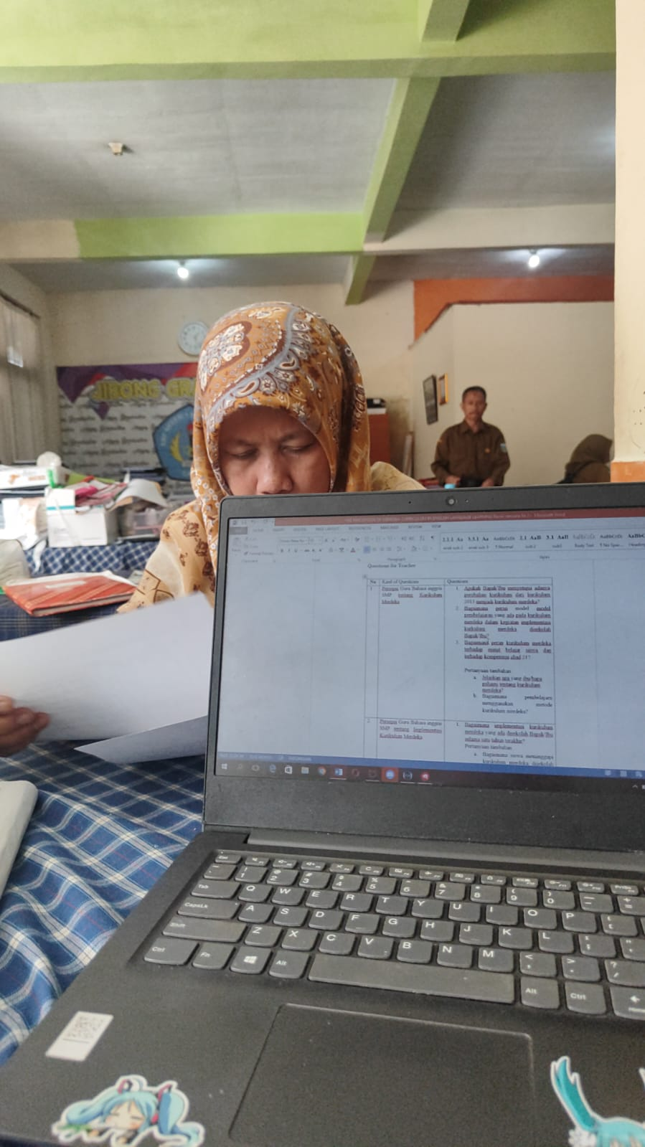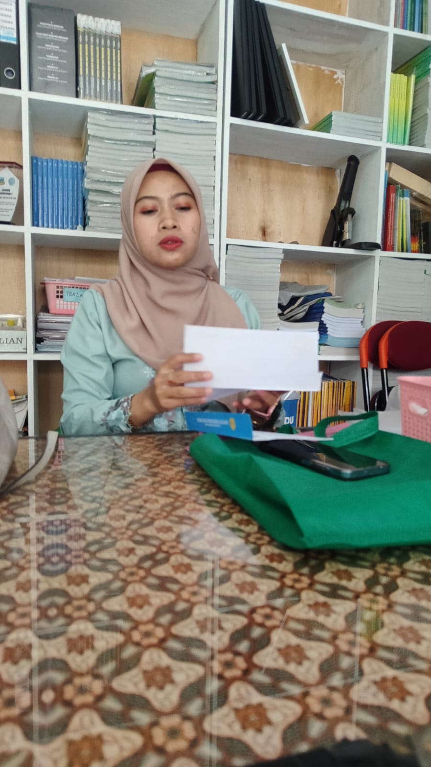

APPENDIX 4
Research Agreement

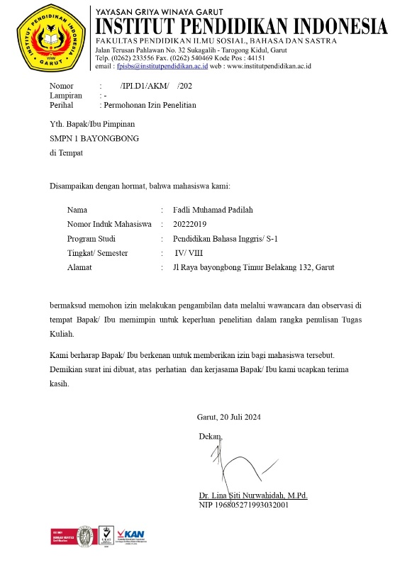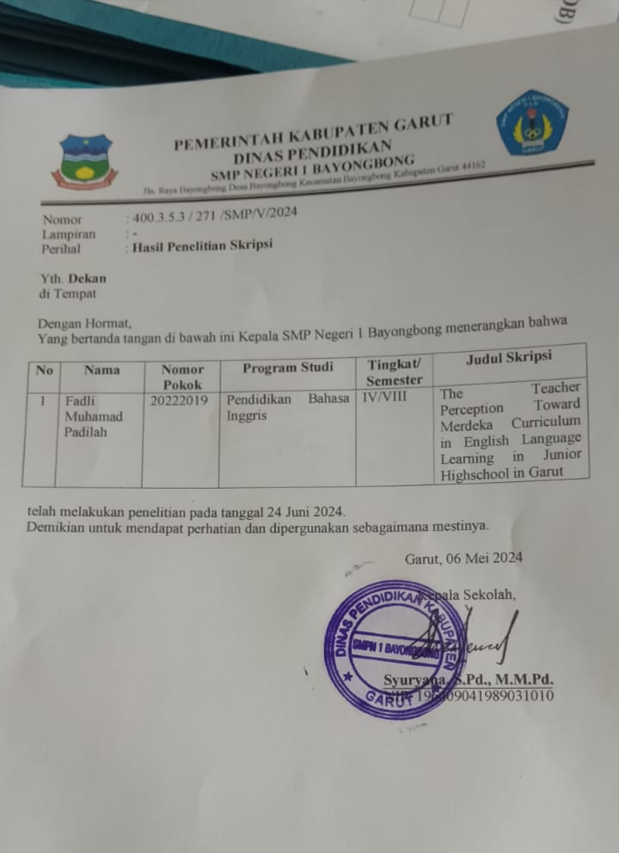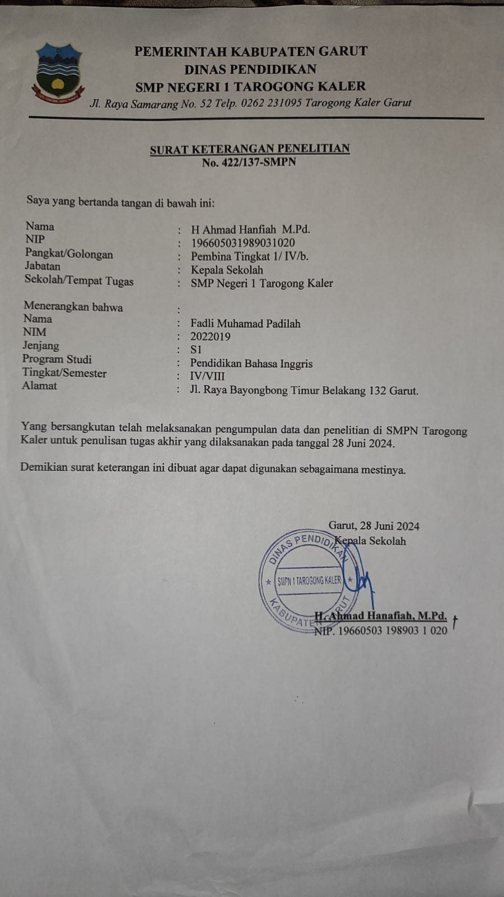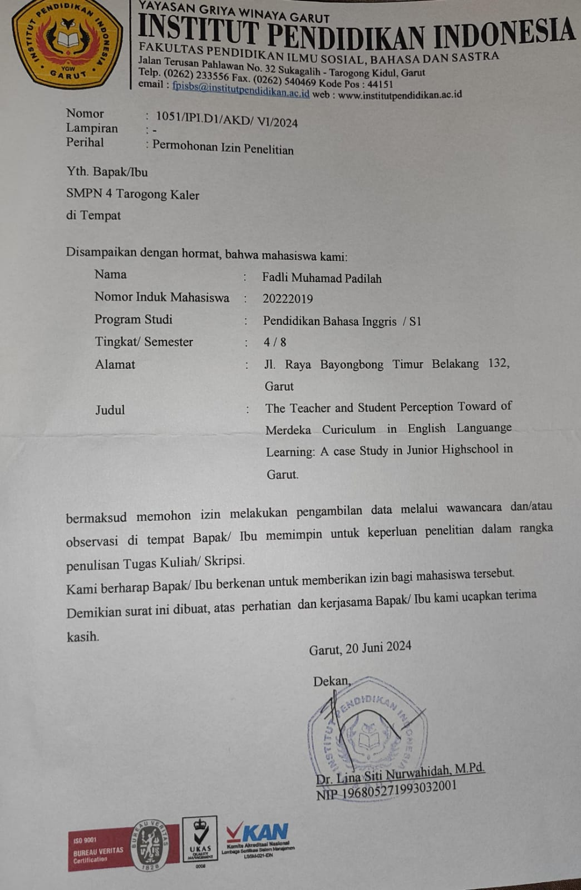

Curriculum Vitae

The author is named Fadli Muhamad Padilah. He is a student in the English Department at the Institut Pendidikan Indoensia (IPI) Garut. He was born on November 7th, 2001 in Garut. He is the last child of Family. He has a 2 sister nd 1 brother, her sister is named Fitri Priyanti and Futri Lupitasari Sova and his brother named Fikri Muchamad Fauzi. He started in elementary school at SDN Lebakjaya 4-SDN Bayongbong 2- SDN Bayongbong 1 and graduate in 2013. In the same year, He registered as a student at MTs Persis and graduate in 2017. After that, he continued at MA Persis and graduate in 2020. Furthermore, the author decided to continue the study at the English Department of Institut Pendidikan Indonesia (IPI) Garut. He was able to complete the paper in 2023 with the title “Teacher’s Perception Toward Merdeka Curriculum in English Language Learning in Junior Highscool at Garut”.

