STUDENTS’ IMPLEMENTATION OF TRANSLATION
AS A LEARNING STRATEGY IN READING COMPREHENSION

A PAPER
Submitted to the English Education Program of Institut Pendidikan Indonesia (IPI) Garut as a Partial Fulfillment of the Requirements for the
Sarjana Pendidikan Degree

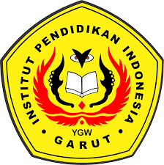

Written by:
Nelly Apriliani
20225002

English Language Education Program
Faculty of Social Science, Language, and Literature Education
Institut Pendidikan Indonesia
2021

APPROVAL SHEET

STUDENTS’ IMPLEMENTATION OF TRANSLATION
AS A LEARNING STRATEGY IN READING COMPREHENSION

Written by:
NELLY APRILIANI
20225002

Approved by:
Supervisor, | Co-Supervisor,
Dr. Setia Muljanto, S.E., M.Pd. | Dr. Lucky Rahayu Nurjamin, M.Pd
NIDN. 0419106705 | NIDN. 041008901

Acknowledged by:
Head of English Education Program,

Anne Ratna Suminar, M.Pd.
NIDN. 0415038601

LEGITIMATION

STUDENTS’ IMPLEMENTATION OF TRANSLATION
AS A LEARNING STRATEGY IN READING COMPREHENSION

By:
NELLY APRILIANI
NIM. 20225002

This paper has been established through an examination held on November 2021

First Examiner ,  Anne Ratna Suminar, M.Pd  NIDN 0415038601 | Second Examiner,  Rajji K. Adiredja, M.Pd  NIDN 0424086301 | Third Examiner,  Drs. Ateng Kurnia, M.Pd  NIDN 0023036301

Acknowledged by:
Dean of Social Science, Language, and Literature Education Faculty

Dr. Lina Siti Nurwahidah, M.Pd.
NIDN 0027056801

DECLARATION

The researcher hereby grants that this paper entitled “Students’ Implementation of Translation as a Learning Strategy in Reading Comprehension” is really written by the researcher and acknowledged as her own intellectual property. In accordance with the use references, the quotations, and the citations of related literatures have been conducted based or rightfully, legal and scientific procedures. Therefore, the contents of this paper are an original work of the researcher. In the case, if here are any complaints or if the researcher breaks these statements, the researcher will be fully responsible for all the consequences given.
Garut, November 23, 2021
The writer

Nelly Apriliani
NIM. 20225002

PERNYATAAN
Dengan ini, saya menyatakan bahwa skripsi yang berjudul “Students’ Implementation of Translation as a Learning Strategy in Reading Comprehension” ini beserta seluruh isinya adalah benar-benar karya saya sendiri. Saya tidak melakukan penjiplakan atau pengutipan dengan cara-cara yang tidak sesuai dengan etika ilmu yang berlaku dalam masyarakat keilmuan. Atas pernyataan ini, saya siap menanggung resiko/sanksi apabila di kemudian hari ditemukan adanya pelanggaran etika keilmuan atau ada klaim dari pihak lain terhadap keaslian karya saya ini.
Garut, November 23, 2021
The writer

Nelly Apriliani
NIM. 20225002

ACKNOWLEDGEMENT
In the name of Allah, the most gracious, the most merciful praise to Allah, the lord of the worlds whom his mercy and blessings, none of these would be possible. The writer is very grateful for the chances He has given her to accomplish the paper.
The writer would like to extend her gratitude to the first advisor Mr. Dr. Setia Muljanto, S.E., M.Pd. and second advisor Mr. Dr. Lucky Rahayu Nurjamin, M.Pd. who has constantly given their endorsement, time, and guidance so that the writer could finish the paper.
Finally, the writer hopes that this little piece of work can be useful for all the readers and also the paper can contribute soothing to the better of English and learning in general.
It is Allah who bestows success and guides to the right path.

Garut, November 23, 2021
The writer

PREFACE
All praise be to Allah SWT, the Most Gracious and Merciful. He has been giving me blessing to complete this research paper. Then, may Allah SWT bless our prophet Muhammad SAW, peace be upon Him and His family, friends, and his followers forever. By blessing of Allah, the researcher has completed this paper entitled “Students’ Implementation of Translation as a Learning Strategy in Reading Comprehension”. The purpose of writing this paper is to fulfill one of the requirements for the Sarjana Pendidikan Degree at IPI Garut.
The researcher hopes this paper will be useful, especially for the researcher her self and generally to the others. The researcher realizes that this paper is still far from being perfect. Thus, the corrections and suggestions are greatly appreciated either its contents or linguistics aspects.

Garut, November 23, 2021
The writer

DEDICATION PAGE

The paper is especially dedicated to:
- Almighty Allah SWT, thanks God all about the precious gift He give me,
- Prof. Dr. H. Nizar Alam Hamdani, M.M., M.T., M.Si., as a Rector of Institute Indonesia of Education (IPI) Garut,
- Dr. Hj. Lina Nurwahidah, M.Pd. as dean of faculty of social science, language and literature education,
- Anne Ratna Suminar, M.Pd. as head of English education program,
- Dr. Setia Muljanto, S.E., M.Pd. as the first supervisor for his valuable guidance and advice during the completion of this paper,
- Dr. Lucky Rahayu Nurjamin, M.Pd. as the second supervisor who has been giving support, ideas, suggestion, and correction in completing this paper,
- My parents who already in heaven, Mr. Akhmad Gunawan and Mrs. Kurniasih, thanks for giving me a life although you are not here on my precious time.
- My beloved mommy, Mrs. Ida Farida who always pray, support, and advise my study,
- My beloved sister Mrs. Desi Rahmawanti, my brother Fauzi Galiban, My aunt Mrs. Otin Suprihatin, my uncles Mr. Wawan, Mr. Arifin Wicaksono, Mr. Suryana, and all of my big family,
- My precious husband that support and love me,
- All of my best friends, Ai and Tita.
- All people who give supports and motivation during study and final research that I could not mention one by one,
- My beloved lectures of Institut Pendidikan Indonesia Garut,
- My beloved colleague and teachers of SMPN 2 Kersamanah.

ABSTRACT

Students tend to translate various texts in order to understand materials, and it affects their reading comprehension. They believe that using translation helps them understand better many aspects of the target language, and they find it appropriate to improve their English language skills. The problem is the translation process is not relevant to the school curriculum and lesson plan, where no part requires teachers or students to be able to understand the reading by translating. The study aims at exploring the implementation of translation as a learning strategy in reading comprehension in Garut, Indonesia. The study was deemed as descriptive qualitative research and used case study design. There are two instruments in collecting all the data, they are observation of students’ translating process and interview. The result shows that there are three translation method that students implement in reading comprehension, they are: word-for-word translation, literal translation, and faithful translation. They may have similar technique; at the first they translate the unfamiliar or unknown word. But at the end, they do their own method to arrange the sentence. It means that students have diverse method to use translation as their language strategy. They consider translation is helpful for them to learn English as Foreign Language. In the other side, they are also admit that it consume their learning time at the first, but they found it challenging that they can increase their vocabulary as often as they open the dictionary.

Keywords: Translation, Translation Method. Reading Comprehension, EFL Learners, Students’ Learning Strategy.

ABSTRAK

Siswa cenderung untuk menerjemahkan teks dalam memahami materi, dan itu mempengaruhi pemahaman bacaan mereka. Mereka percaya bahwa menggunakan penerjemahan membantu mereka memahami lebih baik banyak aspek dari bahasa target, dan mereka merasa bahwa itu sesuai untuk menrubah kemampuan bahasa Inggris mereka. Masalahnya, proses penerjemahan ini tidak relevan dengan kurikulum sekolah dan RPP, dimana tidak ada bagian yang meminta guru ataupu siswa untuk bisa memahami bacaan melalui penerjemahan. Penelitian ini bertujuan untuk mengeksplorasi implementasi penerjemahan sebagai sebuah strategi belajar dalam pemahaman bacaan di Garut, Indonesia. Penelitian ini dilihat sebagai penelitian kualitatif deskriptif dan menggunakan desain studi kasus. Terdapat dua instrumen dalam pengumpulan data, yaitu observasi proses penerjemahan siswa dan wawancara. Hasilnya menunjukan bahwa terdapat tiga metode penerjemahan yang siswa gunakan dalam memahami bacaan, yaitu penerjemahan word-for-word, penerjemahan literal, dan penerjemahan faithful. Mereka mungkin memiliki teknik yang sama; awalnya mereka menerjemahkan kata yang asing atau kata yang tidak mereka ketahui, Tapi pada akhirnya mereka memiliki metode yang berbeda dalam menggunakan penerjemahan sebagai strategi belajar. Mereka beranggapan bahwa penerjemahan ini membantu mereka mempelajari bahasa Inggris sebagai bahasa asing.

Kata Kunci: Penerjemahan, Metode Penerjemahan, Pemahaman Bacaan, Pembelajar EFL, Strategi Belajar Siswa

TABLE OF CONTENTS
COVER
APPROVAL SHEET i
DECLARATION iii
PERNYATAAN iv
DEDICATION v
PREFACE vvi
DEDICATION PAGE vivii
ABSTRACT viii
ABSTRAK ix
TABLE OF CONTENTS x
CHAPTER I INTRODUCTION 1
1.1 Background of the Study………………..…………………………..... 1
1.2 The Reason for Choosing the Topic …………………………………. 4
1.3 The Scope and Limitation ……………..…………………………….. 4
1.4 The Research Question …………….………………………………... 4
1.5 Significant of the Study ……………….…………………………...… 4
1.6 The Research Purpose …………….…………………………………. 4
1.7 The Definition of Terminology ……………………..……………….. 5
CHAPTER II LITERATURE REVIEW 7
2.1 General Remarks ………………...………………………………....... 7
2.2 Definition of Translation ……………..…………………………........ 8
2.2.1 Types of Translation …………….……………………………. 9
2.2.2 The Process of Translation …………….……………………... 9
2.2.3 Translation Method ……………..………………………….... 11
2.2.4 Translation as a Learning Strategy …………………….……. 14
2.2.5 Students' Belief about Translation ………………….……….. 17
2.3 Reading Comprehension ………………….…………………......…. 20
2.4 Translation in Reading Comprehension ……………………………. 21
2.5 Previous Related Studies …………………………………………… 22
CHAPTER III RESEARCH METHODOLOGY .24
3.1 Research Design ………………..…………………………………... 25
3.2 Participant and Setting of the Study …………………..……………. 25
3.3 Subject of the Study ...……………………………………………… 26
3.4 The Data Collection and Instrument ……………………………...... 26
3.4.1 Observation ………………………………………………..... 26
3.4.2 Interviews …………………………………………………… 27
3.5 The Data Analysis ………………………………………………….. 27
3.5.1 Observation ………………………………………………..... 28
3.5.2 Interviews …………………………………………………… 28
3.6 Research Procedures ……………………………………………….. 28
CHAPTER IV FINDINGS AND DISCUSSION 28
4.1 Research Setting ………...………………………………………….. 30
4.2 Research Findings ………………………………………………….. 30
4.2.1 Observation ……………………...…………………………... 31
4.2.2 Interviews ……………………………………………………. 33
4.3 Data Analysis ………………………………………………………. 36
4.4 Discussion ………………………………………………………….. 39
CHAPTER V CONCLUSION AND SUGGESTION 41
5.1 Conclusion ………………………………………………………...... 41
5.2 Suggestion …………………………………...………………...…… 41
BIBLIOGRAPHY 42
APPENDIX A
APPENDIX B
APPENDIX C
CURRICULUM VITAE

CHAPTER I
INTRODUCTION

This chapter presents background of the study, research question, research methodology, and significant of the study.

- Background of the Study
Since the long history of EFL, using translation as a learning strategy as well as a teaching technique has received different compliments and criticism. The translation is unavoidable, especially at the lower level. Even in Indonesia, students tend to translate various texts in order to understand materials. Students believe that using translation helps them to understand better many aspects of the target language, and they find it appropriate to improve their English language skills (reading, writing, listening, and speaking) during language learning process. Many teachers do not embrace the idea of utilizing translation in their teaching. However, one must consider whether the translation is really an outdated form of teaching that should be disregarded completely.
To learn a new language, one must always think in that language, without seeing for the fact that one cannot think in the new language if he/she does not know it. This, of course, is where translation has to play a role; the use of translation by students is a natural tendency. Topolska-Pado (2010) makes a good point by stating that students tend to identify with their L1 that which is newly discovered from the L2, thus causing them to be translators from the very beginning of their training. It is indeed true that although in most cases, the transfer shall remain positive (Cunningham, 2000), translation may cause negative interference, such as wrong language usage that no native speaker would adopt. Nonetheless, it is flawed to think that this sort of automatic translation does not occur on a habitual level. As such, it should be considered important that with proper guidance, students can also learn that translation, whether from the teacher or from activities, helps to understand the idea that the L2 is, in fact, a different language, and with that come different rules and ways of saying and expressing ideas. Essentially, with translation, students can understand that certain phrases and structures may be said in the L1 a certain way, but not in the L2 (Topolska-Pado, 2010). Consequently, the use of translation can assist students in recognizing comparisons and contrasts of structures and grammar points between the L1 and the L2, which can hardly be seen as interfering with one’s acquisition of the target language. All in all, instead of translation, whether inside or outside of the classroom, being a hindrance or an “unnatural co-presence of the mother tongue” (House, 2009, p. 60), it should rather be viewed as quite natural and normal to switch back and forth between the L1 and the L2.
Translation composite of the operation which is then applied to the entire translation process to achieve intended outcome such as for reading comprehension (Hermita & Suyudi, 2009). Reading comprehension can be summarized as the act of one’s mind to understand or to interpret written or printed material containing information (Peni, 2018). Even though English language is still odd for students in junior high school, they are supposed to learn several genres of text. According to Indonesia Curriculum Education 2013, there are several texts must be studied such as descriptive text, recount text, narrative text, procedure text, and etc. Since students must understand the whole text; what the writer tries to inform and tell the readers (Yusmalinda & Astuti, 2020). Thus, the importance of translation is to help students to understand the whole text which each of text type has different generic structure, aim, and also language features.
Students do the translation process to understand the text teacher gives before they answer the question. The process was found in some students in grade 8 at a public junior high school in Garut. This is interesting to see because the translation process is not relevant to the school curriculum and lesson plan, where no part requires teachers or students to be able to understand the reading by translating. In addition, the translation process will be felt to take up student learning time, where during the COVID-19 period, student learning allocations are reduced, it's about 4 hours of lessons or about one hundred minutes per week. Limited face-to-face schools are also applied at 50%, which means there is a break for students to come to school. They were learning English by a teacher only once every two weeks, the rest they do distance learning or learning from home. It is carried out online and offline containing the text accompanied by questions they have to answer.
Some writers have conducted the research about translation as a learning strategy and reading comprehension. The first researchers have been conducted by Ismail, H., Syahruza, J.K., & Basuki. in 2017, they conducted a journal entitled “Improving the Students’ Reading Skill through Translation Method.” The research instrument used is in the form of observation checklist, test, and questioners. The research finding shows that the implementation of translation improves the students’ reading skill in the teaching process and the test result.
The second research has been conducted by Dwi Mailia Putri (IAIN Metro, 2017) entitled “The Correlation between Students Reading Comprehension and Translation Ability at The Fifth Semester of English Education Department In State Islamic Institute of Metro.” The study aims to know whether there is a correlation between the reading comprehension and translation ability at the fifth semester of English Education Department in State Islamic Institute of Metro. The correlation level between reading comprehension and translation ability is 39,32 %. It means that the finding of the research is in line with the theories asserting that there is any positive and significant correlation between students reading comprehension and translation ability.
While all of the previous research addressed translation and reading comprehension, there was no analysis as to why translation was allocated to students, without teaching how it should be achieved or how influential the effects of translation were in the student's achievement of reading comprehension in the English class. Where the current curriculum does not require students to translate a lot, it allows them to practice speaking, listening, reading and writing.
Taking all the explanations, and evidences, the study would like to investigate whether there is positive and significant of translation as a learning strategy in reading comprehension in Junior High School in Garut. Therefore, the study would like to conduct a research entitled “Students’ Implementation of Translation as a Learning Strategy in Reading Comprehension.”

- The Reason for Choosing the Topic
There are several reasons why this topic is chosen:
- Translation is still often used in the teaching and learning process.
- Translation is not part of the ability that must be mastered by student, but it is used as a tool to comprehend the reading text.

- The Scope and Limitation
The study focuses on the implementation of translation as a learning strategy in reading comprehension. It is mainly aimed at exploring the translation as a learning strategy which is implemented by students to comprehend the reading text in one of Public Junior High School in Garut, Indonesia.

- The Research Question
Considering the issues aforementioned in the backgrounds explained above, this study attempted to find an answer to, “How is translation implemented as a learning strategy in reading comprehension?”

- Significant of the Study
The results of the study will be of great benefit to give the information on learning strategy for the EFL students. The result of the study hopefully will help the students to develop their language skill by implementing translation as a learning strategy.

- The Research Purpose
Based on the research question above, the aim of the study is to find out the process of the EFL students using metacognitive strategies and the influence of students’ achievement in reading comprehension.

- The Definition of Terminology
- Translation
According to Hatim and Ian (2005) translation is an act of communication which attempts to relay, across cultural and linguistic boundaries, another act of communication (which may have been intended for different purposes and different readers/hearers). Translation plays an important role in crossing different cultures and communication. Translation acts as a bridge to communicate all kinds of languages especially those similar to each other considering their linguistic features and cultural customs in all parts of the world (Abbasi et al., 2012).
- Translation Method
Albir (2002) cited in Nafisah et al. (2018) state that translation method is a method used by the translator in the translation process in accordance with its purpose. It means that the result of the translation is largely determined by the translation method adopted by the translator because the intent and purpose of the translator will influence the result of the overall translation result. It is necessary to decide what method will be used during translation process since the result of the translation is affected by the translation methods used by the translator (Shabitah W. Hartono R., 2020)
- Translation as a Learning Strategy
Translation is defined as “the process of translating words or texts from one language to another” (Oxford Dictionary) and as a learning strategy, it refers to “using the first language as a base for understanding and/or producing the second language (Tan, 2015).
- Reading Comprehension
Reading comprehension means understanding information included in a text and interpreting it in a suitable way (Grabe & Stoller, 2002). However, reading texts with comprehension means that the students will understand the purpose and function of the text, be aware of the main topic, how it develops from one paragraph to another, and understand the meaning of sentences as well as the relationships among them. Thus, the main goal of reading is to obtain a general understanding of what is included in the text rather than to obtain meanings from separate words or sentences (Duke & Pearson, 2002).

CHAPTER II
LITERATURE REVIEW
This chapter discusses translation, reading comprehension, and translation in reading comprehension and previous related studies.

- General Remarks
Translation composite of the operation which is then applied to the entire translation process to achieve intended outcome such as for reading comprehension (Hermita & Suyudi, 2009). Reading comprehension can be summarized as the act of one’s mind to understand or to interpret written or printed material containing information (Peni, 2018). Even though English language is still odd for students in junior high school, they are supposed to learn several genres of text. According to Indonesian Educational Curriculum 2013, there are several texts must be studied such as descriptive text, recount text, narrative text, procedure text, and etc. Since students must understand the whole text; what the writer tries to inform and tell the readers (Yusmalinda & Astuti, 2020). Thus, the importance of translation is to help students to understand the whole text which each of text type has different generic structure, aim, and also language features.
On the lesson plan that designed by the English teacher in 8th grade, there is a reading text that should student learn, it is recount text. It states on the Educational Curriculum in 2013, “Menangkap makna secara kontekstual terkait fungsi sosial, struktur teks, dan unsur kebahasaan teks recount lisan dan tulis, sangat pendek dan sederhana, terkait pengalaman pribadi di waktu lampu (personal recount).” The teacher use Modul Pembelajaran Jarak Jauh pada Masa Pandemi Covid-19 untuk Jenjang SMP, Bahasa Inggris Kelas VIII. The textbook consist of two main theme, they are, My Unforgettable Experience and You are the Music on Me. Each main theme consist of 4 lesson and evaluation. The recount text is on the first theme, where the class learned the personal recount text.
- Definition of Translation
In general, translation means transferring the message from Source Language (SL) into the Target Language (TL) without changing the idea or meaning of the source language. When people speak of the form of a language, they are referring to the actual words, phrases, clauses sentences, paragraphs, which are spoken or written. Those forms are referred to as the surface structure of a language.
Translation is a very effective solution in overcoming language barrier. The variety of language with different culture and necessity of communication in human life causes translation to be a very effective factor in communication, exchanging culture, and knowledge (Abbasi et al., 2012). According to Hatim and Ian (2005) translation is an act of communication which attempts to relay, across cultural and linguistic boundaries, another act of communication (which may have been intended for different purposes and different readers/hearers). Translation plays an important role in crossing different cultures and communication. Translation acts as a bridge to communicate all kinds of languages especially those similar to each other considering their linguistic features and cultural customs in all parts of the world (Abbasi et al., 2012). Translation can be used as an alternative way if we do not master a foreign language. We can understand everything in a foreign language through its translation without having to refer to the original language. Translation can be a moderator in multilingual communication by converting one language into another.
According to Siregar (2016) translation involves at least two languages known as source language and target language. The source language is the language used in the material (text) to be translated, while the target language is the language in which the meaning is transferred. Every language have their own grammatical structure and may be different with another language. In translating, there are many processes that must be known such as, studying and analyzing the source language, and reconstructing the meaning.
From the definition of both translations above, translation is a process of transferring the source language to target language without changing the meaning of the idea and the purpose is to find the equivalent meaning of the source language into the target language, so the information from the source language still remained and people knew about the author intention.

  - Types of Translation
Practically, there are some kinds of translation that have their own characteristics and forms. Some kind s of translation are found because of the differences and similarities of the source structures, different kinds of text that are going to be translated and different purpose of translation. Newmark cited in Machali (2000) stated that translation method relate to whole texts, translation procedures are used for sentences and the smaller units of language.
Roman Jacobson in Hatim and Munday (2004) makes a very important distinction between three types of written translation : 1) Intralingual translation, translation within the same language, which can involve rewording or paraphrase, 2) Interlingual translation, translation from one language to another, 3) Intersemiotic translation, translation of verbal sign by nonverbal sign for example music or image.
Nababan differentiates kinds of translation, such as word for word translation, free translation, literal translation, dynamic translation, pragmatic translation, aesthetic-poetic translation, ethnographic translation, linguistic translation, communicative translation, and semantic translation.

  - The Process of Translation
The translation process is a series of actions, where the translator devotes their knowledge, skills and abilities of translating to transfer the messages from source language into target language. Nababan (2007:3) stated that translation process along with the product and translation process along with the product and translator is a harmony and cannot be separated from each other.
When taking up a new language, many students will be faced with some fear and anxiety (Arenas-Iglesias, 2006), especially when it comes time to do speaking activities. Many students have insisted that if they are allowed to express themselves first in the L1 and then convert their discourse to the L2, they tend to feel more at ease (Pan & Pan, 2012). Moreover, when the teacher is explaining something in the L2, it has often been noted that students may be more susceptible to drift in thought. A few translations, at least on some of the most important points in a lecture, may allow for students to snap back into and pay attention to the core of the lesson. According to Yang (2018), students must develop such a way of thinking to accurately express the meaning of the content that they are translating. On the other hand, some students have nothing to do because translation is not an instructional skill, they learn the strategy as an auto-didactic person. Translation can be frustrating and de-motivating for students (Carreres, 2006).
Throughout many English classroom settings, translation is prohibited based on the teachers` assumption that referring back to the L1 can cause interference in the target language learning (Cunningham, 2000, Dagilienė, 2012, Talebinejad, 2013). Teachers believe that learners need to think in the target language instead of reprocessing it into the learners` L1 first. Tsagari and Floros (2013) note that “it is promising to apply translation tasks to improve L2 learner proficiency in language control and reading skills”. Liao (2006) also states that translation is used in students` L2 learning as a tool to comprehend, remember and produce L2. Dagiliene's (2012) suggests that asking students to translate is not a way to set up a translation practice. The aim of translation as a learning strategy is not to communicate, it just lead students to second language learning, to read and understand foreign language literature. This might prove that translation is still an important strategy for many learners to comprehend the foreign language (Brown, 2002; Karimian & Talebinejad, 2013; Putrawan, 2018). In addition, as many teachers know, translation can assist with instructions and explanations in the classroom. How often have bilingual teachers been faced with a student who has asked a question dealing with the L2 and the teacher could either give a clear explanation in the L1 in two minutes and then move on from there or spend 20 minutes giving the same explanation in the L2, but with an added increased chance that the student did not fully understand anyway. Students themselves often comment on how well they are able to understand certain concepts when the teacher gives explanations in the mother tongue (Artar, 2017).

  - Translation Method
In order to produce a high quality of translation product, it is important for a translator to enhance their knowledge about translating. It is impossible to translating some text properly without understanding the context. A translator who translate about something that related to foreign culture from other countries must know the non-verbal language used in that society in order to find the equivalent word in the target language.
Albir (2002) cited in Nafisah et al. (2018) state that translation method is a method used by the translator in the translation process in accordance with its purpose. It means that the result of the translation is largely determined by the translation method adopted by the translator because the intent and purpose of the translator will influence the result of the overall translation result. It is necessary to decide what method will be used during translation process since the result of the translation is affected by the translation methods used by the translator (Shabitah W. Hartono R., 2020)
Translation in which more emphasis is given to overall meaning than to exact wording is known as free translation. A translation that approximates to a word for word representation of the original is known as a literal translation. The terms translation and interpretation are often used interchangeably. While both activities involve transferring a message between two different languages, translation refers to transfer between written texts and interpretation refers to spoken discourse and the unrehearsed transfer of a spoken message from one language to another (Richards &Schmidt, 2002).
According to Newmark cited in Iordan C. (2021) stated there are eight translation methods. They are word-for-word, literal, faithful, semantic, communicative, idiomatic, free, and adaptation. The methods can be classified into two: four of them are oriented in source language (SL Emphasis) and the other four are oriented in target language (TL Emphasis). It can be seen in the figure below:
SL Emphasis |  |  |  | TL Emphasis
Word for word Translation |  |  |  |  | Adaption
 | Literal Translation |  |  | Free Translation
 |  | Faithful Translation |  | Idiomatic Translation
 |  |  | Semantic Translation | Communicative Translation
Figure 2.1 Newmark’s V-Diagram
From the figure above, it can be explained that the eight methods of translation are:
      - Word-for-Word Translation
The source language word order is preserved and the words translated singly by their most common meanings, out of context. For example:
SL: Astri bought me a dress yesterday.
TL: Astri membelikan sebuah gaun untuk saya kemarin.
      - Literal Translation
The SL grammatical constructions are converted to their nearest TL equivalents, but the lexical words are again translated singly, out of context. For example:
SL: Bobby is a smart student.
TL: Bobby adalah murid yang pintar.
- Faithful Translation
It attempts to produce the precise contextual meaning of the original within the constraints of the TL grammatical structures. For example:
SL: I want to work in the big company.
TL: Saya ingin bekerja di perusahaan yang besar.
- Semantic Translation
It may translate less important cultural words by culturally neutral third or functional terms but not cultural equivalent and it may make other small concessions to the readership. For example:
SL: He is a book-worm.
TL: Dia adalah seorang kutu buku.
- Adaption
The freest form of translation, and is used mainly for plays (comedies) and poetry; the themes, characters, plots are usually preserved, the SL culture is converted to the TL culture and the text is rewritten. For example:
SL: The rising sun is found not to be the rising sun. It is the world which goes round.
TL: Matahari terbit ternyata bukan matahari terbit. Dunialah yang sebenarnya mengorbit.
- Free Translation
It reproduces the matter without the manner, or the content with the form of the original. For example:
SL: The girl with pink dress is my friend.
TL: Perempuan yang memakai gaun merah muda adalah teman saya.
- Idiomatic Translation
It reproduces the 'message' of the original but tends to distort nuances of meaning by preferring colloquialisms and idioms where these do not exist in the original. For example:
SL: She is a woman of steel.
TL: Dia adalah wanita yang berjiwa kuat.
- Communicative Translation
It attempts to render the exact contextual meaning of the original in such a way that both content and language are readily acceptable and comprehensible to the readership. For example:
SL: Beware of dog!
TL: Awas anjing galak!
The use of translation method depends on the translator needed.
Whichever method they use, the main point in translation is to transfer the source language messages to target language.

  - Translation as a Learning Strategy
English teaching and learning strategies have been on a constant debate since the early years of ELT development. Contradictive to lessons that have steady ways and strategies, ELT is in the state of ever-changing environment, as Celce - Murcia (2001) states, “language teaching is a field in which fads and heroes have come and gone”. Hosseini-Maasoum stated that translation is a legitimate pedagogical tool of language learning. Studies attempted on researching English learning, especially from students’ perspective, have not received considerable amount of attention as many as teaching strategies because of the wide variety of strategies students use on their learning. Among this wide variety of learning strategies, translation is one of the strategies that have been used for many years (Talebinejad, 2013). Even though for over a long period of time translation has been banished and banned by numerous teachers in ELT (Fazel and Bagheri, 2011, Hosseini-Maasoum, n.d. p.2), there are facts that show the resilience of translation use among students (Popovic, 2001, p.1., Fasel and Bagheri, 2011).
Translation as an ELT strategy has been concluded as a cognitive type of learning strategy. Ashouri and Fotovatnia (2010) carried out a study on 120 Iranian learners to investigate their belief about translation and the effect of two variables of students` individual differences; risk-taking and tolerance of ambiguity. Their finding indicated that EFL learners had a positive attitude toward translation; the learners belief that translation has a positive role in their English learning. In the case of advanced English learners.
Translation is defined as “the process of translating words or texts from one language to another” (Oxford Dictionary) and as a learning strategy, it refers to “using the first language as a base for understanding and/or producing the second language (Tan, 2015). It is generally accepted that good language learners use some language learning strategies in learning. Kerr (2016) summarizes the arguments that are against the use of first language in learning a foreign language as follows:
      - Translation is less important than the four skills of reading, writing, listening and speaking, and, in any case, is not a useful skill for most learners to acquire.
      - Time spent using own language is time lost using English.
      - Learners need to learn to think in English and own-language use discourages them from doing so.
      - Own language use encourages the false belief that there is a word-forward equivalence between languages, and therefore leads to language interference problems.(cited in Kerr, 2016, p. 3)
In addition to these negative opinions on translation use above, Pan and Pan (2012, p. 4) assume that “translation involves the use of two languages and, thus, deprives students of opportunities to receive sufficient FL input” (cited in Fernandez-Guerra, 2014, p. 154). In spite of these arguments aforementioned, many researchers give importance to the use of L1 as Scheffler (2013) states that reassessment of translation has been taken into consideration since the twenty-first century and also pays attention to the use of it as an interesting and useful activity. Additionally, Cook (2010) and Liao (2006) put emphasis on the necessity and the facilitating role of the learners’ mother tongue in the development of learning (cited in Karimian & Talebinejad, 2013, p. 606). In a similar vein, Tan (2015) claims that “it is arbitrary to completely deny the positive effects of employing mother tongue to learn English” (p. 59). Rolin-Ianziti and Varshney (2008) and Lee (2012) acknowledge that many students having low level of English hold a positive attitude towards the use of their mother tongue (cited in Kerr, 2015). Moreover, Fernandez-Guerra (2014) find out that learners have “a very positive attitude towards translation and its potential” assuming that four language skills can be improved with the help of translation (pp. 166-167).For Mollaei, Taghinezhad and Sadighi (2017), translation is an important method for the following reasons:
      - It is useful to remove the psychological barriers learners may take to the learning environment;
      - It is helpful when teaching some complex grammatical structures unless the learners are proficient enough to cope with the L2 explanations;
      - It is a technique at hand in vocabulary practice when all the other practical techniques fail, for example for memorizing difficult words;
      - In a reading activity and when comprehension comes to a standstill (cultural-bound items) teachers are allowed to apply translation.
A number of researchers studied on the effectiveness of translation strategy use among EFL learners. For this purpose, Karimian and Talebinejad (2013) explored the use of translation strategy by learners studying in Iran. 170 students studying English took part in the study. Learning Strategy Questionnaire, Interview Guide for students and Quick Placement Test were applied as data collection tools. The findings of the study indicated that translation strategy helped learners to learn English and the students trusted in the importance of it as a learning strategy. Additionally, Mutlu, Bayram and Demirbüken (2015) studied on the correlation between the proficiency level of Turkish students who studied English as a foreign language in preparatory classes of a university and the use of translation as a learning strategy. The findings of the study revealed that the learners used translation strategy while writing and reading a passage in English in that they found it easier to think about how to complete a learning activity in their native language first and then translate into the target language. They felt themselves more confident when using this strategy. With regard to the relationship between the use of translation and the participants’ proficiency, the learners with higher proficiency level used translation less than those with lower proficiency. Moreover, the findings of the study conducted by Ramachandran and Rahimi (2004) indicated that translation could be used as a method in order to develop students’ vocabulary. Accordingly, the use of translation provided learners to contrast and compare two different languages.
Furthermore, students also utilize translation for vocabulary development and reading skills (Calis & Dikilitas, 2012). Dagiliene (2012) studied on the use of translation in the classroom activities to find out whether it helped students attending to a university to learn, improve and strengthen their competence and knowledge in English. The results of the study demonstrated that translation is a useful instrument that can be used to develop learners’ language skills such as writing, speaking, vocabulary, grammar and reading.

  - Students’ Belief about Translation
Translation has also been investigated in terms of learners’ view on it. Focusing on the role of translation in a different language skill, Kim (2011) combined 20 students’ previous learning experiences that they gained through GTM with her writing classes. She aimed to help her students see their own writing objectively in this way. Her students were Korean learners of English and placed in a low-level class after a placement test. They were asked to translate their writings into Korean and reflect what they felt and learnt as a result of this task.
The second task she asked her students to do was to translate one of their friends’ writing and write reflections on that task accordingly. The analysis of the reflections revealed that the students benefited from these tasks in analyzing their writing more objectively and understood that grammatical accuracy was important for written communication. The study shows one clear and efficient way of incorporating students’ L1 into language teaching.
Focusing on learners’ perceptions on translation as a learning strategy, Liao (2006) aimed to explore the role of translation in learning English by collecting data from survey questionnaires and interviews. The results showed that in addition to their conflicting beliefs about translation, most of the 351 Taiwanese learners of English believed that translation played a positive role in their English learning experiences. The participants showed a medium to high level use of translation as a learning strategy. Their beliefs about translation were found to affect the translation strategies they chose to use in learning English. The researcher also came up with the result that the students having foreign language majors and high proficiency level reported negative beliefs about translation and less use of translation.
Along the same line, Brooks-Lewis (2009) conducted a classroom-based research in an English as a Foreign Language (EFL) course which included L1 use with university students who were native speakers of Spanish. After the completion of the course, the participants were asked for their perceptions about their experience in written form. Results demonstrated learners’ positive response to the experience; they considered that the inclusion of their L1 was beneficial to their language learning experience. The reasons for the participants who were in favor of using L1 in their classrooms were explained: “…being able to understand what is being said; being able to participate; making the learning meaningful and easier; dissolving the sense of rupture in knowledge, along with ideas of forgetting or replacing identity or the L1; promoting confidence and a sense of achievement; and inspiring language, learning, culture, and self-awareness.” (Brook-Lewis, 2009:234)
Calis and Dikilitas (2012) analyzed elementary learners’ reaction to the use of translation as a L2 learning practice. It was a classroom-based research lasted for seven weeks and conducted with 28 Turkish learners of English in a preparatory school. The participants were taught some grammatical subjects through the translation exercises. Following these exercises, the participants were asked for their perceptions of this learning experience through a questionnaire together with interview questions adapted from Liao (2002). Results showed that learners, in general, had positive ideas about the use of translation as a practice. Additionally, they believed that the use of translation helps them understand reading passages better and memorize target vocabulary. The students also reported that they themselves use bilingual dictionaries frequently and translate the text first to understand it.
Employing the same qualitative and quantitative data collection instruments, Karimian and Talebinejad (2013) investigated Iranian English learners’ use of translation. In the quantitative part of the study, 170 Iranian EFL learners were asked to answer the Inventory for Translation as a Learning Strategy (ITLS) and in the qualitative part, 120 students were selected to respond the learners’ interview guide (Liao, 2002). The data analysis revealed that language learners used translation in a wide variety of learning strategies to comprehend and use English effectively.
Humairoh (2020) investigate students’ beliefs and use about translation as a strategy in learning English: Indonesian undergraduate students and the result indicates that Indonesian students most believed to use translation to read English, to learn English vocabularies, and to write. Generally, the participants strongly believe that doing translation supports them learning English language skills such as receptive skill i.e. reading, both productive skills (writing and speaking), vocabulary, idioms, and phrases. Most of them perceived that translation helps them much in reading English particularly.
The findings on the students’ beliefs of the students about translation are consistent with the past studies of Liao. Liao (2006) found that they believed translation assists them acquire three English language skills such as reading, writing, and speaking skill. Besides, it also helps building vocabulary, comprehending idioms, and phrases.
Indonesian students have the lowest beliefs on keeping out their Indonesian of their mind. It means that they tend to use Indonesian translation as the way of their thinking English or their strategy in English learning. Considering the use of translation are still debatable with the students’ beliefs, it is suggested that teachers help students raise lit their awareness up about the advantages and disadvantages of doing translation” (Liao, 2006). From this thought, teachers need to encourage and motivate students to take positive action by applying translation as their helpful English learning strategy, but to decide it by paying attention rather than take any risks, as an excessive dependency on translation may prevent their progress in learning English.
In other words, the Indonesian students’ positive beliefs about translation as English learning strategy also consistent with the newest published research conducted by Aktekin & Glienecki (2015), they found that lots of their participants endorsed that they assume that translation play an important role in their English learning process. This current study proved that the Indonesian students indicated that the role of translation plays so important in their English learning process by facilitating them as an English learning strategy.
Dealing with another research question is about the strategies involving translation Indonesian students’ apply in the process of English learning, the participants of this study were also asked to rate their level of agreements with the some statements on five Likert scale which relevant to research questions and then their responses were added up and averaged. This way provides an insight into how frequently they reported applying translation as their learning strategy.

- Reading Comprehension
Reading comprehension means understanding information included in a text and interpreting it in a suitable way (Grabe & Stoller, 2002). However, reading texts with comprehension means that the students will understand the purpose and function of the text, be aware of the main topic, how it develops from one paragraph to another, and understand the meaning of sentences as well as the relationships among them. Thus, the main goal of reading is to obtain a general understanding of what is included in the text rather than to obtain meanings from separate words or sentences (Duke & Pearson, 2002). Honestly, students who are not able to read appropriately and who are not able to process and comprehend what they read will not be able to succeed (Kerubo, 2014).
In general, many researchers (McCardle & Hoff, 2006; Hoffman, 2001) indicated that English as a foreign language (EFL) students encounter many difficulties while learning English which affect their achievement negatively. The difficulties may due to the fact that English teachers are not well-trained on how to teach English and its four skills appropriately. Also, they may not attract the interests of students or motivate them towards learning English. Besides, the curriculum sometimes is not suitable for helping students to enhance their levels of proficiency. Furthermore, some teachers do not use the appropriate learning strategies to improve the four skills of language (Souriyavongsa et al., 2013).
At the level of reading comprehension, difficulties and problems may stem from many sources. For example, students sometimes cannot read the words correctly so how can they understand what they cannot even read. Another challenge, students may just read word by word, or sentence by sentence. They may fail to understand the relationship between sentences and the meaning of any text as a whole so they do not access to the appropriate level of comprehension (Pardo, 2004). Possibly, it is partly because students are not informed to use effective levels of reading comprehension to comprehend a text effectively. To be more specific, students tend to focus on the meaning of individual words which may negatively affects their comprehension and their achievement in English in general.

- Translation in Reading Comprehension
Karnal and Pereira’s study (2015) in which he reported that when students were using the translation strategy, they developed a pattern that was referring to a lexical item that prevented comprehension which resulted in the use of the translation as a learning strategy. After translating, participants expressed success in reading comprehension. Moreover, memorization is one of the most frequently used strategies. Using translation to learn English grammatical structures and specifically building vocabularies, idioms and phrases is also as another most frequently employed strategy by students. Thus, students uses translation to cover their weaknesses of English knowledge and to guide their self-checking of their English tasks. The general impression in the result shows that the participants have been depending heavily on translation a helpful way to learn English and in the learning process.
Generally, the positive views of applying translation is that translation can help students’ English reading comprehension. Besides, translation can assist students to confirm whether their comprehension is correct or not related to memorizing English vocabulary, translation eases the complexity of memorizing more English words, idioms, grammar, and sentence structures. In various situations, they did mental activity such as reprocessing their background knowledge and to ask for help to find the answers for better understand English words and phrases in their own language. Moreover, they use translation as a strategy to compare and make any distinctions and similarities between Indonesian as their first language and English through translation. They also attempted grasp the meaning of what they read without first thinking of the Indonesian equivalent when reading and speaking English,
Specifically one of receptive skill which is reading skill, translation seems to be an effective aid and can play a useful role in Indonesian EFL students’ reading comprehension process. They frequently use translation to help themselves expand their English words, idioms, phrases, and grammar, to read, write, and to have high performance speaking English, and to check their reading, and listening comprehension. These findings were consistent with Karimian (2013) shows that Iranian students as the participants use translation as one of their learning strategies to help them in English language learning.
Besides, they use other ways by asking other classmates or other people as their problem solver when they have difficulty with their English. It perhaps because of their anxiety with any language task in English, so they rely on doing those tasks in their Indonesia language, which is believed to inspire them read English, compose English text, organize ideas, form sentences, and then employ translation to achieve the outcome of the tasks easily and correctly. Another probability comes from their habit. It means that they are probably not accustomed to doing their assignment directly in English and they are still comfort to use translation as their strategy in learning as well as it is.
Probably, insufficient support of a good English environment in which Indonesian students should actively exposure their English by staying away from translation tends to alienate their capability to freely perform English both written and orally without dictionaries to find the meaning.

- Previous Related Studies
The use of translation as a learning strategy in teaching environments has been a research target for many studies to understand if it is beneficial compared to other teaching methods. One of them, comparing translation with a non-translation method, Ramachandran and Rahim (2004) investigated the effectiveness of translation in teaching vocabulary to 60 Malaysian elementary level ESL learners. The students were randomly assigned to one experimental and one control group. While the experimental group received translation method as the treatment, the control group received non-translation method. The findings of the study revealed that the translation method had a positive impact on learners’ recall and retention of the meanings of the target words. In other words, the study evidently showed that translation method was an effective way to improve ESL learners’ vocabulary learning ability.
In the next study, Nara Djo (2016) attempts to discover EFL students’ beliefs about translation and the way they use translation. Two questionnaires were filled out by 102 senior students of English Department of Satya Wacana Christian University. The result showed that the majority of the students believed that translation was considered as a significant and helpful tool in their English learning and they used translation for several purposes such as accomplishing assignment and understanding teachers` instruction.
In another comparison study, Putri (2017) focused on the reading comprehension and translation ability. The 26 samples of this research were randomly selected by random sampling technique. The data were collected by test and documentation. The finding of the research indicates that there is positive and significant correlation between students reading comprehension and translation ability and alternative hypothesis is accepted. It is proved by the data analysis illustrating that the critical value of retable for N 26 at 5% level is 0.404 and for 1% level is 0.515. Consequently, it can be shown that 0.404< 0,627>0.515. The conclusion this research is there are positive and significant correlation between students reading comprehension and translation ability at the fifth semester of State Islamic Institute of Metro.

CHAPTER III
RESEARCH METHOD
This chapter presents the research design, location of the study, subject of the study, population and sample, the data collection and instrument, and the data analysis.

  - Research Design
The study was deemed as descriptive qualitative research and used case study design. The research design was appropriate to the objectives of the research which focuses on how do the students implement translation as their learning strategy, when they are facing reading comprehension and the possible kind of translation strategy they were used. The research results emphasize more toward the data interpretation found in the field. The result is not written in the form of figures and tables with statistical measures; but it is illustrated in the form of describing words to the results and it is presented in the descriptive.

  - Participants and Setting of the Study
The study was carried out at a Public Junior High School in Garut with 3 students of 8th grade that learning English as their foreign language as their academic education. They were chosen because based on the results of preliminary research, it was found that several students at 8th grade carried out the translation process as a learning strategy in learning English. Besides that, the case study is a qualitative design that uses a small sample so that by selecting the sample well, the results to be achieved in the research will be optimal. In this case, the selection of a small group population is expected to represent the sample population overall. Students were taught pronouns, regular/irregular verbs, auxiliary verbs, etc. structures through translation for 4 weeks. One hundred minutes (4 hours of learning) or two times of face-to-face learning per week. Although half of the amount students are online and others are offline. When they are offline, one hour of learning (25 minutes) is allocated for translation practice in which the students were required to translate English sentences into Indonesia and vice versa. They were also assigned to do the assignment in the school’s learning management system when they are learning from home (online), where are they also translating the assignment from English into Indonesia. The 8th students are more intended to translate the text by themselves, they did not need to be instructed to bring a dictionary or to translate the unfamiliar word, and they do it by their own will.

  - Subject of the Study
In conducting this research, the subjects are people who are sources of information and can provide data according to the problem being studied. The research subjects are as follows:
    - Primer Subjects, consist of three students of 8th grade in a public junior high school, in the future will be mentioned as respondent 1, respondent 2, and respondent 3.
    - Secondary Subjects, consist of vice principal of curriculum and 8th English Teacher.

  - The Data Collection and Instrument
3.4.1 Observation
The first method of data collection was observing 8th grade students’ when they are translating in the reading comprehension section of the class. The study proposals were then analyzed in terms of elements to answer the research question, to identify how the students implemented translation as a learning strategy in reading comprehension. Observation fosters an in-depth and rich understanding of a phenomenon, situation, and/or setting and the behavior of the participants in that setting. The study used observing by video recording, it affords the study the opportunity to transcribe what occurs in a setting and play it over and over. This can be very useful in the analysis process. In the study, the researcher’s role is as a non-participant observer. Whereas there is separated test that held out of the school time, because face-to-face learning only held for 50% of quantity. So, there is a space time for students to come to school. The observation goals is to see how translation used as a learning strategy in comprehend the reading text. It has been done based on the permit of school parties (the headmaster, the English teacher, and the vice principal of curriculum).
3.4.2 Interviews
The use of interviews is as a guide to take a series of questions and also ask things related to the explanations that have been presented. The source of the data was the interview with all participants of the study. It is a technique in which the data is collected through face-to-face interaction between the interviewer and the respondent. The interview was carried out after the students’ translation process that has been completed. It is used to obtain more comprehensive data on their perspective. The semi-structured interview was used to collect data.
Relying on our research problem, questions, and hypotheses, an interview guide was built with the main themes that were later on transformed into questions which were in turn asked to interviewees. Before the interview proper, appointments were taken with various interviewees a day before the interview day. This was to brief them on the objectives of the research and expose them to the various topics found in the interview. After this, another day was scheduled to administer the interview. The interviewees, in compliance with the researcher, agreed on the date, place, and time of the interview. The tools which were used, in brief, include an interview guide, a mobile phone, a memory card and a card redder. During the interview, the researcher would record the audio. It will be hoped that students think about their answers and give details to reasonably answer the question presented to them. It elaborates on details, expresses thoughts, and offers opinions.

  - The Data Analysis
The data were analyzed through qualitative data analysis on the basis of the research questions. As discussed in the data collection section, there were two sources of data in the study, they are the students’ translation process and interview. The followings were steps of data analysis for each source of data.
3.5.1 Observation
There are three steps of observation applied in the study. First, each of student were given reading comprehension test with a text that the teacher prepared, they didn’t asked to translation, and there is no limit of time. Second, the process of how they finish the reading comprehension text were documented, and the study will collect the result from teacher to make sure that there is a comparation between each students who have been implemented translation as their learning strategy and students who have not to do it as well. Third, the result of the analysis of all students’ translation process are described and discussed. After described the data, the interview will be held for students for getting more information about the process they did.
3.5.2 Interviews
The data from interview are analyzed in three steps. First, the interviews were transcribed or converted in to written form. Second, the transcripts were condensed into briefer statements in which the main sense of what is said is rephrased in a few words. Third, the data would be categorized by using data analysis with regard to the research problems, how do the students implemented translation as a learning strategy in reading comprehension.

  - Research Procedure
The study has several procedures, they are follows:
- Obtaining approved title on 05th January 2021.
- Composing proposal on 07th January 2021.
- Deciding the title of the research on 27th February 2021.
- Deciding research instrument on 27th October 2021.
- Deciding data collection: observation on 02nd November 2021 and interview on 16th November 2021
- Deciding data analysis on 22nd November 2021.
- Concluding the study on 23rd November 2021.

CHAPTER IV
RESEARCH FINDINGS AND INTERPRETATIONS
This chapter presents the research findings of the data collected from the case study samples. The main source of data is the interview and is also supplemented by observation. The findings will be interpreted in relation to the research objectives stated in the study. The method used to analyze the data is already discussed in the previous chapter.
- Research Setting
In fact, the study was conducted at one of Public Junior High School in Garut. In 2021/2022 this junior high school has 67 teachers and 910 students. The 2013 curriculum is applied in learning. This school has adequate infrastructure to support the teaching and learning process.

- Research Findings
The description is intended to describe the first time conducting observations and interviews with resource persons at Public Junior High School in Garut in the teaching and learning activities of 8th grade students. Based on the observations made, the researchers found that there were some students who used a dictionary in translating English texts before answering the questions given by the teacher. They carry out the translation process based on their own wishes and their willingness to answer questions in teaching and learning activities. Interviews with students revealed that they translated the English text into Indonesian with the aim that the text’s intent and content was easy to understand.
The researcher conducted the research from November 2 to November 16, 2021. The author explained the results of the research which was carried out according to the lesson schedule of the English subject educators at one of Public Junior High School in Garut. According to the data obtained, the study obtained data on the implementation of translation as a strategy in the learning process, the media used in implementing translation as a learning strategy, and found weaknesses or strengths in the use of translation as a learning strategy.
In this study, the authors obtained data using observation and interview methods. Presented data that is in accordance with what has been obtained in the field, the presentation of the data is intended to describe the data obtained from the results of research. In this study, the analysis used is to determine the implementation of translation as a strategy in learning activities. This analysis was obtained from the results of observations made by researchers and based on the results of interviews with respondents.
4.2.1 Observation
The observation has done with three students of 8th grade in Public Junior High School in Garut. In the future, they will be mentioned as Respondent 1 (R1), Respondent 2 (R2), and Respondent 3 (R3). To collect observation data, the researcher prepared the tools, such as hand phone as a digital camera to record the teaching-learning process, observation checklist to find out students’ use translation as their learning strategy, and stationery to write out other findings on the observation. The results of observations are presented as the following table:
No. | Observation Items | R1 |  | R2 |  | R3
No. | Observation Items | Yes | No | Yes | No | Yes | No
Observation tools availability
1 | Video recorder
2 | Observation checklist
3 | Lesson Plan
4 | Module
5 | Worksheet
Teaching – learning process
1 | Teacher explains the generic structure of recount text clearly
2 | Teacher explains the language feature of recount text clearly
3 | Teacher explains the social function of recount text clearly
4 | Students identify the generic structure, language feature, and social function of recount text
5 | Teacher gave students a worksheet
6 | The worksheet contain recount text
7 | The worksheet contain reading comprehension test
The implementation of translation as a learning strategy
1 | Student has a dictionary on his/her table
2 | Student reads the text/the question before translating
3 | Student translates the text into Bahasa Indonesia
4 | Student translates the question into Bahasa Indonesia
5 | Student answers the questions with Bahasa Indonesia, and then translate them into English
6 | Student answers the question directly into English
7 | Student open the dictionary to find the meaning of new words found in the text
8 | Student translates the text/the questions using translation method
9 | Student comprehend every phrase, sentence, and paragraph
10 | Student finish the worksheet on time
Table 4.1 the result of observation checklist
The teaching learning process has been observed on 02 November 2021. From table 4.1, the results of observations in this study are classified into three aspects, the first is related to the availability of research elements which include teachers, students, lesson plans, worksheets and answer sheets, recording devices and a list of observations to be carried out. The second aspect relates to the teaching and learning process which includes the teaching process of educators, student activities in the learning process, and worksheets as part of the tasks given by the educator. The last aspect is related to the application of the translation method used as the topic discussed in this study.

4.2.2 Interviews
Furthermore, the researchers conducted interviews with the three respondents on November 16, 2021. Both of these data collections had a pause because respondents studied face-to-face only once or a week in two weeks. the author conducted interviews with informants about how important it is to translate the English text. There are four variable in this data, such as understanding of translation as a learning strategy, language learning barriers, translation process in reading comprehension, and students’ use translation as a learning strategy. Then the answer is obtained as follows:

Ya, menurut saya penting. Karena saya ingin bisa berbahasa asing (R1)
Ya, penting sih, soalnya kan takutnya nanti ada (bertemu) orang luar gitu, jadi (nanti) bisa berkomunikasi.(R2)
Penting, biar kalau (nanti) ngobrol sama orang asing, bisa.(R3)

The three respondents answered that translating text is an important thing to do in order to understand the intent and purpose of the information conveyed. In addition, they also use translation as memorization material in order to communicate well with foreigners.
A good teaching and learning process can be marked by the active participation of students in learning activities. English learning activities at SMPN 2 Kersamanah can be said to be a good learning process, this can be seen from the desire of 8th graders to take the initiative to translate without being asked by their teacher. The researcher asked if the teacher gave instructions for translating, they answered with:

Ya, (guru) memberi instruksi, terkadang kalau tidak mengerti (saya) menanyakannya. (R1)
Tidak juga.(R2)
Nggak (R3)

In addition, when the researchers asked the reason for translating the text, the average answer was because they wanted to understand the content of the question, this was conveyed by the three sources as follows:

Saya terlebih dahulu untuk membacanya, menerjemahkan, dan dimengerti. (R1)
Saya lebih dahulu menerjemahkannya ke dalam bahasa Indonesia, jika dirasa perlu, saya membuka kamus. (R2)
(Saya) menerjemahkannya. (R3)

Then the researcher asked further about their difficulties in learning English. They answered as follows:

Tidak, saya tidak merasa kesulitan, saya mempunyai kamus, dengan ada kamus saya bisa mengerti apa arti teks tersebut. (R1)
Kadang-kadang sih iya sulit, karena kan ada bahasa Inggris-nya tersendiri ‘kan, gitu. Ya sedangkan selama berbulan-bulan diajarkan bahasa Inggris itu, apa namanya, buat hari-hari biasa. (R2)
Iya, karena kosa katanya asing (R3)

Basically, the activity of translating text in understanding the content of reading is one of the methods in learning (Ismail et al, 2017). This is in accordance with what happened in the 8th grade learning of SMPN 2 Kersamanah. Even though the researcher asked the respondents whether they knew about this method, they answered that they did not know. In other words, they only translate texts that they find difficult because of their own initiative and they learn on their own in using this dictionary tool. This is in accordance with the answer of the first informant as follows:

Saya membuka kamus dan mencari kata yang ingin dicari artinya. (R1)
Saya baca dulu. Saya baca kalimatnya, lalu mencari arti kata dari kata yang tidak dimengerti. (R1)
Ya, setelah menerjemahkan saya jadi memahami (teks).(R1)

But sometimes there are also students who after translating using a dictionary do not know the contents of the sentence, this is shown by the third respondent as follows:

Kadang bisa (memahami), kadang juga nggak. Kadang udah translate, malah bingung maksudnya apa.

When asked about the time-consuming process of translating, the respondents answered by saying the following:

Tidak (menyita waktu belajar). Tapi kalau misalkan bahasa Inggris itu diwaktu, (dan) artinya belum diketahui, dilewat dulu yang (tidak) dimengerti. (R1)
Iya sih, kadang bikin waktu cepet habis. (R2)
Iya (menyita waktu belajar), kalau mepet, lihat ke temen. (R3)

Based on the results of the interviews above, it can be concluded that translating activities are students' own initiatives in understanding reading to make it easier to answer questions asked by the teacher. In addition, by translating, students have basically learned learning methods using dictionary tools in understanding information in English. The process of translating the text does not go through certain education, in the sense that they learn to be self-taught in using a dictionary and looking for their own words written in it.

- Data Analysis
This research is descriptive-qualitative where the researcher has conducted research to see or describe the implementation of the use of translation as an English language learning strategy. In explaining the implementation of learning strategies, researcher used several aspects as guidelines in research including aspects of understanding, aspects of weaknesses or barriers, aspects of activity processes and aspects of strategy. These four aspects are described using questions presented in interviews with respondents.
The first aspect is about understanding. All respondent have not known that translation they were doing was a learning strategy, they found it helpful to comprehend the text even they admit that it has taken up their learning time. It relates with Bayram and Demirbüken (2015), they revealed that the learners used translation strategy while writing and reading a passage in English in that they found it easier to think about how to complete a learning activity in their native language first and then translate into the target language. They felt themselves more confident when using this strategy. In line with it Liao (2006) also states that translation is used in students` L2 learning as a tool to comprehend, remember and produce L2.
Based on the results of the interview, it was found that regarding the aspect of understanding, students who used the translating method were able to increase their understanding of the content of the text delivered. It relates with Hermita & Suyudi (2009) stated that there is a positive relationship between the use of translation and the ability to understand and read English. In addition, Liao (2006) concluded that using the translated method can help understand, remember and produce appropriate answers.
The second aspect is about barriers. Based on the respondent 2, she had assumed that a whole English class in 7th grade is simple conversation, so when there is the text in 8th grade, she had been confused because English has so many unfamiliar and unknown words. On the other side respondent 1, she said that it was not difficult because she could find the words by using dictionary. All respondents considered that English is important to communicate with people around the world, especially on this globalization era. It relates with Yang (2018), students must develop such a way of thinking to accurately express the meaning of the content that they are translating. On the other hand, some students were helpless because translation is not an instructional skill, they learned the strategy as an auto-didactic person.
The application of translation strategies basically has not only provided students with convenience in interpreting the meaning of words. However, it has often left students dependent on translation. This, of course, have spent their time just opening the dictionary to be able to understand every sentence delivered by the teacher. So, if they had only relied on a dictionary, when they were communicating directly, it has become less effective. This is in accordance with research from Carreres, (2006) that translation results can sometimes cause confusion and reduce students' interest in learning foreign languages.
The third aspect is about process. According to Fernandez-Guerra (2014) find out that learners have “a very positive attitude towards translation and its potential” assuming that four language skills can be improved with the help of translation. All respondents agreed that the first thing to do when they were facing English text is to read and translated if it was possible. Because they have considered that English must be comprehend, so they could answer and have completed the assignment. They have carried out translation as their own initiative, they have asked the teacher or classmate if there are difficult words that could not found on dictionary. Cook (2010) and Liao (2006) put emphasis on the necessity and the facilitating role of the learners’ mother tongue in the development of learning (cited in Karimian & Talebinejad, 2013, p. 606).
The learning process basically has a specific goal. One of the objectives of learning was to educated or to formed concepts that could be mastered by students at the end of the learning period, Albir (2002) cited in Nafisah et al. (2018). In relation to this research, the learning process using the translation method could aim at educating students to be able to understood the concept of comprehensive reading. In addition, learning objectives usually refered to indicators of competency achievement. These results were in accordance with research from Karimian and Talebinejad (2013) which concluded that language learners used translation in a wide variety of learning strategies to comprehend and use English effectively.
The last aspect is about strategies. As known as fifth language skill, translation is not a part of skills in Indonesia Curriculum 2013. So, the students were not taught how to translate. As the respondents 2 stated that she learned to translate by her own or auto-didact, but somehow they could read dictionary and then comprehended the sentences even her translation product unorganized or unstructured. It in lines with Karnal and Pereira’s study (2015) in which he reported that when students were using the translation strategy, they developed a pattern that was referring to a lexical item that prevented comprehension which resulted in the use of the translation as a learning strategy.
The learning method has a procedural nature and describes how to achieve learning objectives. Each learning method has certain characteristics with all its advantages and disadvantages. Regarding the translation method, basically it has advantages compared to other methods. Among the advantages of this method according to the results of the interview is that this method is able to facilitate the teaching and learning process related to foreign languages, and can avoid misunderstandings in understanding sentences by translating word for word. This is in accordance with research from Moritomo and Loewen (2007) which states that explicit instruction in learners' use of L2 words in a more accurate way.
However, the weakness in translating sentences was sometimes unavoidable due to cultural differences. In other words, the translation of sentences basically did not have to be seen from the words alone, but from the sentence structure. So that the delivery of the translation results in the target must be able to represent the ideas brought by the original language.

- Discussion
Students might have similar technique to finish the reading comprehension test, at the first they read the text and then translate the unfamiliar or unknown word. And at the end they arranged the sentence by their own. It has meant that students have diverse method to used translation as their language strategy. There were three translation method that students were implemented in reading comprehension, they are word-for-word translation, literal translation, and faithful translation. The translation result, students used it to comprehend the following question related to the reading text. Students could answer the following question and comprehend the whole reading text. Students’ perception about translation was positive, they consider translation was helpful for them to learn English as Foreign Language. In the other side, they were also admitting that it consumed their learning time at the first, but they found it challenging that they can increase their vocabulary as often as they open the dictionary.
This study has limitations that possibly affected the results of the study, including the results of this study were very dependent on the honesty of the respondents in interviews with researchers and this study has limitations in the data collection process due to activity restrictions due to the spread of the Covid-19 virus.
In addition to the limitations mentioned above, this study also has strength including the population taken from 8th grade and the research location is at Public Junior High School in Garut. The location was chosen, consider to its accessibility to arrange a research and its relevance to the problem of the study. The participants were the students who learned English as foreign language, they are the 8th students at one of Public Junior High School in Garut. The reason for choosing them were that they are have been learn English as a Foreign Language for over 1 year, they have already familiar to the text, and as a beginner they have their own learning strategy to finish the reading comprehension task. The main purpose of the study required for the data to be collected was to analyze the implementation of translation as a learning strategy in learning reading comprehension.
This research was different when compared to the previous research. This has leaned in the use of data analysis methods. This study used descriptive-qualitative in describing the application of the translation method to the research subject. While previous research with this research, there were differences in the research methods used. Several previous studies with the same theme used quantitative research methods. In addition, on the previous researches, there was no analysis as to why translation was allocated to students, without teaching how it should be achieved or how influential the effects of translation were in the student's achievement of reading comprehension in the English class. Where the current curriculum did not required students to translate a lot, it allowed them to practice speaking, listening, reading and writing.

CHAPTER V
CONCLUSION AND SUGGESTION
This chapter presents conclusion of the study and suggestion for the future study.
5.1 Conclusion
Based on the findings of the research, the researcher would to make a conclusion by showing the result of the observation checklist and interview towards the students.
- There are three translation method that students implement in reading comprehension, they are word-for-word translation, literal translation, and faithful translation. The translation result, students use it to comprehend the following question related to the reading text. Students can answer the following question and comprehend the whole reading text.
- They may have similar technique, at the first they read the text and then translate the unfamiliar or unknown word. And at the end they do their own method to arrange the sentence. It means that students have diverse method to use translation as their language strategy.
- Students’ perception about translation is positive, they consider translation is helpful for them to learn English as Foreign Language. In the other side, they are also admit that it consume their learning time at the first, but they found it challenging that they can increase their vocabulary as often as they open the dictionary.

5.2 Suggestion
Based on theoretical framework and the research findings, it was intended to offer some suggestion which were primarily addresses to students, teachers and further researchers.
For students, implementing the translation as a learning strategy may be helpful sometimes, but it has to be wise in time management.
For the teacher, it is better to motivate the students to be more active in learning English by helping them of expand their knowledge by comprehending the reading text and tell them to be wise in implementing translation as a learning strategy.
For further researchers, the implementation of translation as a learning strategy in reading comprehension limited only on Junior High School. So, similar study about translation as a learning strategy can be done to find the various method of translation that students implemented as a learning strategy.

BIBLIOGRAPHY

Bibliography

​Afiah, D. S. S. (2018). Improving Students’ Reading Ability Using Grammar Translation Method. Academic Journal Perspective : Education, Language, and Literature, 2(1). https://doi.org/10.33603/perspective.v2i1.1624
Akef, K., & Kherad Ranjbar, M. (2015). The Comparative Impact of Reading Comprehension and Translation Practices on EFL Learners’ Grammar Achievement. Journal of Studies in Education, 5(4). https://doi.org/10.5296/jse.v5i4.8321
Ambarwati, N. K., Wiryasaputra, R., & Puspasari, S. (2017). Pembangunan Modul Pembelajaran Bahasa Inggris Menggunakan Grammar Translation Method Berbasis Android. Jurnal ULTIMATICS, 8(2). https://doi.org/10.31937/ti.v8i2.516
Brown, H. D. (2002). Teaching by Principles: An Interactive Approach to Language Pedagogy. 4th ed.
Creswell, J. W. (2003). Research design Qualitative quantitative and mixed methods approaches. Research Design Qualitative Quantitative and Mixed Methods Approaches. https://doi.org/10.3109/08941939.2012.723954
Dagilienė, I. (2012). Translation as a Learning Method in English Language Teaching. Studies About Languages, 0(21). https://doi.org/10.5755/j01.sal.0.21.1469
Despita, D. (2020). The Correlation among Students’ Reading Interest, Reading Comprehension, and Their Intralingual Translation Achievement. Lectura : Jurnal Pendidikan, 11(1). https://doi.org/10.31849/lectura.v11i1.3666
Elmayantie, C. (2015). The Use of Grammar Translation Method in Teaching English. Journal on English as a Foreign Language, 5(2). https://doi.org/10.23971/jefl.v5i2.372
Grover, P. (2014). Teaching of English in Indian Schools through Grammar Translation Method―Low Performance―A Field Study. OALib, 01(05). https://doi.org/10.4236/oalib.1100731
Hernandani, H. S. (2017). A Correlational Study on Translation Ability, Reading Habit and Writing Skill. English Education, 6(1). https://doi.org/10.20961/eed.v6i1.35846
Ismail, H., Syahruzah, J. K., & Basuki, B. (2017). Improving The Students’ Reading Skill through Translation Method. Journal of English Education, 2(2). https://doi.org/10.31327/jee.v2i2.405
Khodadady, E., & Hesarzadeh, R. (2014). The effect of schema-vs-translation-based teaching on learning English in high schools. Theory and Practice in Language Studies, 4(1). https://doi.org/10.4304/tpls.4.1.143-154
Kovács, G. (2018). Reading Strategies, Reading Comprehension, and Translation. Acta Universitatis Sapientiae, Philologica, 10(2), 55–67. https://doi.org/10.2478/ausp-2018-0013
Kusumayanthi, S., & Fitria, T. (2020). An Analysis of Translation Method Used by College Students in Translating An Article. English Journal Literacy Utama, 4(1). https://doi.org/10.33197/ejlutama.vol4.iss1.2020.388
Liao, P. (2006). EFL Learners’ Beliefs about and Strategy Use of Translation in English Learning. RELC Journal, 37(2). https://doi.org/10.1177/0033688206067428
Mailia Putri, D., & Subhan Roza, A. (n.d.). The Correlation between Students Reading Comprehension and Translation Ability at the Fifth Semester of English Education Department in State Islamic Institute of Metro.
Megawati, M. (2017). The Improving Students’ Reading Comprehension through Grammar Translation Method. English Education: Journal Of English Teaching and Research, 2(2). https://doi.org/10.29407/jetar.v2i2.833
Milawati, M. (2019). Grammar Translation Method: Current Practice In EFL Context. IJELTAL (Indonesian Journal of English Language Teaching and Applied Linguistics), 4(1). https://doi.org/10.21093/ijeltal.v4i1.437
Nawawi. (2017). Improving Students’ Reading Comprehension through Pedagogical Translation Strategy (An Action Research to Students of Faculty of Economics Universitas Mataram). Asian EFL Journal, 9.
Newmark, P.
Robertson, P., Adamson, J., & Guzman, E. (2016). Tesol indonesia international conference edition volume 4 senior editors. Asian EFL Journal, 9(March).
Schulte, Rainer. (2009). Theories of Translation. Washington, DC: University of Chicago.
Shreve, G. M., Schäffner, C., Danks, J. H., & Griffin, J. (1993). Is There a Special Kind of “Reading” for Translation? Target. International Journal of Translation Studies Target / International Journal of Translation Studies Target, 5(1), 21–41. https://doi.org/10.1075/target.5.1.03shr
Strategies for teaching reading comprehension. (2017). English Education Journal (Program Pascasarjana Universitas Negeri Semarang), 8(1). https://doi.org/10.15294/eej.v8i1.22135
Sutopo, A., & Said, R. R. (2020). The influence of reading comprehension and vocabulary mastery toward translation skill. International Journal of Scientific and Technology Research, 9(1).
Teaching Reading Comprehension to EFL Junior High School Students. (2015). English Education Journal, 6(3).
Tugrul Mart, C. (2013). The Grammar-Translation Method and the Use of Translation to Facilitate Learning in ESL Classes. Journal of Advances in English Language Teaching, 1(4).
Wang, P. C.-T. (1995). Translation a barrier to language acquisition. Thrust for Educational Leadership, 24(4).
Yang, Y. (2018). An English translation teaching model based on interactive reading theory. International Journal of Emerging Technologies in Learning, 13(8). https://doi.org/10.3991/ijet.v13i08.9047
Yusmalinda, A., & Astuti, P. (2020). English teachers’ methods in teaching reading comprehension of procedure text. ELT Forum: Journal of English Language Teaching, 9(1). https://doi.org/10.15294/elt.v9i1.38676

APPENDIX A
RESEARCH INSTRUMENTS

INTERVIEW GUIDELINES
Students’ Implementation of Translation as a Learning Strategy in Reading Comprehension
Theory | Variable | Questions
Bayram and Demirbüken (2015) revealed that the learners used translation strategy while writing and reading a passage in English in that they found it easier to think about how to complete a learning activity in their native language first and then translate into the target language. They felt themselves more confident when using this strategy. | Understanding | 3. Did you know that the process of translating that you are doing is a learning strategy?
 | Understanding | 7. Can you understand the text after translating?
 | Understanding | 8. Do you think the translation process consume your study time? Why?
According to Yang (2018), students must develop such a way of thinking to accurately express the meaning of the content that they are translating. On the other hand, some students have nothing to do because translation is not an instructional skill, they learn the strategy as an auto-didactic person. Translation can be frustrating and de-motivating for students (Carreres, 2006). | Barriers | 2. Do you find it difficult to learn English? If so, what difficulties did you face?
 | Barriers | 6. Do you think that translating in learning English is important? Why?
Fernandez-Guerra (2014) find out that learners have “a very positive attitude towards translation and its potential” assuming that four language skills can be improved with the help of translation | Process | 1. What do you do when you are faced with a question accompanied by an English text? Did you translate the text first or answered the question directly?
 | Process | (Optional based on answer no. 1:
 | Process | - Why did you translate the text first? Did your English teacher give you instructions for translating the text? Or was it on your own initiative?
 | Process | - Why did you answer the question directly? Do you understand the questions?)
 | Process | 5. Do you use a dictionary as a tool for translating? What dictionary do you use? What do you do if the word you are looking for cannot be found in the dictionary?
Karnal and Pereira’s study (2015) in which he reported that when students were using the translation strategy, they developed a pattern that was referring to a lexical item that prevented comprehension which resulted in the use of the translation as a learning strategy. | Strategies | 4. In school you are not taught how to translate, how do you translate? Do you translate after reading the entire text first or do you translate the text directly?

No | Question | R1 | R2 | R3
1 | Apa yang anda lakukan ketika dihadapkan pada soal yang disertai teks berbahasa Inggris? Apakah anda menerjemahkan teks terlebih dahulu atau langsung menjawab pertanyaan? | Saya terlebih dahulu untuk membacanya, menerjemahkan, dan dimengerti. | Saya lebih dahulu menerjemahkannya ke dalam bahasa Indonesia, jika dirasa perlu, saya membuka kamus. | (Saya) menerjemahkannya.
1 | Kenapa anda menerjemahkan teks terlebih dahulu? | Karena soal yang disertai bahasa Inggris harus bisa dimengerti, karena jika tidak dimengerti lebih dahulu saya tidak tahu apa isi teks tersebut dan kalau tidak menerjemahkan (saya) takut jawaban salah. | (Saya menerjemahkan) agar bisa cepat mengerjakan soal. | Karena biar nggak sulit menjawab.
1 | Apakah guru bahasa Inggris anda memberi instruksi untuk menerjemahkan? | Ya, (guru) memberi instruksi, terkadang kalau tidak mengerti (saya) menanyakannya. | Tidak juga. | Nggak.
1 | Apakah itu atas inisiatif anda sendiri? | Ya, itu inisiatif saya sendiri, karena saya ingin lebih mengerti serta menguasai bahasa Inggris. | Ya, itu atas inisiatif sendiri. | Itu inisiatif saya sendiri.
2 | Apa anda merasa kesulitan dalam belajar bahasa Inggris? Jika ya, kesulitan apa yang anda hadapi? | Tidak, saya tidak merasa kesulitan, saya mempunyai kamus, dengan ada kamus saya bisa mengerti apa arti teks tersebut. | Kadang-kadang sih iya sulit, karena kan ada bahasa Inggris-nya tersendiri ‘kan, gitu. Ya sedangkan selama berbulan-bulan diajarkan bahasa Inggris itu, apa namanya, buat hari-hari biasa. | Iya, karena kosa katanya asing.
3 | Apakah anda tahu bahwa proses menerjemahkan yang anda lakukan merupakan sebuah strategi belajar? | Tidak tahu. | Nggak tahu. | Tidak.
4 | Di sekolah tidak diajarkan cara menerjemahkan, bagaimana cara anda menerjemahkan? | Saya membuka kamus dan mencari kata yang ingin dicari artinya. | (Saya) belajar sendiri sih. | Saya buka kamus kalau belajar bahasa Inggris, biar yakin.
4 | Apakah anda menerjemahkan setelah membaca teks terlebih dahulu atau menerjemahkan langsung? | Saya baca dulu. Saya baca kalimatnya, lalu mencari arti kata dari kata yang tidak dimengerti. | Biasanya dibaca dahulu, terus langsung dicari kata-kata yang susahnya. | Translate kata per kata, nanti dibaca dan dipahami.
5 | Apakah anda menggunakan kamus sebagai alat untuk menerjemahkan? | Ya (menggunakan kamus). | Ya, menggunakan (kamus). | Iya, menggunakan (kamus).
5 | Kamus apa yang anda gunakan? | Kamus cascus. | Saya menggunakan kamus yang diberikan guru bahasa Inggris. | (Saya) ada dua kamus.  Nggak (memakai kamus elektronik)
5 | Apakah kamus anda cukup lengkap untuk membantu anda belajar bahasa Inggris? | Saya rasa cukup (lengkap). | Ga terlalu lengkap sih, Cuman untuk yang penting-pentingnya aja. | Lumayan.
5 | Apa yang anda lakukan jika kata yang anda cari tidak dapat ditemukan di kamus? | (Saya) menanyakannya kepada guru. | (Saya) menanyakan kepada orang yang bisa bahasa Inggris. Ya, kadang temen juga ada kan yang bisa (bahasa Inggris). | (Saya) cari lagi dari kamus yang lain.
5 | Apakah anda menggunakan kamus elektronik ketika anda belajar online atau tetap pakai kamus manual yang sama? | Ya, sama. Saya tau beberapa kata dalam bahasa inggris dan untuk pertanyaan sehari-hari saya mengerti. | Ya, sama. Saya menggunakan kamus manual (tidak menggunakan kamus elektronik). | Ya, ada (ponsel) tapi nggak (menggunakan kamus elektronik).
6 | Apa menurut anda menerjemahkan dalam mempelajari bahasa Inggris itu penting? Kenapa? | Ya, menurut saya penting. Karena saya ingin bisa berbahasa asing. | Ya, penting sih, soalnya kan takutnya nanti ada (bertemu) orang luar gitu, jadi (nanti) bisa berkomunikasi. | Penting, biar kalau (nanti) ngobrol sama orang asing, bisa.
7 | Apakah setelah menerjemahkan anda dapat memahami teks? | Ya, setelah menerjemahkan saya jadi memahami (teks). | Iya, biasanya gitu sih. | Kadang bisa (memahami), kadang juga nggak. Kadang udah translate, malah bingung maksudnya apa.
8 | Apakah menurut anda proses penerjemahan ini menyita waktu belajar anda? Kenapa? | Tidak (menyita waktu belajar). Tapi kalau misalkan bahasa Inggris itu diwaktu, (dan) artinya belum diketahui, dilewat dulu yang (tidak) dimengerti. | Iya sih, kadang bikin waktu cepet habis. | Iya (menyita waktu belajar), kalau mepet, lihat ke temen.
8 |  | (Kalau tidak bisa memahami teks sama sekali) berusaha sebisanya, mengira-ngira. | (Kalau tidak bisa memahami teks sama sekali) kalau yang dihafalin bahasa (Inggris) sehari-hari insha Allah (mengerti), atau nanti pasti ada nyambung-nyambung (antara teks) sama soal. | (Kalau tidak bisa memahami teks sama sekali) ya tanya/liat ke temen.

OBSERVATION CHECKLIST
Students’ Implementation of Translation as a Learning Strategy in Reading Comprehension
Date : 2nd November 2021 | Repondent : 1
Time : 07.30 – 08.20 | Observer : Nelly Apriliani

No. | Observation Items | Yes | No | Notes
Observation tools availability
1 | Video recorder
2 | Observation checklist
3 | Lesson Plan
4 | Module
5 | Worksheet
Teaching – learning process
1 | Teacher explains the generic structure of recount text clearly
2 | Teacher explains the language feature of recount text clearly
3 | Teacher explains the social function of recount text clearly
4 | Students identify the generic structure, language feature, and social function of recount text
5 | Teacher gave students a worksheet
6 | The worksheet contain recount text
7 | The worksheet contain reading comprehension test
The implementaion of translation as a learning strategy
1 | Student has a dictionary on his/her table |  |  | She has two dictionary, “English Galaxy” and “Conversation Galaxy”
2 | Student reads the text/the question before translating |  |  | She reads the question and then reads the text
3 | Student translates the text into Bahasa Indonesia |  |  | She did not translate the whole text into Indonesia
4 | Student translates the question into Bahasa Indonesia |  |  | She translate the whole question, word by word
5 | Student answers the questions with Bahasa Indonesia, and then translate them into English |  |  | First, she write the translation of the answer in the back of her notebook and then copy it on the worksheet
6 | Student answers the question directly into English |  |  | She did not answer the question directly into English
7 | Student open the dictionary to find the meaning of new words found in the text |  |  | She open the dictionary to find the meaning of the words, and asking the teacher for the words which is not on her dictionary
8 | Student translates the text/the questions using translation method |  |  | She use word for word translation method
9 | Student comprehend every phrase, sentence, and paragraph |  |  | She can comprehend, but it has a chaotic structure, but she can answer them
10 | Student finish the worksheet on time |  |  | She did not finish the worksheet on time, she just finish five of ten question

OBSERVATION CHECKLIST
Students’ Implementation of Translation as a Learning Strategy in Reading Comprehension
Date : 2nd November 2021 | Repondent : 2
Time : 07.30 – 08.20 | Observer : Nelly Apriliani

No. | Observation Items | Yes | No | Notes
Observation tools availability
1 | Video recorder
2 | Observation checklist
3 | Lesson Plan
4 | Module
5 | Worksheet
Teaching – learning process
1 | Teacher explains the generic structure of recount text clearly
2 | Teacher explains the language feature of recount text clearly
3 | Teacher explains the social function of recount text clearly
4 | Students identify the generic structure, language feature, and social function of recount text
5 | Teacher gave students a worksheet
6 | The worksheet contain recount text
7 | The worksheet contain reading comprehension test
The implementaion of translation as a learning strategy
1 | Student has a dictionary on his/her table |  |  | She has a dictionary, “Conversation Galaxy”
2 | Student reads the text/the question before translating |  |  | She reads the question and then reads the text
3 | Student translates the text into Bahasa Indonesia |  |  | She did not translate the text into Indonesia
4 | Student translates the question into Bahasa Indonesia |  |  | She did not translate the whole question, she just translate the unfamiliar word
5 | Student answers the questions with Bahasa Indonesia, and then translate them into English |  |  | She directly answer the question in English
6 | Student answers the question directly into English |  |  | She directly answer the question in English
7 | Student open the dictionary to find the meaning of new words found in the text |  |  | She open the dictionary to find the meaning of the words, and asking the teacher for the words which is not on her dictionary
8 | Student translates the text/the questions using translation method |  |  | She use literal translation method
9 | Student comprehend every phrase, sentence, and paragraph |  |  | She can comprehend and she can answer them
10 | Student finish the worksheet on time |  |  | She did not finish the worksheet on time, she just finish seven of ten question

OBSERVATION CHECKLIST
Students’ Implementation of Translation as a Learning Strategy in Reading Comprehension
Date : 2nd November 2021 | Repondent : 3
Time : 07.30 – 08.20 | Observer : Nelly Apriliani

No. | Observation Items | Yes | No | Notes
Observation tools availability
1 | Video recorder
2 | Observation checklist
3 | Lesson Plan
4 | Module
5 | Worksheet
Teaching – learning process
1 | Teacher explains the generic structure of recount text clearly
2 | Teacher explains the language feature of recount text clearly
3 | Teacher explains the social function of recount text clearly
4 | Students identify the generic structure, language feature, and social function of recount text
5 | Teacher gave students a worksheet
6 | The worksheet contain recount text
7 | The worksheet contain reading comprehension test
The implementaion of translation as a learning strategy
1 | Student has a dictionary on his/her table |  |  | He doesn’t have a dictionary, but she borrow the dictionary from his classmate
2 | Student reads the text/the question before translating |  |  | He reads the text and the question
3 | Student translates the text into Bahasa Indonesia |  |  | He did not translate the text into Indonesia
4 | Student translates the question into Bahasa Indonesia |  |  | He did not translate the whole question, he just translate the unfamiliar word
5 | Student answers the questions with Bahasa Indonesia, and then translate them into English |  |  | He directly answer the question in English
6 | Student answers the question directly into English |  |  | He directly answer the question in English
7 | Student open the dictionary to find the meaning of new words found in the text |  |  | He open the dictionary to find the meaning of the words
8 | Student translates the text/the questions using translation method |  |  | He use faithful translation method
9 | Student comprehend every phrase, sentence, and paragraph |  |  | He can comprehend and she can answer them
10 | Student finish the worksheet on time |  |  | He did not finish the worksheet on time, he just finish five of ten question

APPENDIX B
LESSON PLAN

APPENDIX C
SHEETS OF RESEARCH PERMIT

APPENDIX D
DOCUMENTATIONS

Teaching – Learning Process
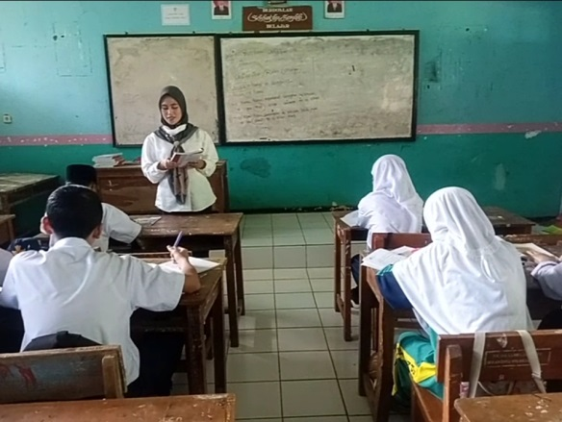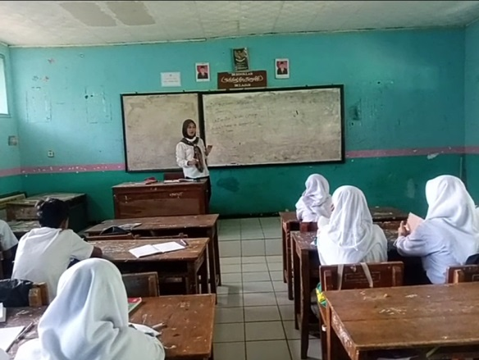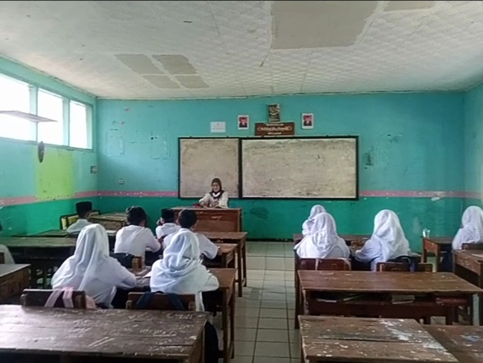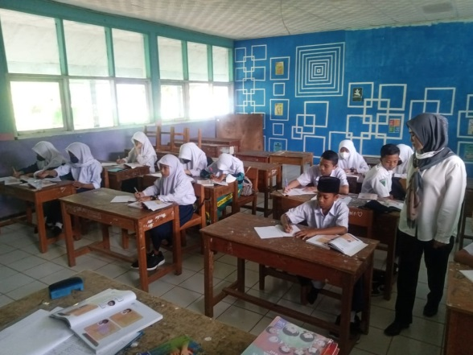
Translation Process
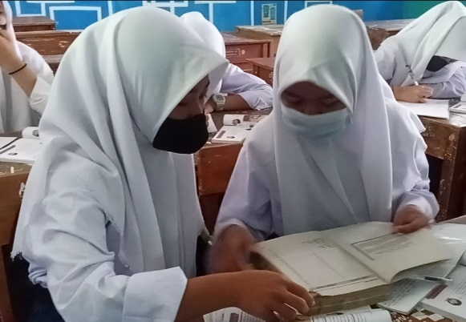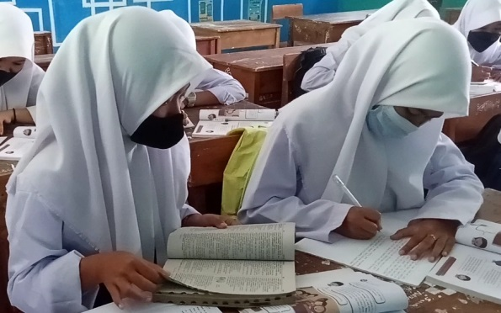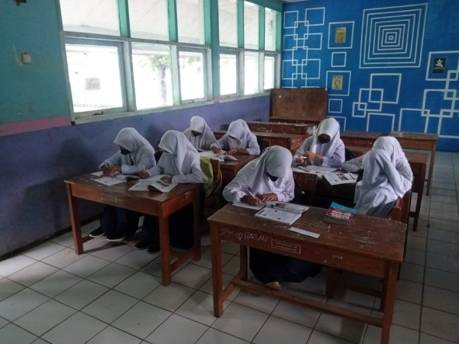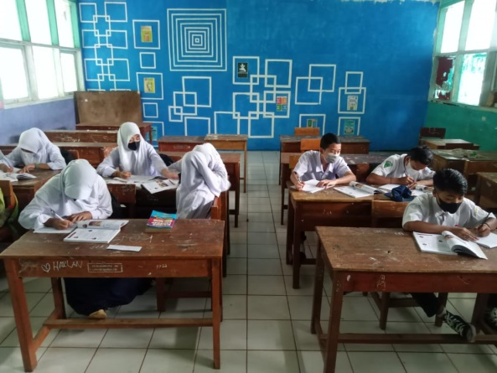
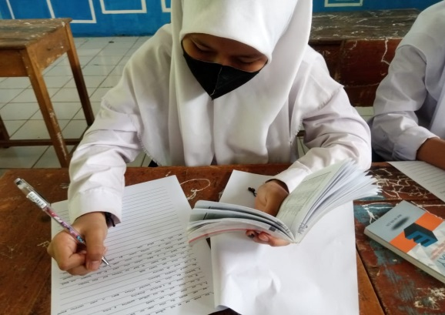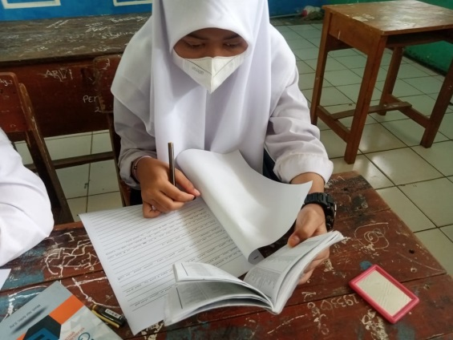
Interview with Respondents, Head Master, & Teacher 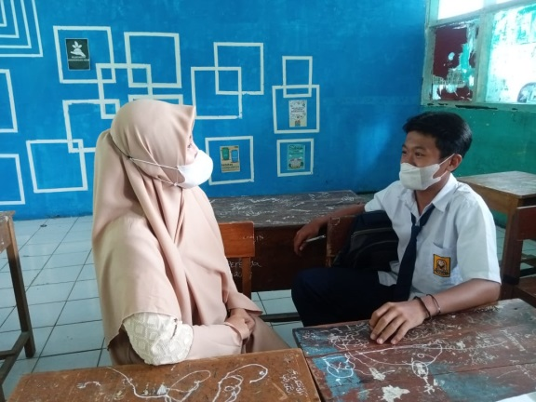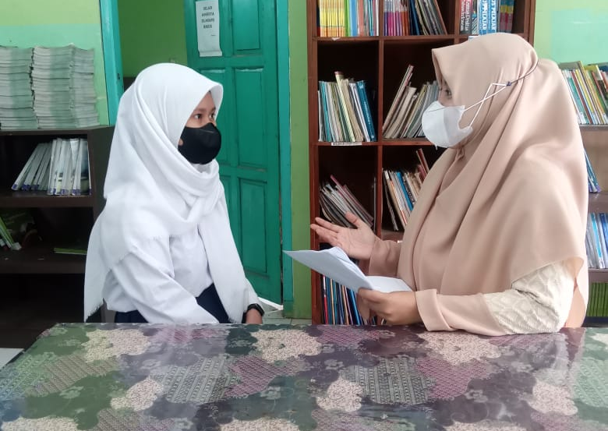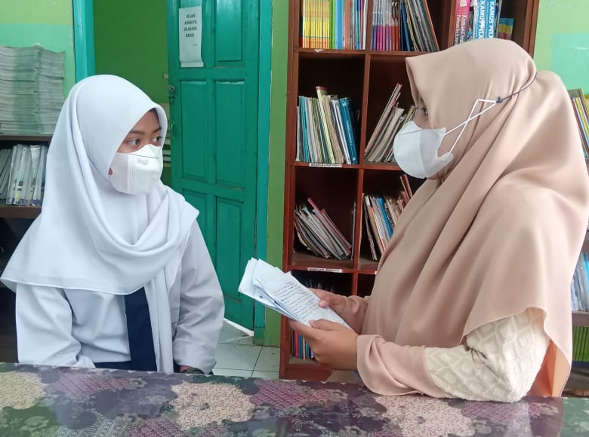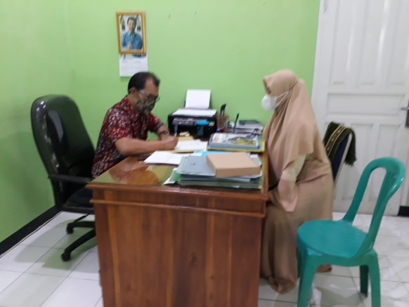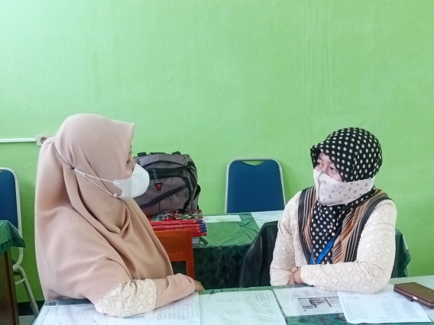

CURRICULUM VITAE


The researcher’s name is Nelly Apriliani. She was born in Bandung on April 26, 1995. She is the second child in her family, has one brother and one sister. Now, she lives in Jl. Raya Bandrek, Kersamanah, Garut.
In 2006, she graduated from SDN Sukamerang I and continued her study in SMPN 2 Kersamanah for 3 years and graduated in 2009. After that, she graduated in 2012 from SMAN 3 Garut and continued her study in English Educaion Program in Institut Pendidikan Indonesia Garut.
She did not have a dream to be a teacher, but English in Indonesia is significant, and she want everyone can communicate by use English, it connects the world!

