**A NARRATIVE STUDY ON EFL EXCELLENT STUDENT ARGUMENTATIVE WRITING PROCESS**

**A PAPER**

*Submitted to English Education Program of Institute Pendidikan Indonesia Garut as a Partial Fulfilment of the Requirement for Sarjana Pendidikan Degree*

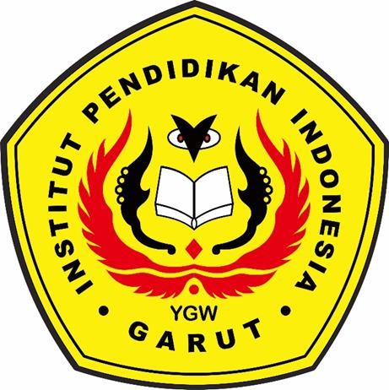

By:

**YOGA NUGRAHA**

**17224004**

**ENGLISH EDUCATION DEPARTMENT**

**FACULTY OF SOCIAL SCIENCE, LANGUAGE, AND LITERATURE**

**EDUCATION INSTITUTE OF INDONESIA**

**2021**