**TURN-TAKING DURING THE QUESTION AND ANSWER SESSION IN ONLINE CLASS PRESENTATIONS**

**A Paper**

Submitted as Partial Requirement for S.Pd Degree (*Sarjana Pendidikan*)

English Education Program at Institut Pendidikan Indonesia

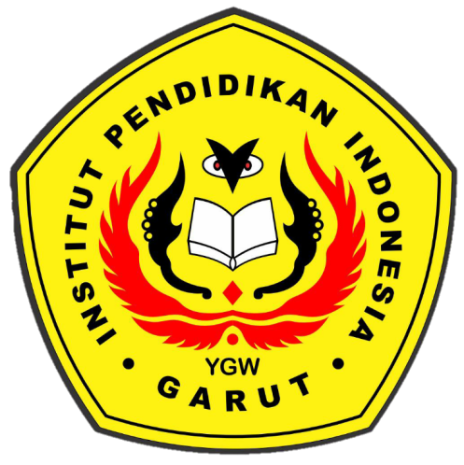

By

Teza Siti Zahara

17222006

**ENGLISH EDUCATION DEPARTMENT**

**FACULTY OF SOCIAL SCIENCE LANGUAGE EDUCATION AND LITERATURE**

**INSTITUT PENDIDIKAN INDONESIA (IPI) GARUT**

**2021**