**TEACHER’S QUESTIONING STRATEGIES AND STUDENTS’ RESPONSES IN YOUNG LEARNERS’ CLASSROOM INTERACTION**

**A Paper**

Submitted to the English Education Department of the School of Postgraduate Studies in Partial Fulfilment of the Requirements for Master’s Degree in Education

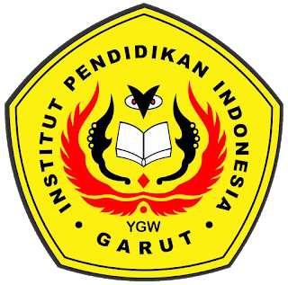

**By**

**Kintan Nimal Maula**

**17223040**

**ENGLISH EDUCATION PROGRAM**

**FACULTY OF SOCIAL STUDIES, LANGUAGE, AND LITERATURE**

**INDONESIA INSTITUTE OF EDUCATION**

**2021**