**HOW DOES YOUTUBE SUPPORT SPEAKING SKILLS:**

**A NARRATIVE STUDY**

**A PAPER**

Submitted to The English Program of IPI Garut as A Partial Fulfillment of The Requirements for The Bachelor of Education Degree

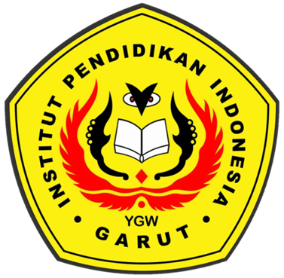

**By:**

**Arinil Haq**

**17222011**

**ENGLISH EDUCATION PROGRAM**

**Faculty of Social, Science, Language and Literature Education**

**INSTITUT PENDIDIKAN INDONESIA (IPI)**

**GARUT**

**2021**