**USING INSTAGRAM TO IMPROVE VOCABULARY OF JUNIOR HIGH SCHOOL STUDENTS**

**A PAPER**

Submitted to English Education Program of Faculty of Social Science, Language and Literature in partial fulfillment of the requirements for Bachelor degree

**By:**

**Yola Yopita**

**18221003**

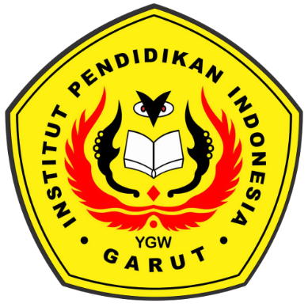

**English Education Program**

**Faculty of Social Science, Language and Literature**

**Institut Pendidikan Indonesia**

**2022**