ENGLISH IN ELEMENTARY SCHOOLS:
TEACHERS’ PERCEPTION

A PAPER

Submitted to the English Education Program of IPI Garut as a Partial Fulfillment of the Requirements for the Bachelor’s Degree in Education

Arranged by:
VERA SRI RAHAYU
18221011

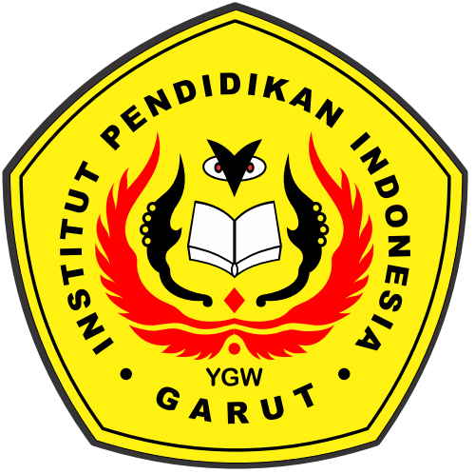

ENGLISH EDUCATION PROGRAM
FACULTY OF SOCIAL SCIENCE, LANGUAGE, AND LITERATURE EDUCATION
INSTITUT PENDIDIKAN INDONESIA
2022

