**THE INVESTIGATION OF FACE-THREATENING ACTS IN TEACHER'S UTTERANCES DURING CLASSROOM INTERACTION**

**A PAPER**

Submitted to the English Education Program of IPI Garut as a Partial Fulfilment of the Requirement for the Bachelor of Education Degree

**Arranged by:**

**ULWIATU SA’ADAH**

**18223053**

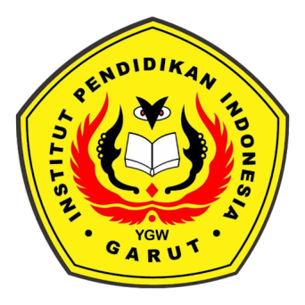

**ENGLISH EDUCATION PROGRAM**

**FACULTY OF SOCIAL SCIENCE, LANGUAGE, AND LITERATURE**

**INSTITUT PENDIDIKAN INDONESIA**

**2022**