**AN ANALYSIS OF HIGHER-ORDER THINKING SKILLS (HOTS) IN ENGLISH TEST ITEMS OF SUMMATIVE TESTS IN SENIOR HIGH SCHOOL**

**A PAPER**

Submitted to English Education Program of Faculty Social Science, Language and Literature Education of Institut Pendidikan Indonesia as Partial Fulfilment of the Requirements for the Sarjana Pendidikan Degree

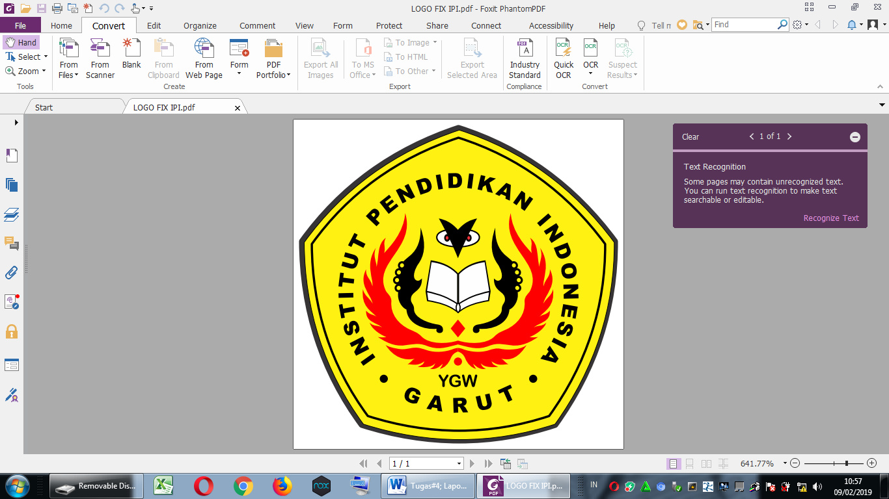

**By:**

**SINDY INDRIANTI BARNESI  
NIM. 18223009**

**ENGLISH EDUCATION DEPARTMENT**

**FACULTY OF SOCIAL SCIENCE, LANGUAGE AND LITERATURE EDUCATION**

**INSTITUT PENDIDIKAN INDONESIA**

**2022**