**WILLINGNESS TO COMMUNICATE IN ENGLISH: A CASE STUDY OF EFL STUDENTS AT ONE OF THE UNIVERSITIES IN GARUT**

**A PAPER**

Submitted to the English Education Program of IPI Garut as a Partial Fulfillment to Achieve Bachelor Degree in Education.

By:

SERNI USWATUN HASANAH

18224003

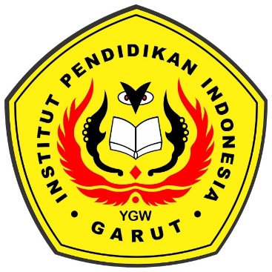

**ENGLISH EDUCATION PROGRAM**

**FACULTY OF SOCIAL SCIENCES, LANGUAGE, AND LITERATURE**

**INDONESIAN INSTITUTE OF EDUCATION GARUT**

**2022**