# TEACHERS' UNDERSTANDING OF MULTIMODAL TEACHING IN EFL CONTEXT

## A PAPER

"Submitted to the English Education Program of Faculty of Social Science, Language and Literature in Partial Fulfilment of the Requirements for Bachelor Degree"

by:

## SANTI NIM 18222016

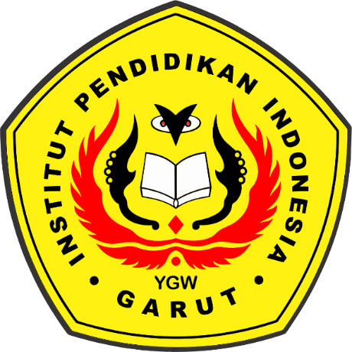

**ENGLISH EDUCATION PROGRAM**

**FACULTY OF SOCIAL SCIENCE LANGUAGE AND LITERATURE EDUCATION**

**INSTITUT PENDIDIKAN INDONESIA GARUT**

**2022**