AN ERROR ANALYSIS OF INDONESIAN POEMS TO ENGLISH TRANSLATION BY STUDENTS IN ONE OF SENIOR HIGH SCHOOLS
IN GARUT

A PAPER
Submitted to the English Education Program of Institut Pendidikan Indonesia (IPI) Garut as a Partial Fulfillment of the Requirements for the Bachelor
of Education Degree

By:
SAFITRI NUR AFFIFAH
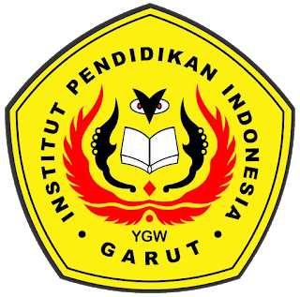
(18224002)

ENGLISH EDUCATION PROGRAM
FACULTY OF SOCIAL SCIENCE, LANGUAGE, AND LITERATURE
INDONESIA EDUCATIONAL INSTITUTION
2022

