**THE ROLE OF ENGLISH DIGITAL STORIES IN DEVELOVING STUDENTS’ SPEAKING SKILLS**

**A Paper**

*Submitted to English Education Program of Faculty of Social Science, Language and Literature in partial fulfilment of the requirements for Bachelor degree*

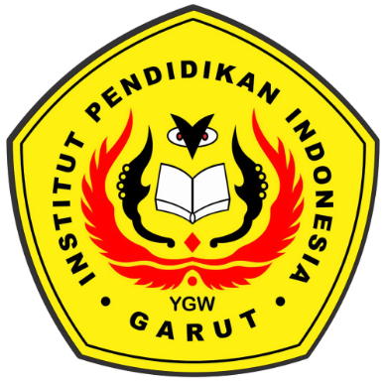

**By:**

**Rika Hanifah Padilawati**

**18221010**

**English Education Program**

**Faculty of Social Science, Language and Literature**

**Institut Pendidikan Indonesia**

**2022**