**IMPROVING STUDENTS’ WRITING SKILL IN DESCRIPTIVE TEXT THROUGH THEME-BASED APPROACH**

(A Pre-experimental Research at the 2nd Grade in one Junior High School in Garut)

**A PAPER**

Submitted to the English Education Program of IPI as Partial Fulfilment of the Requirement for Sarjana Pendidikan Degree

**By :**

**RESTIANI NURAENI**

**21225001**

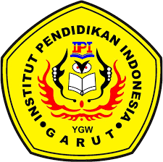

**ENGLISH EDUCATION PROGRAM**

**FACULTY OF SOSIAL SCIENCE, LANGUAGE, AND LITERATURE EDUCATION**

**INSTITUT PENDIDIKAN INDONESIA**

**2022**