**RURAL STUDENTS' EXPERIENCES IN LEARNING ENGLISH DURING DISTANCE LEARNING**

**A PAPER**

Submitted to the English Education Program of Faculty of Social Science, Language and Literature in Partial Fulfilment of the Requirements for Bachelor Degree

By:

**RESTI FEBRIANTI**

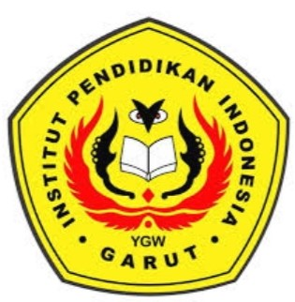**18222022**

**ENGLISH EDUCATION PROGRAM**

**FACULTY OF SOCIAL SCIENCE, LANGUAGE, AND LITERATURE EDUCATION**

**INSTITUT PENDIDIKAN INDONESIA (IPI)**

**GARUT**

**2022**