**A COMPARATIVE STUDY OF THE STUDENT’S PRONUNCIATION LEARNED BY GOOGLE NOW APPLICATION AND MANUAL DICTIONARY**

**A paper**

Submitted to the English Education Program of Institut Pendidikan Indonesia (IPI) Garut as a Partial Fulfillment of the Requirements for Bachelor of Education Degree.

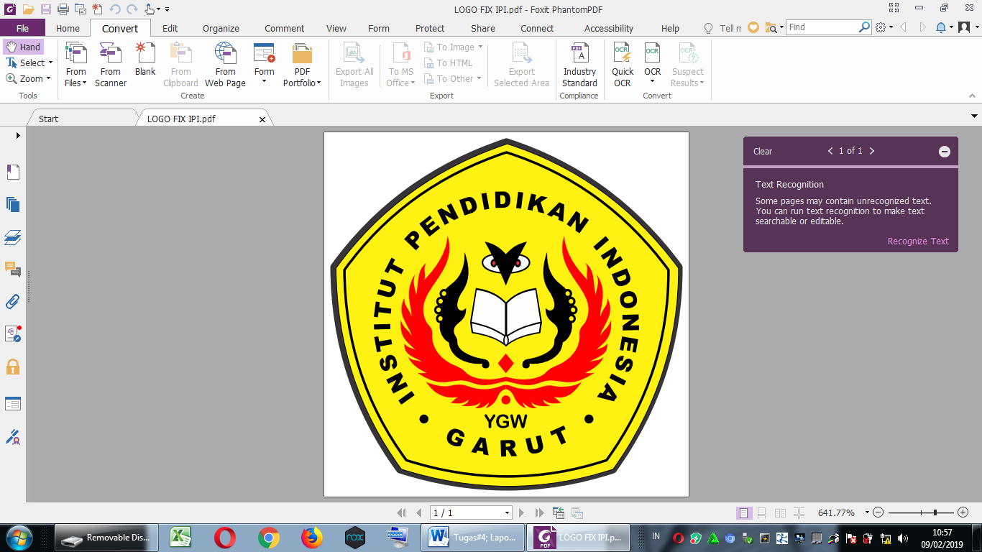

**By:**

**Rafika Hasna Nur Oktavia  
NIM. 18223030**

**ENGLISH EDUCATION PROGRAM**

**FACULTY OF SOCIAL SCIENCE, LANGUAGE AND LITERATURE**

**2022**