**UNDERGRADUATE STUDENTS’ STRATEGIES IN WRITING ENGLISH COMPOSITION: RECOUNT TEXT**

**A PAPER**

Submitted to the English Education Program of IPI Garut as the Partial Fulfillment of the Requirements for the Bachelor of Education Degree

**By**

**PUTRI HARDIYANTI**

**(18221014)**

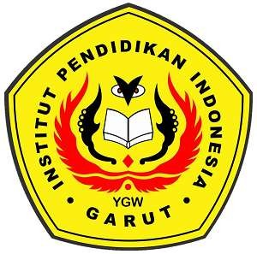

**ENGLISH EDUCATION PROGRAM**

**FACULTY OF SOCIAL SCIENCE, LANGUAGE, AND LITERATURE INSTITUT PENDIDIKAN INDONESIA**

**2022**