**Students' Perceptions of the outcome and motivation on Blended Learning amid Pandemic Covid19 Transition**

**(A Case Study of Senior High School Students in Garut)**

**A PAPER**

Submitted to the English Education Program of IPI Garut as a Partial Fulfillment of the Requirements for the Bachelor Degree in Education

**By**

**Nikita Purnamasari**

**17223043**

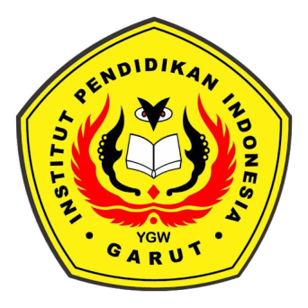

**English Education Program**

**Faculty of Social Science, Language, and Literature**

**Indonesia Institute Of Education**

**2022**