**CLASSROOM INTERACTION IN LEARNING ENGLISH PROCESS IN VOCATIONAL HIGH SCHOOL**

A Research Paper

Submitted to English Education Program of Institut Pendidikan Indonesia (IPI) Garut as the Partial Fulfillment of the Requirement for the Bachelor of Education Degree

**Arranged by:**

**Naya Nurrahmi**

**18221025**

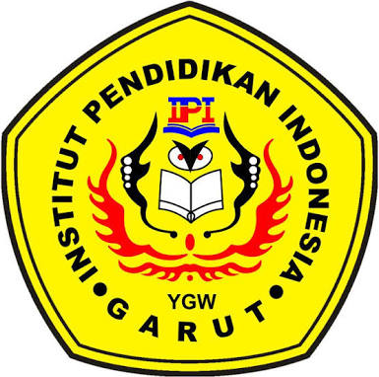

**ENGLISH EDUCATION PROGRAM**

**FACULTY OF SOCIAL SCIENCE, LANGUAGE, AND LITERATURE EDUCATION**

**INSTITUT PENDIDIKAN INDONESIA**

**2022**