STUDENTS’ PERSPECTIVE ON WRITTEN CORRECTIVE FEEDBACK

(A Qualitative Study of the Student Perspective on University in Garut)

**A PAPER**

Submitted to English Education Program of Institut Pendidikan Indonesia (IPI) Garut as the Partial Fulfilment of the Requirement for the Bachelor of EducationDegree

**By:**

**Muhammad Farhan Pribadi**

**NIM 18224012**

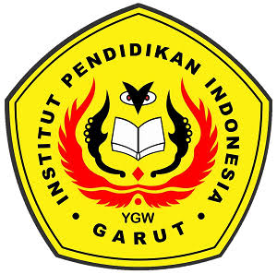

**ENGLISH EDUCATION PROGRAM**

**FACULTY OF SOCIAL SCIENCE LANGUAGE AND LITERATURE EDUCATION**

**INSTITUT PENDIDIKAN INDONESIA**

**GARUT**

**2022**