**THE REASON OF STUDENTS ERRORS IN TRANSLATING RECOUNT TEXT FROM INDONESIAN INTO ENGLISH**

**( A Case Study on the 8th Semester Students of English Education Program in Garut)**

**A Paper**

Submitted to the English Education Program of Institut Pendidikan Indonesia (IPI) Garut as the Partial Fulfillment of the Requirement for the Bachelor of Education Degree

**By:**

**MOHAMMAD ALFA ARDIAN FIRDAUS**

**18223016**

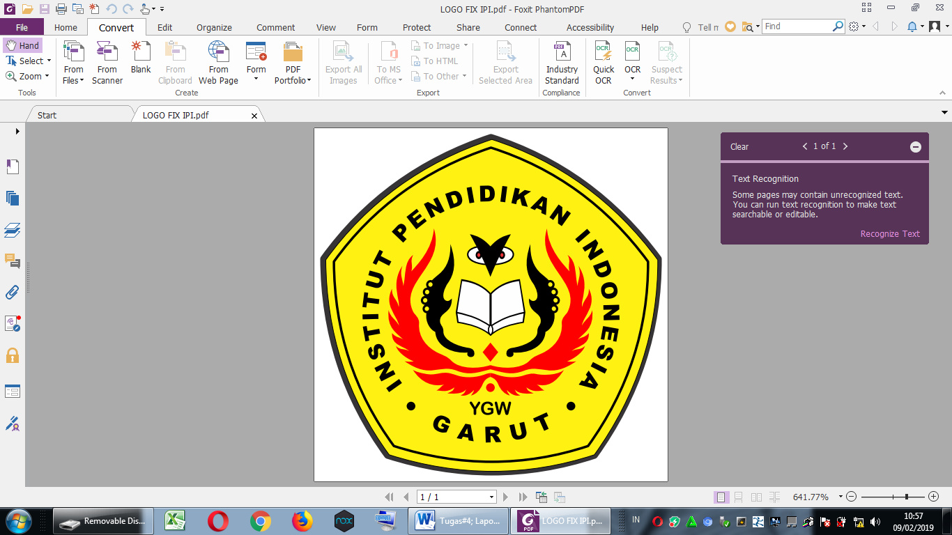

**ENGLISH EDUCATION PROGRAM**

**FACULTY OF SOCIAL SCIENCE LANGUAGE AND LITERATURE EDUCATION**

**INSTITUT PENDIDIKAN INDONESIA GARUT**

**2022**