**TEACHERS’ TECHNIQUES OF TEACHING VOCABULARY FOR EFL YOUNG LEARNERS**

**A PAPER**

Submitted to English Education Program of Faculty of Social Science, Language and Literature in partial fulfilment of the requirements for bachelor degree

**Arranged by:**

**LINDA SHALINA NABILA  
18222013**

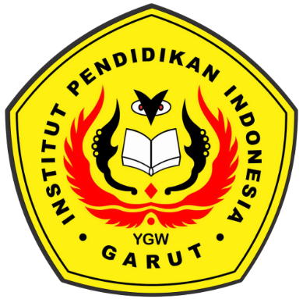

**ENGLISH EDUCATION PROGRAM**

**FACULTY OF SOCIAL SCIENCE, LANGUAGE AND LITERATURE**

**INSTITUT PENDIDIKAN INDONESIA**

**(IPI) Garut**

**2022**