**THE USE OF DIGITAL STORYTELLING IN LEARNING SPEAKING (NARRATIVE TEXT)**

(A Pre-Experimental Research at One of Junior High Schools in Garut)

**A PAPER**

Submitted to the English Education Program of IPI Garut as a Partial Fulfillment of the Requirements for the Bachelor Degree

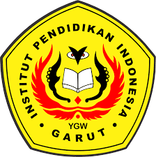

**Written By :**

**Khoerun Nissa**

**18222028**

**ENGLISH EDUCATION PROGRAM**

**FACULTY OF SOCIAL SCIENCES, LANGUAGE AND LITERATURE**

**INSTITUT PENDIDIKAN INDONESIA GARUT**

**2022**