**THE INTEGRATION OF TECHNOLOGY IN TEACHING EST**

**CASE STUDY IN ENGLISH INSTITUTE IN GARUT**

**A PAPER**

Submitted to the English Education Program of IPI Garut as a Partial Fulfillment of the Requirements for the Sarjana Pendidikan Degree

**By :**

**KARINA NAUVALIA**

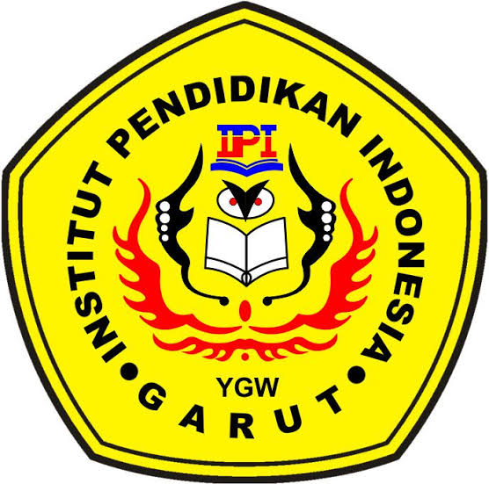**18222011**

**ENGLISH EDUCATION PROGRAM**

**FACULTY OF SOCIAL SCIENCE, LANGUAGE, AND LITERATURE EDUCATION**

**INSTITUT PENDIDIKAN INDONESIA (IPI) GARUT**

**2022**