VOCABULARY LEARNING STRATEGIES USED IN JUNIOR HIGH SCHOOL LEVEL: STUDENTS’ VOICE

A Research Paper
Submitted to English Education Program of Institut Pendidikan Indonesia (IPI) Garut as the Partial Fulfilment of the Requirement for the Bachelor of Education Degree

By:
ISTIQOMAH
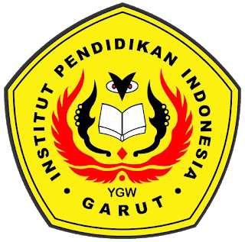
(18221028)

ENGLISH EDUCATION PROGRAM
FACULTY OF SOCIAL SCIENCE, LANGUAGE, AND LITERATURE
INDONESIA EDUCATIONAL INSTITUTION
2022

