**TEACHERS’ STRATEGIES IN SPEAKING CLASS ACTIVITY**

**A Paper**

Submitted to the English Education Program of IPI Garut as the Partial Fulfillment of the Requirements for the Bachelor of Education Degree

**By**

**ISMI NADYA**

**(18221022)**

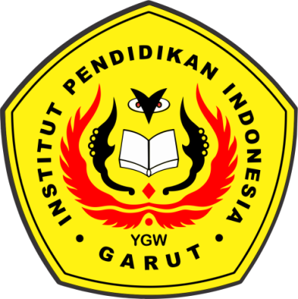

**ENGLISH EDUCATION PROGRAM**

**FACULTY OF SOCIAL SCIENCE, LANGUAGE, AND LITERATURE**

**INSTITUT PENDIDIKAN INDONESIA**

**2022**