**AN ANALYSIS OF STUDENTS’ ACADEMIC DISHONESTY THROUGH ONLINE LEARNING: TEACHERS PERCEPTION AND SOLUTION**

**A PAPER**

Submitted to the English Education Program of IPI Garut as a Partial Fulfillment

of the Requirements for the *Sarjana Pendidikan* Degree

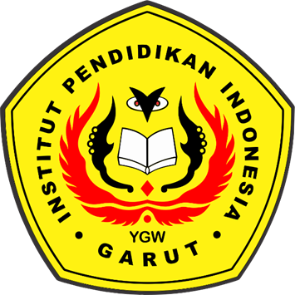

**Arranged by:**

**Indira Indriyani**

**18223014**

**ENGLISH EDUCATION PROGRAM**

**FACULTY OF SOCIAL SCIENCE, LANGUAGE, AND LITERATURE**

**INDONESIA INSTITUTE OF EDUCATION**

**2022**