**TASK-BASED LEARNING APPROACH AMID ENGLISH ONLINE CLASSROOM**

**A PAPER**

Submitted to the English Education Program of the School of

Postgraduate Studies in Partial Fulfillment of the Requirements for

Bachelor’s Degree in Education

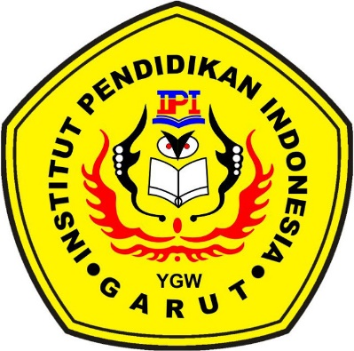

**BY:**

**HUSNI PASCA ADZANI**

**18221008**

**FACULTY OF SOCIAL SCIENCE, LANGUAGE, AND LITERATURE EDUCATION**

**INSTITUT PENDIDIKAN INDONESIA**

**2022**