**TEACHERS’ CHALLENGES AND STRATEGIES IN ENGLISH TEACHING TO YOUNG LEARNERS DURING COVID-19 PANDEMIC**

**AT JUNIOR HIGH SCHOOL IN GARUT**

**A PAPER**

Submitted to the English Education Program of IPI Garut

as a Partial Fulfillment of the Requirements for the Sarjana Pendidikan Degree

By

**Hizbi Hizbul Muhaimin**

**17223009**

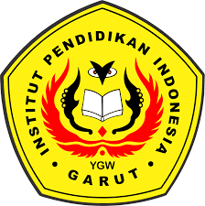

**ENGLISH EDUCATION PROGRAM**

**FACULTY OF SOCIAL STUDIES, LANGUAGE, AND LITERATURE INDONESIA INSTITUTE OF EDUCATION**

**2022**