**Teachers' Strategies in Developing**

**Students' Communication Skill in English During a Pandemic**

(A case Study Research in One of Senior High School, Garut, West Java)

**A Paper**

Submitted in Partial Fulfillment of the Requirements

for *Sarjana Pendidikan* Degree to the English Education Program

**By**

**HISNA OCTAVIA**

**NIM. 18223022**

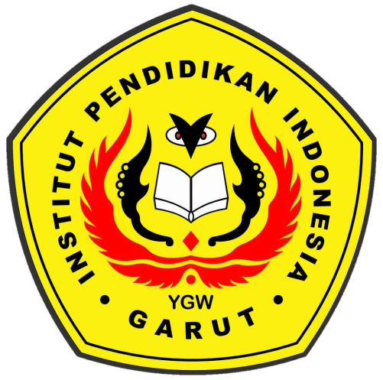

**English Education Program**

**Faculty of Social Science, Language, And Literature Education**

**Institut Pendidikan Indonesia**

**2022**