**MEASURING STUDENT ENGAGEMENT IN HYBRID CLASSROOMS**

**A PAPER**

*Submitted to the English Education Program of IPI Garut as a Partial Fulfillment of the Requirements for the Sarjana Pendidikan Degree*

Arranged by:

**GISTA MONIKA LESTARI**

**18224004**

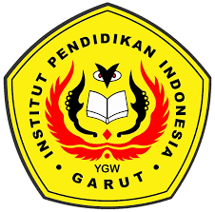

**ENGLISH EDUCATION PROGRAM**

**FACULTY OF SOCIAL SCIENCE, LANGUAGE, AND LITERATURE EDUCATION**

**INSTITUT PENDIDIKAN INDONESIA GARUT**

**2022**