# **AN EFL TEACHER’S UNDERSTANDING ON MULTIMODALITY IN TEACHING READING TO YOUNG LEARNERS**

**A PAPER**

Submitted to the English Education Program of Institut Pendidikan Indonesia Garut as a Partial Fulfillment of the Requirements for *Sarjana Pendidikan* Degree

# **By:**

# **Gina Siti Faiza**

# **NIM. 18222012**

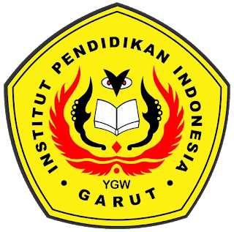

**ENGLISH EDUCATION PROGRAM  
FACULTY OF SOCIAL SCIENCES, LANGUAGE AND LITERATURE  
INSTITUT PENDIDIKAN INDONESIA GARUT  
2022**