**THE INFLUENCE OF COLLABORATIVE STRATEGIC READING (CSR) ON STUDENT’S READING COMPREHENSION**

**A PAPER**

Submitted to the English Education Program of Institute Pendidikan Indonesia (IPI) Garut as the Partial Fulfilment of the Requirements for Bachelor of Education Degree

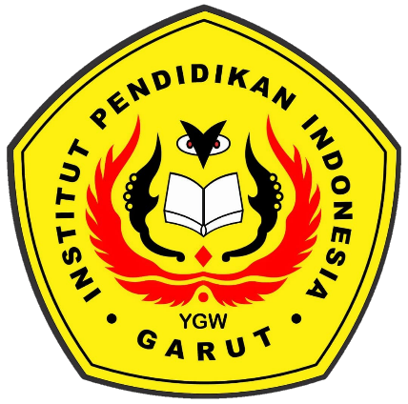

By:

**Ganjar Sapaat**

**NIM. 18223035**

**ENGLISH EDUCATION PROGRAM**

**FACULTY OF SOCIAL STUDIES, LANGUAGE, AND LITERATURE EDUCATION**

**INSTITUT PENDIDIKAN INDONESIA GARUT**

**2022**