**STUDENTS’ IMPROVEMENT IN LISTENING COMPREHENSION THROUGH DIGITAL NARRATIVE MEDIA**

**A PAPER**

Submitted to English Education Program of Institut Pendidikan Indonesia (IPI) Garut as the Partial Fulfillment of the Requirement for the Bachelor of Education Degree

**Arranged by**

**Falen Yuanisa**

**18223011**

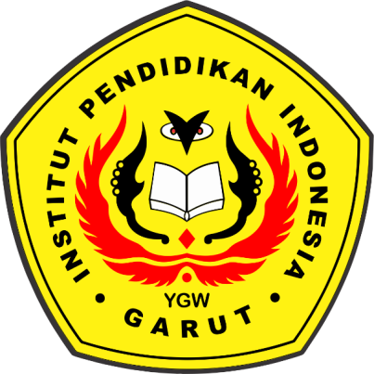

**ENGLISH EDUCATION PROGRAM**

**Faculty of Social Science, Language, and Literature Education**

**INSTITUT PENDIDIKAN INDONESIA (IPI)**

**2022**