**ENGLISH TEACHER’ OPINION AND IMPLEMENTATION OF POPULAR CULTURE TO MOTIVATE THEIR STUDENTS IN ONE OF THE JUNIOR HIGH SCHOOL IN GARUT**

(A study case in one of Junior High School in Garut)

**A PAPER**

Submitted to the English Education Program of IPI Garut as a Partial Fulfilment of Requirement for the Sarjana Pendidikan Degree

**By:**

**EMMIR SULAEMAN ANGKASA**

**18222001**

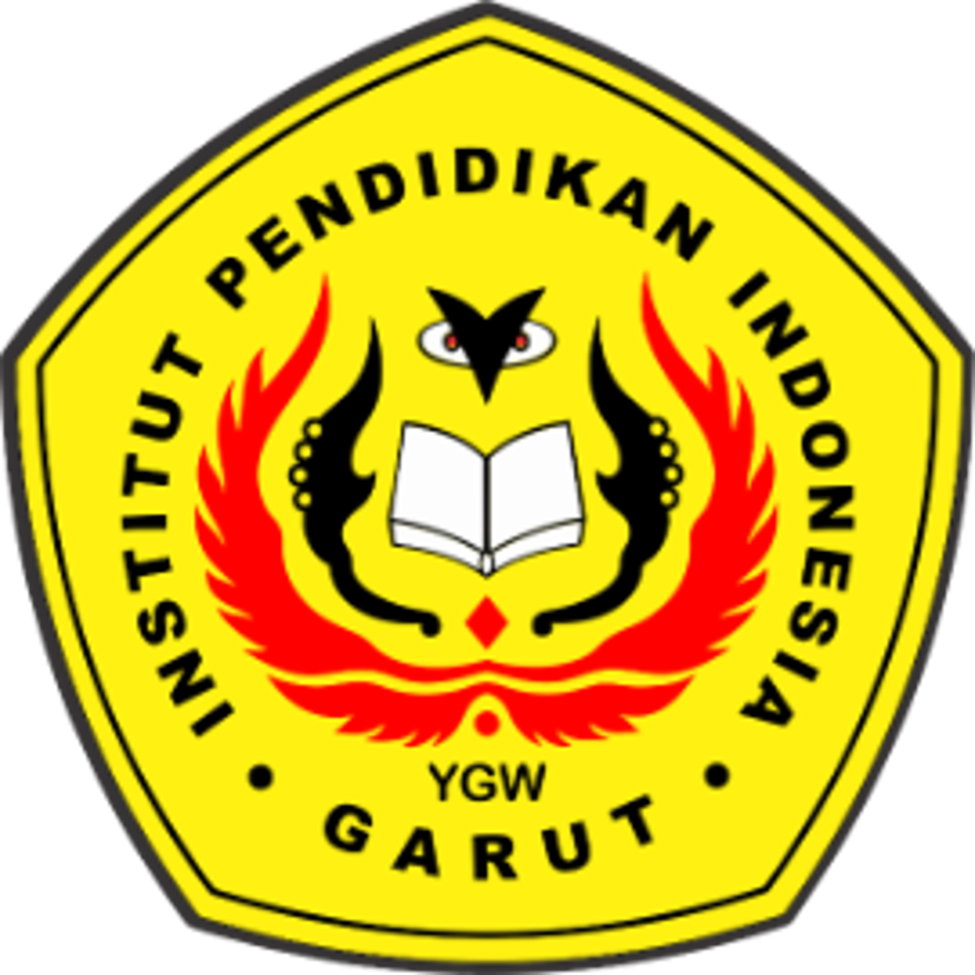

**ENGLISH EDUCATION PROGRAM**

**FACULTY OF SOCIAL SCIENCE LANGUAGE AND LITERATURE**

**INSTITUT PENDIDIKAN INDONESIA GARUT**

**2022**