TEACHERS' ATTITUDES ON STUDENTS’ CHEATING BEHAVIOR IN ENGLISH ONLINE TESTS

A PAPER
Submitted to English Education Program of Institut Pendidikan Indonesia (IPI) Garut as the Partial Fulfillment of the Requirement for the Bachelor of Education Degree

By:
ATTHIYYAH NAIFA
(18223057)

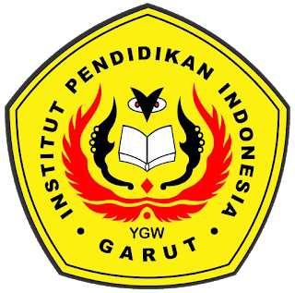

ENGLISH EDUCATION PROGRAM
FACULTY OF SOCIAL SCIENCE, LANGUAGE, AND LITERATURE EDUCATION
INSTITUT PENDIDIKAN INDONESIA (IPI)
GARUT
2022

