**PORTRAYING HOW “GENRE” IS TAUGHT IN JUNIOR HIGH SCHOOL LEVEL**

**A PAPER**

Submitted to the English Educational Program of Institut Pendidikan Indonesia Garut as Partial Fulfillment of the Requirements for a Bachelor’s Degree

**By:**

**ASRIE FEBRIYANI NURSYAMSI**

**18222002**

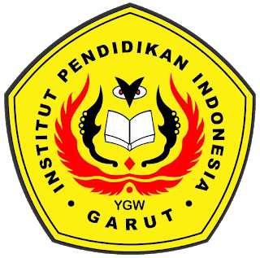

**ENGLISH EDUCATION PROGRAM  
FACULTY OF SOCIAL SCIENCES, LANGUAGE AND LITERATURE  
INSTITUT PENDIDIKAN INDONESIA GARUT  
2022**