# THE INFLUENCE OF USING CAKE APPLICATION

**ON** **STUDENTS' SPEAKING** **SKILL**

**A PAPER**

Submitted to the English Education Program of IPI Garut

As partial fulfillment of the requirement for the Sarjana Pendidikan Degree

**By:**

**ASEP MUHAMMAD SAEPURROHMAN**

**NIM 18223036**

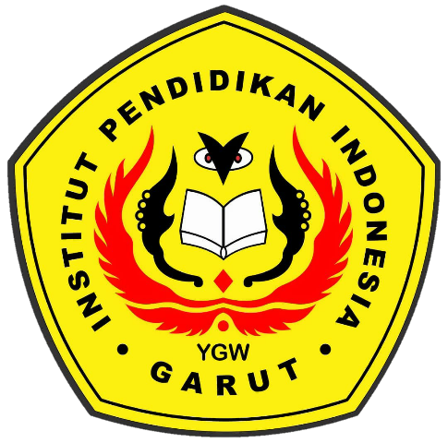

**ENGLISH** **EDUCATION** **PROGRAM**

**FACULTY OF** **SOCIAL STUDIES, LANGUAGE, AND**

**LITERATURE EDUCATION**

**INSTITUT PENDIDIKAN INDONESIA GARUT**

**2022**