**THE USE OF ENGLISH SINGSING VIDEOS IN IMPROVING YOUNG LEARNERS’ SPEAKING**

**A PAPER**

Submitted to the English Education Program of Institut Pendidikan Indonesia Garut as the Partial Fulfillment of the Requirement for the Bachelor of Education Degree

**Arranged by:**

**ANDINA NURHALISA**

**18221018**

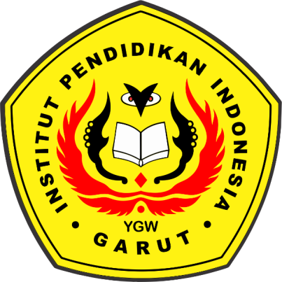

**ENGLISH EDUCATION PROGRAM**

**Faculty of Social Science, Language, and Literature Education**

**INSTITUT PENDIDIKAN INDONESIA GARUT**

**2022**