**ANALYSIS OF PATTERN INTERACTION EFL CLASSROOM BETWEEN NATURAL AND SOCIAL SCIENCE PROGRAM AT SENIOR HIGH SCHOOL**

**A PAPER**

Submitted to the English Education Department of Institut Pendidikan Indonesia (IPI) Garut as a Fulfillment of the Requirements for the Bachelor of Education Degree

Arranged by:

**AJENG LINA AGUSTIN**

**NIM 18223028**

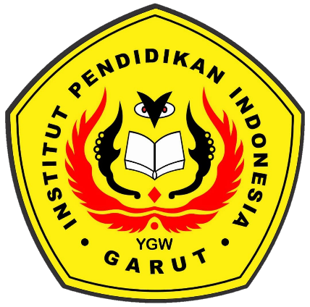

**ENGLISH EDUCATION PROGRAM**

**FACULTY OF SOCIAL SCIENCE LANGUAGE AND LITERATURE**

**INSTITUT PENDIDIKAN INDONESIA**

**2022**