**USING TED TALKS FOR IMPROVING STUDENTS’ SPEAKING SKILL**

(A Pre-Experimental Research at one of Senior High Schools in Garut)

**A PAPER**

*Submitted to the English Education Program of IPI Garut as a Partial of the Requirements for the Degree of Sarjana Pendidikan (S.Pd.)*



**By:**

**Ai Nurul Sipa Paujiah**

**18223010**

**ENGLISH EDUCATION PROGRAM**

**FACULTY OF SOCIAL SCIENCE, LANGUAGE AND LITERATURE**

**INDONESIA INSTITUTE OF EDUCATION**

**2022**

**APPROVAL SHEET**

**USING TED TALKS FOR IMPROVING STUDENTS’ SPEAKING SKILL**

**Written by:**

**Ai Nurul Sipa Paujiah**

**NIM. 18223010**

**Approved by:**

**First Supervisor Second Supervisor**

**Dr. Lia Novita, M.Pd H. Surtiana Harjadijaya, Drs., M.A.**

**NIDN. 0416127702 NIDN. 0010075102**

**Certified by:**

**Head of English Education Program**

**Anne Ratna Suminar, M.Pd**

**NIDN. 0415038601**

**LEGITIMATION OF EXAMINATION BOARD**

**USING TED TALKS FOR IMPROVING STUDENTS’ SPEAKING SKILL**

**(A Pre-Experimental Research at One of Senior Schools in Garut)**

**Written by:**

**Ai Nurul Sipa Paujiah**

**NIM. 18223010**

**The paper has been examined on 27thththt56 of August 2022**

**First Examiner, Second Examiner, Third Examiner,**

**Yuyu Wahyudin, M.Pd Muhammad Taufiq, M.Pd Wahid Hasim, M.Pd**

**NIDN. 0402015791 NIDN. 0423938591 NIDN. 0428078409**

**Acknowledged by:**

**Decan of Faculty of Social Science, Language, and Literature Education**

**Dr. Lina Siti Nurwahidah, M.Pd**

**NIP. 196805271993032001**

**DECLARATION**

The researcher hereby declares that this paper entitled “USING TED TALKS FOR IMPROVING STUDENTS’ SPEAKING SKILL” is fully written by the researcher and acknowledge as her own intellectual property. In accordance with the use of the references, citations, and quotations of the related literature have been conducted based on the rightfully legal and scientific procedures. Therefore, the contents of this paper is an original work of the researcher. In this case, if there are any complaints or if the researcher breaks the statement, the researcher will be fully responsible for all consequences given.

Garut, July 2022

Garut, July 2022

The researcher,

Ai Nurul Sipa Paujiah

NIM. 18223010

**PERNYATAAN**

Dengan ini, peneliti menyatakan bahwa skripsi saya yang berjudul **“USING TED TALKS FOR IMPROVING STUDENTS’ SPEAKING SKILL”** ini benar-benar hasil karya saya sendiri. Pengutipan dari sumber-sumber lain telah peneliti lakukan dengan berdasarkan pada kaidah-kaidah pengutipan yang sesuai dengan etika keilmuan yang berlaku sehingga isi skripsi serta semua kelengkapannya ini merupakan hasil karya asli. Kemudian, apabila ditemukan hal-hal yang tidak sesuai dengan isi pernyataan penelti ini, peniliti bersedia menerima resiko atau konsekuensi apapun.

Garut, Juli 2022

Yang Membuat Pernyataan,

Ai Nurul Sipa Paujiah

NIM. 18223010

**PREFACE**

First of all, all praises be to Allah SWT., because of His blessings and mercy, the researcher was able to complete a paper entitled **“USING TED TALKS FOR IMPROVING STUDENTS’ SPEAKING SKILL”** which aims to be used as a theoretical and practical reference for future readers. The researcher realise that this paper is far from perfect, both in content and grammar. Therefore, the researcher hopes for more constructive criticism and suggestions so that this paper can be better. The researcher also hopes that this paper will be useful for readers or can be a reference by future researchers.

Garut, July 2022

The Researcher

**ACKNOWLEDGEMENTS**

All praises be to Allah SWT., Lord of the worlds. Without His blessing, help and His mercy, this paper would not be completed. Peace and blessing be upon our great prophet Muhammad SAW., his family, his companion and all of his followers.

This paper could not be completed without a great deal of help from many people. The researcher would like to express her sincere gratitude and deep appreciation to:

1. Dr. Nizar Alam Hamdani, S.E., M.T., M.Si. as the Rector of Institut Pendidikan Indonesia Garut.
2. Anne Ratna Suminar, M.Pd. as the Head of English Education Program of Institut Pendidikan Indonesia Garut.
3. Dr. Lia Novita, M.Pd as the first supervisor for her valuable guidance and advices during the completion of this paper.
4. H. Surtiana Harjadijaya, Drs., M.A. as the second supervisor for her valuable guidance and advices during the completion of this paper.
5. Her beloved family, especially her parents who always give the best pray and support for her. Alhamdulillah.
6. Her classmates from class C who shared happiness, sadness, and thoughts during the journey of her study.

**ABSTRACT**

This study aims to find out if TED Talks can be an effective way for improving students’ speaking skill. The researcher used TED talks exactly the video of TED Talks as a treatment, pre-test and post-test at one of the Senior High Schools in Garut. The researcher used quantitative method and experimental research as a research design. Data collection was done by analyzing pre-test and post-test result by using SPSS and the formula to find out the value. The result was shown that the improvement of students’ speaking skill exactly in three aspects; vocabulary, fluency and comprehension of speaking skill was enhanced. Also, TED Talks motivate students to learn about speaking English in an interactive and alternative way.

***Keywords:*** *TED Talks, speaking skill*

**ABSTRAK**

Penelitian ini bertujuan untuk mengetahui apakah TED Talks dapat menjadi cara alternatif untuk meningkatkan keterampilan berbicara siswa. Peneliti menggunakan TED Talks persisnya video dari TED Talks sebagai treatment, pre-test dan post-test di salah satu Sekolah Menengah Atas (SMA) di Garut. Peneliti menggunakan metode kuantitatif dan penelitian eksperimental sebagai desain penelitian. Pengumpulan data dilakukan dengan menganalisis hasil pre-test dan post-test dengan menggunakan SPSS dan rumus untuk mengetahui nilainya. Hasilnya menunjukan bahwa peningkatan keterampilan berbicara siswa tepatnya dalam tiga aspek keterampilan berbicara siswa juga meningkat. TED Talks memotivasi siswa untuk belajar berbicara bahasa Inggris dengan cara yang interaktif dan alternatif.

***Kata kunci:*** *TED Talks, keahlian berbicara*

# **LIST OF CONTENTS**

**DECLARATION i**

**SURAT PERNYATAAN ii**

**PREPACE iii**

**ACKNOWLEDGEMENT iv**

**ABSTRACT** **v**

**ABSTRAK vi**

**LIST OF CONTENTS vii**

**LIST OF TABLE** **x**

**LIST OF APPENDICES xi**

**CHAPTER I**

**INTRODUCTION** **1**

**1.1 Background of the Study** **1**

**1.2 Research Questions** **2**

**1.3 Research Objectives** **3**

**1.4 Research Significance** **3**

**1.4.1 Theoretical Aspect 3**

**1.4.2 Practice Aspect 3**

**1.5 The Limitation of the Research** **3**

**1.6 Definition of Terminologies 3**

**CHAPTER II**

**LITERATURE REVIEW** **5**

**2.1 Speaking Skill** **5**

**2.1.1 Definition of Speaking 5**

**2.1.2 Speaking Skill 6**

**2.1.3 Components of Speaking 6**

**2.1.4 Speaking Assesment 7**

**2.1.5 Problem of Speaking Activities 10**

**2.1.6 The Way to Solve the Speaking' problem 10**

**2.2 TED Talks** **11**

**2.2.1 Definition of TED Talks 11**

**2.2.2 The Concept of TED Talks 12**

**2.2.3 Procedures of Watch TED Talks Video on Youtube 13**

**2.2.4 TED Talks Performance 14**

**2.3 Previous Study** **15**

**CHAPTER III**

**RESEARCH METHODOLOGY** **17**

**3.1 Research Design** **17**

**3.2 Population and Sample** **19**

**3.3 Research Variable and Indicators** **19**

**3.4 Research Instrument** **20**

**3.5 Data Collection** **22**

**3.6 Technique of Data Analysis** **23**

**CHAPTER IV 25**

1. **Findings 25**
2. **Discussions 32**

**CHAPTER V 35**

1. **Conclusions 35**
2. **Suggestions 35**

**REFERENCES** **37**

**APPENDIXES** **39**

**LIST OF TABLE**

**Table 3.1 The test scoring Categories for Speaking 20**

**Table 3.2 Rating Points 22**

**Table 3.3 Criteria for Hypotesting Points** **24**

**Table 4.1 The Score of Student's speaking Skill of Pre-test 25**

**Table 4.2 Correlations** **26**

**Table 4.3 Scoring Aspects of Students' Speaking Skill 27**

**Table 4.4 Reliability Statistic 27**

**Table 4.5 The Descriptive Statistic 27**

**Table 4.6 The Score of Student's speaking Skill of Post-test 29**

**Table 4.7 Correlations 30**

**Table 4.8 Scoring Aspects of Students' Speaking Skill 31**

**Table 4.9 Reliability Statistic 31**

**Table 4.10 The Descriptive Statistic 31**

**Table 4.11 Improvement of Vocabulary 32**

**Table 4.12 Improvement of Fluency 32**

**Table 4.13 Improvement of Comprehension 32**

**APPENDICES**

**APPENDIX I 39**

**A. The Table of Students' Score 39**

**B. The Table of Descriptive Statistic** **40**

**C. Calculating the Students' Improvements Score 41**

**D. Distribution of t-test 42**

**E. Topics of Pre-test and Post-test 43**

**APPENDIX II****44**

**Documents** **44**

# **CHAPTER I**

# **INTRODUCTION**

## **Background of the Study**

Learning foreign languages, especially English, in this technological era is useful and more than just an international language. English has been used as a strategy tool and strategy for human resource development at variuos time in the history of education in this world. This is also based on Balan (2011) states that the importance of English as an international language where by education and cultures are exchanged at all levels. With different levels of English skill, people can use effective strategies for increasing their skill in English. For example, using technological tool for increasing their skill.

Talking about English Skill, there are four skills that must be mastered. The four skills are categorized into two categories namely speaking and writing are called active and productive skills, while reading and listening are called passive or receptive skills. Skills are our ability to do these things. They are usually divided into two types: 1) receptive and 2) productive. Receptive skills are those used in understanding, that is reading or listening. Productive skills involve producing language, that is speaking or writing. It is generally accepted that receptive skills should come before productive skills; however, it is important to remember that communication is interactive and requires the use of all skills most of the time. Dividing language into skill areas for teaching and evaluation purposes does not necessarily reflect how language is really used. It is important to consider skills when designing language learning materials. This helps to identify the aims of an activity or lesson. Ideally, learning materials have a multi-layered skills approach, where all skills are covered and combined in a realistic way. According to Mohan (1986), in a segregated skill approach, the mastery of discrete skills, such as reading and writing, or reading and speaking are considered as the key to successful language learning. Language learning is typically separated from content learning (Oxford, 2001).

Other than, according to Huges in Yolanda and Hadi (2019) the goal of speaking is communicative. Speaking is an interactive process of building meaning that includes generating, receiving, and processing information. Moreover, speaking is the skill that they need most as students. The improvement of speaking skill for students is influenced by some factors. Speaking is an important skill in learning a laguage besides reading, listening and writing. Speaking skills are recognized as the most important skills to be mastered by everyone, because speaking skill is needed to help everyone to communicate and socialize with other people. Technology also plays a role in influencing students’ speaking skills. According to Gomez (2016), technology is considered as a powerful tool that can perform teaching and learning.

Many people have made technology an interesting and effective learning opportunity. Hence, Ted Talks present as one of video-based learnings that could improve speaking skills. According to Nurmukhamedov (2017), using TED Talks as a model can help students in oral presentations in front of the general public and reflect the presentation by Western style. TED Talks are multimedia tools in the form of presentations used by people who are not professional speakers or commonly called open presentations (Kedrowicz & Taylor, 2016). Ted Talk is useful for improving public speaking skills like eye contact, movement, gesture, pronunciation, and etc. It means that TED Talks can improve students’ speaking skills. The researcher believes that students can learn many things through Ted Talk video besides learning about speaking skill. Thus, the aim to find out how TED Talk can be an alternative way for improving students’ speaking skills.

## **Research Questions**

Based on the background of the study, the researcher’s question: Can TED Talks be an effective way for improving students’ speaking skills?

## **Research Objectives**

Based on the research question, this study will focus on to find out to what extent TED Talk can be an alternative way for improving students’ speaking skills.

## **Research Significance**

The results of this research are expected to be beneficial to both theoretically and practically elaborated in the following section and also helpful to the students in the process of improving speaking skills.

## **Theoretical Aspect**

Theoretically, this research will be shown the information about using TED Talks for improving students’ speaking skills. The students will be understand about TED Talks and it will be helped the students to improve their speaking skills.

## **Practice Aspect**

Practically, this research can be practiced for students. They must use TED Talks to help theirselves for improving their speaking skills. So, she hope the students can use the TED Talks. The researcher also can understand how important TED Talks for improving speaking skills.

## **The Limitation of the Research**

This reserach focused on using TED Talks for improving students’ speaking skills in junior high school. Moreover, TED Talk as a tool for learning to improve speaking skills. According to Kedrowicz & Taylor (2016), TED Talks are multimedia tools in the form of presentations used by people who are not professional speakers or commonly called open presentations.

## **Definition of Terminologies**

## Based on the title is ***using TED Talks for improving students’ speaking skills at one of senior high schools in Garut***. The researcher’s define as follows:

1. Speaking Skills

Speaking skills are recognized as the most important skills to be mastered by students, also speaking skill is needed to help students to communicate and socialize with other people.

1. TED Talks

TED (technology, entertaiment and design) Talks are a video created from a presentation at the main TED (technology, entertainment, design) conference. Ted Talk is useful for improving public speaking skills like eye contact, movement, gesture, pronunciation, and etc.

1. **Hyphothesis**

When it is found that the value of t-test is equal or greater than the value of t-table, it means that Null Hypothesis (H0) is rejected and Alternative Hypothesis (H1) is accepted because there is significance difference between pre-test and post-test after taught speaking using TED Talks. The criteria for the hypothesis testing as follows:

**Table 1.7: Criteria for the hypothesis testing**

|  |  |  |
| --- | --- | --- |
| **Testing** | **Hypothesis** | |
| **H0** | **H1** |
| t-test>t-table | Rejected | Accepted |
| t-test<t-table | Accepted | Accepted |

# **CHAPTER II**

# **LITERATURE REVIEW**

This chapter presents the theoretical framework of the related literature that is relevant to the topic that is about the definition of speaking, speaking skills, and about TED Talk. Also this chapter consists of the previous research studies.

## **Speaking Skill**

## **Definition of Speaking**

## As we know, speaking is one form of communication. Speaking is a language skill that is developed in child life, which is produced by listening skill, and at that period speaking skill is learned (Tarigan, 1990). Referring to the previous context, speaking related to language skill. Why is speaking related to language skill? Because, when we communicate with other people, of course we must learn about language skill first. For example, when we want to communicate with an older human we must master the etiquette of how to talk or speak with them, also when we want to communicate with a young human we must master the etiquette of how to talk with them. The previous example explained that language skill is a key to speaking and it means that language skill and speaking are related. As humans, we know that speaking is the most important thing in our lives.

## Based on Competence Based Curriculum, speaking is one of the four basic competences that the students should gain well. Channey (1998) states that speaking is the process of building and sharing meaning through verbal and non-verbal symbols in a variety of contexts. In carrying out speaking, students face some difficulties, one of them is about language itself. In fact, almost all students have difficulty speaking even though they have a lot of vocabulary and have written them well. The problems are afraid for students to make some mistakes.

## **Speaking Skills**

There are four skills that must be mastered. The four skills are: speaking skill, listening skill, writing skill and reading skill. The most important skill is speaking. Speaking skills are recognized as the most important skills to be mastered by students, because speaking skill is needed to help students to communicate and socialize with other people. Speaking skills are classified as crucial. This is what makes speaking skills feared by many students, especially for those who have less self-confidence so that it affects the ability to speak English. Channey (1998) stated that speaking was the process of building and sharing meaning through verbal and non-verbal symbols in a variety of contexts.

* + 1. **Components of Speaking Skills**

Based on the Haris’s statement (1974), there are five components of speaking skill concerned with comprehension, grammar, vocabulary, pronunciation, fluency.

1. Grammar

It is needed for students to arrange a correct sentence in conversation. It is relate with explanation suggested by Heaton (1988) that students’ ability to manipulative structure and to distinguish appropriate grammatical form in appropriatness. The utility of grammar is to learn the correct way to gain expertise in a language in oral and written form.

1. Fluency

Fluency is the ability to speak quickly and accurately. Fluent speakers are able to concentrate their attention on the meaning of the speech. Fluent speakers comprehend and recognize words at the same time.

1. Comprehension

Comprehension is one of the aspects of speaking, it is the ability to take meaning from the speaker and to communicate and remember the meaning from the speaker. Good speakers are those who monitor their listener comprehension to make sure they understand the speaker and comprehension as the final goal of speaking.

1. Vocabulary

Vocabulary can be defined as the appropriate diction which is used in communication. Without having a sufficient vocabulary it one can not communicative effectively or express their ideas both oral and written form. Having limited vocabulary is also a barrier that precludes learners from learning a language. In the previous study said “without grammar very little can be conveyed, without vocabulary nothing can be conveyed”. So, based on that explanation, the researcher concluded that without mastering vocabulary sufficiently is English learners will not be able to speak English or write English properly.

1. Pronunciation

In speaking, pronunciation plays a vital role in order to make the process of communication easy to understand. Pronunciation can be defined as the way for students to produce clearer language when they speak. From the previous statements, the researcher concluded that pronunciation is the knowledge of studying about how the words in a particular language are produced clearly when people speak.

* + 1. **Speaking Assesment**

The statement of Brown and Yule (1983) said “there are six components of speaking to be scored; pronunciation, grammar, vocabulary, fluency, comprehension and task.

1. Grammar

The score pf grammar are:

5= equivalent to that of an educated native speaker

4= able to use language accurately on all levels normally pertinent to professional needs. Errors in grammar are quite rare.

3= control of grammar is good. Able to speak the language with sufficient structural accuracy to participate effectively in most formal and informal conversation on practical, social and professional topics.

2= can usually handle elementary constructions quite accurately but does not have through or confident control of the grammar.

1= errors in grammar are frequent, but speaker can be understood by a native speaker used to dealing with foreigners attempting to speak the langauge.

1. Fluency

5= Has complete fluency in the language such that his speech is fully accepted by educated native speakers.

4= Able to use language fluently on all levels normally pertinent to professional needs. Can participate in any conversation within the range of this experience with a high degree of fluency.

3= Can discuss particular interests of competence with reasonable ease. Rarely has to grope for words.

2= Can handle with confidence but not with facility most social situations, including introductions and casual conversations about current events, as well as work, family, and autobiographical information.

1= No Specific fluency description. Refer to the other four language areas for implied level of fluency.

1. Comprehension

5= Equivalent to that of an educated native speaker

4= Can understand an conversation within the range of their experience

3= Comprehension is quite complete at a normal rate of speech.

2= Can get the gist of most conversations of non-technical subjects (i.e., topics that require no specialized knowledge).

1= Within the scope of his very limited language experience, can understand simple questions and statements if delivered with slowed speech, repetition, or paraphrase.

1. Vocabulary

5= Use vocabulary and idioms is virtually that of native speaker

4= Sometimes uses inappropriate terms and/ or must rephrase ideas because inadequacies

3= Frequently uses the wrong words, conversation somewhat limited because inadequate vocabulary

2= Long pause while search for the desired meaning of word

1= Full of long and unnatural pauses

1. Pronunciation

5= equivalent to and fully accepted by educated native speaker

4= errors in pronunciation are quite rare.

3= errors never interfere with understanding are rarely disturb the native speaker. Accent may be obviuosly foreign.

2= accent is intelligible though often quite faulty.

1= errors in pronunciation are frequent but can be understood by a native speaker used to dealing with foreigners attempting to speak his language.

1. Task

5= speaking profiency equivalent to that of an educated native speaker.

4= would rarely be taken for a native speaker but can respond appropriately even in unfamiliar situations. Can handle informal interpreting from and into language.

3= can participate effectively in most formal and informal conversations on practical, social, and profesional topics.

2= able to satisfy routine social demand and work requirement; needs help in handling any complication or difficulties.

1= can ask and answer questions on topics very familiar to him. Able to satisfy routine travel needs and minimum courtesy requirements.

* + 1. **Problem of Speaking Activities**

According to Ur (2012) explains there are some problems with speaking activities:

1. Inhibition

Speaking requires full attention of the listener while the students are commonly embarrassed when observed. Most of the students do not want to speak in foreign language. They avoid making any mistakes. They fear criticism.

1. Nothing to say

The students do not know what thing to say. They think that they do not have any reason to speak.

1. Low or uneven participation

There is only one participant who speaks on the occasion when the goal is to be heard. While in a large group means that each person only has a little time to talk, then, there will be only some participants who dominate in speaking. Because of that, the others will do little or even they do not speak at all.

1. Mother tongue use

If the students are a large group of students with the same mother tongue, they will tend to use their mother tongue because it is easier than having to continue to speak in a foreign language.

* + 1. **The Way to Solve the Speaking’s Problem**

1. Use the Group Work

Using the group work can increase the number of student speech solely occurring within a limited period of time and also lowers barriers to learners who do not want to speak in front of a full class. By group work, the students can have the amount of time remaining for positive, oral practice is likely to be far more useful than a full class setup. Even though teachers can not monitor all the student speech, not all speech that would be true, and learners can sometimes slip into their native language.

1. Base the Activity on Easy Language

The requirement of language level discussion should be lower than that used in intensive language learning activities in the same class. It should be easy to remember and produced by the participants, so that they can speak fluently with minimal hesitation. It is an idea to teach or review important vocabulary well before the event.

1. Make a Careful Choice of Task and Topic to Stimulate Interest

The more increasingly apparent the purpose of the discussion participants were, the more motivated they will be.

1. If the assignment is based on the discussion group and then include instructions about participation when introducing it.
2. Keep Students Speaking the Target Language

The best ways to make students keep speaking in the target language are just to be there alone as much as possible, and remind them to use their own modeling language.

* 1. **TED Talks**
     1. **Definition of TED Talks**

Talking about TED Talks, it is found by Anderson (Anderson, 2016). He is a British-American businessman who is the head of TED, a non-profit organization that provides idea based talks and hosts an annual conference in Vancouver, British Columbia, Canada. TED is spreading innovative ideas and exciting discoveries through 18 minutes of talk delivered in front of live audiences at TED conferences.

There are many definitions of TED (Technology, Entertainment and Design) Talks, and one definition of TED Talks is a video-based learning delivered openly and for free. TED (technology, entertainment and design) Talks is a private, non-profit organization founded in 1984 (Broadaway, 2012). TED Talks is an online platform that distributes quality videos with ideas worth distributing and one of the most popular sites to study in presentations (Cong-lem, 2018). Hence, Ted Talk presents as one of video-based learning that could improve speaking skills. A Ted Talk is a video created from a presentation at the main TED (technology, entertainment, design) conference. We can learn many things through Ted Talk video besides learning about speaking skill. Ted Talk is useful for improving public speaking skills like eye contact, movement, gesture, pronunciation, and etc.

TED Talks has become a new pillar of public speaking excellence. Therefore, TED Talks can provide authentic and interesting materials in learning speaking skills. Alleles and Hall (2016) said that the authentic nature is intended for real-life input. TED Talks increase students’ self-confidence since they have counted with the elements that allowed them to express their ideas, their feelings and their perspective on socio-cultural topics. In addition, the fact that TED Talks speakers come from various countries lets the students realize that learning English is not only perfect pronunciation, but also includes how to use language to communicate, no matter whether it is true or not. Its features are intended to help you improve your pronunciation, intonation, accents, phrases in relevant contexts, and vocabulary.

* + 1. **The Concept of TED Talks**

TED is an acronym for technology, entertainment and design, although TED Talks cover much more ground. TED Talks are not only informative but also inspirational for everyone who watches it. Slickly produced videos of TED Talks are posted for free online and shared all over YouTube. TED Talks, although typically fewer than 18 minutes long, pack a punch: unique ideas presented with passion (Windingland, 2014). TED Talks is a series of public speeches made by both notable and not so famous people. The wide range of topics TED speeches offer help stimulate the students’ inspiration and innovative ideas (Li et al., 2016). The distinction between this research and previous research is on the implementation of TED Talks to improve students’ speaking skill.

TED Talks increase students’ self-confidence since they have counted with the elements that allowed them to express their ideas, their feelings and their perspective on socio-cultural topics. In addition, the fact that TED Talks speakers come from various countries lets the students realize that learning English is not only perfect pronunciation, but also includes how to use language to communicate, no matter whether it’s true or not. Its features are intended to help you improve your pronunciation, intonation, accents, vocabulary, and phrases in relevant context. One of the features in the TED Talks app is the ability to interact with people who are learning English using the public speaking method from all over the world so that they can practice English together, beginning with how to communicate, present presentation, express thoughts, and so on, so that the audience can see how they are drawn into the discussion that is being discussed. It’s unusual for them to use comedy to make the viewer feel more at ease.

* + 1. **Procedures of Watch TED Talks Video on YouTube**

There are some steps in watching TED Talks video on YouTube, they are:

1. Write ‘TED Talks’ in the search of button of YouTube

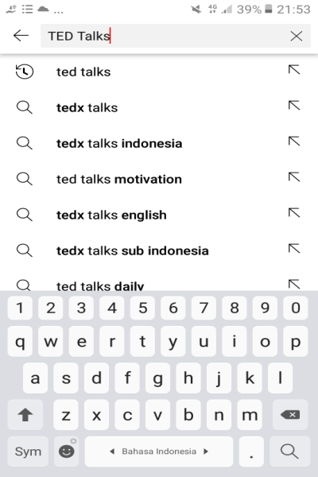

1. Click the ‘TED’ account to see the videos

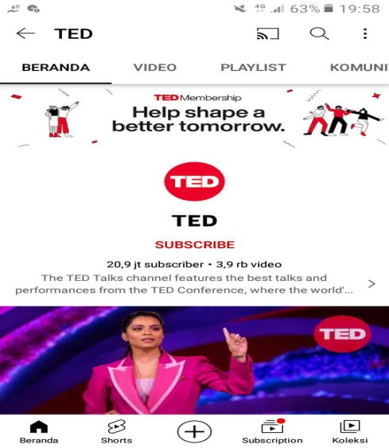

1. Choose the interesting video to watch

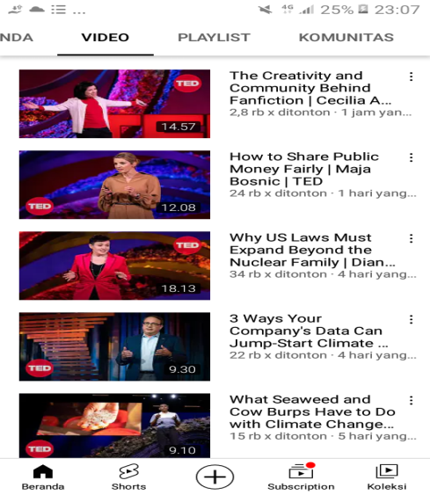

* + 1. **TED Talks Performance**

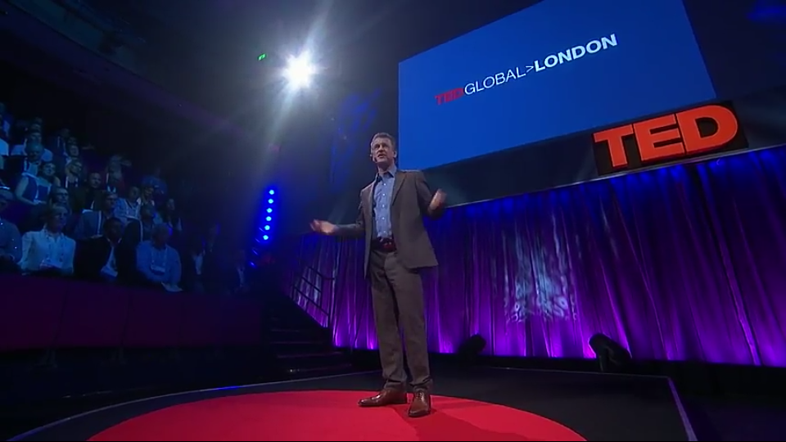

In this TED Talks "How to stay calm when you know you’ll be stressed” the speaker tells about her experience that led to being a journalist. The speaker, Daniel Levitin from London. In that performance, Daniel talked about how he was able to overcome the obstacles in his life. Furthermore, the content of that performance he has conveyed was that you are not at your best when you are stressed. In fact, your brain has evolved over millennia to release cortisol in stressful situations, inhibiting rational, logical thinking but potentially helping you survive, say, being attacked by a lion. Neuroscientist Daniel Levitin thinks there is a way to avoid making critical mistakes in stressful situations, when you’re thinking becomes clouded-the pre-mortem. “We all are going to fail now and then,” he says. “The idea is to think ahead to what those failures might be.”

## **Previous Study**

Previously, some researchers conducted studies intended to improve students’ speaking skills using TED Talks an in this writing, researcher found some related studies that excited researcher to realize the research, that are:

Nursafira (2020) have researched under the title of; TED Talks in EFL Context: An Alternative Way for Teaching and Improving Students’ Speaking Skills as an video-based learning for improving students’ speaking skills with Qualitative research to reach the aim. In addition, the fact that TED Talks speakers come from various countries lets the students realize that learning English is not only perfect pronunciation, but also includes how to use language to communicate. Therefore, TED Talks is one of the ICT tools that can be effectively used to promote speaking skills.

Kusumastuty (2019) has researched under the title of; Student’s Perception of Using TED Talks Improve EFL Speaking Skill that used Questionnaires to collect the data. The objective of this current study was to explore the student’s Perception of Using TED Talks to Improve EFL Speaking Skill. Findings of this study were analyzed using SPSS and found four indicators of student’s

perceptions. The indicators were effectiveness and knowledge, interest of aspect, skill and experience, and the last is motivation. The result revealed that there was no difference in significance between student’s perception of using TED Talk to improve their speaking skill.

Therefore, TED Talks is one of the ICT tools that can be effectively used to promote speaking skills. It represents an effective instructional tool for developing language skills due to its authentic nature (Salem, 2019). The perfection will come if you keep practicing.

According to Takaesu (2013) stated a research entitle “TED Talks as an extensive listening resource for EAP students” that TED (Technology, Entertainment, and Design) Talks, used is an extensive listening material, affected college students’ listening skill, and explores strategies to tailor the activity for lower-proficiency students.

Another presentation by Zahriani (2018) that stated the research entitled “Utilizing TED video for improving Students’ Public Speaking Skills for Academic Purposes”. In her research, the result showed that teaching public speaking by exploring TED Talks style has an effect on the public speaking students. The mean score from the test was pre-test (56.3) and post-test (66.7). It means that TED Talks play an important role in improving students' public speaking which has increased 18,5% in the fifth year students of Department of English Language Education of Bina Bangsa Getsempena.

**CHAPTER III**

**RESEARCH METHODOLOGY**

1. **Research Design**

In order to know the students’ improvement in speaking skill using TED Talks, the researcher conducts an experimental research. Experimental research is designed to find out the effect of presumed cause. In this case, Pre-Experimental Design is used in this research. It occurs in a single group which has no control and experiment class needed. In this study, One-Group Pre-Test and Post-Test are chosen to give the treatment. One-Group Pre-Test and Post-Test is one of the designs of a Pre-Experimental method that has one group of experiments without using a control group, to know the significance by comparing the score of pre-test and post-test (Ary, Jacobs, Irvine, & Walker, 2018). The form of design chart is as follows:

|  |  |  |
| --- | --- | --- |
| O1 | X | O2 |
| Pre-test | Treatment | Post-Test |

Notes:

O1= Pre-Test

X= Treatment

O2= Post-Test

That form above adapted from Sugiyono (2018:110)

1. **Pre-Test**

The researcher asks the students to speak in front of their classmates with random topics to know the capacity of the students’ speaking skill.

The proses of pre-test:

1. Explain the purpose of the researcher
2. The researcher gives 3 topics for students, that are: technology, entertainment and design. But if the student can not choose that one, they can choose the random topics.
3. The researcher randomly mention the name of student
4. The researcher gives 3 minutes to students to persentation.
5. **Treatment**

The researcher teaches the students about TED (Technology, Entertainment, and Design) Talks that can improve their speaking skill. In this case, the researcher gives the students an explanation about what TED Talks and the researcher asked the students to watch the TED Talks video and give a certain topic for students to retell what the students get from the video.

|  |  |
| --- | --- |
| Researcher | Students |
| The researcher explains the definition and how the use of TED Talks. | Students listen and pay attention to the researcher to the material about TED Talks. |
| The researcher gives instructions to the students to pay attention to the way the speaker did the presentation in the video. | Students follow the teacher's instructions to focus on the way the speaker did the presentation in the video. |
| The researcher gives some topics to the students to present. | Students are given a topic to present. |
| The researcher randomly mention the name of the students one by one or ask the students who is going to be the first speaker | Students are called one by one to tell their experience. |
| The researcher gives the rules of presentation; maximum 3 minutes. | The students tell about the topic in front of the other student and the other student should pay attention to the speaker. |
| Every 3 minutes, the researcher asks the students who wants to be the next speaker. | The student (a speaker) changes every 3 minutes, they presented rnatively. |
| The researcher asks every student to make a conclusion based on the video they have watched. | Students make conclusions and speak directly. |
| At the end of discussion, the researcher asks the students to memorize new vocabularies that students’ get after watching the video and after that in the next meeting, students should mention new vocabularies that they learned before. | Students memorize and mention new vocabularies for the next meeting. |
| On the last day, the researcher focused on analyzing the students’ smoothness when the presentation went on. Afterwards, the teacher will explain how to be smooth in speaking. | At the end of the presentation, the students get explanations from the researcher about how to be smooth when speaking. |

**Allocation time**

|  |  |
| --- | --- |
| May 23, 2022 | Pre-test |
| May 23, 2022 | First treatment |
| May 30, 2022 | Second treatment |
| June 6, 2022 | Last treatment |
| June 13, 2022 | Post-test |

1. **Post-Test**

The researcher gives TED (Technology, Entertainment, and Design) Talks topics and limits the time for the students to speak in front of the class. This test is similar to a Pre-Test.

* 1. **Population and Sample**

This research will be conducted in senior high school. The subject of this research is the first grade students in one of the senior high schools in Garut.

1. **Population**

The population of this research is the tenth grade students of senior high schools in Garut, which consists of 4 classes and the average student in each class is 20 students.

1. **Sample**

The sample of this research is one class of the tenth grade students in one of the senior high schools in Garut. Based on the stated of Fraenkel et al. (2012, p. 91), “A sample in a research study is the group on which information is obtained”. The sample is chosen by using purposive sampling. The total of the sample is 26 students.

**Criteria purposive sampling**

1. The method for performing purposive sampling is fairly straighforward.
2. All researcher must do is reject the individuals who do not fit a particular profile when creating the sample.
3. Researchers use purposive sampling when they want to access a particular subset of people, as all participants of a survey are selected because they fit a particular profile.
   1. **Research Variable and Indicators**
4. **Research Variable**

In this research, the independent variable is TED Talks because it influences the dependent variable. Meanwhile, the dependent variable is speaking skill because that variable can give response or influence to a dependent variable.

1. **Indicators**

The indicator to measure accuracy is vocabulary while the indicator to measure fluency is smoothness and the last one is comprehension.

* 1. **Research Instrument**

In research, one of the most important things is the instrument for collecting data. The accuracy of the research result is mostly dependent on how accurate the use of the instrument is. Before doing the research, the instrument for the data collection should be well prepared. Based on the research used for the oral test. It aimed to measure the students’ ability in speaking. The researcher aims at knowing the students’ improvements in learning process by using TED Talks.

Brown and Abeywickrama (2010) contend that to provide effective assessment, there are four rules that need to be established: specify criterion, give appropriate tasks, present maximum output, and set practical and reliable scoring procedures. For this assessment, the table on oral presentation criteria below is going to be used to evaluate students’ presentation. It is also practical as the teacher only needs to put ticks on the appropriate score presented in.

The criteria used to evaluate students’ performance are based on those developed by Brown (2007). He suggests there are at least six criteria to assess speaking skill: pronunciation, fluency, grammar, vocabulary, discourse feature, and task accomplishment. In addition, a presentation skill checklist will be added to the oral presentation assessment criteria. However, the point is not more than twenty percent of the overall score to maintain the validity of an assessment which focuses on speaking skill.

In this case, the researcher only take three aspect to measure students’ speaking performance; they are vocabulary, fluency and comprehension which will be scored based on criteria which classify as follows:

**Table 3.1.**

**THE TEST SCORING CATEGORIES FOR SPEAKING**

**(Brown, 2001: 406-407)**

|  |  |  |  |
| --- | --- | --- | --- |
| **Scores** | **Vocabulary** | **Fluency** | **Comprehension** |
| 1. 1 | Full of long and unnatural pauses | (No Specific fluency description. Refer to the other four language areas for implied level of fluency.) | Within the scope of his very limited language experience, can understand simple questions and statements if delivered with slowed speech, repetition, or paraphrase. |
| 1. 2 | Long pause while search for the desired meaning of word | Can handle with confidence but not with facility most social situations, including introductions and casual conversations about current events, as well as work, family, and autobiographical information. | Can get the gist of most conversations of non-technical subjects (i.e., topics that require no specialized knowledge). |
| 1. 3 | Frequently uses the wrong words, conversation somewhat limited because inadequate vocabulary | Can discuss particular interests of competence with reasonable ease. Rarely has to grope for words. | Comprehension is quite complete at a normal rate of speech. |
| 1. 4 | Sometimes uses inappropriate terms and/ or must rephrase ideas because inadequacies | Able to use language fluently on all levels normally pertinent to professional needs. Can participate in any conversation within the range of this experience with a high degree of fluency. | Can understand an conversation within the range of their experience |
| 1. 5 | Use vocabulary and idioms is virtually that of native speaker | Has complete fluency in the language such that his speech is fully accepted by educated native speakers. | Equivalent to that of an educated native speaker |

**Table 3.2 Rating Points**

|  |  |  |
| --- | --- | --- |
| **Initial** | **Criteria** | **Score** |
| E | Excellent | 5 point |
| VG | Very good | 4 point |
| G | Good | 3 point |
| S | Satisfactorily | 2 point |
| P | Poor | 1. point |

* 1. **Data Collection**

The data collection in this research was Quantitative research. Quantitative research is research that uses numbers in the calculation process and identification of research results. The reason why researchers use quantitative research is because with this type of data, the researcher can use statistics to generalize a finding and look at the relationship between variables and could establish cause and effect in highly controlled circumstances.

The researcher will collect the Pre-Test and Post-Test data to get the final result of the researcher. Pre-test applies to get the first achievement of the students before treatment, and the post-test applies to get the student’s achievement after treatment. In treatment, the researcher will observe the learning process when applying the method.

**Procedure of Collecting Data**

1. Showing the TED Talks videos to the students in the experiment.
2. It conducted pre-test and post-test
3. Pre-test administered to the students before treatments.
4. The treatment was done in two experimental meetings.
5. Post test administered after treatments in order to know the students speaking skill after having the treatment by using TED Talks video.
6. Giving three topics to choose by the students to present.
7. Students are assigned to select one of the themes to be featured.
8. Students prepare titles and materials to be presented in front of the class.
9. Randomly mention the name of the students one by one or ask the students who is going to be the first speaker
10. Giving the rules of presentation; Each student is given a maximum 3 minutes.
11. Whena student is speaking, the teacher assesses the student’s performance about; vocabulary, fluency and comprehension.
    1. **Technique of Data Analysis**

After the technique procedure of collecting data, the next step was data analysis. To describe the students’ ability in speaking, the researcher employed the formula as follows:

1. Calculating The Mean Score of pre-test and post-test

The calculating of the students’ speaking skill by using SPSS 20.

The procedure to find out the mean:

* + - 1. Prepared the data in coloumn SPSS 20
      2. Click analyze then choose ‘Descriptive Statistic’
      3. click descriptive statistic then choose ‘descriptive’
      4. the result of mean score is already

1. Calculating the improvement of the score in three aspects in speaking skill

The improvement of the students’ score in the three aspects of speaking skills

P= $\frac{X2-X1}{X1}$ x 100%

Where:

P= Percentage of the students

X1= the mean score of pre-test

X2= the mean score of post-test

1. Testing hypothesis

After getting the students’ significance score (value of t) it will compare with the value of t-table. When it is found that the value of t-test is equal or greater than the value of t-table, it means that Null Hypothesis (H0) is rejected and Alternative Hypothesis (H1) is accepted because there is significance difference between pre-test and post-test after taught speaking using TED Talks. The criteria for the hypothesis testing as follows:

**Table 3.3: Criteria for the hypothesis testing**

|  |  |  |
| --- | --- | --- |
| **Testing** | **Hypothesis** | |
| **H0** | **H1** |
| t-test>t-table | Rejected | Accepted |
| t-test<t-table | Accepted | Accepted |

**CHAPTER IV**

**FINDINGS AND DISCUSSIONS**

In this chapter the researcher will discuss the data collected from the research in order to find out whether the TED Talks teaching strategy can improve the students’ speaking skill or not. The reseacher will present the finding of the research which is presented as data description and discussion of the findings reveals argument and furher interpretation of the findings. The researcher processes the data through statistical technique using SPSS and follows the formula that had been determined in the previous chapter.

1. **Findings**

After collecting the data, the researcher obtained two kinds of data that are the score of pre-test and the score of post-test. Pre-test is given before the treatment and Post-test is given after the treatment. The results are presented as follows:

1. **Analysis of students’ score in pre-test**
2. Pre-test

In this case, the researcher shows the students’ scores completely in pre-test students’ score in vocabulary, fluency and comprehension presented in the tables, reability, and validity score are calculated by using SPSS 20, it is tabulated by the following table, as follows:

**Table 4.1 The Score of Students’ Speaking Skill in the Pre-test**

|  |  |  |  |  |  |  |  |
| --- | --- | --- | --- | --- | --- | --- | --- |
| **No** | Respondents | Three Aspects of Students’ Speaking Skill | | | | Final  score | level |
| Vocabulary | Fluency | Comprehension | All Score of Test |
| 1 | RD 01 | 4 | 3 | 2 | 9 | 3 | G |
| 2 | RD 02 | 4 | 3 | 3 | 10 | 3 | G |
| 3 | RD 03 | 3 | 3 | 2 | 8 | 3 | G |
| 4 | RD 04 | 4 | 3 | 4 | 11 | 4 | VG |
| 5 | RD 05 | 4 | 4 | 3 | 11 | 4 | VG |
| 6 | RD 06 | 3 | 3 | 3 | 9 | 3 | G |

|  |  |  |  |  |  |  |  |
| --- | --- | --- | --- | --- | --- | --- | --- |
| 7 | RD 07 | 3 | 3 | 4 | 10 | 3 | G |
| 8 | RD 08 | 3 | 3 | 2 | 8 | 3 | G |
| 9 | RD 09 | 3 | 3 | 1 | 7 | 2 | S |
| 10 | RD 10 | 5 | 4 | 4 | 13 | 4 | VG |
| 11 | RD 11 | 3 | 4 | 3 | 10 | 3 | G |
| 12 | RD 12 | 3 | 3 | 3 | 9 | 3 | G |
| 13 | RD 13 | 2 | 3 | 2 | 7 | 2 | S |
| 14 | RD 14 | 4 | 5 | 2 | 11 | 4 | VG |
| 15 | RD 15 | 3 | 2 | 1 | 6 | 2 | S |
| 16 | RD 16 | 3 | 3 | 3 | 9 | 3 | G |
| 17 | RD 17 | 2 | 3 | 3 | 8 | 3 | G |
| 18 | RD 18 | 5 | 3 | 4 | 12 | 4 | VG |
| 19 | RD 19 | 3 | 2 | 1 | 6 | 2 | S |
| 20 | RD 20 | 3 | 4 | 4 | 11 | 4 | VG |
| 21 | RD 21 | 4 | 4 | 3 | 11 | 4 | VG |
| 22 | RD 22 | 4 | 4 | 2 | 10 | 3 | G |
| 23 | RD 23 | 5 | 4 | 3 | 12 | 4 | VG |
| 24 | RD 24 | 4 | 4 | 4 | 12 | 4 | VG |
| 25 | RD 25 | 3 | 5 | 3 | 11 | 4 | VG |
| 26 | RD 26 | 3 | 4 | 2 | 9 | 3 | G |

The table above shows the scoring of students’ speaking skills in the pre-test. In that table, there are three aspects of speaking skill assessment from respondents, that are: Vocabulary, Fluency and Comprehension. Every respondent has the scores that already shown in that table. Also the researcher fill the all score of the test then all scores are divided by three (the number of assessed aspects). If score is subdivided, then it seems to revel a student level in speaking skills.

1. The validity of pre-test

The table bellow is the result of SPSS 20 that explain about validity of pre-test, as follows:

|  |  |  |  |  |  |
| --- | --- | --- | --- | --- | --- |
| **Table 4.2 Correlations** | | | | | |
|  | | X1 | X2 | X3 | Total |
| X1 | Pearson Correlation | 1 | 0.320 | 0.371 | 0.743** |
| Sig. (2-tailed) |  | 0.111 | 0.062 | 0.000 |
| N | 26 | 26 | 26 | 26 |
| X2 | Pearson Correlation | 0.320 | 1 | 0.327 | 0.702** |
| Sig. (2-tailed) | 0.111 |  | 0.103 | 0.000 |
| N | 26 | 26 | 26 | 26 |
| X3 | Pearson Correlation | 0.371 | 0.327 | 1 | 0.795** |
| Sig. (2-tailed) | 0.062 | 0.103 |  | 0.000 |
| N | 26 | 26 | 26 | 26 |
| Total | Pearson Correlation | 0.743** | 0.702** | 0.795** | 1 |
| Sig. (2-tailed) | 0.000 | 0.000 | 0.000 |  |
| N | 26 | 26 | 26 | 26 |
| **. Correlation is significant at the 0.01 level (2-tailed).  Notes: | | | | | |

* Reability
* Variables=X1 X2 X3
* X1= Vocabulary
* X2= Fluency
* X3= Comprehension
* Scale ('All Variables') All
* Model=Alpha
* Summary=Total

**Table 4.3 Scoring Aspects of Students’ Speaking Skill**

|  |  |  |  |
| --- | --- | --- | --- |
| Scoring Aspects of Students’ Speaking Skill | t-test | t-table | Information |
| Vocabulary | 0.743 | 0.320 | Valid |
| Fluency | 0.702 | 0.320 | Valid |
| Comprehension | 0.795 | 0.320 | Valid |

**Notes:**

* t-table 5%= 0.320
* t-test › t-table= valid

1. The Reliability of Pre-test

|  |  |  |  |  |  |  |  |  |  |
| --- | --- | --- | --- | --- | --- | --- | --- | --- | --- |
| **Table 4.4 Reliability Statistics**   |  |  |  |  | | --- | --- | --- | --- | | Alpha Cronbach’s value | Result of Collecting Data | Information |  | | 0.6 | 0.603 | Valid |  | | |
|  | |
| Cronbach's Alpha | N of Items |
| 0.603 | 3 |

The data above is reliable or accepted because according to Pallant (2001) states Alpha Cronbach’s value above 0.6 is considered high reliability and acceptable index (Nunnaly and Bernstein, 1994). It means that the researcher’s data is reliable because more than 0.6 that is 0.603.

|  |  |  |  |  |  |
| --- | --- | --- | --- | --- | --- |
| **Table 4.5 Descriptive Statistics** | | | | | |
|  | N | Minimum | Maximum | Mean | Std. Deviation |
| X1 | 26 | 2.00 | 5.00 | 3.4615 | 0.81146 |
| X2 | 26 | 2.00 | 5.00 | 3.4231 | 0.75753 |
| X3 | 26 | 1.00 | 4.00 | 2.7308 | 0.96157 |
| Total | 26 | 6.00 | 13.00 | 9.6154 | 1.89899 |
| Valid N (listwise) | 26 |  |  |  |  |

* + 1. **Analysis of treatment**

After the researcher finished giving the pre-test, the researcher gives some treatments to the students, as follows:

* First treatment on May 23, 2022. The researcher given the students an explanation about what TED Talks, what is speaking, the aspects of speaking and what the connection about TED Talks and speaking. The researcher also gve an ianstruction to the students if they had a spare time, they could watch the TED Talks’s video on Youtube.
* Second treatment on May 30, 2022. The researcher given the students an explanation about what TED Talks more detail from previous and the researcher had prepare several videos from TED Talks that were already to show to the students. The researcher asked the students to watch the TED Talks video when the videos was finished the researcher asked some students to retell or make a conclusion based on the video they had watched what the students get from that videos. Then, the researcher give an information to the students that they will perform one by one in front of class next week as an exercise before post-test and there are three (technology, entertainment and social) topics and students must choose one of them.
* The last treatment on June 6, 2022. Before the students perform in front of the class the researcher prepares a video from TED Talks entitled ‘The Psychology of Your Future Self’ presented by Dan Gilbert that already to show to the students. After the video finished, the researcher randomly mentions the name of the students one by one or ask the students who are going to be the first speaker. The researcher given the rules of presentation; maximum 3 minutes. Every 3 minutes, the researcher asks the students who wants to be the next speaker until everyone has finished.
  + 1. **Analysis of students’ score in post-test**

1. Post-test

In this case, the researcher shows the students’ scores completely in post-test students’ score in vocabulary, fluency and comprehension presented in the tables, reability, and validity score are calculated by using SPSS 20, it is tabulated by the following table, as follows:

**Table 4.6 The Score of Students’ Speaking Skill in the Post-test**

|  |  |  |  |  |  |  |  |
| --- | --- | --- | --- | --- | --- | --- | --- |
| **No** | Respondents | Three Aspects of Students’ Speaking Skill | | | | Final  score | Level |
| Vocabulary | Fluency | Comprehension | All Score of Test |
| 1 | RD 01 | 4 | 4 | 3 | 11 | 4 | VG |
| 2 | RD 02 | 5 | 4 | 4 | 13 | 4 | VG |
| 3 | RD 03 | 3 | 2 | 2 | 8 | 3 | G |
| 4 | RD 04 | 4 | 3 | 4 | 11 | 4 | VG |
| 5 | RD 05 | 4 | 5 | 3 | 12 | 4 | VG |
| 6 | RD 06 | 4 | 4 | 3 | 11 | 4 | VG |
| 7 | RD 07 | 5 | 5 | 4 | 14 | 5 | E |
| 8 | RD 08 | 4 | 5 | 4 | 13 | 4 | VG |
| 9 | RD 09 | 4 | 4 | 3 | 11 | 4 | VG |
| 10 | RD 10 | 5 | 4 | 4 | 13 | 4 | VG |
| 11 | RD 11 | 4 | 5 | 3 | 12 | 4 | VG |
| 12 | RD 12 | 3 | 4 | 1 | 8 | 3 | G |
| 13 | RD 13 | 4 | 4 | 3 | 11 | 4 | VG |
| 14 | RD 14 | 5 | 5 | 4 | 14 | 5 | E |
| 15 | RD 15 | 4 | 4 | 2 | 10 | 3 | G |
| 16 | RD 16 | 4 | 2 | 1 | 9 | 3 | G |
| 17 | RD 17 | 4 | 5 | 5 | 14 | 5 | E |
| 18 | RD 18 | 5 | 4 | 4 | 13 | 4 | VG |
| 19 | RD 19 | 4 | 5 | 3 | 12 | 4 | VG |
| 20 | RD 20 | 5 | 5 | 5 | 15 | 5 | E |
| 21 | RD 21 | 4 | 4 | 3 | 11 | 4 | VG |
| 22 | RD 22 | 4 | 5 | 4 | 13 | 4 | VG |
| 23 | RD 23 | 5 | 4 | 3 | 12 | 4 | VG |
| 24 | RD 24 | 4 | 4 | 4 | 12 | 4 | VG |
| 25 | RD 25 | 5 | 5 | 4 | 14 | 5 | E |
| 26 | RD 26 | 5 | 4 | 5 | 14 | 5 | E |

The table above shows the scoring of students’ speaking skills in the post-test. In that table, there are three aspects of speaking skill assessment from respondents, that are: Vocabulary, Fluency and Comprehension. Every respondent has the scores that already shows in that table. Also the researcher fill the all score of the test then all scores are divided by three (the number of assessed aspects). If score is subdivided, then it seems to revel a student level in speaking skills.

1. The validity of post-test

The table is result of SPSS 20 that explain about validity of post-test, as follows:

|  |  |  |  |  |  |
| --- | --- | --- | --- | --- | --- |
|  | **Table 4.7 Correlations** | | | | |
|  |  | X1 | X2 | X3 | Total |
| X1 | Pearson Correlation | 1 | 0.363 | 0.643 | 0.762 |
| Sig. (2-tailed) |  | 0.068 | 0.000 | 0.000 |
| N | 26 | 26 | 26 | 26 |
| X2 | Pearson Correlation | 0.363 | 1 | 0.536 | 0.783 |
| Sig. (2-tailed) | 0.068 |  | 0.005 | 0.000 |
| N | 26 | 26 | 26 | 26 |
| X3 | Pearson Correlation | 0.643 | 0.536 | 1 | 0.911 |
| Sig. (2-tailed) | 0.000 | 0.005 |  | 0.000 |
| N | 26 | 26 | 26 | 26 |
| Total | Pearson Correlation | 0.762 | 0.783 | 0.911 | 1 |
| Sig. (2-tailed) | 0.000 | 0.000 | 0.000 |  |
| N | 26 | 26 | 26 | 26 |
|  | **. Correlation is significant at the 0.01 level (2-tailed). | | | | |

**Table 4.8 Scoring Aspects of Students’ Speaking Skill**

|  |  |  |  |
| --- | --- | --- | --- |
| Scoring Aspects of Students’ Speaking Skill | t-test | t-table | Information |
| Vocabulary | 0.762 | 0.320 | Valid |
| Fluency | 0.783 | 0.320 | Valid |
| Comprehension | 0.911 | 0.320 | Valid |

**Notes:**

t-table 5%= 0.320

t-test › t-table= valid

1. The reliability of Post-test

|  |  |  |  |  |  |  |  |
| --- | --- | --- | --- | --- | --- | --- | --- |
| **Table 4.9 Reliability Statistics**   |  |  |  | | --- | --- | --- | | Alpha Cronbach’s value | Result of Collecting Data | Information | | 0.6 | 0.742 | Valid | | |
|  | |
| Cronbach's Alpha | N of Items |
| 0.742 | 3 |

The data above is reliable or accepted because according to Pallant (2001) states Alpha Cronbach’s value above 0.6 is considered high reliability and acceptable index (Nunnaly and Bernstein, 1994). It means that the researcher’s data is reliable because more than 0.6 that is 0. 742.

|  |  |  |  |  |  |
| --- | --- | --- | --- | --- | --- |
| **Table 4.10 Descriptive Statistics** | | | | | |
|  | N | Minimum | Maximum | Mean | Std. Deviation | |
| X1 | 26 | 3.00 | 5.00 | 4.2692 | 0.60383 | |
| X2 | 26 | 2.00 | 5.00 | 4.1923 | 0.84943 | |
| X3 | 26 | 1.00 | 5.00 | 3.3846 | 1.06120 | |
| Total | 26 | 7.00 | 15.00 | 11.8462 | 2.09174 | |
| Valid N (listwise) | 26 |  |  |  |  | |

Notes:

X1= Vocabulary

X2= Fluency

X3= Comprehension

In that table is the results of minimum and maximum test also mean and standar deviation of the data that already colected in post-test.

In conclusion, the minimum score in vocabulary is 3 points and the maximum score is 5 points with mean value is 4.2696. in fluency, the minimum score is 2 points and the maximum score is 5 points with mean value is 4.1923. Then, in comprehension the minimum score is 1 points and the maximum score is 5 points with mean value is 3.3846.

* + 1. **Calculating the students’ score improvement**

1. Improvement of vocabulary

**Table 4.11 Improvement of vocabulary**

|  |  |  |  |
| --- | --- | --- | --- |
| Indicator | Mean score | | The improvement |
| Pre-test | Post-test |
| Vocabulary | 3.46 | 4.27 | 23.41% |

In that table, the researcher conclude that the improvement of students’ vocabulary using TED Talks is 23.41%.

1. Improvement of fluency

**Table 4.12 Improvement of fluency**

|  |  |  |  |
| --- | --- | --- | --- |
| Indicator | Mean score | | The improvement |
| Pre-test | Post-test |
| Fluency | 3.42 | 4.19 | 22.51% |

In that table, the researcher conclude that the improvement of students’ fluency using TED Talks is 22.51 %

1. Improvement of comprehension.

**Table 4.13 Improvement of comprehension**

|  |  |  |  |
| --- | --- | --- | --- |
| Indicator | Mean score | | The improvement |
| Pre-test | Post-test |
| Comprehension | 2.73 | 3.38 | 23.8% |

In that table, the researcher conclude that the improvement of students’ comprehension using TED Talks is 23.8%.

1. **Discussions**

The main purpose of this research was to find out whether or not the use of TED Talks video could improve students’ speaking skill in terms of vocabulary, fluency and comprehension. The result of this research showed that how TED Talks improved students’ speaking skill also related with Pell (2015), he said “how students could use TED to improve their English at home and how teachers can use them in class”. A return to the researcher’s invention, as shown in the findings part, is that students can improve enflish-speaking skills primarly by using TED Talks. So far, TED Talks can be an alternative way for improving students’ speaking skill. There were explanation for the result found in this research.

1. **The students’ speaking skill in term of Vocabulary**

At the first, the researcher gave a pre-test to measure students’ capabilityin speaking skill in term of vocabulary. The result of pre-test showed that the students’ capability in speaking was still in average. The researcher found the problem in pre-test was the students got difficulties in misused of vocabulary and very limited vocabulary. So, the students did not know about what students wanted to say and sometimes the students writen the vocabularry on the paper and read it when students were speaking. Because of their actions, they will be difficult in remembering new vocabulary and will be slow to master new vocabulary.

The data on table 4.11 showed that the score of vocabulary was improved 23.41% from the mean score 3.46 in pre-test to be 4.27 in post-test. In pre-test, the students mean score was low in vocabulary because they did not know what to said altough they had arranged in their paper in Indonesia, they used much time to do their test to thought what word or vocabulary they want to said and most of them shy when they do a mistake. Furthermore in post-test, the mean score was up in vocabulary, after the treatments was done the score was higher of post-test.

1. **The students’ speaking skill in term of Fluency**

At the second, the researcher gave a pre-test to measure students’ capabilityin speaking skill in term of fluency. The result of pre-test showed that the students’ capability in speaking was still in average. The researcher found the problem in pre-test was the students got difficulties in rythm, speed of speech or students tried to said a sound but it did not come out and drag out syllables. When the treatment has been made, the students’ fluency is increasing even further. They know the good reading speed and rythm when they speak. The data on table 4.12 showed that the score of fluency was improved 22.51% from the mean score 3.42 in pre-test to be 4.19 in post-test.

1. **The students’ speaking skill in term of comprehension**

At last, the researcher gave a pre-test to measure students’ capabilityin speaking skill in term of comprehension. The result of pre-test showed that the students’ capability in speaking was still in average. The researcher found the problem in seet was the students got difficulties, that is confusion about the meaning of words and sentences. When the treatment has been made, the students’ fluency is increasing even further. The students can overcome the problem in comprehension, the average of them can deduce what a word or sentence is going to or being uttered. The data on table 4.13 showed that the score of comprehension was improved 23.8% from the mean score 2.73 in pre-test to be 3.38 in post-test.

Based on pre-test results, there were 10 students who got the *very good* (VG) score, 12 students who got the *good* (G) score and 4 students who got the *satisfactory* (S) score. Also based on post-test results, there were 16 students who got the *very good* (VG) score, 4 students who got the *good* (G) score and 6 students who got the *excellent* (E) score.

**CHAPTER V**

**CONCLUSIONS AND SUGGESTIONS**

1. **Conclusions**

Based on the result and discussion of the findings previously, it could be concluded that the use of TED Talks’ video was effective for improving students’ speaking skill, for more details, see the conclusion below:

1. To begin with vocabulary, it was proven by the students’ vocabulary achievement in post-test was greater than in pre-test that is 0.762 › 0.743 and improving from pre-test to post-test is 23.41%.
2. In addition about Fluency, it was proven by the students’ fluency achievement in post-test was greater than in pre-test that is 0.783›0.702 and and improving from pre-test to post-test is 22.51%.
3. Furthermore, comprehension be a last from the result and discussion, it was proven by the students’ fluency achievement in post-test was greater than in pre-test that is 0.911›0.795 and and improving from pre-test to post-test is 23.8%.

Based on hyphothesis testing in previous chapter, the null hyphothesis (H0) was rejected whereas the alternative hyphothesis (H1) was accepted. It was proven by the value of the t-test greater than t-table (t-test › t-table= valid) based on the researcher’s finding.

1. **Suggestions**

The successful teaching does not defend on the lesson program only, but how the students feel comportable with the teacher way in learning. Along with the development of technology, these video-based learning are highly prized by students, as are the the use of TED Talks. Based on the conclusion above, the researcher proposes the some suggestions:

1. The teacher should be more creative in teaching and prepared the interesting material. Teaching using video in an alternative and effective way. Usually, the materials are presented in an enjoyable, understandable

and relaxed way. It is suggested for the teacher to use video TED Talks to materials in teaching English.

1. The students are hoped to be more creative in enriching their ideas in a speaking. they have to comprehend the general concept of the main material clearly before do a speaking and if they have no understand in material, they can ask to their teacher.
2. For the next researcher, the finding of this research can be used as reference and can be applied this media in the other classroom when teaching English exactly in speaking material.

# **REFERENCES**

Aleles, J., & Hall, M. (2016). TED Talks for authentic Learning: an Academic Oral Communication course for Improving presentation skill. *International Journal of Humanities and Manajement Science*, 16(1), 34-40.

Anderson, C. (2016). TED Talks - The Official TED Guide to Public Speaking . Dalam C. Anderson. New York: Houngton Mifflin Hartcourt Publishing Company.

Balan. (2011). English As a Foreign Language. *English Language*.

Gomez, J. (2016). Multimedia Resourcs and their Incidence in the English Speaking Skill. *Online Submission*.

Kedrowicz, A., & Taylor, L. (2016). Shifting Rhetorical Norms and Electroic Eloquence: TED Talks as formal Presentation. *Journal of Business and Technical Communication*, 352-377.

Nurkhamedov, U. (2017). lexical Couverage of TED Talks. *Implication for Vocabulary Instruction*, 768-790.

Yolanda, D., & Hadi, M. (2019). Using puppets Games in Teaching Speaking Graders of Senior High School. *English Language in Focus (ELIF)*, 1-8.

Broadaway, R. (2012). Content-Based Instruction using Moodle: Teaching with TED Talks . 8(3), 211-213.

Brown, G., & Yule, G. (1983). *Teaching The Spoken Language; An Approach Based on the Analysis of Conversational English.* Cambridge: Cambridge University Press.

Channey, A. (1998). Teaching Oral Communication in Grades K-8. Boston: Allyn and Bacon.

Cong-lem, N. (2018). Web-Based Language Learning (WBLL) for enhancing L2 Speaking Performance: A review. 9(4), 10.

Haris, D. (1974). *Testing English as a Second Language.* New York: Mc. Book Hill Company.

Heaton, J. (1988). *Writing English Language Text. Longman: Longman handsbooks for language teachers.* London and New York.

Nursafira, M. S. (2020). TED Talks in EFL Context: An Alternative Way for Teaching and Improving Students' speaking Skill. *Journal of English Language Studies*.

Salem, A. A. (2019). A Sage on a Stage, to Express and Impress: TED Talks for Improving Oral PresentationSkills, Vocabulary Retention and its Impact on Reducing Speaking Anxiety in ESP Settings. Dalam *English Language and Teaching* (hal. 12(6), 146-160).

Takaesu, A. (2013). TED Talks as an extensive listening resource for EAP students. Dalam *Asian focused ELT research and Practice: Voices from the far edge* (hal. 108-120).

Tarigan, H. G. (1990). Berbicara: Sebagai Suatu keterampilan Berbahasa. Bandung: Angkasa.

Ur, P. (2012). *A Course in English Language Teaching.* Cambridge: Cambridge University Press.

Zahriani. (2018). Utilizing TED Video to Improve Students' Public Speaking Skills for Academic Purposes.

**APPENDICES**

**APPENDIX I**

1. **The table of students’ score**

**Pre-test**

**The Score of Students’ Speaking Skill in the Pre-test**

|  |  |  |  |  |  |  |  |
| --- | --- | --- | --- | --- | --- | --- | --- |
| **No** | Respondents | Three Aspects of Students’ Speaking Skill | | | | Final  score | level |
| Vocabulary | Fluency | Comprehension | All Score of Test |
| 1 | RD 01 | 4 | 3 | 2 | 9 | 3 | G |
| 2 | RD 02 | 4 | 3 | 3 | 10 | 3.34= 3 | G |
| 3 | RD 03 | 3 | 3 | 2 | 8 | 2.67= 3 | G |
| 4 | RD 04 | 4 | 3 | 4 | 11 | 3.67=4 | VG |
| 5 | RD 05 | 4 | 4 | 3 | 11 | 3.67-=4 | VG |
| 6 | RD 06 | 3 | 3 | 3 | 9 | 3 | G |
| 7 | RD 07 | 3 | 3 | 4 | 10 | 3.34=3 | G |
| 8 | RD 08 | 3 | 3 | 2 | 8 | 2.67=3 | G |
| 9 | RD 09 | 3 | 3 | 1 | 7 | 2.34=2 | S |
| 10 | RD 10 | 5 | 4 | 4 | 13 | 4.34=4 | VG |
| 11 | RD 11 | 3 | 4 | 3 | 10 | 3.34=3 | G |
| 12 | RD 12 | 3 | 3 | 3 | 9 | 3 | G |
| 13 | RD 13 | 2 | 3 | 2 | 7 | 2.34=2 | S |
| 14 | RD 14 | 4 | 5 | 2 | 11 | 3.67=4 | VG |
| 15 | RD 15 | 3 | 2 | 1 | 6 | 2 | S |
| 16 | RD 16 | 3 | 3 | 3 | 9 | 3 | G |
| 17 | RD 17 | 2 | 3 | 3 | 8 | 2.67=3 | G |

|  |  |  |  |  |  |  |  |
| --- | --- | --- | --- | --- | --- | --- | --- |
| 18 | RD 18 | 5 | 3 | 4 | 12 | 4 | VG |
| 19 | RD 19 | 3 | 2 | 1 | 6 | 2 | S |
| 20 | RD 20 | 3 | 4 | 4 | 11 | 3.67=4 | VG |
| 21 | RD 21 | 4 | 4 | 3 | 11 | 3.67=4 | VG |
| 22 | RD 22 | 4 | 4 | 2 | 10 | 3.34=3 | G |
| 23 | RD 23 | 5 | 4 | 3 | 12 | 4 | VG |
| 24 | RD 24 | 4 | 4 | 4 | 12 | 4 | VG |
| 25 | RD 25 | 3 | 5 | 3 | 11 | 3.67=4 | VG |
| 26 | RD 26 | 3 | 4 | 2 | 9 | 3 | G |

**Post-test**

**The Score of Students’ Speaking Skill in the Post-test**

|  |  |  |  |  |  |  |  |  |  |  |  |  |  |  |  |
| --- | --- | --- | --- | --- | --- | --- | --- | --- | --- | --- | --- | --- | --- | --- | --- |
| **No** | | Respondents | Three Aspects of Students’ Speaking Skill | | | | | | | | | Final  Score | | Level | |
| Vocabulary | | Fluency | | Comprehension | | | All Score of Test | |
| 1 | | RD 01 | 4 | | 4 | | 3 | | | 11 | | 3.67=4 | | VG | |
| 2 | | RD 02 | 5 | | 4 | | 4 | | | 13 | | 4.34=4 | | VG | |
| 3 | | RD 03 | 3 | | 2 | | 2 | | | 8 | | 2.67=3 | | G | |
| 4 | | RD 04 | 4 | | 3 | | 4 | | | 11 | | 3.67=4 | | VG | |
| 5 | | RD 05 | 4 | | 5 | | 3 | | | 12 | | 4 | | VG | |
| 6 | | RD 06 | 4 | | 4 | | 3 | | | 11 | | 3.67=4 | | VG | |
| 7 | | RD 07 | 5 | | 5 | | 4 | | | 14 | | 4.67=5 | | E | |
| 8 | | RD 08 | 4 | | 5 | | 4 | | | 13 | | 4.34=4 | | VG | |
| 9 | | RD 09 | 4 | | 4 | | 3 | | | 11 | | 3.67=4 | | VG | |
| 10 | | RD 10 | 5 | | 4 | | 4 | | | 13 | | 4.34=4 | | VG | |
| 11 | | RD 11 | 4 | | 5 | | 3 | | | 12 | | 4 | | VG | |
| 12 | | RD 12 | 3 | | 4 | | 1 | | | 8 | | 2.67=3 | | G | |
| 13 | | RD 13 | 4 | | 4 | | 3 | | | 11 | | 3.67=4 | | VG | |
| 14 | | RD 14 | 5 | | 5 | | 4 | | | 14 | | 4.67=5 | | E | |
| 15 | | RD 15 | 4 | | 4 | | 2 | | | 10 | | 3.34=3 | | G | |
| 16 | | RD 16 | 4 | | 2 | | 1 | | | 9 | | 3 | | G | |
| 17 | | RD 17 | 4 | | 5 | | 5 | | | 14 | | 4.67=5 | | E | |
| 18 | | RD 18 | 5 | | 4 | | 4 | | | 13 | | 4.34=4 | | VG | |
| 19 | | RD 19 | 4 | | 5 | | 3 | | | 12 | | 4 | | VG | |
| 20 | | RD 20 | 5 | | 5 | | 5 | | | 15 | | 5 | | E | |
| 21 | | RD 21 | 4 | | 4 | | 3 | | | 11 | | 3.67=4 | | VG | |
| 22 | | RD 22 | 4 | | 5 | | 4 | | | 13 | | 4.34=4 | | VG | |
| 23 | | RD 23 | 5 | | 4 | | 3 | | | 12 | | 4 | | VG | |
| 24 | | RD 24 | 4 | | 4 | | 4 | | | 12 | | 4 | | VG | |
| 25 | | RD 25 | 5 | | 5 | | 4 | | | 14 | | 4.67=5 | | E | |
| 26 | | RD 26 | 5 | | 4 | | 5 | | | 14 | | 4.67=5 | | E | |
| Notes:   1. X1= vocabulary 2. X2= fluency 3. X3= comprehension 4. N= banyak siswa 5. **The Results of Descriptive Statistic**   **Descriptive Statistics in Pre-test** | | | | | | | | | | | | | |
|  | | | N | | Minimum | | Maximum | Mean | | Std. Deviation | | | |
| X1 | | | 26 | | 2.00 | | 5.00 | 3.4615 | | 0.81146 | | | |
| X2 | | | 26 | | 2.00 | | 5.00 | 3.4231 | | 0.75753 | | | |
| X3 | | | 26 | | 1.00 | | 4.00 | 2.7308 | | 0.96157 | | | |
| Total | | | 26 | | 6.00 | | 13.00 | 9.6154 | | 1.89899 | | | |
| Valid N (listwise) | | | 26 | |  | |  |  | |  | | | |
| **Descriptive Statistics in Post-test** | | | | | | | | | | | |
|  | | | N | | Minimum | | Maximum | Mean | | Std. Deviation | | | |
| X1 | | | 26 | | 3.00 | | 5.00 | 4.2692 | | 0.60383 | | | |
| X2 | | | 26 | | 2.00 | | 5.00 | 4.1923 | | 0.84943 | | | |
| X3 | | | 26 | | 1.00 | | 5.00 | 3.3846 | | 1.06120 | | | |
| Total | | | 26 | | 7.00 | | 15.00 | 11.8462 | | 2.09174 | | | |
| Valid N (listwise) | | | 26 | |  | |  |  | |  | | | |

1. **Calculating the students’ score improvement**

Notes:

1. x1= pre-test
2. x2= post-test
3. Improvement of vocabulary

**Improvement of vocabulary**

|  |  |  |  |
| --- | --- | --- | --- |
| Indicator | Mean score | | The improvement |
| Pre-test | Post-test |
| Vocabulary | 3.46 | 4.27 | 23.41% |

P= $\frac{X2-X1}{X1}$ x 100%

P= $\frac{4.27-3.46}{3.46}$ x 100%

P= $\frac{40.81}{3.46}$ x 100%

P= 23.41%

1. Improvement of fluency

**Improvement of fluency**

|  |  |  |  |
| --- | --- | --- | --- |
| Indicator | Mean score | | The improvement |
| Pre-test | Post-test |
| Fluency | 3.42 | 4.19 | 22.51% |

P= $\frac{X2-X1}{X1}$ x 100%

P= $\frac{4.19-3.42}{3.42}$ x 100%

P= $\frac{0.77}{3.42}$ x 100%

P= 22.51%

1. Improvement of comprehension

**Improvement of comprehension**

|  |  |  |  |
| --- | --- | --- | --- |
| Indicator | Mean score | | The improvement |
| Pre-test | Post-test |
| Comprehension | 2.73 | 3.38 | 23.8% |

P= $\frac{X2-X1}{X1}$ x 100%

P= $\frac{3.38-2.73}{2.73}$ x 100%

P= $\frac{0.65}{2.73}$ x 100%

P= 23.8%

1. **Distribution of t-table**

|  |  |  |  |  |
| --- | --- | --- | --- | --- |
| **Df** | **Level of Significant for one tailed test** | | | |
| **0.05** | **0.025** | **0.005** | **0.0005** |
| **Level of Significant for one tailed test** | | | |
| **0.10** | **0.05** | **0.001** | **0.0001** |
|  | 6.314 | 12.706 | 63.657 | 636.619 |
|  | 2.920 | 4.303 | 9.925 | 31.598 |
|  | 2.353 | 3.182 | 5.841 | 12.941 |
|  | 2.132 | 2.776 | 4.604 | 8.610 |
|  | 2.015 | 2.571 | 3.707 | 6.869 |
|  | 1.943 | 2.247 | 3.707 | 5.959 |
|  | 1.895 | 2.365 | 3.499 | 5.408 |
|  | 1.860 | 2.306 | 3.335 | 5.041 |
|  | 1.833 | 2.262 | 3.250 | 4.781 |
|  | 1.812 | 2.226 | 3.169 | 4.587 |
|  | 1.796 | 2.201 | 3.106 | 4.437 |
|  | 1.782 | 2.179 | 3.055 | 4.318 |
|  | 1.771 | 1.460 | 3.120 | 4.221 |
|  | 1.761 | 2.145 | 2.977 | 4.140 |
|  | 1.753 | 2.131 | 2.974 | 4.037 |
|  | 1.746 | 2.120 | 2.921 | 4.015 |
|  | 1.740 | 2.110 | 2.898 | 3.965 |
|  | 1.743 | 2.101 | 2.878 | 3.922 |
|  | 1.729 | 2.903 | 2.861 | 3.883 |
|  | 1.725 | 2.086 | 2.845 | 3.850 |
|  | 1.721 | 2.080 | 2.831 | 3.819 |
|  | 1.314 | 2.074 | 2.819 | 3.792 |
|  | 1.714 | 2.690 | 2.807 | 3.767 |
|  | 1.711 | 2.060 | 2.797 | 3.745 |
|  | 1.708 | 2.056 | 2.787 | 3.725 |
|  | 1.706 | 2.052 | 2.779 | 3.707 |
|  |  |  |  |  |

1. **Topics for Pre-test and Post-test**
2. **Pre-test**
3. Technology
4. Entertainment
5. Design
6. Random topics
7. **Post-test**
8. Technology
9. Entertainment
10. Design

**APPENDIX II**

**Documents**

**Pre-test**

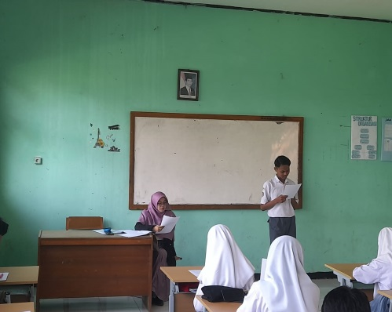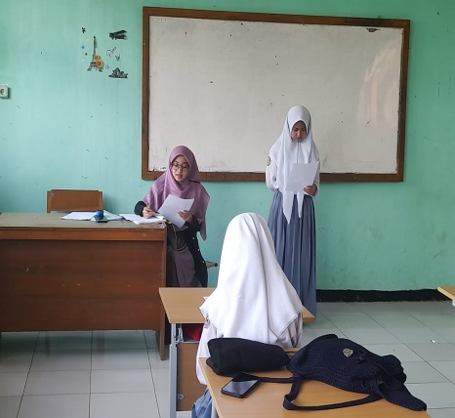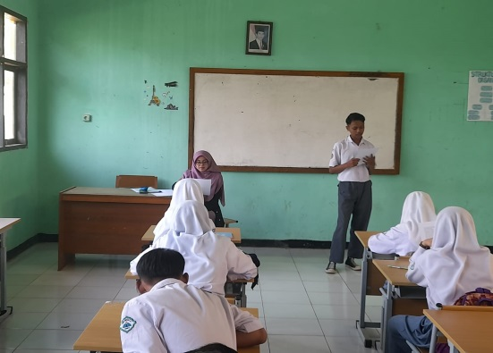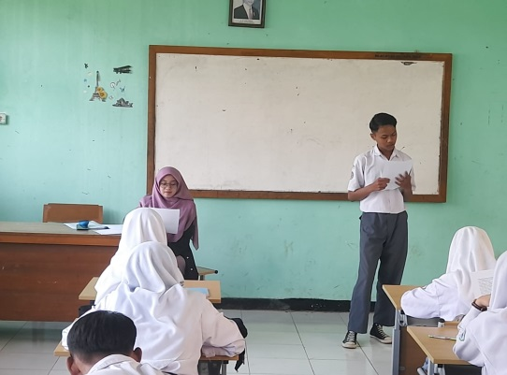

**Treatment**

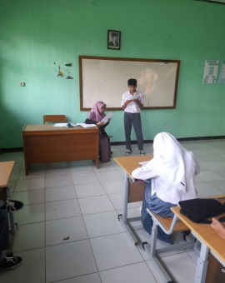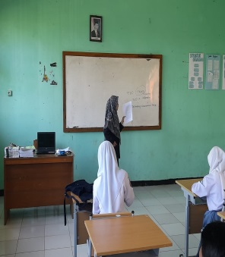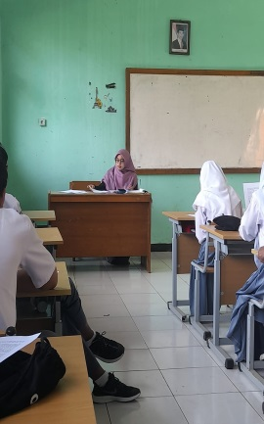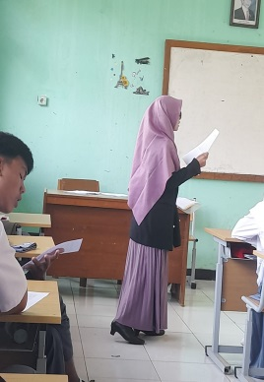

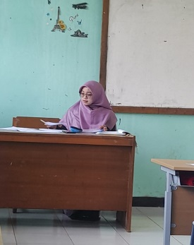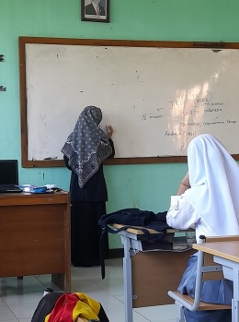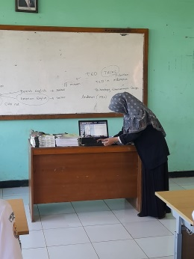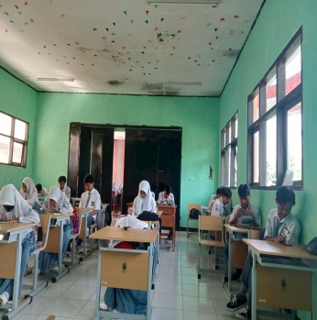

**Post-test**

