**TEACHERS’ PROBLEMS DURING HYBRID LEARNING PROCESS IN NON-FORMAL EDUCATION SETTING**

**A PAPER**

Submitted to the English Education Program of the School of Postgraduate Studies in Partial Fulfillment of the Requirements for Bachelor’s Degree in Education

by**:**

**AGUNG GUMILAR**

**NIM 18224014**

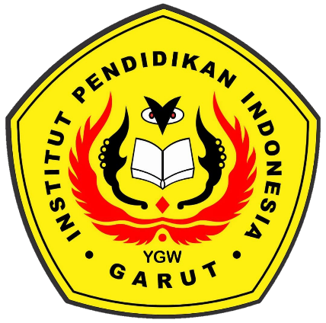

**ENGLISH EDUCATION PROGRAM**

**FACULTY OF SOCIAL SCIENCE LANGUAGE AND LITERATURE EDUCATION**

**INSTITUT PENDIDIKAN INDONESIA GARUT**

**2022**