**AN ANALYSIS OF FORMATIVE ASSESSMENT ON STUDENTS’ WRITING SKILLS**

**A PAPER**

Submitted to the English Education Program of IPI Garut

as a Partial Fulfillment of the Requirements for the Sarjana Pendidikan Degree

By

**Achmad Ilham**

**17223025**

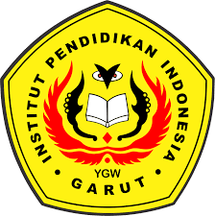

**ENGLISH EDUCATION PROGRAM**

**FACULTY OF SOCIAL STUDIES, LANGUAGE, AND LITERATURE INDONESIA INSTITUTE OF EDUCATION**

**2022**